Please use this form to clearly and concisely report on project progress. The information included should reflect quantifiable results that can be used to evaluate and measure project success. Comments should be limited to the designated boxes. Technical reports, no longer than 4 pages, may be attached to this summary report.

Project Number:
Project Title: | Development of climate-smart high-yield practices associated with high-end biological treatments and soybean-related microbiome resiliency.
Organization: | University of Texas-Arlington
Project Lead Name: | Woo-Suk Chang
Report Date: | December 15, 2023
In the Progress Summary section below, please provide a brief summary of project progress in lay language that will be shared publicly in the National Soybean Checkoff Research Database. Do not include any confidential or proprietary information. If no lay language is provided, the contents of this entire report will be published in the National Soybean Checkoff Research Database.

Progress Summary (in non-proprietary lay language suitable to be shared publicly):
Since September 15th, we have completed a second round of sampling in Colt (AR), Norborne (MO), and Winnsboro (LA). We collected rhizosphere soil samples for both conventionally tilled and no-tilled fields. We have also analyzed physiochemical properties of soils for all the field sites: Corpus Christi (TX), Port Lavaca (TX), Norborne (MO), Colt (AR), Winnsboro (LA), and Leland (MS). In addition to the soil analysis, we conducted nodulation assays and the final yield for both conventionally tilled and no-tilled fields in Colt, AR.

Detailed Progress Status – Expand upon the above section. What key activities were undertaken and what were the key accomplishments during this reporting period? List each key deliverable from the proposal and describe progress made (or not made) toward achieving it, including metrics were appropriate.
Table 1. Summary of 2023 field work.
Location | Collaborators | Planting Date | Sampling Date | Plant Growth Stage | Pre-Harvest Sampling | Harvest Date | Cultivars Used | Maturity Group
Corpus Christi, TX | Dr. Josh McGinty | 3/28 | 5/30 | R3 - R4 | N/A | No yield | Pioneer-P47A25BX, Lynda, Pamela | 4L, INDT, INDT
Port Lavaca, TX | Dr. James Grichar | 3/29 | 5/31 | R3 - R4 | N/A | 8/24 | Pioneer-P47A25BX, Lynda, Pamela | 4L, INDT, INDT
Norborne, MO | Dr. Eric Oseland | 5/1 | 8/17 | R5 | 9/25 | Week of 10/9 | Pioneer (42) | 3.8 - 4.2
Colt, AR | Dr. Shawn Clark | 5/24 | 7/11 and 7/12 | V6 - R1 | 9/19 | 10/14 & 10/16 | Ellis,  S14-9017R* | 4L, 5
Winnsboro, LA | Dr. Trey Price | 5/26 | 7/14 | V6 - R1 | 11/2 | 11/12 | Ellis | 4L
Leland, MS | Dr. Tessie Wilkerson | 6/9 | 8/10 | R3 - R4 | N/A | No yield | Ellis | 4L
*: drought-sensitive
NA: not applicable

Initial soil samples were collected from each of the 6 field sites during the planting season. During the mid-sampling harvest, rhizosphere soils were collected form 6 plants of equal biomass from the outside rows per plot. Additionally, leaf samples were collected from 10 soybean plants from the two outside rows of each plot, collecting the trifoliate leaf, third node from the top. In Colt, AR, the soil physiochemical analysis showed higher concentrations of N & P in the conventionally tillage field compared to the no-tilled field, while K concentrations were higher in the no-tilled field with respect to TXVA treatment and the no treatment control (Fig. 1). For comparison between conventional tillage and no-till practice, we primarily focus on soybean fields in AR, LA, and MO. The results shown in Figure 2 represent higher K concentrations in the no-tilled soils with respect to TXVA and the control in Winnsboro, LA.

Nodulation assays revealed that TXVA produced more nodules in both taproot and total roots compared to the control and the TAG treatment for the no-till fields in Colt, AR and Winnsboro, LA (Figs. 3 - 4). We are currently measuring nodule counts for the conventional tillage and no-till fields in Norborne, MO.

The final yield for the conventionally tilled field in Colt, AR showed a 5.7% increase in the TXVA treatment compared to the control (Fig. 5). For the Ellis cultivar, it was a 1.69% increase in TXVA compared to the control (Fig. 5). As for the no-tilled field, the final yield was much lower due to the non-irrigated nature. However, the TXVA treated plants still yielded 20% more than those with no treatment (the control) (Fig. 6). For the no-tilled field trials in Winnsboro, LA, we were able to collect soil samples at harvest time; however, due to extreme heat and drought, we failed to harvest soybeans.
Figure 7 shows the soybean plant with stunted and shattered pods.

For the conventionally tilled and no-tilled fields in Norborne, MO, we were able to collect rhizosphere soil samples from the 6 sites. Figures 8A and 8B show pictures taken during the sampling process. The farmers from Norborne, MO have estimated the final yield of ca. 55 bushels/acre. All the fields were maintained rainfed.

We are currently processing DNA extractions from the rhizosphere soils collected from the conventionally tilled and no-tilled fields for the soil microbiome analysis.

Figure 1. Soil physiochemical properties for cultivars Ellis and S14-9017R in conventional tillage vs. no-till fields in Colt, AR. The initial sample indicates soil physiochemical properties before applying any inoculant treatment. Organic matter (OM%) is measured as a percent, and all nutrients are measured as parts per million (ppm).

Figure 2. Soil physiochemical properties for cultivar Ellis in conventional tillage vs. no-till fields in Winnsboro, LA. The initial sample indicates soil physiochemical properties before applying any inoculant treatment. Organic matter (OM%) is measured as a percent, and all nutrients are measured as parts per million (ppm).

Figure 3. Taproot and total root nodulation in the no-till field in Colt, AR.

Figure 4. Taproot and total root nodulation in the no-till field in Winnsboro, LA.

Figure 5. Final yield from the conventional tillage field (irrigated) in Colt, AR.

A
B

Figure 6. (A) Final yield from the no-till field in Colt, AR. (B) A picture of the no-tilled field (non-irrigated) taken during pre-harvest sampling.

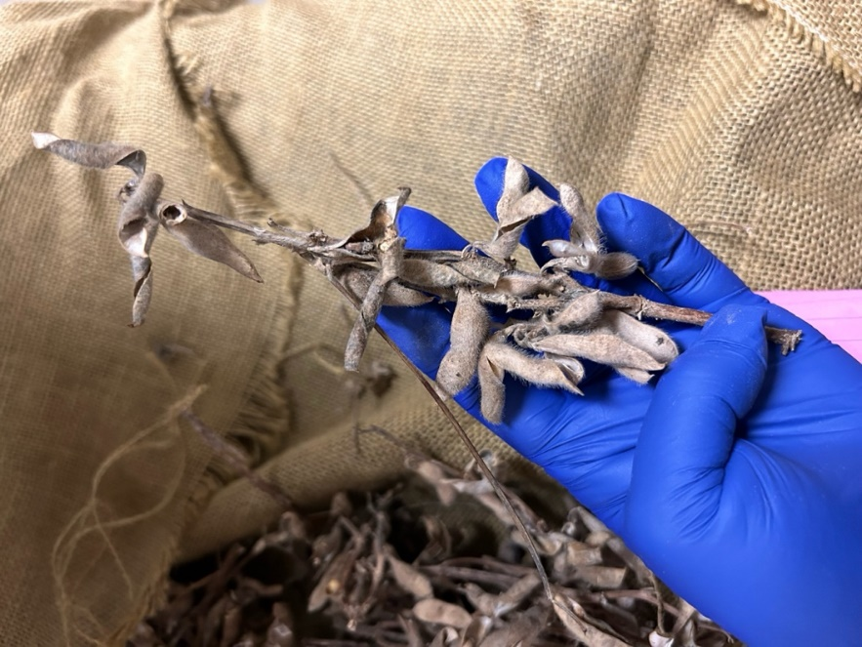

Figure 7. A picture of a soybean plant with shattered pods taken at harvest time from the no-tilled field in Winnsboro, LA.

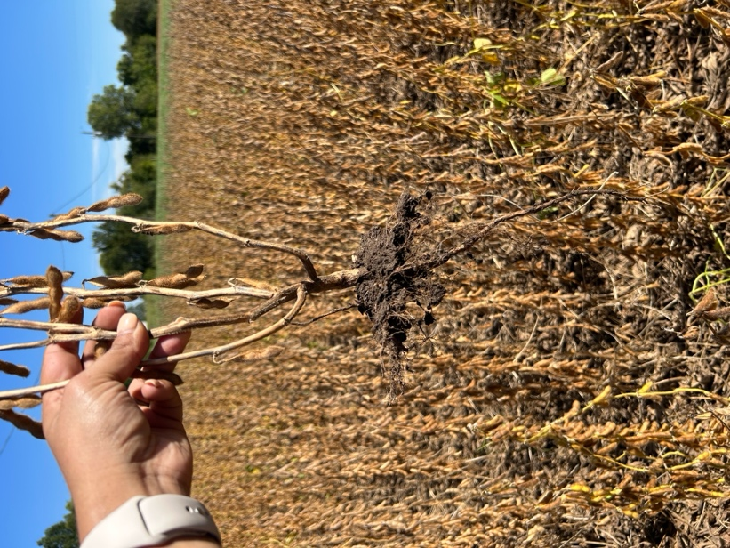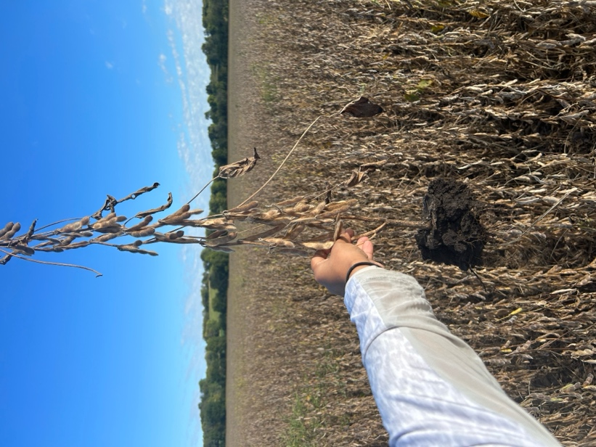
A
B

Figure 8. (A) A picture taken during harvest sampling of a no-tilled field in Norborne, MO. (B) A picture taken during harvest sampling of a conventionally tilled field in Norborne, MO.

