Please use this form to clearly and concisely report on project progress. The information included should reflect quantifiable results that can be used to evaluate and measure project success. Comments should be limited to the designated boxes. Technical reports, no longer than 4 pages, may be attached to this summary report.
Project Title: | Evaluation of a novel drought-tolerant inoculant on soybean yield in the Mid-South
Organization: | University of Texas at Arlington
Principal Investigator Name: | Woo-Suk Chang
Report Period: | March 1, 2019 – June 15, 2019

Project Status - What key activities were undertaken and what were the key accomplishments during this quarter? Please use this field to clearly and concisely report on project progress. Limit 5,000 characters.
The objective of this project is to evaluate the effects of the TXVA strain (a drought-tolerant inoculant) on soybean yield in comparison to the commercial inoculant Cell-Tech™ and a non-inoculated control under irrigated and non-irrigated conditions. We set up the field trials in TX, TN, MO, LA, and MS and plan to set it up in AR. Field trial set-up has been delayed in AR due to the weather condition. However, we will do it in the week of June 17th. Detailed plot design and experimental conditions are described in the Technical Report attached.

It has been well established that the microorganism Bradyrhizobium japonicum has a beneficial impact on soybean plants. Previously, we isolated TXVA strain that showed outstanding performance in nodulation, nitrogen fixation, and enhancing plant growth and production. To improve the inoculants’ performance and optimize the benefits of biological nitrogen fixation in the Mid-South, we set up field trials to evaluate the effects of the drought-tolerant inoculant on soybean yield at drought-prone sites. For the first year trial (year 2019), three inoculation treatments (drought-tolerant inoculant TXVA, commercial inoculant Cell-Tech, and no inoculation) will be compared under irrigated vs. non-irrigated conditions at drought prone sties in the Mid-South. At the first sampling, the number of nodules per plant will be counted and nodule size will be measured. A second harvest of plants will be performed to evaluate final soybean seed production. The climate and weather factors (e.g., precipitation, temperature, and humidity) for each location will also be monitored.

At the completion of the proposed research, we expect to provide positive effects of the drought-tolerant inoculant on soybean profitability and aid Mid-South producers in better understanding of the potential benefits for biological nitrogen fixation. We believe that providing such information will allow soybean producers to advance the management of soybean plants and inoculants for economical and ecological benefits.

Technical Report

Texas A&M AgriLife Research Plot – Yoakum, Texas.
This site is in collaboration with Dr. James Grichar, a senior research scientist at Texas A&M AgriLife research. This was the first plant this year (April 2nd). The Yoakum research plot rests on Tremona loamy fine sand, which is a somewhat poorly drained and slowly permeable soil type. The previous crop here has been peanuts. The plot layout that we designed here (Fig.1) is a Randomized Complete Block Design (RCBD) with 3 treatments and 5 replicates and was repeated across each test site, with minor variations mostly due to site specifics. As seen below, the plot is broken up into an irrigated and non-irrigated section with a 50-foot spacer block. Each block contains 6 rows and each row is 20’ with a 5’ spacer row between blocks and has 38” row spacing.
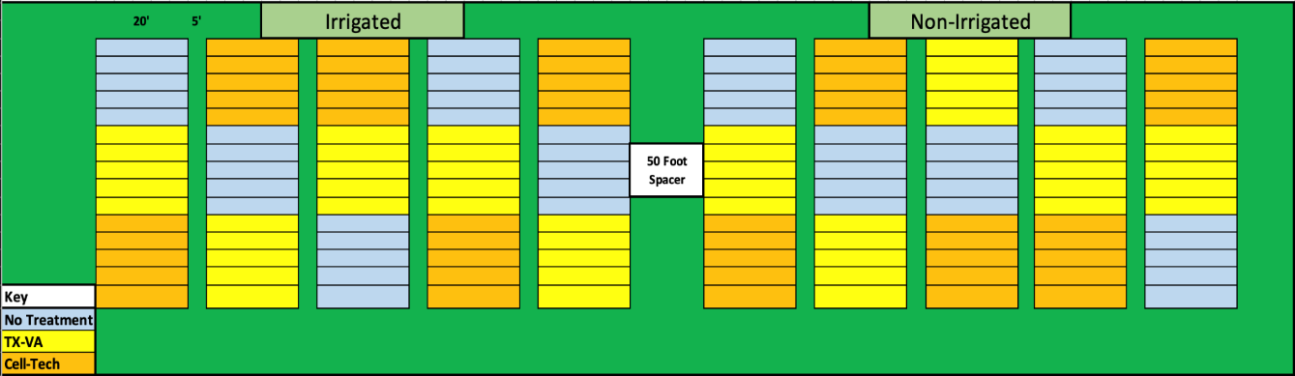
Figure 1. Plot layout in Yoakum, TX

Tennessee Agricultural Experiment Station – Jackson, Tennessee.
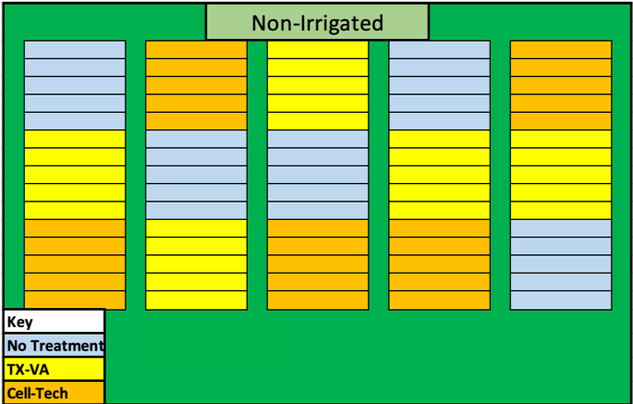
This site is in collaboration with Drs. Vince Pantalone and Avat Shekoofa at the University of Tennessee. This was the second plant this year (May 6th) which puts the mid-harvest sampling date at the week of June 17th or 24th, depending on growth progression. This research station is on iuka fine loamy sand, which is moderately well drained and moderately permeable. This station is the only in our trials that uses a no-till management system. The previous crop here was soybeans for the past two years, but no inoculant was used at the time. The plot layout for TN (Fig. 2) is half the size of our TX plot because there was no way to set up the irrigated portion of our plot due to space restrictions. This leaves only a non-irrigated trial here that contains the same 3 treatments but only 4 replicates. Here, each block contains 4 rows and each row is 10’ with a 3’ spacer and 30” row spacing. The tractor used was a John Deer 6120 pulling an Almaco 4-row cone plot planter. Since the cone planter is a different style than the vacuum planter used in TX the seeds must be put into individual packs of 360 seeds per plot, giving 9 seeds/foot. While the no treatment seeds were being planted, we treated the TXVA seeds with inoculum at a rate of 10 ml/3 lb. of seed and split them up into packages for planting. Between treatments, the planter was disassembled and cleaned with a 50% bleach solution, triple rinsed, and air dried to prevent cross-contamination. The Cell-Tech™ seed was then treated and planted in the same manner as the previous.
Figure 2. Plot layout in Jackson, TN

T.E. “Jake” Fisher Delta Research Center – Portageville, Missouri.
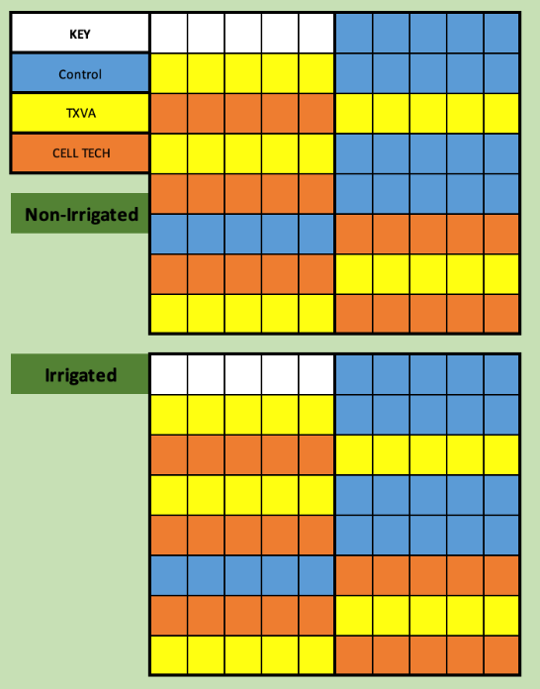
This site is in collaboration with Dr. Pengyin Chen at the University of Missouri. This was our 3rd plant (May 7th) which puts the mid-harvest sampling date at the week of June 17th or 24th, depending on growth progression. The actual plot site is located in Clarkton, MO and rests on a bed of Malden fine sand which is excessively drained with rapid permeability. The previous crop was cotton. The plot layout for MO was reconfigured by their Research Associate to fit into the space available (Fig. 3). The irrigated and non-irrigated sections are separated by a 20-foot spacer. Although reconfigured, the plot still contains 3 treatments with 5 replicates. Each block has 8 rows of 12’ with a 4’ spacer row with 30” row width. The tractor used was a Case MXM140 with an Almaco 8-row cone plot planter. The no treatment seeds were planted while we treated the TXVA seeds with inoculum at a rate of 10 ml/3 lb. and divided them into packets that allowed for 12 seeds/foot. Between treatments, the planter was disassembled and cleaned with 50% bleach, triple rinsed, and air dried to prevent cross-contamination.
Figure 3. Plot layout in Clarkton, MO

Macon Ridge Research Station – Winnsboro, Louisiana.
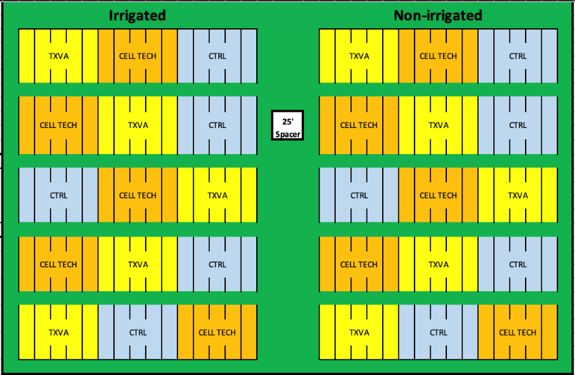
This site is in collaboration with Dr. Trey Price at Louisiana State University AgCenter. This was our 4th site to plant (May 16th) which puts the mid-harvest sampling date around June 24th or July 1st, depending on growth stage. The soil type at the Macon Ridge research station is Jigger-Gilbert silt loam, which is a very deep slowly draining soil with very slow permeability. The previous crop here was Soybeans, but inoculant wasn’t used. The plot layout for Winnsboro is shown below (Fig. 4) and follows the same RCB design as those at our other plots. The irrigated and non-irrigated portions were separated by a 25-foot spacer and contain the standard 3 treatments with 5 replicates of each. Each block has 4 rows of 25’ with a 3.5’ spacer row with 40” row width. The tractor used was a Case Puma 145 with a 4-row cone plot MaxEmerge 2 planter. At this site, all of the seeds were treated at once and packed so that there is 9 seed/foot. We applied 10 ml/3 lb. of seed using a mechanical seed treater, being sure to sterilize between treatments just like we do the planter itself.
Figure 4. Plot layout in Winnsboro, LA

Stoneville USDA Agricultural Research Site – Leland, Mississippi.
This site is in collaboration with Dr. Rusty Smith at USDA. This was our 5th site to plant (May 17th) which puts the mid-harvest sampling date around the week of June 24th or July 1st, depending on growth stage. The soil type at the Stoneville research station is commerce silty clay loam, which are somewhat poorly drained soils with moderately slow permeability but a constant soil saturation in lower layers. The previous crop here was soybeans, but no inoculant was used. The plot layout for our MS plot is shown below (Fig. 5) and reflects the same RCB design with 3 treatments, 5 replications, and two environmental conditions that most of the previous plots have. The irrigated and non-irrigated conditions are separated by a 15-foot spacer. Each block contains 4 rows of 15’ with a 5’ spacer row between blocks and a 38” row width. The tractor used was a John Deere with an Almaco 4-row cone plot planter that planted 10 seed/foot. The no treatment plots were planted while we treated the TXVA seeds with inoculum at a rate of 10 ml/3 lb. The planter was disassembled and treated with 50% bleach, triple rinsed, and dried with air from an air compressor to prevent cross-contamination.
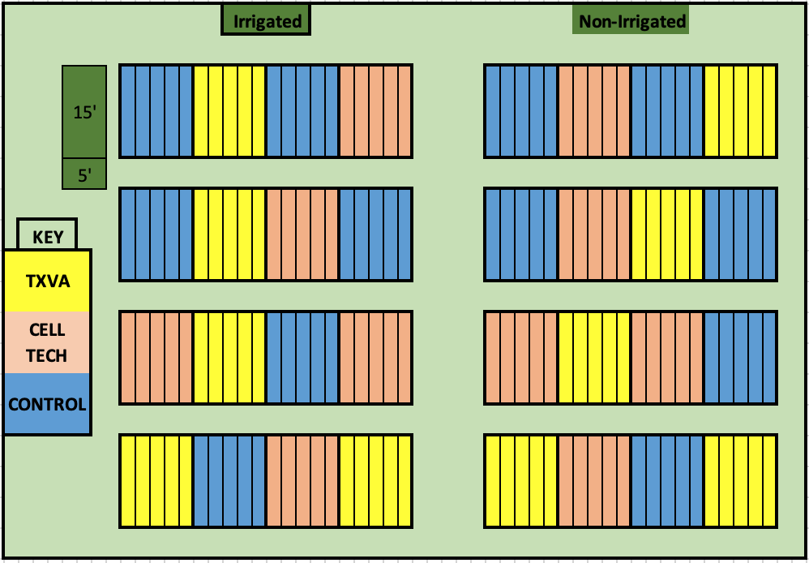

Figure 5. Plot layout in Stoneville, MS

In summary, we have planted Soybean research plots in 5 states testing our novel Texas-native drought-tolerant Bradyrhizobium inoculant in the irrigated and non-irrigated condition across drought prone regions. We plan to plant soybeans in AR in the week of June 17th. Below is a summary of general site specifics (Table 1).

Table 1. General site characteristics that summarize each plant completed this year.
Location | Plant date | Soil type | Cultivar | MG
TX | 4/2/19 | Tremona loamy fine sand | S52RS86 | 5E
TN | 5/6/19 | Iuka | TN16520 | 4L
MO | 5/7/19 | Malden fine sand | TN16520 | 4L
LA | 5/16/19 | Jigger-Gilbert silt loam | TN16520 | 4L
MS | 5/17/19 | Commerce silty clay loam | TN16520 | 4L
AR | The week of June 17th | To be determined | TN16520 | 4L

