Please use this form to clearly and concisely report on project progress. The information included should reflect quantifiable results that can be used to evaluate and measure project success. Comments should be limited to the designated boxes. Technical reports, no longer than 4 pages, may be attached to this summary report.
Project Title: | Whole Soy Food Acceptability and Market Viability Study
Organization: | B & B Legacy Farms, LLC
Principal Investigator Name: | Karen Ballard
Report Period: | June 16 – September 15, 2024

Project Status - What key activities were undertaken and what were the key accomplishments this quarter? Please use this field to clearly and concisely report on project progress. Limit 5,000 characters.
A broad range of activities occurred this quarter, in support of research and development of consumer awareness and acceptance of whole soy foods.

Missouri and Arkansas Cooperative Extension teams implemented their Soy Chef state plans, getting boots on the ground in record time. The University of Missouri Soy Chef Changemaker mini grant was signed on July 31st with faculty/educator work already underway. B&B provided consultation support to both state teams, supplying educational materials, exhibit resources, and bulk roasted soy nuts for taste testing with large groups.
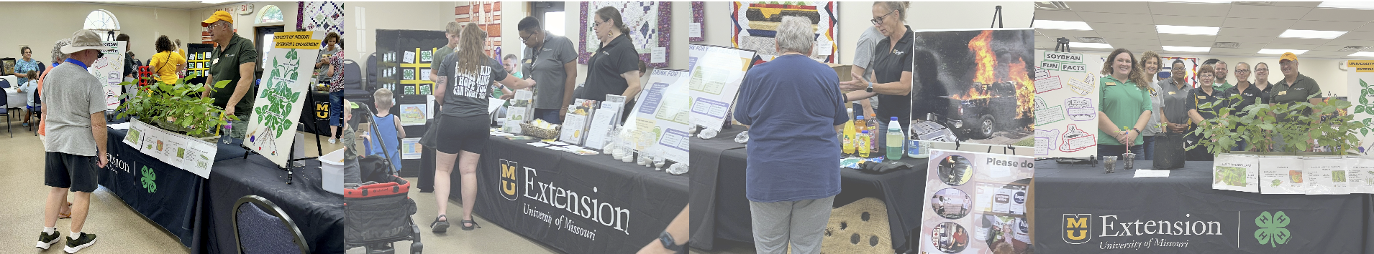

June-September Soy Chef Outreach Activities included:
Date | Target Audience | Location | Event/Method
June 4-6 | Women | Little Rock, AR | Arkansas Extension Homemakers Council State Meeting with and educational exhibit and soy food taste tests (soy yogurt and roasted soy nuts).
July 1st | General Public | Missouri | Truth or Trend Podcast: The Truth About Soy*  (Interview with Sarah Wood, MS, RD)
August 2-3 | General Public | Norborne, Missouri | Norborne Soybean Festival. Live food demonstrations preparing BBQ soybeans and Beef and Edamame Stir Fry. Taste tests of both dishes and roasted soy nuts (over 1500 attendees)
August 7-17 | General Public | Sedalia, MO | Missouri State Fair: Soybean Cookoff. Sarah won the competition preparing Cajun Soybeans & Rice! The competition was livestreamed over the Extension Facebook site.
August 20th | AR Extension educators | Arkansas soybean fields. | Family and consumer science agents/specialist educational field day to expand knowledge of soybean production and whole soy foods.
September 9th | Pre-K – 5th grade students | Portland Elementary School.  Porland, Arkansas | AR Extension educators conducted classroom education and taste tests of roasted soy nuts and chocolate soy milk with students. Students provided sensory evaluation of each product.

*Podcast LINK: https://healthy-truth-or-trend-podcast.podbean.com/e/episode-7-eating-soybeans-for-more-protein/

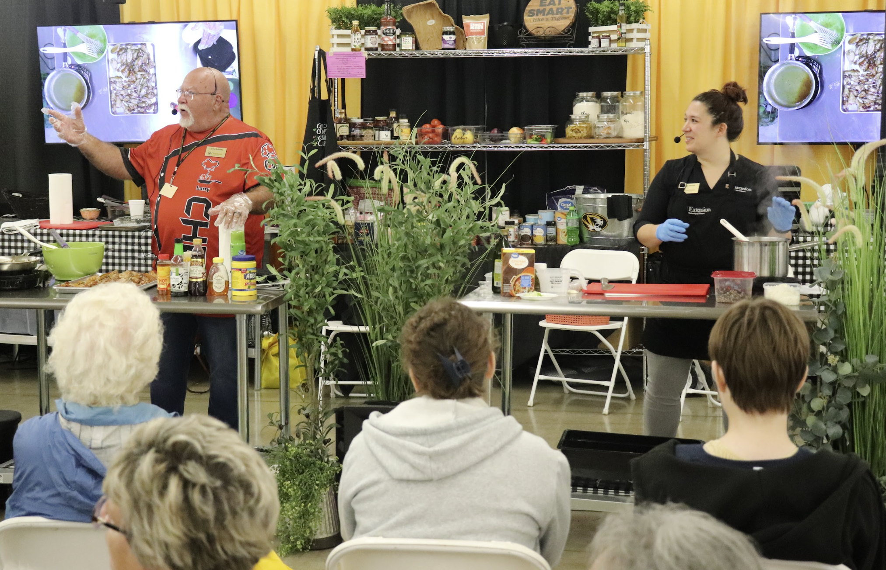
Registered dietician Sarah Wood took home the trophy at the Missouri State Fair whole Soy Food Cook-Off.
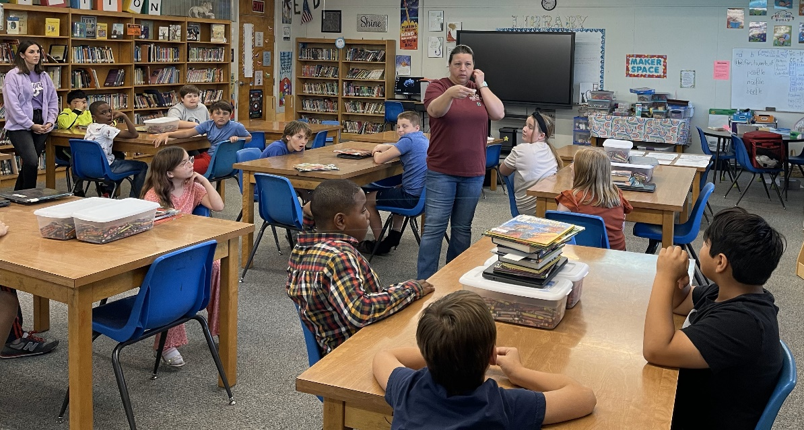
Amber Hairston taught Pre-K – 5th grade classes in Portland Elementary School (Arkansas) about the soybeans that grow around them and introduced students to roasted soy nuts and soy chocolate milk, and why soy is a super food.

Planning meetings began this quarter between Mandie Smith, MS, RD, and Karen Ballard, in support of content development for consumer education and institutional guides for publication by the end of this project.

Third party research is ongoing to inform the following educational products in development:
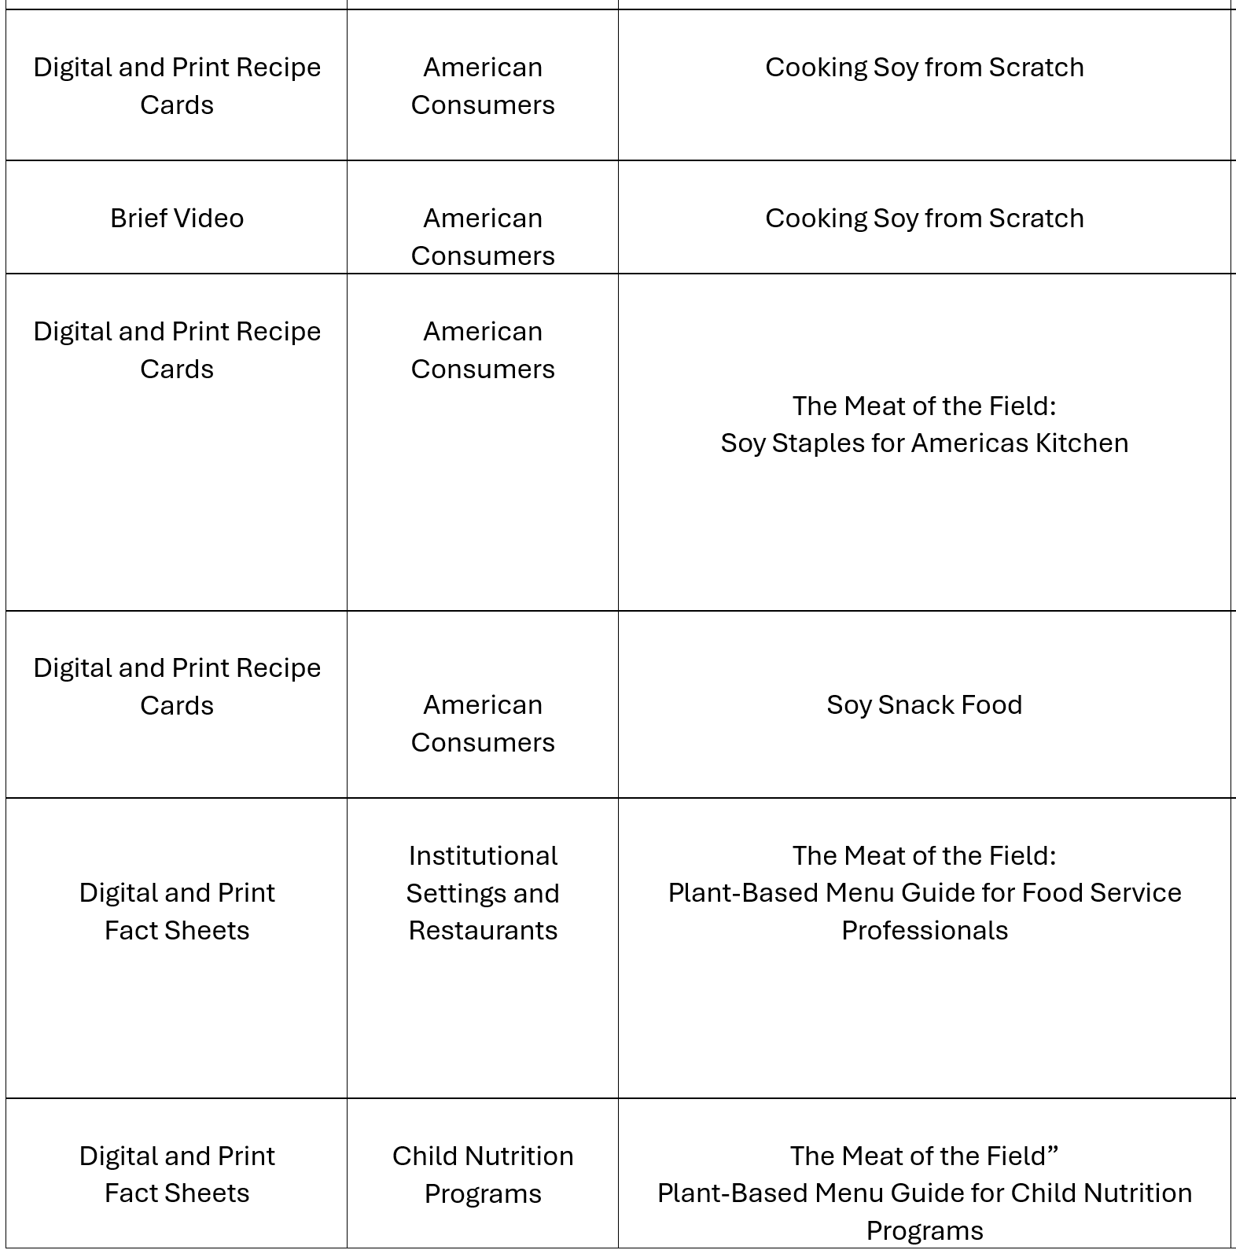
Planning meetings were also conducted throughout this quarter by Soy Chef team members from Missouri and Arkansas with a range of external target audiences and community partners.

