Whole Soy Food Acceptability and Market Viability Study
Dr. Karen Ballard, PI
karen@bandblegacyfarms.com

Final Report
April 28, 2025
Study Period: April 2022 – March 2025.

Photo Source: Blake Bennett, Soybean farmer. American soy farmers are in the driver’s seat.

Executive Summary
This study evaluated consumer acceptability and the viability of an expanded, regional, domestic market for food-grade soybeans. Volatile prices and looming tariffs require thoughtful consideration of alternative soy markets. 2025 Legislation impacting USDA SNAP and other school nutrition programs reflects a tipping point for the largest U.S. food system. Bans on processed foods in schools and debates over the “Hateful 8” threaten traditional American soy markets. Obesity in America has become an economic, health and public policy issue. Child obesity is of epidemic proportions. America’s child nutrition program is coming under increased scrutiny. Despite profound market growth in the plant-based food market, whole and minimally processed soy foods have limited market share. Ironically, soybeans have been recognized as the “gold standard” for plant-based protein (Good Food Institute). Research regarding this disconnect was conducted with consumers, agronomists, schools, universities, and USDA officials. This study provides a path to market, potentially resulting in farmers increasing their share of the American food dollar, while directly contributing to a change in the health trajectory for America’s youth. This study identified the needs and preferences of consumers, examined current agronomic considerations, and identified USDA sector support options for direct “path to market” development and expansion.

Study Objectives
- Evaluation of the agronomic viability and profitability of food-grade soy cultivars.
- Evaluation of direct product acceptability of whole soy products through key informant interviews, surveys, and focus groups.
- Evaluation of regional market opportunities with school nutrition program directors and USDA food and nutrition officials.
- Dissemination of study results and increased knowledge of producers and consumers regarding the value of whole soy foods.

Study Methods & Outputs by Objective
Methods | Obj #1 | Obj #2 | Obj #3 | Obj #4
Consumer acceptability testing |  | X
-Creation of sensory testing rubric and recruitment of testing sites. |  | X
-Recipe development with whole/minimally processed soybeans. |  | X
-Sensory testing (adult and youth). |  | X
-Student focus groups. |  | X
-Acceptability testing (adult and youth). |  | X
SoyChef education and research partnership with the UA Pulaski Technical College Culinary School. |  | X
-Collaborative partnership developed with the UAPTC-Culinary School to provide student chef training and co-hosting for a SoyChef student competition (1 year partnership) and public event with key influencers. |  | X
-Multi-state SoyChef nutrition faculty training (including taste tests and soy food preparation training). Collaborative mini-grants with University of Arkansas-Extension and the University of Missouri-Extension partners for outreach and consumer testing. |  | X
USDA and Child Nutrition Program Path to Market Analysis |  |  | X
-Key informant interviews with child nutrition staff, USDA officials, Farm to School program staff, and Senate AG Committee staff. |  |  | X
-Review of USDA policies and procedures. |  |  | X
-Educational outreach, sensory tasting surveys, and key informant interviews at the Louisiana Farm to School Conference. |  |  | X
-Interviews and research collaboration with USDA child nutrition program directors, Agricultural Marketing Service staff, and Food Supply Chain Impact Fellows with the Federation of American Scientists. |  |  | X
US Soy Food Market Opportunity Analysis | X
-USB Non-GMO Study Analysis. | X
-Mid-South Soybean Univ Faculty Interviews. | X
-Environmental grocery store scans & interviews. | X
-3rd Party review of academic agronomic, market, and nutrition literature, current health care and public policy popular press/public facing communications, and ratified and proposed legislation related to food policy (SNAP, USDA-School Nutrition Programs). | X |  | X
Dissemination of study results. |  |  |  | X
-Content creation for educational events and targeted publications for outreach with farmers, university faculty, industry representatives, child nutrition personnel, government agency staff, and students (ages 7-18). * |  |  |  | X
Educational exhibit development and hosting. |  |  |  | X
- Mult-year hosting of the MSSB educational exhibit and taste tests at annual Conservation Conference with farmers, industry representatives, and university faculty. |  | X |  | X
-Soy Chef event media packets produced and disseminated, exhibit development, and coordination of whole soy food tasting for event participants. |  |  |  | X
Mass Media |  |  |  | X
-Print articles (Delta Farm Press, Arkansas Democrat Gazette, etc.) |  |  |  | X
-AgDay-RFD-TV live national news interview. |  |  |  | X
-Recipes developed and published. |  |  |  | X
-Podcast (interview with Farm Bureau). |  |  |  | X
-Produced and co-hosted national Soy-Chef Webinar. |  |  |  | X
-Produced An Ancient Food that Delivers educational video for child nutrition directors and policy makers. ** |  |  |  | X
-Content creation for print and digital educational resources for consumers, child nutrition directors, university partners, and farmers. ** |  |  |  | X
Soy Food content creation, curriculum development by University of Missouri and Arkansas SoyChef Extension partners for dissemination through state-wide nutrition education and producer programs. |  |  |  | X
Invited presentations. |  |  |  | X
*See Attachment A: 4th Quarter Activities Report (January-March 2025).
**Content pending publication.

Study Findings: The bottom line.

What are the needs of farmers and consumers?
- A stable market for soybeans.
- Increased access to lower-cost, protein rich, nutrient dense, convenient food options.
- Access to expanded soy milk and soybean products to help stem America’s persistent child-obesity epidemic.

Background & Significance

Current Challenges

- Food Politics & Tariffs

Lack of stable prices and a volatile export market threaten farm viability. The increasing export market share by Brazil in recent years and the proposed tariffs threaten the American soybean market as never before. Domestically, Congress reintroduced the 2025 “Healthy SNAP Act”, to exclude unhealthy food and beverages, starting with soda, from the Supplemental Nutrition Assistance Program. An article published in The Hill (SNAP shouldn’t subsidize America’s obesity epidemic, 2/2/25), reported that, “20 percent of the 113 billion annual SNAP budget - $23 billion annually – is used to pay for unhealthy foods and beverages purchased by SNAP recipients. The authors recommended that “programs savings should be used to incentivize SNAP participants purchasing of fruits and vegetables from famers . . . a much-needed agricultural stimulus for specialty crop production.”


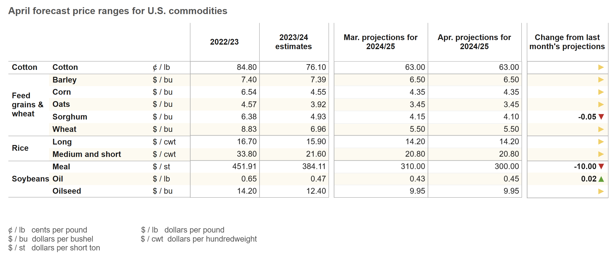
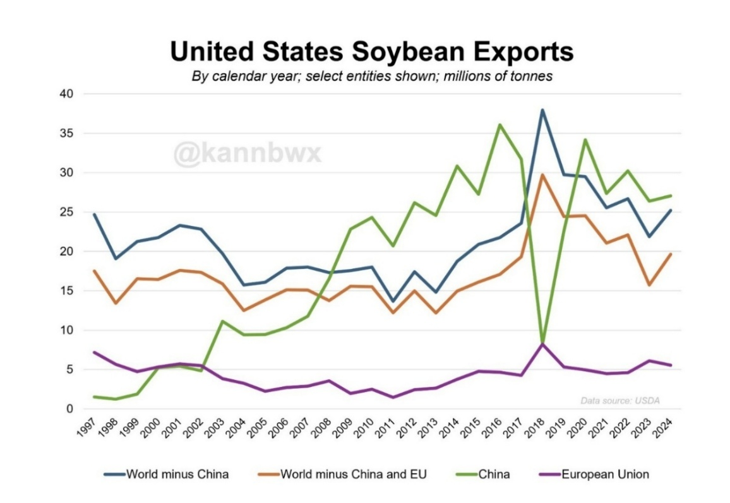

- The trajectory of diet-related disease experienced by young Americans.

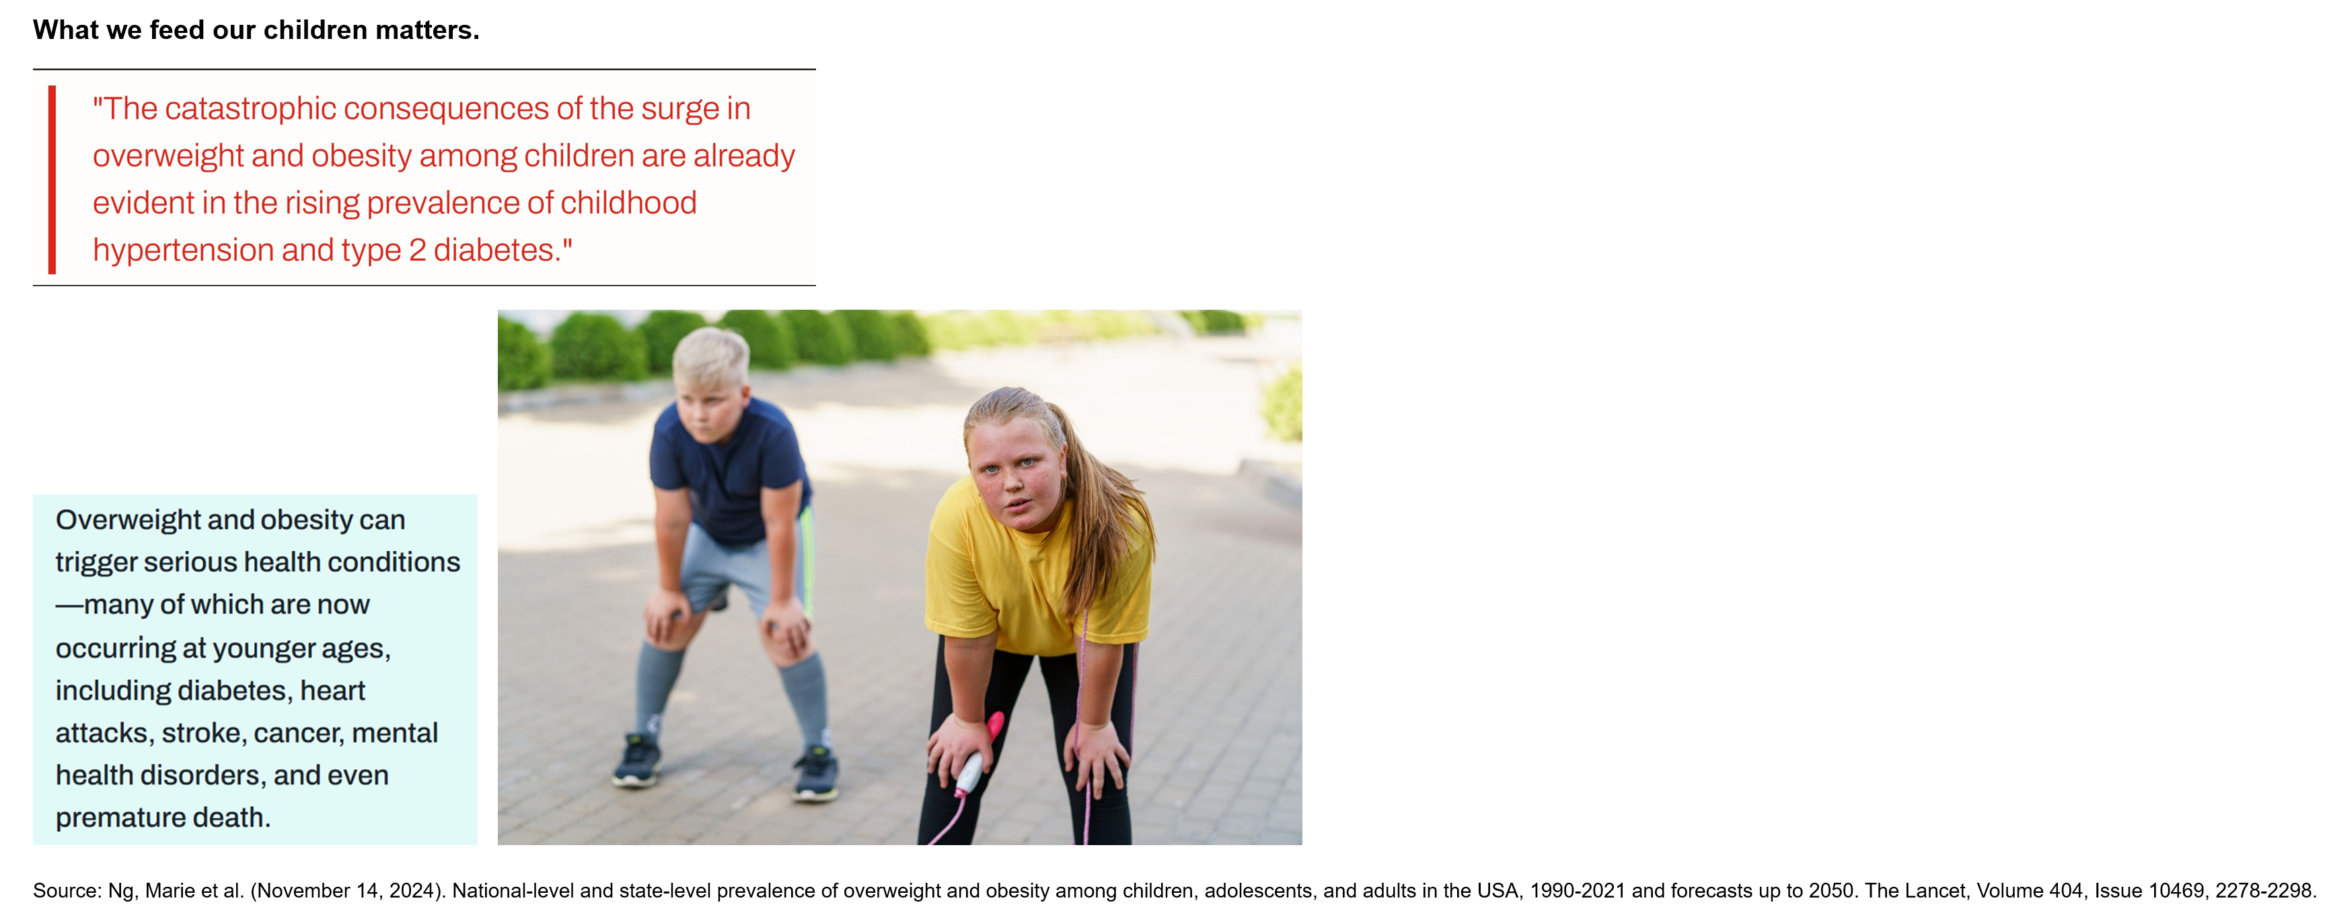

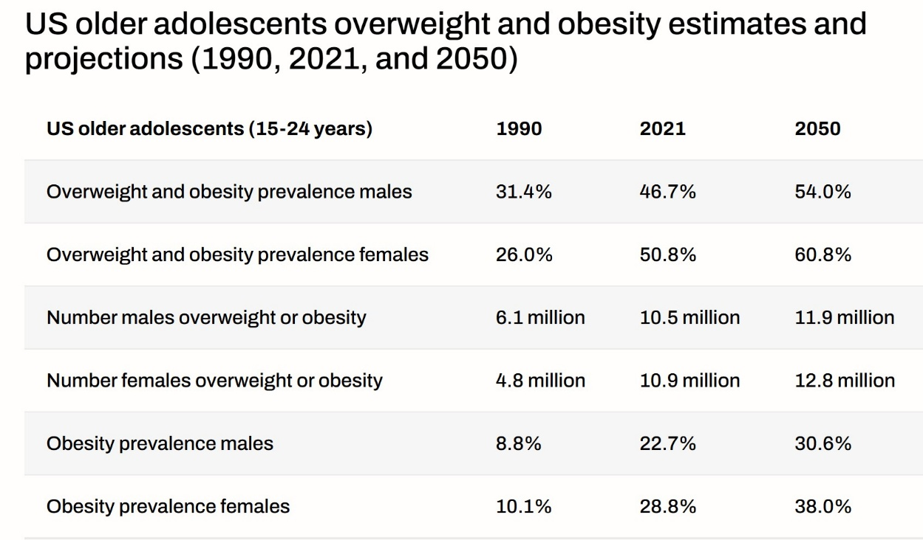
Source: Ng, Marie et al. (November 14, 2024). National-level and state-level prevalence of overweight and obesity among children, adolescents, and adults in the USA. 1990-2021 and forecasts up to 2050. The Lancet. Volume 404.

- Sick and getting sicker: America’s diet-related disease and disability epidemic.

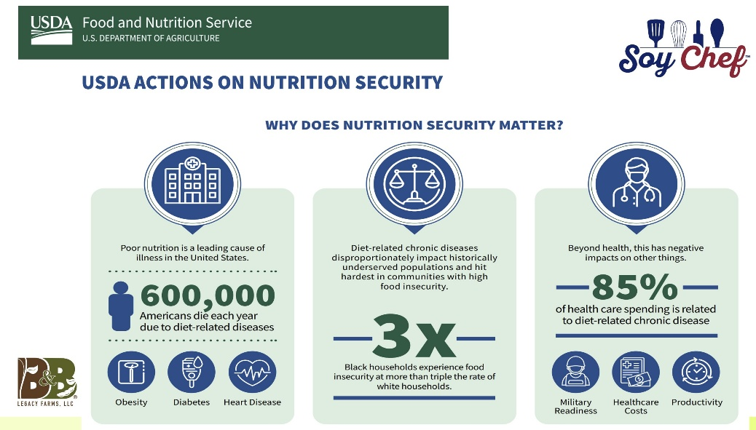

On March 17, 2022, Agriculture Secretary Tom Vilsack announced USDA’s “Actions on Nutrition Security” report. The report reported on the increasing prevalence and cost of diet-related diseases to our nation. The report noted the intertwined role of food and health, and the need to make fundamental changes to address this health crisis. At the time of the report, Vilsack noted that 85% of current health care spending was due to diet-related disease, and that our military had increasing difficulty recruiting soldiers critical to military readiness due to increasing health issues across the younger population.

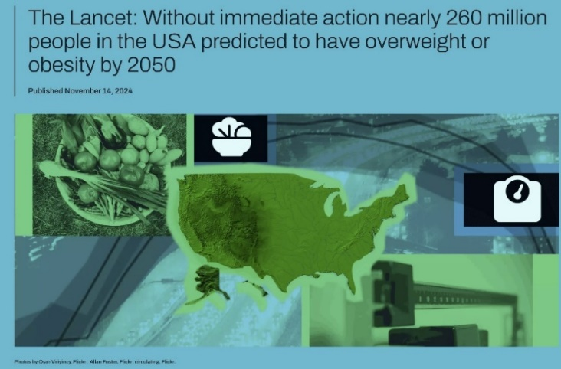 In a November 2024 article published in The Lancet, the Global Burden of Disease Study Collaborator Network reported that “Over the past three decades there has been a startling increase across the USA, at least doubling (obesity) in adult men and women (aged 25 and older) and older female and male adolescents (aged 15-24 years) since 1990-a trend set to continue in the coming decades without significant reform.”
- Clearing the clouds of doubt about soy.
In America, (except for oil) soy for human consumption has been largely relegated to the role of a food ingredient. Counter-advertising continues to be a significant marketing issue for soy market development in the human food space.
This study revealed that soy food products are frequently excluded in nutritional comparisions leading to consumer misinformation.
Mandie Smith, clinical dietitian and study adviser reported that blanket statements and inconsistency about the “safety” and suggested frequency of soy consumption often leaves consumers with the sense that soy should be avoided. “Can safely be consumed” type communications result in consumer doubts and fears, as reported during consumer interviews. How often should you eat soy foods often includes comments such as “current research is limited to establish a safe level of soy consumption.
Smith notes that most foods should not be consumed in excess. This is not unique to soy. A warning label for overconsumption is unique to soy foods. Popular press communications about soy ironically include negative or provocative titles, even when the author’s recommendations eventually speak to soy foods nutritional value. Soy bashing is rampant in America and based on who is leading the conversation and their motivations.
The Nutritional Value of Soy: How good is soy as a whole food?
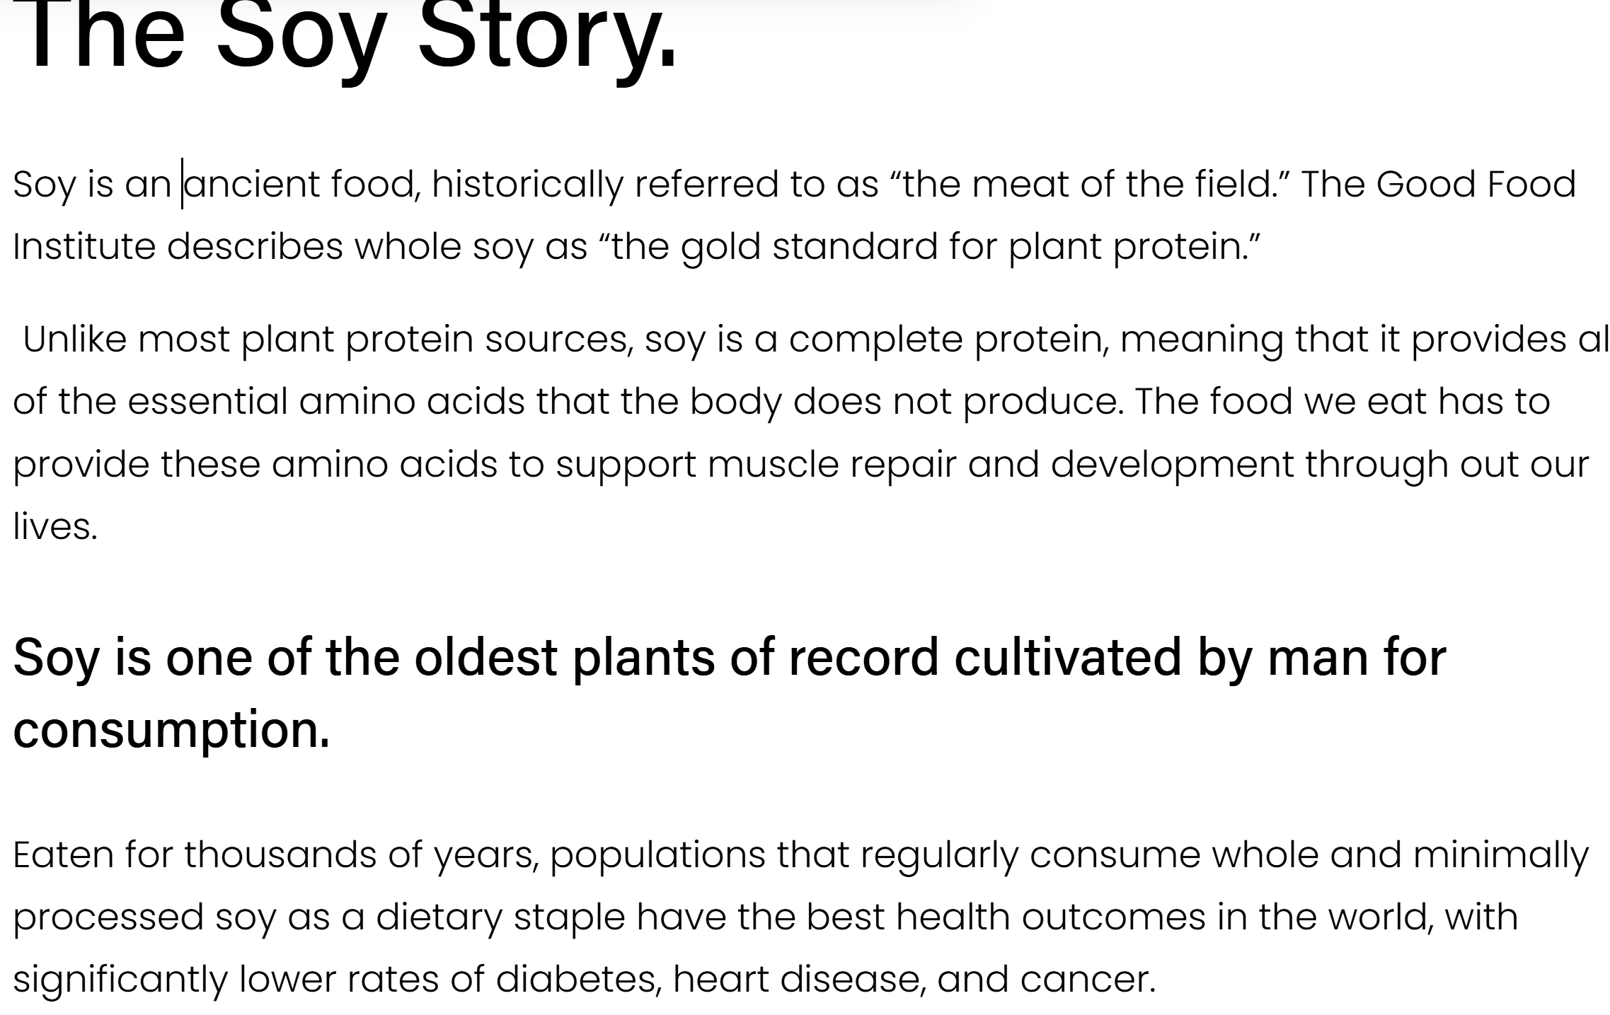
Do the math. 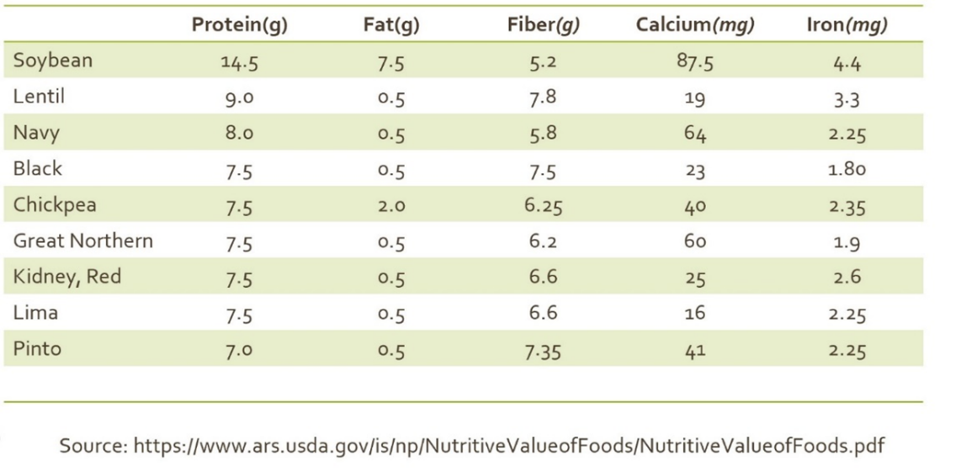

Soybeans stand out among other beans for their versatility, low cost, significantly higher protein, and healthy fat content, while also being a good source of fiber and minerals, including iron, calcium, and magnesium. The current public policy debate, including removal of ultra-processed food from child nutrition programs, has elevated the nutrition discussion across our country.
Results

Consumer Sensory Testing: Will They Eat It?
They did and they will. Ninety-seven percent of students participating in structured sensory testing (n=65) with a range of soy foods reported that they would like one or more of the sampled foods added to the school lunch menu. A majority of adult study participants likewise reported that they would purchase whole soy foods if available and convenient to prepare. Taste tests and sensory testing with whole and minimally processed soy foods over the course of this study included: appetizers/snacks, salads/vegetable sides, entrees, and desserts.
Market Development in a Shifting Food Culture
The Food and Nutrition Service's (FNS) 2025 Budget request (for 16 nutrition assistance programs) was $163.6 billion. The 2024 federal budget provided $32 billion for Child Nutrition Programs alone. Whole and minimally processed soy foods are absent from this large U.S. market. The irony remains that soy is the only food that can be credited across USDA’s My Plate, due to its unparalleled nutritional profile, but remains absent from the USDA Foods and DoD Fresh inventory.
During the 2022 research project presentation to the MSSB a board member asked,
“What happened to soy milk?”
Soy milk entered the America retail market in 1929 (Soyfoods Center, Lafayette, California). American consumption of soy milk was estimated to have grown 15-20% per year between 1984 and 1991.
Almond milk became commercially available in the U.S. in 2008. By 2013 almond milk surpassed soy milk as the most popular plant-based milk. By 2018 sales of almond milk accounted for 64% of the U.S. plant milk market, while soy milk had dropped to around 13% of market share (Mintel). Between 2018 and 2019, sales of oat milk skyrocketed from U.S. $6 to around U.S. 40 million. According to Meticulous Market Research, the global plant-based milk market is expected to be more than $42.8 billion by 2029.
What happened? Market analysts point to a combination of factors that toppled soy from its plant-milk pedestal, including: concerns about GMOs, phytoestrogens/isoflavones, allergies, and taste/mouth feel. Expanded competition and counter marketing systematically planted seeds of doubt about the safety and desirability of soy foods.
Where does this leave soy milk?
Nutrition is in the news. Dieticians consistently rank soy milk at the top of the list as the healthiest plant-based milk.
Soy milk is the only plant-based milk approved for use in the USDA WIC program for children.
There is a reason soy is a leading foundational food ingredient in highly processed foods.
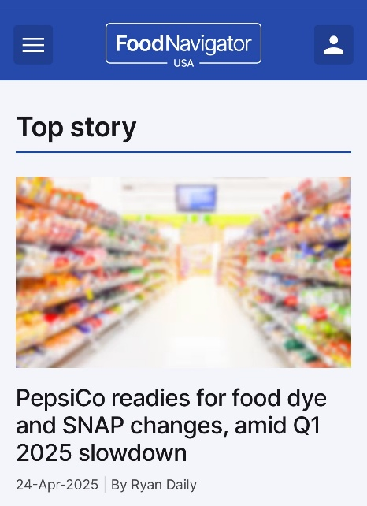 The most frequently purchased item in SNAP, sugar-sweetened beverages, comprise 9.3 percent of SNAP expenditures.” It is estimated that the SNAP subsidy currently represents 20 to 25 percent of U.S. revenues for Coca-Cola and Pepsico (The Hill, 2025).
USDA is revamping the criteria for its food system, first with the elimination of soft drinks, followed closely by an examination and reduction in highly processed foods.
Soy needs a market makeover related to perception and its potential future role in this $164 billion food system.
Agronomic Viability of Non-GMO Food-Grade Soybean Production

Limited data is systematically collected by state or USDA regarding the scope and profitability of non-GMO soybean production. Key informant interviews were conducted with university-based soybean agronomists/breeders/researchers from the Mid-South states of Missouri, Arkansas, Mississippi, and Louisiana. Faculty members shared their knowledge of non-GMO production in their respective states, their direct research experience with non-GMO varieties, and their insight into grower interest and concerns. All researchers reported limited current grower interest in non-GMO variety development and limited production in each state. Farmer concerns about non-GMO production included weed control challenges, yield drag, and drift. All four researchers expressed interest in expansion of their work in this direction in order to support grower decisions and ensure seed quality for this emerging domestic market.
A 2024 study funded by the U.S. Soybean Export Council, “Non-GMO Food Grade Soybeans Quantification Study,” collected online survey data from 142 non-GMO soybean growers, 15 processors/purchasers/traders of U.S.-produced non-GMO food-grade soybeans, and conducted phone interviews with three State Soybean Associations (Indiana, North Dakota, and Michigan). The final report also included data from secondary sources, including the United States Department of Agriculture (USDA). Study authors reported that, “87.1 million total soybean acres were planted in the U.S. in 2024, of which 4%, or 3.5 million were non-GMO soybeans. Of the 3.5 million non-GMO acres, 92% or 3.2 million were sold for a premium. About 79% of the non-GMO food-grade soybeans or 1.8 million acres were produced under contract in 2024.”
The study’s final report noted that most U.S. non-GMO food-grade soybeans were destined for Japan, the single largest percent for the tofu market (39%). An additional 28% were utilized for soymilk, 13% for natto, and 9% for miso. Competition from other countries has impacted the U.S. non-GMO export market. The study’s fall 2024 market forecast suggested slow production growth, noting the impact of unfavorable conditions abroad in the past, which they noted “could ease over the next year.”
Producer concerns identified through this study mirrored those identified by the Mid-South university research faculty study participants, with weed control reported as the greatest challenge for growers, followed by perceptions of yield gap between GMO and non-GMO soybeans, and contamination identified as the third most mentioned risk associated with non-GMO production. The study reported that, “In 2024, growers estimated getting between two and five bushels less from their non-GMO soybeans.” A range of different production practices utilized by growers are noted in the report, with 54% of producers stating that they did not engage in different production practices with their non-GMO and GMO soybeans. Overall, growers reported paying a net $8.80 per acre more for non-GMO production (n=142).”
Risks and Rewards.
The study concluded that, “a combination of lower soybean commodity prices and higher premiums has led to a more favorable market for non-GMO food-grade soybean production. In 2023/2024, commodity soybean prices fell by 11% and premium prices rose by 45% (from $1.89 to $2.73). The trend continued this year (2024) when commodity prices fell roughly 22% ($9.93) while premium prices rose 10% ($3.01).”
Source: SMR&P. (September 2024). Non-GMO Food-grade Soybean Quantification Study. Final Report. U.S. Soybean Export Council (USSEC). Retrieved February 2025 from: chrome-extension://efaidnbmnnnibpcajpcglclefindmkaj/https://solutions.ussec.org/wp-content/uploads/2024/10/20241015_USSEC-2024-Non-GMO-Acreage-Report-v2.pdf

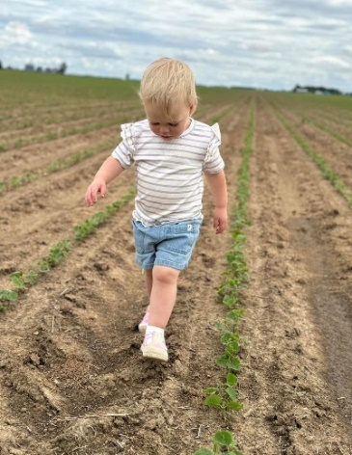 Opportunities: What is the future of US soy?
Photo Source: Blake Bennett, Soybean farmer.

As international markets ebb and flow, building a stable domestic market could move the next generation of farmers toward a more stable and profitable future.
The exploration of soybeans as a potential staple in the American diet comes at an historically crucial time for consumers, farmers, and national policy makers. Nutritionally, in the case of soybeans, the whole is greater than the sum of its parts.
Scope of Opportunities
-Size and stability of the USDA nutrition programs diminishes farmer risk.
-Expansion of a domestic market reduces dependence on exports.
-Increase in regional food systems supporting economic development in rural areas where soy is grown, while reducing transportation costs.
The question remains, will soy become a viable player in the expanding plant-based domestic food market?
The most nutritious food grown in America is not fed to our children through USDA child nutrition programs, the largest restaurant in America. In the meantime, our children are getting sicker based on what they are fed. A lot sicker. The data is irrefutable.

The definition of insanity is doing the same thing and expecting different results.
-Albert Einstein

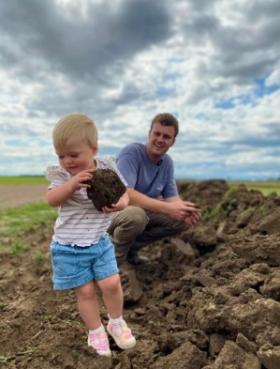 Prototype Pilot: Is It worth the lift?
Photo Source: Blake Bennett, Soybean farmer.

A journey of a thousand miles begins with a single step.
-Chinese philosopher Lao Tzu

What if we changed the field?

In FY2023, the U.S. government spent $7.7 billion on food and agricultural products across several federal agencies (Congressional Research Service. https://www.congress.gov/crs-product/R48141)
The US soybean industry has the capacity to meet a market as large as the USDA Child Nutrition Program. The soy industry is a force to be reckoned with.
What if farmer-led industry representatives developed a blueprint for a stronger domestic market that started with feeding our children an ancient, highly nutritious food that they like?
What if minimal processing for this bean did not require being shipped down a river during a drought year or trucked to another state with escalating fuel prices?
What if the industry had boots on the ground partners to broadly support child nutrition programs with education and hands-on training for food service workers? This research has identified resources across the current food system that could collaborate in a regional whole food system pilot. With key partners in place, whole roasted and frozen yellow and black soybeans can show up on the salad bar, as a substitute for any black bean, in vegetable soups, in sandwich wraps and casseroles.
Roasted soybeans received high acceptability ratings by students during sensory testing, and roasted soybeans could be used as a breakfast pairing with yogurt or alone as a high-protein, nutrient dense snack. Minimally processed soy staples like soy milk, tofu, soy sour cream, cream cheese, and ricotta have tremendous versatility and would assist dietary staff in reduction of cholesterol and saturated fat and increase the safety of dietary offerings across the menu for all students (due to dairy and peanut allergies). Whole and minimally processed soy foods can expand the nutritional profile on each child’s plate, at a low cost, with less health-related consequences.
What if the soy industry could provide our kids with food that gives them more on their plate? The world’s healthiest populations have eaten whole and minimally processed soybeans for thousands of years. There is a preponderance of evidence to support these findings. Consumer research conducted through this study with 2nd graders through adults has provided credible evidence that soybeans prepared for an American palate consistently receive high reviews.
What if initial domestic market expansion simply requires the right 6 people meeting together with a common goal: to provide some space on our children’s plates for soy. USDA policy provides a system and path-to-market. American farmers grow soybeans; USDA Foods program leaders can make processing and distribution happen, using USDA nationally contracted processers located across the U.S., delivering frozen and roasted whole soybeans to schools for the first time in history, directly through the USDA Foods and DoD Fresh programs.
Path to Market Research: Getting U.S. soybeans from field to plate for America’s children. See Attachment B: USDA Commercialization Linkages.
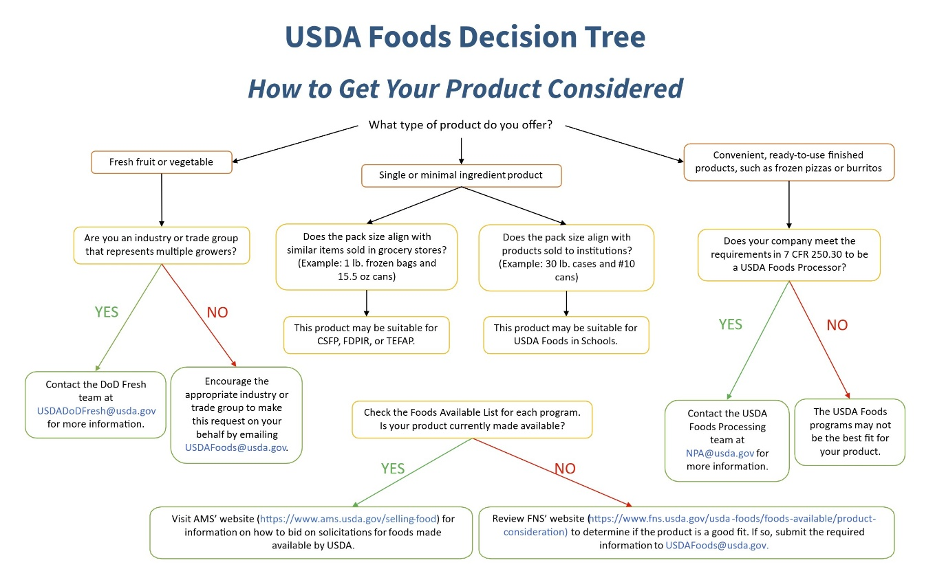

Source: https://www.fns.usda.gov/usda-foods/foods-available/decision-tree

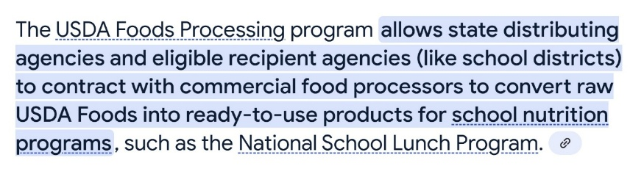
USDA Nationally Approved Processors List: https://www.fns.usda.gov/usda-fis/npa-approved-processors
An Environmental Scan: Walking Around Wal-Mart
Retail grocery market audits were conducted over three years during this study. Progress was noted in allocated shelf space, product placement, and whole/minimally processed soy product options. Nonetheless, soy primarily remains an ingredient of other products on grocery store shelves across the Mid-South. The most nutritious forms of soy are still hard to find.
The Medical Community is Talking.
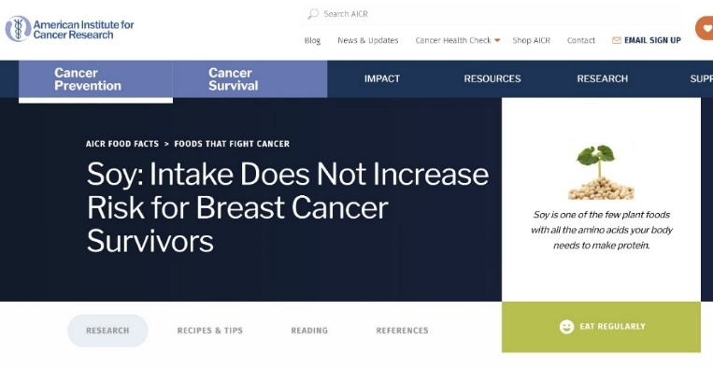
Project monitoring of health care industry messaging demonstrated their investment in correcting soy-related health myths.

While messaging evolved during the study period, long-standing fears, attitudes, and beliefs continued to resonate across study discussions with key stakeholders, including some farmers.
Lessons learned from this study include the high price of non-response, an inadequate response, or a complicated response to consumer concerns.
Major Market Access Barriers: Limited/No Convenient Soy Foods on Grocery Shelves
- Frozen soy is limited to edamame.
- Minimally processed products are regionally limited to tofu, soy milk, and tempe.
- Limited availability of soy nut butter.
- Most plant-based cream, yogurt, sour cream, cream cheese, and ricotta are produced with other plants.
- Soy products have less desirable shelf placement (top shelf and bottom shelf).
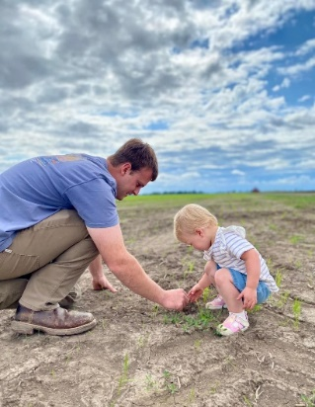 Conclusions: Whose job is it?
Expanding domestic markets for whole and minimally processed soy foods will require a champion.

From inertia to action.
Identified barriers to development of a diversified domestic soy food market.
- Grower cynicism and disbelief.
- Limited, sustained industry investment in and leadership of whole food market bridge development.
- Lack of broad-based regional advocacy, content creation, outreach, and nutrition education.
Bridge to Market Strategy: Recommendations for Development of a Regional Soy Food System with USDA Partners
- Identification of minimally processed whole soy food products for pilot testing and marketing.
- Soy industry collaboration with state and federal policy makers, USDA-Agricultural Marketing Service staff, and USDA Foods staff to develop initial manufacturing and distribution pilot agreements for identified school partners in the Mid-South.
- Industry partnership with university research and extension partners for agronomic and economic research, cost-effective educational material development for farmers and consumers, and experiential nutrition and health education and outreach with identified school nutrition directors, dietary staff, and students.
Domestic Trade Mission Messaging Musts:
- Trusted Sources are involved through expanded regional partnerships.
- Digestible messages are created for diverse target audiences.
- Meaningful messaging delivered through a range of channels for consumers.
- Advocacy and monitoring with USDA and other public and private entities for inclusion of soybeans in nutritional comparisons and soy foods placed on American children’s plates every week (based on sound nutrition science).
Taking charge of soy’s future.
Unprecedented input costs during COVID took many farmers out of the picture.
Reducing input costs and increasing farmer share of the food dollar will require expansion of current marketing options and continued market diversification. Whole and minimally processed soy food products have the potential to exponentially grow the domestic food market share if convenient soy food products are available and are processed in a fashion that is more closely aligned with shifting food culture values including: support for local farmers (locally/regionally grown), minimal processing, understandable ingredient deck, taste, and cost. Food sector sub-groups that reported a strong interest in whole and minimally processed soy foods have diverse motivators ranging from long-standing vegetarian/vegans, to preppers, and the evolving flexitarians, who this study included in the large and growing “health seeker” group.
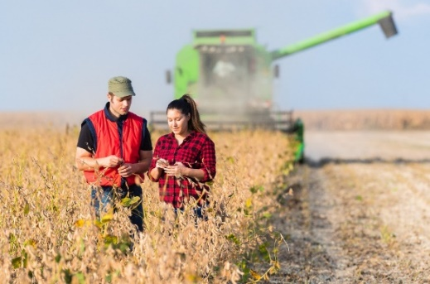 With so much at stake: Soy’s domestic trade mission is a historic step.

Our doubts are traitors and make us lose the good we oft might win, by fearing to attempt.
-William Shakespeare

Special recognition: This study was made possible due to the enthusiastic support of study participants, collaborators, colleagues, government officials, agency staff, university partners, and MSSB board members and administrators (Dr. Joyce Doyle and Dawn Howe) from Arkansas, Missouri, Mississippi, Louisiana, and Texas. Special thanks to Dr. Lynn Wilson, Leigh Ann Bullington, Ginger Ellison, and clinical dietitian Mandie Smith who supported planning, outreach, project management, content development and data analysis. Angela Gardner, Food Supply Chain Impact Fellow with the Federation of American Scientists likewise was a loyal advisor who provided support throughout the project and identified and obtained USDA cost and purchasing data not publicly available to inform the final market study.

APPENDIX
Attachment A: 4th Quarter Activities (B&B, UADA & UM)
Attachment B: USDA Commercialization Linkages

Appendix A
4th Quarter Activities Progress Report (B&B, UADA, UM)

Project Number:
Project Title: | Whole Soy Food Acceptability and Market Viability Study
Organization: | B & B Legacy Farms, LLC
Project Lead Name: | Karen Ballard
Reporting Period:  Please select the appropriate reporting period for this report. | ☐ December ☒ March ☐ June ☐ September ☐ Final
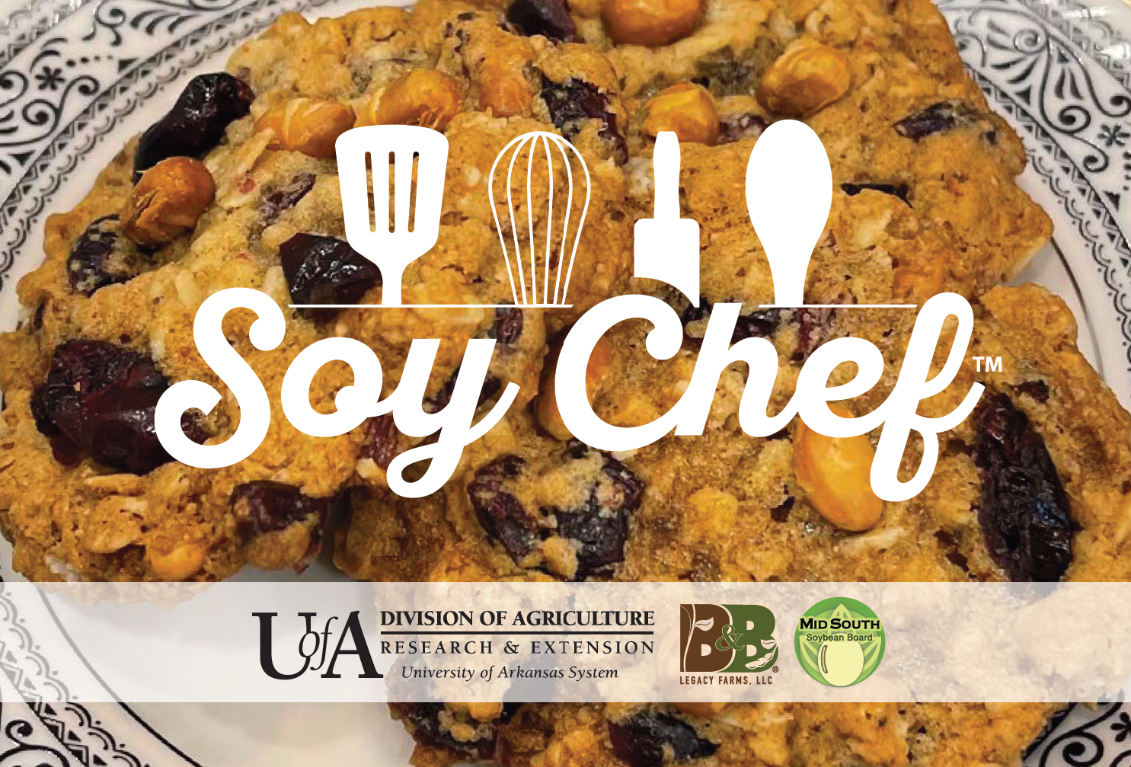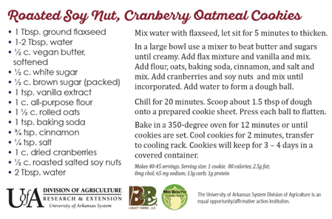

Key activities completed this quarter included:

- Curriculum development and dissemination.
Date | Audience | Activity | Accomplishments
Jan-Mar | Consumers | UM- Soy Short course dissemination. | Soy nutrition, health benefits, and cooking tips course released state-wide.

- Outreach with strategic partners.
Date | Audience | Activity | Accomplishments
Jan 27-28 | 2025 Arkansas Conservation Conference | Hosted & staffed Mid-South Soybean Board Educational Booth with soy food tasting for roasted soy nuts, soy trail mix, and soy cookies.  300+ participants | University of Arkansas and University of Missouri Extension nutrition educators and B&B staff developed educational materials, prepared and packaged 350 Soy Trail Mix Samples, and provided trail mix recipe cards and nutritional education materials to participants.
Jan-March | Arkansas Winter Production Meetings, Pipe Planner, & Pesticide Applicator Trainings. | Same as above.  279+ Participants. | Chocolate soy milk and roasted soy nut tastings were provided for the following Arkansas counties: Arkansas, Cross, Crittenden, Ashley, Chicot, Monroe, St. Francis, Phillips, and Lee.  Farmer comments included: “Did you wash all the seed treatment off it?” “Was the Vitavax off before roasting?” “I’m not eating a soybean” (then they proceeded to eat the roasted soybeans).

- Experiential education, outreach, and evaluation with consumers.
Date | Audience | Activity | Accomplishments
February | Annual Four States AgExpo | Hosted Soy Food Educational exhibit & soy food tasting. Soy food samples provided for roasted soy nuts and chocolate soy milk.  350 Participants | Direct feedback was collected from 50+ consumers, farmers, and ag industry testers. Samples of Soy Trail Mix, chocolate soy mix, and roasted soy nuts were provided to participants along with a Soy Trail Mix recipe card designed and printed by UADA Communications Department.
Feb 10th | Woodruff County AgExpo Meeting. | Same as Above.  71 Participants | Participants including agriculture teachers and farmers. 35-40 participants participated in taste tests. Evaluation feedback: many of the individuals who tried the milk seemed very unsure about it. Lots of questions about soy milk. Participant feedback was positive.

- Content creation and communications (dissemination).
Date | Audience | Activity | Accomplishments
Jan-Feb | Conservation Conf attendees, County agents, nutrition staff & consumers | Recipe development and testing at 2025 Conservation Conference. | UADA instructor Keith Cleek developed and tested a soy cookie recipe at the 2025 Conservation Conference and collected feedback. The recipe was modified to increase the soy protein content. A recipe card was developed, printed, and disseminated.
Oct | Consumers | Content development for consumer education. | Soy Snack Food and Cooking Soy from Scratch publication drafts were completed on 10/4 and 10/18.
Oct-Nov | Child Nutrition Directors and Policy Makers | Script and collaborative work with partners completed for the video, An Ancient Food that Delivers on 11/22. | Video recorded on 11/25/24 was targeted for Mid-South school nutrition directors and policy makers regarding the value of whole soy foods in the US child nutrition program.
Nov-Dec | Farmers, researchers, and industry | Planning with UA/MU partners for co-hosting MSSB booth at 2025 Conservation Conference. | The MSSB booth will feature whole soy foods and will be co-hosted by Sarah Wood, Leigh Ann Bullington, Keith Statham-Cleek & Karen Ballard on Jan 27-28, 2025, in Memphis, Tenn.

Key Objectives and Overall Deliverables for this project include:

Objective 1: Evaluation of agronomic viability and profitability of food-grade cultivars.
Progress Made: Key-informant interviews were conducted with university soybean research faculty from the states of Missouri, Arkansas, Mississippi, and Louisiana. A semi-structured interview rubric was utilized to assess current interest in and knowledge of non-GMO food grade soybean varieties. Faculty members shared their research experience and opinions regarding agronomic issues and production practices supporting profitability with non-GMO soybean production for the U.S. domestic food market.

Objective 2: Evaluation of direct whole soy food acceptability.
Progress Made: The activities outlined above reflect the expanded scope of this project, made possible through our strategic partnerships with the University of Missouri and the University of Arkansas Extension Service. The work of the University of Missouri and University of Arkansas Extension nutrition faculty, family and consumer science instructors, and agents address the significant need for a systems approach to improving awareness of the value of whole soy foods at the grass roots level across diverse audiences.

Objective 3: Evaluation of regional market opportunities.
Progress Made: The focus for this quarter’s work was to systematically review project data, related research reports, and food market data related to consumer concerns and preferences, consumer myths and misinformation about whole soy foods, and market opportunities and requirements for market linkages with USDA.

Objective 4: Dissemination of study results to increase knowledge of producers and consumers.
Key target groups include farmers, school nutrition directors, Extension educators, consumers, students, and policy makers.
Progress Made: Content development steps were completed this quarter. Final graphic design, editing for all products, and digital and print publication will be completed and released during 2025 to the MSSB, USDA Agricultural Marketing Service personnel, other MSSB research grantees, agricultural media representatives, and Senate AG Committee staff.
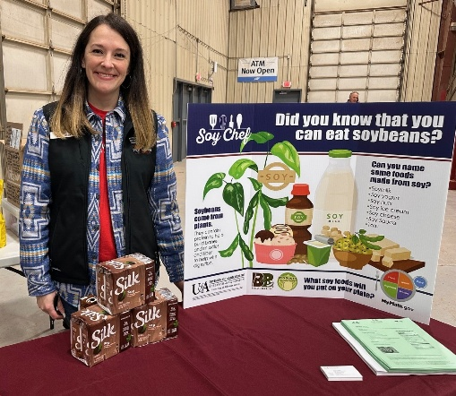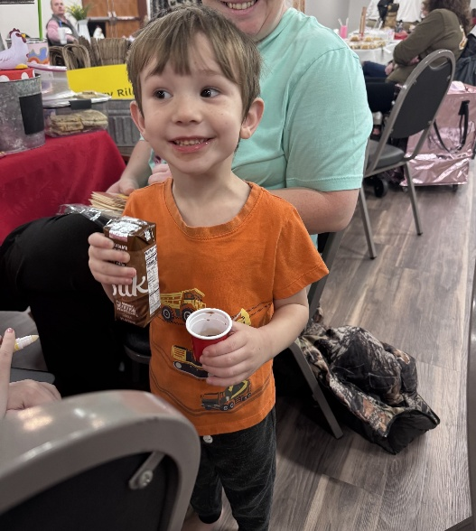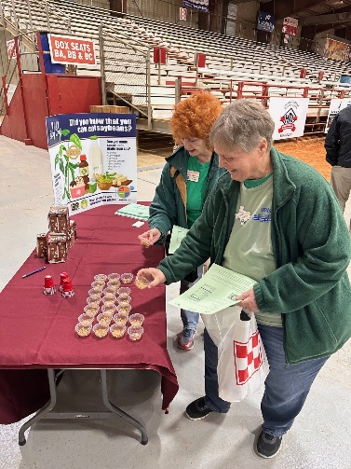
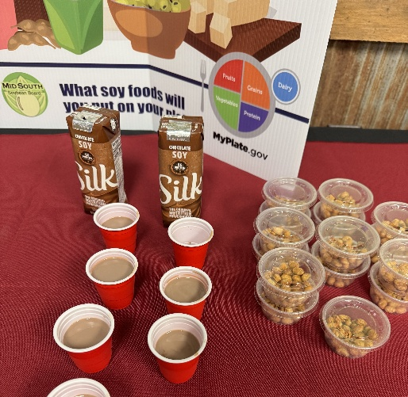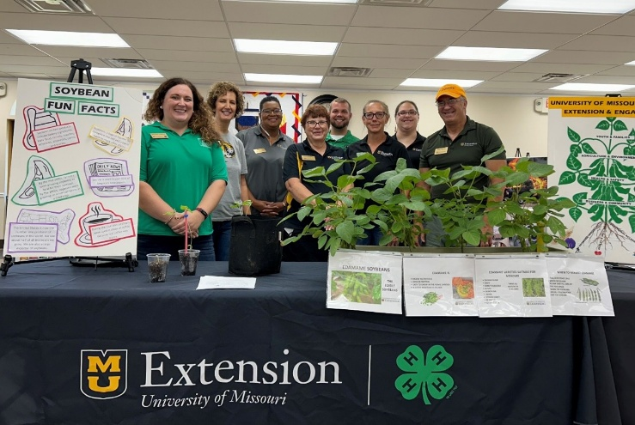

Appendix B
USDA Commercialization Linkages
Attachment B: USDA Commercialization Linkages



Link: https://www.fns.usda.gov/usda-foods/foods-available
Link: https://www.fns.usda.gov/usda-fis/foods-available
Link: https://www.fns.usda.gov/usda-foods/usda-dod-fresh-fruit-and-vegetable-program
NOTE: To be considered for purchase and inclusion on the USDA Foods Available lists, products must meet the minimum Criteria Listed below.
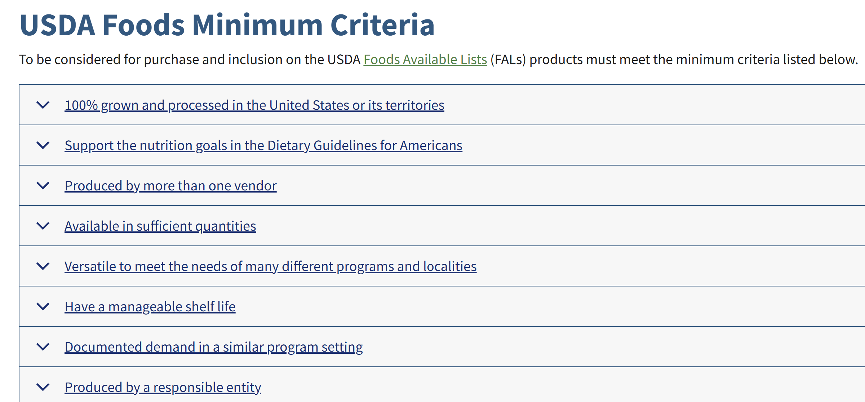
Link: https://www.fns.usda.gov/usda-foods/foods-available/criteria\

Link: https://www.fns.usda.gov/usda-foods/foods-available/product-consideration
Selling to the USDA:
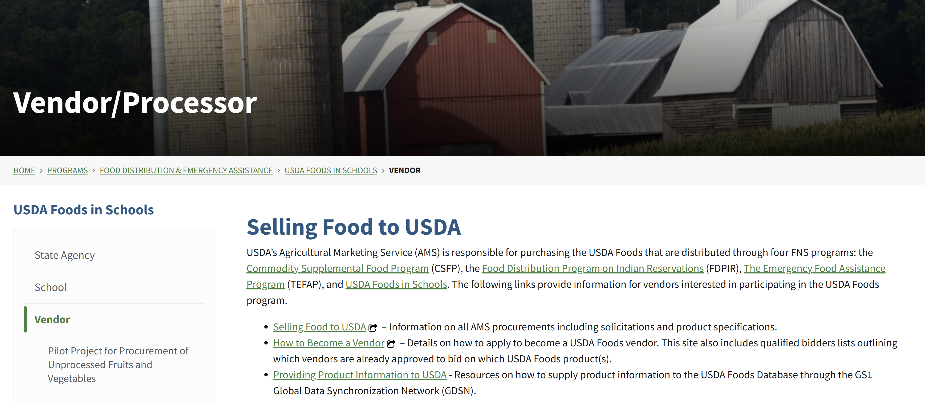
Link: https://www.fns.usda.gov/usda-fis/vendor
How to get your soybean products minimally processed?
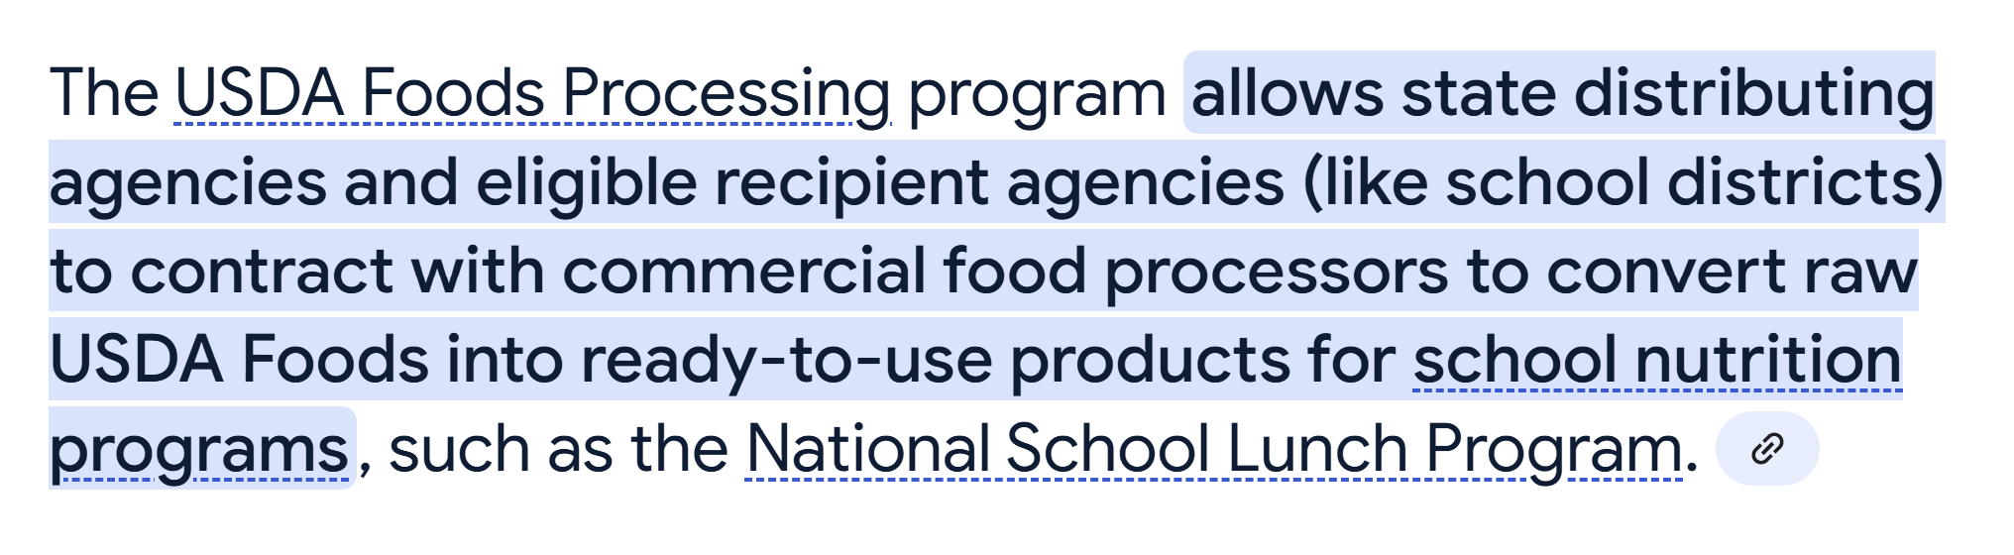
In addition to:
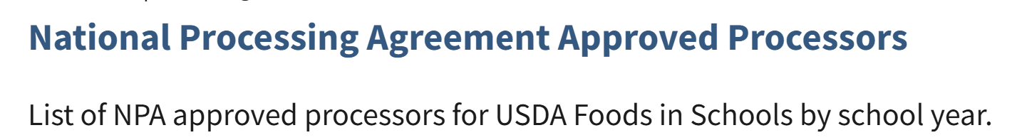
Link: https://www.fns.usda.gov/usda-fis/npa-approved-processors
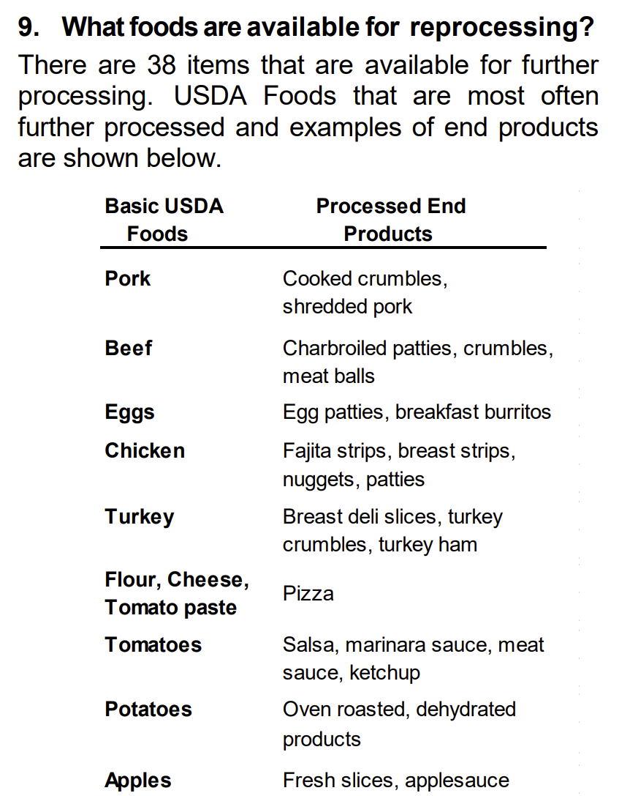


Access to USDA Foods vendor-specific information for all direct delivered USDA foods for the National School Lunch Program.
Link: https://www.fns.usda.gov/usda-fis/usda-foods-database
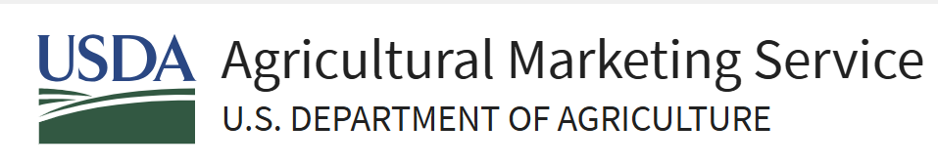
Resources:
FY24 Commodity Purchasing Data.
https://www.ams.usda.gov/reports/food-commodity-purchasing

FY24 Purchases by Commodity Through 9-30-2024 Domestic and International.
https://www.ams.usda.gov/sites/default/files/media/AMSPurchasesbyCommodityFY24.pdf

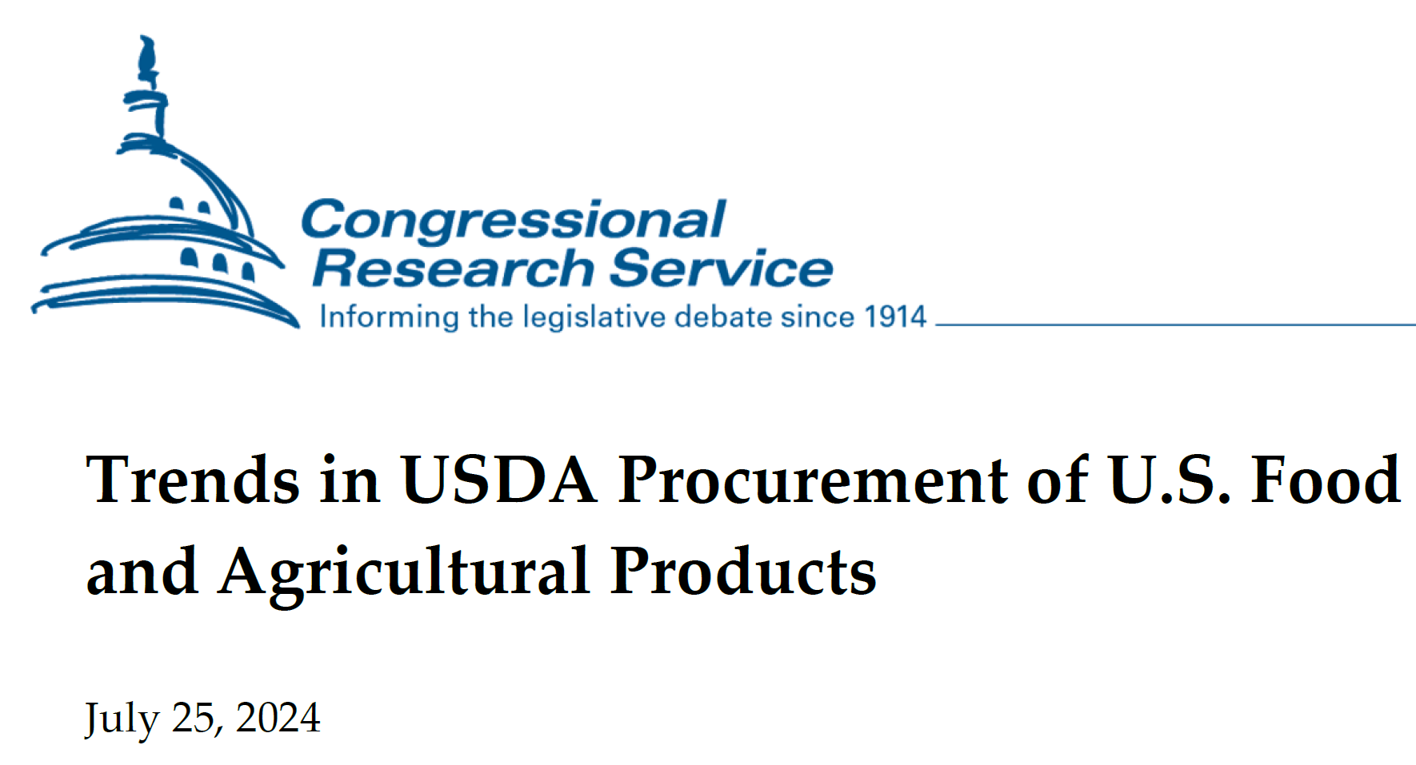
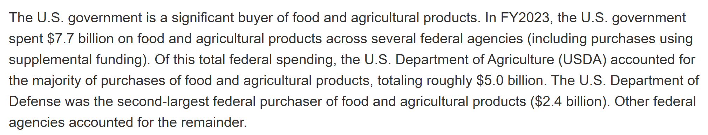
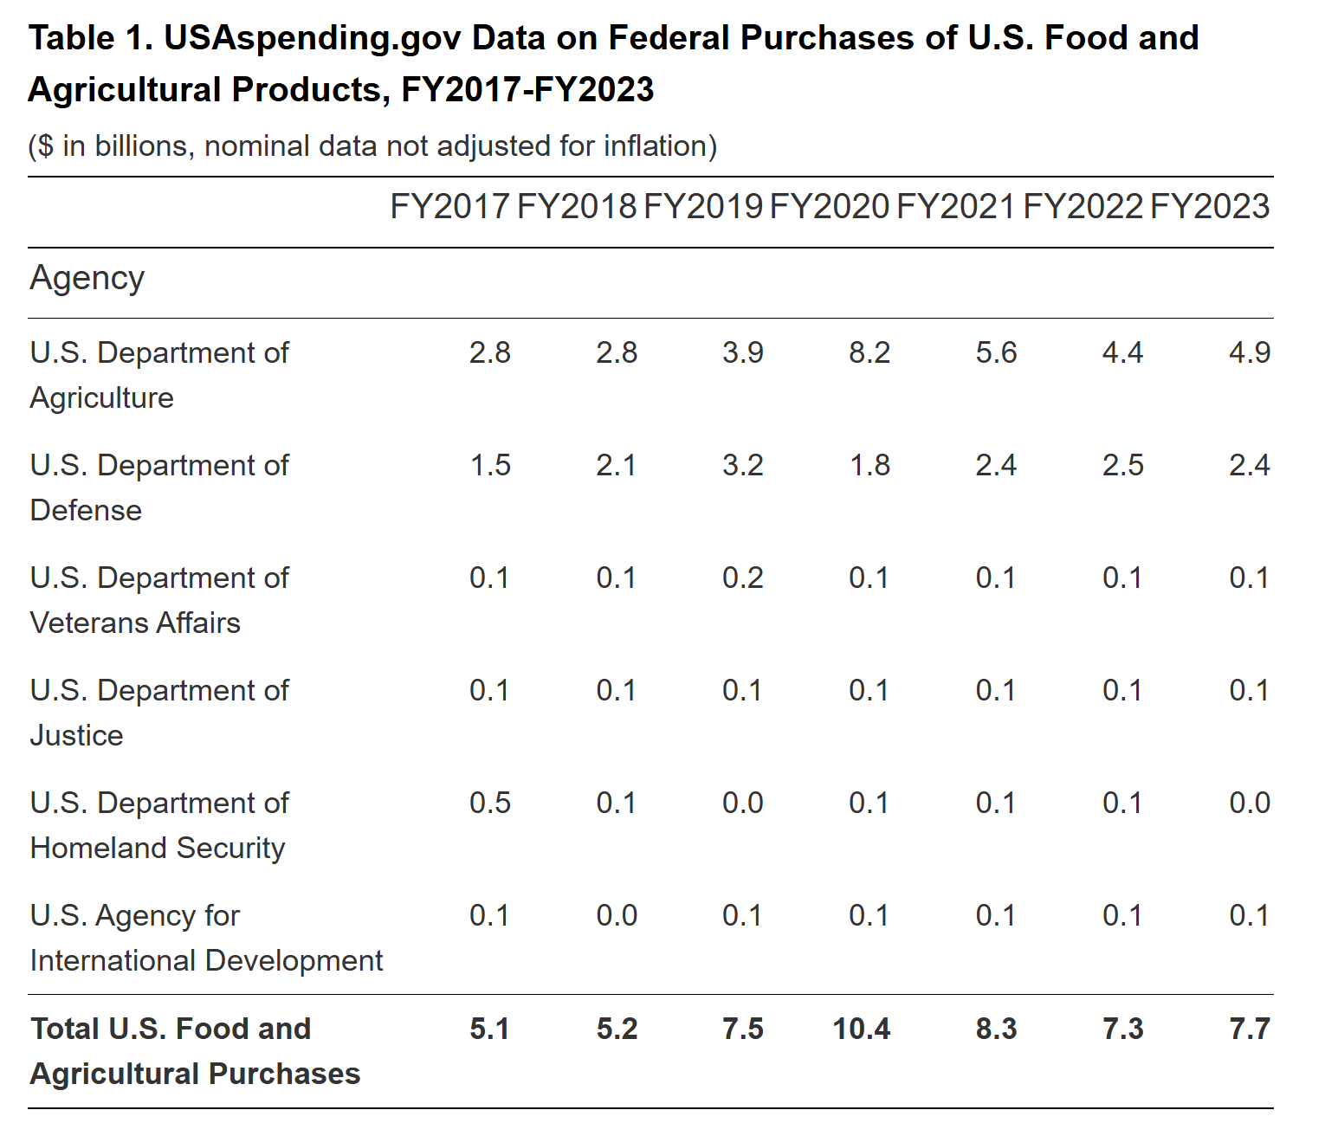
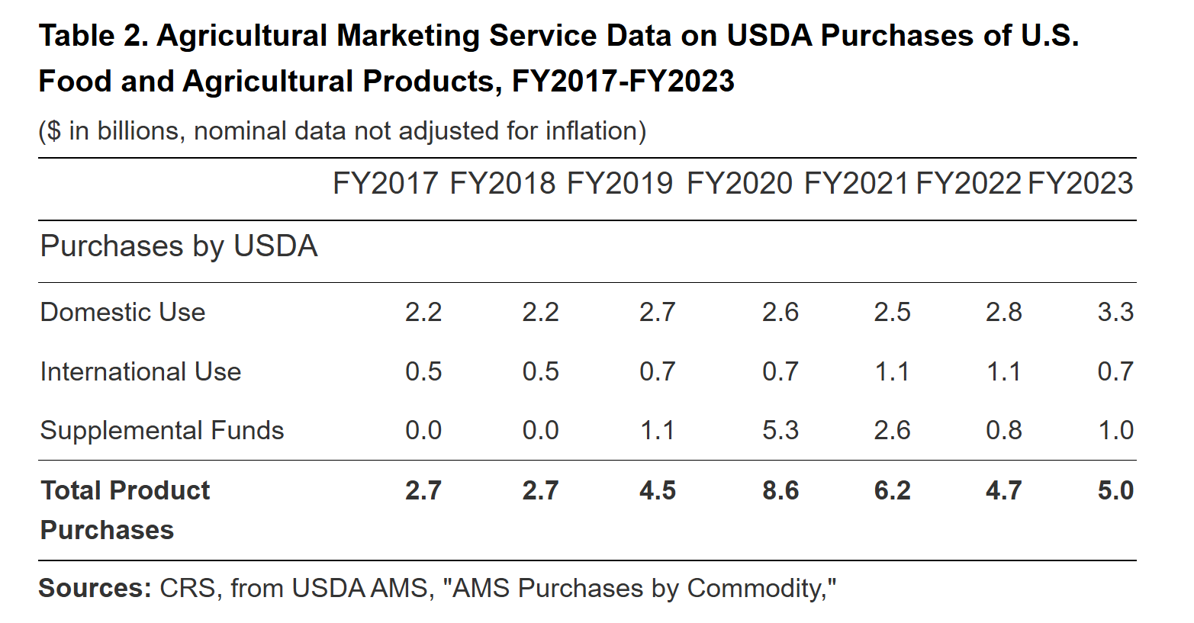Link: https://www.congress.gov/crs-product/R48141
Total Spend – This data shows the total spend by USDA AMS and does not show spending from schools/states on direct source contracts through the LFPA/LFS program.
AMS Purchases by Commodity – USDA Foods by category and DoD Fresh aggregated
- Domestic purchases FY 2024 (Oct 1 2023- Sept 30 2024)
  - Dry Beans: 53,823,360 lbs, $42,121,160 (this includes lentils and split peas)
  - Information on canned beans is also available but grouped into canned vegetables.
  - Frozen beans were not listed as a distinct category within the list.

LFPA/LFS spending – Legume spend is aggregated together with nuts.

Additional data of interest for Total Spend calculations:
- State of Origin for food items purchased for FNS programs: https://www.fns.usda.gov/research/usda-foods-state-origin-usda-foods
- Data background on USDA DoD fresh food purchases through the DoD Defense Logistics Agency (2018-2022): https://www.gao.gov/assets/gao-24-106602.pdf
- DLA spending on subsistence items, top purchases. I could not find information that summarized DLA procurement for all subsistence items
- Archive webpage for AMS Purchases by Commodity, pre FY 2022

