Please use this form to clearly and concisely report on project progress. The information included should reflect quantifiable results that can be used to evaluate and measure project success. Comments should be limited to the designated boxes. Technical reports, no longer than 4 pages, may be attached to this summary report.

Project Number:
Project Title: | Identification and confirmation of natural tolerance to off-target Dicamba damage in non-Xtend soybeans
Organization: | University of Missouri
Principal Investigator Name: | Pengyin Chen
Other investigators: | Caio Canella
Report Period: | June 16 to September 15, 2022
Research updates:

In this quarter, the team finalized all planting and conducting of field experiments (Table 1). Plants are reaching the late reproductive stage and harvest is expected to start over the next couple of weeks. Off-target dicamba exposure has been more severe than in previous years, which could have been attributed to a late planting due to excessive rain (concentration of applications around mid-May to early-June) and nearly 60 days of intense drought. We were able to complete 8 crosses including a tolerant parent, which will be sent to off-season nurseries for generation advancement in November.

Table 1. Summary of field trials to study dicamba tolerance in soybean
Test | Entries | Locations¹ | Replications | Data | Objective
22-AYT | 259 | Portageville (3)  Mid-South (6-8) | 3 Portageville  2 Mid-South | Yield, Soy6K SNP,  Dicamba R3, UAV R3 | Identification and selection of high-yielding tolerant advanced lines
DIC-Map² | 450 | Portageville (2) | 2 | Yield, Soy6K SNP,  Time-series Dicamba,  Time-series UAV | Genomic studies to identify significant marker-trait associations
¹Mid-South locations include AR, IL, LA, MS, MO, TN, and VA. ²DIC-Map consists of two populations derived from a susceptible breeding line and a tolerant plant introduction (PI).

DIC-Map, which are two mapping populations derived from a tolerant PI and a susceptible breeding line, has shown excellent differentiation for dicamba exposure (Figure 1). These plants were phenotyped around R3 and this metric will be used for further mapping studies. This experiment will be repeated in 2023 for confirmation.
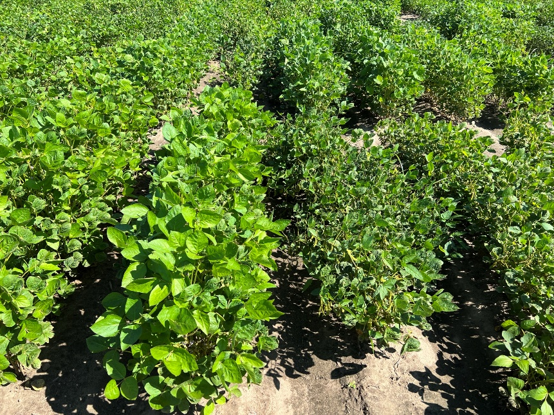
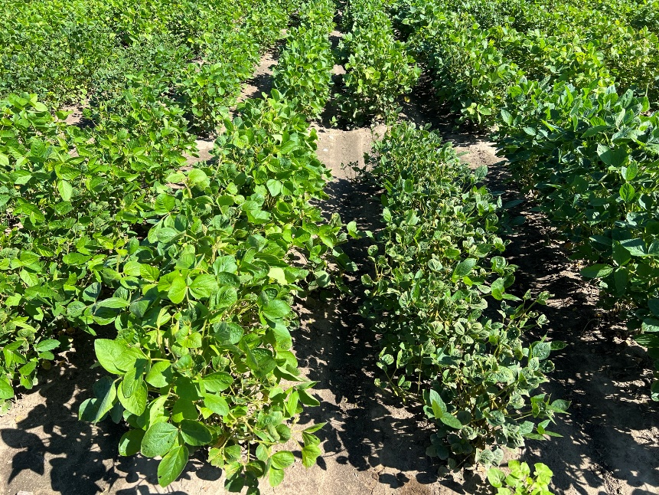
Figure 1. Mapping lines derived from a cross between a tolerant PI by a susceptible breeding line.

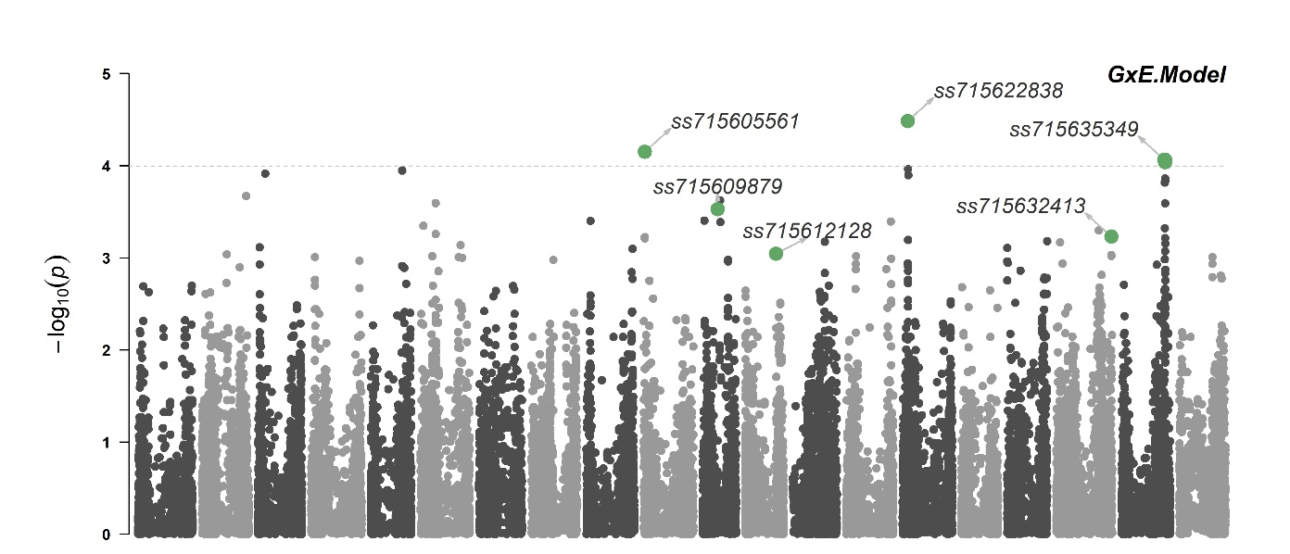
The team also made significant progress in identifying genomic regions associated with tolerance. Using a panel of over 380 PIs genotyped with the Soy50K SNP chip, we identified two genomic regions harboring a multidrug resistance gene and a glycosyl-transferase gene, both associated with plant detoxification from herbicides (Figure 2). These results are being prepared to be submitted for publication in Frontiers in Plant Science in October.
Figure 2. Manhattan plot showing SNPs significantly associated with the differential response of soybean to off-target dicamba.

Summary and Highlights:

- Two candidate genes have been identified for regulating this differential response to dicamba.
- Mapping populations derived from tolerant PIs are showing excellent differentiation to dicamba.
- High-yielding breeding lines with higher tolerance are being advanced throughout the pipeline.

