Please use this form to clearly and concisely report on project progress. The information included should reflect quantifiable results that can be used to evaluate and measure project success. Comments should be limited to the designated boxes. Technical reports, no longer than 4 pages, may be attached to this summary report.

Project Number:
Project Title: | Identification and confirmation of natural tolerance to off-target Dicamba damage in non-Xtend soybeans
Organization: | University of Missouri
Principal Investigator Name: | Pengyin Chen
Other investigators: | Caio Canella
Report Period: | September 16 to December 15, 2021
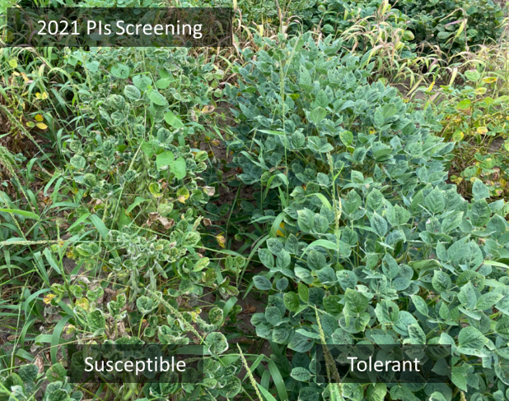
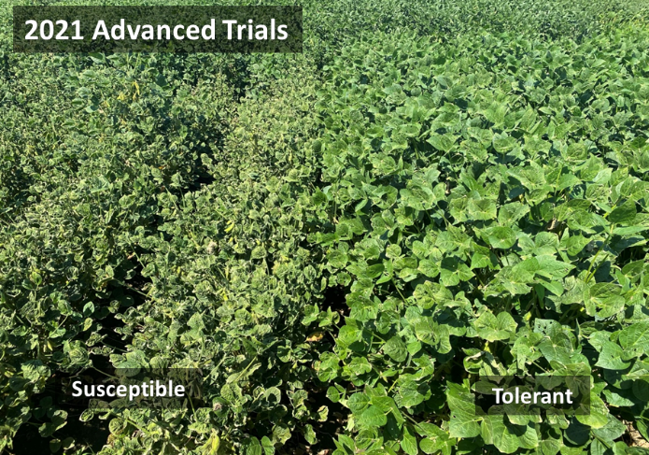
2021 Research and Field Test updates: We successfully completed all the note-taking and harvesting for the 2021 season. For the third year of this study, season-long off-target dicamba exposure resulted in differential responses among genotypes (breeding lines and plant introductions) in the field (Figure 1). Besides the visual assessment of the damage, we completed the second year of UAV-based image data collection. Collectively, three layers of data (visual, UAV-based, and molecular) will be used to further understand the ability of genotypes to tolerate and recover from dicamba damage.
Figure 1. Early symptoms of off-target dicamba injury and differential response among genotypes in the 2021 season.

UAV-based genotype classification: With the use and aid of a drone-mounted RGB camera and machine learning algorithms, we have developed a classification system to speed up the process and increase accuracy in the identification of tolerant soybean lines. A total of seven image features were extracted and used to train the models. High accuracy was observed in the tolerant and susceptible classes (0.894 and 0.837, respectively), whereas moderate accuracy was observed in the middle class (0.751). We plan to incorporate this platform in 2022 to precisely identify and select tolerant genotypes early in the breeding pipeline.

Figure 2. Gradient change and differentiation in color pattern, entropy, and canopy coverage across tolerant and susceptible genotypes (left to right).
Table 1: Confusion matrix for the classification of dicamba response (tolerant, moderate, and susceptible) according to ground visual assessment using an artificial neural network algorithm.
Classes | Tolerant |  | Moderate |  | Susceptible |  | Algorithm
Tolerant | 12 |  | 15 |  | 2 |  | ANN
Moderate | 53 |  | 410 |  | 68
Susceptible | 7 |  | 46 |  | 120
Class accuracy | 0.894 |  | 0.751 |  | 0.837
Kappa | 0.222 |  | 0.493 |  | 0.597
Precision | 0.413 |  | 0.772 |  | 0.714
Sensitivity | 0.166 |  | 0.870 |  | 0.631
Specifity | 0.974 |  | 0.538 |  | 0.910
Model Accuracy | 1st fold | 2nd fold | 3rd fold | 4th fold |  | 5th fold
 | 0.761 | 0.760 | 0.755 | 0.712 |  | 0.707
Overall accuracy | 0.74

Dosage-controlled field screening: Field experiments to determine the dicamba rates to cause differential response among genotypes were conducted. A total of 37 breeding lines and 3 commercial checks (2 Xtend, 1 R2Y) were used in this study. Three dicamba rates including 1/100th, 1/1,000th, and 1/10,000th of the labeled rate (0.56, 0.056, and 0.0056 g ha⁻¹, respectively) were applied at three timings: 1st trifoliate (V1), 3-4 trifoliates (V3-V4), and beginning of flowering (R1). Visual injury ratings were initiated one week after the initial application and concluded 10 days after the final application. The injury was recorded as 0 = no damage, 5 = severe cupping and/or stunting. Preliminary analysis showed that for the 1/100th application rate S16-12774C (our most tolerant breeding line based on field observations) displayed the lowest injury while PR17-507 (among the most susceptible type based on field observations) displayed the most severe injury.
Summary and Highlights:

- Proposed field tests and data collection successfully completed for the 2021 season.
- Dosage-controlled experiments are showing similar responses to the original field observations for the contrasting genotypes.
- An UAV-based classification system was developed and will be incorporated in the 2022 season to detect tolerant lines.
- Genomic studies are on-going and SNPs have been identified to be associated with the tolerance trait.
- Tolerant high-yielding breeding lines have been advanced throughout our pipeline. This is the second year where we entered tolerant lines in the USDA uniform trial.

