Please use this form to clearly and concisely report on project progress. The information included should reflect quantifiable results that can be used to evaluate and measure project success. Comments should be limited to the designated boxes. Technical reports, no longer than 4 pages, may be attached to this summary report.

Project Number:
Project Title: | Identification and confirmation of natural tolerance to off-target Dicamba damage in non-Xtend soybeans
Organization: | University of Missouri
Principal Investigator Name: | Pengyin Chen
Other investigators: | Caio Canella
Report Period: | December 16, 2020 to March 15, 2021

Project Status: On-going

(What key activities were undertaken and what were the key accomplishments during this quarter? Please use this field to clearly and concisely report on project progress).

In 2020 season, dicamba off-target movement continued through the season and crop injury was evident in all our research plots. Early maturing lines were more severely impacted than late-maturing lines. We were able to collect visual scores, drone images, and yield data.
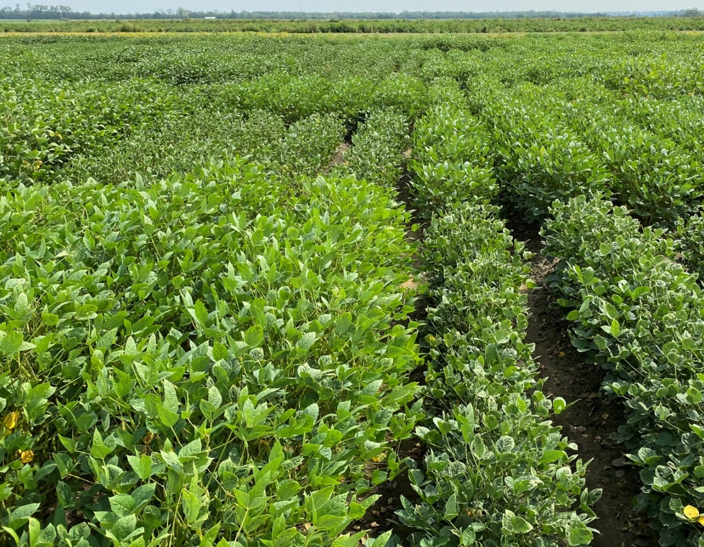
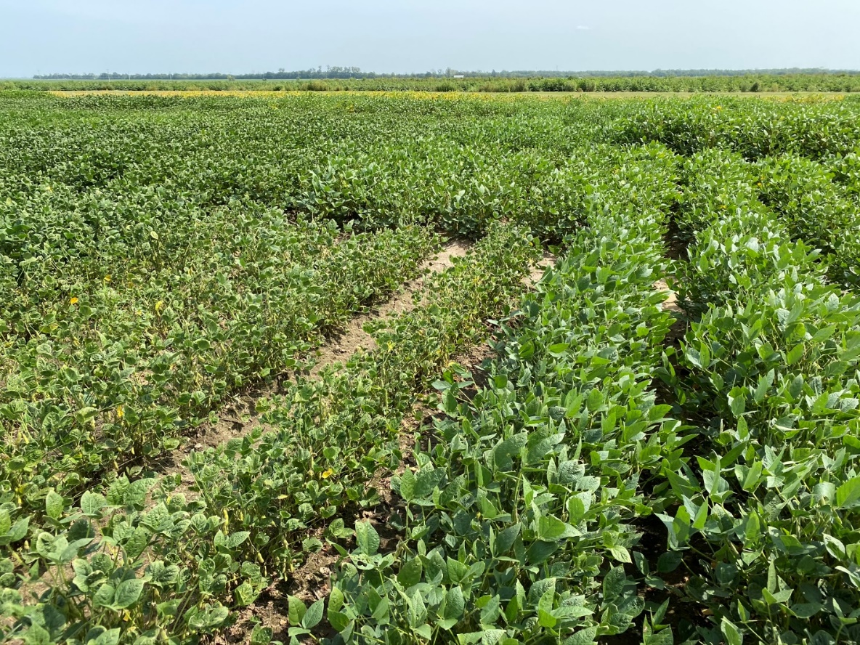

2021 Research and Field Trials:
- Yield x Dicamba damage – Advanced Breeding Lines
In 2021, we will screen 248 advanced breeding lines and Xtend checks across five locations each with three replications (15 different observations per line, roughly 4,000 total observations). In addition to the visual scores, plots will be digitally phenotyped using a drone mounted with an RGB/Multispectral camera. This will complete a large screening of advanced breeding lines under continuous dicamba exposure through the growing season over three years.
- Yield x Dicamba damage – Extreme lines
A set of 40 extreme lines with contrasting response to dicamba damage (20 tolerant and 20 susceptible) will be re-tested in a replicated trial for yield and dicamba injury scores in two locations. The purpose of this trial is to confirm the phenotypic differential dicamba responses that are consistent across environments and corelate to yield performance.
- Mapping populations and genomic studies
A total of 400 RILs derived from 3 tolerant x sensitive crosses for mapping purposes and a set of 340 exotic soybean germplasm accessions will be re-tested in 2021 for confirmation of differential response to dicamba damage. These materials will be grown in single row plots in 2 locations each with 2-3 reps and phenotyped based on visual and digital scores. All entries are currently being genotyped with the Soy6K SNP chip. The goal is to identify molecular markers and QTLs/genes associated with natural tolerance to off-target dicamba damage.

Results from 2020 Confirmation Trial (not included in last report):
In 2020, we tested two sets of extreme lines (maturity groups 4 and 5) in a replicated test in two locations. These entries were initially phenotyped in 2019 and represented the 20 most tolerant and 20 most susceptible lines. Results confirmed the ratings from 2019, and yields were negatively correlated with the dicamba damage (-0.68). This set of extreme genotypes are currently being tested under different dicamba doses in the greenhouse.

Summary and Highlights:

- Two-year confirmation data from extreme genotypes show a consistent response to dicamba and superior performance of the tolerant group under off-target dicamba exposure throughout the season.
- A manuscript showing the impact of off-target damage on yield has been prepared for submission to Crop Science. In summary, one increment in dicamba injury score (1-5) decreases yield potential by approximately 8%, with the effect being more pronounced in earlier maturity group lines.
- Presentations were given to the Missouri Soybean Merchandising Council and the 24th Annual National Conversation Systems Conference, highlighting the findings of this project.

