Please use this form to clearly and concisely report on project progress. The information included should reflect quantifiable results that can be used to evaluate and measure project success. Comments should be limited to the designated boxes. Technical reports, no longer than 4 pages, may be attached to this summary report.

Project Number:
Project Title: | Identification and confirmation of natural tolerance to off-target Dicamba damage in non-Xtend soybeans
Organization: | University of Missouri
Principal Investigator Name: | Pengyin Chen
Report Date: | December, 2020
National Soybean Checkoff Research Database https://www.soybeanresearchdata.com/ (public website funded by USB). Please include a non-technical summary along with your project status. The non-technical summary will be published to the website. If a non-technical summary is not provided, the contents of this entire report will be published.

Project Status: On-going
2020 Field Trials: In 2020, we tested over 1,500 different soybean genotypes in over 7,500 field plots that were exposed to season-long dicamba drift (Table 1). All these genotypes were rated in a 1-5 scale (0.5 increments) based on their response to off-target Dicamba damage, as well as phenotyped using a multispectral camera mounted in an Unmanned Aerial Vehicle (UAV) for plant architecture and canopy features associated with damage. These genotypes included elite breeding lines, recombinant inbred lines (RILs) for genetic mapping, and exotic soybean lines, and will be assayed with the Soy6K SNP chip for molecular studies. In addition to the damage symptoms, yield data was collected in many plots to confirm the negative impact of Dicamba on yield and select genotypes with superior tolerance.

Table 1. Summary of the 2020 Dicamba field trials at MU-Fisher Delta Center and University of Illinois (UIUC)
Test Name | # Entries | Source | # Env | # Reps | Plot layout | Data collected | Marker
Dicamba Field Demo | 8 | AYT (17, 19) | 1 | 1 | 4-row strip, field length | UAV, Dicamba | Soy6K
UIUC Screening | 10 | AYT (17, 19) | - | - | Greenhouse | Dicamba | Soy6K
AYT-Screening
S400-20 | 32 | 2019 PYT | 5 | 3 | 4-row plots, 12 ft long | UAV, Yield, Dicamba | Soy6K
S450-20 | 32 | 2019 PYT | 5 | 3 | 4-row plots, 12 ft long | UAV, Yield, Dicamba | Soy6K
S470-20 | 32 | 2019 PYT | 5 | 3 | 4-row plots, 12 ft long | UAV, Yield, Dicamba | Soy6K
S480-20 | 36 | 2019 PYT | 5 | 3 | 4-row plots, 12 ft long | UAV, Yield, Dicamba | Soy6K
S500-20 | 32 | 2019 PYT | 5 | 3 | 4-row plots, 12 ft long | UAV, Yield, Dicamba | Soy6K
S550-20 | 24 | 2019 PYT | 5 | 3 | 4-row plots, 12 ft long | UAV, Yield, Dicamba | Soy6K
S560-20 | 36 | 2019 PYT | 5 | 3 | 4-row plots, 12 ft long | UAV, Yield, Dicamba | Soy6K
GS-SW | 447 | PI Subset | 1 | 2 | 1-row plot, 7 ft long | Time-series UAV, Dicamba | Soy50K
DIC-4YT | 24 | 2019 AYT | 2 | 3 | 4-row plots, 12 ft long | UAV, Yield, Dicamba | Soy6K
DIC-5YT | 24 | 2019 AYT | 2 | 3 | 4-row plots, 12 ft long | UAV, Yield, Dicamba | Soy6K
DIC-Screening:
DPS-1 | 160 | Nursery (19) | 2 | 2 | 1-row plot, 7 ft long | UAV, Dicamba | -
DPS-2 | 160 | Nursery (19) | 2 | 2 | 1-row plot, 7 ft long | UAV, Dicamba | -
DPS-3 | 160 | Nursery (19) | 2 | 2 | 1-row plot, 7 ft long | UAV, Dicamba | Soy6K
DPS-4 | 120 | Nursery (19) | 2 | 2 | 1-row plot, 7 ft long | UAV, Dicamba | Soy6K
DPS-5 | 120 | Nursery (19) | 2 | 2 | 1-row plot, 7 ft long | UAV, Dicamba | Soy6K
DIC-Contrast 1 | 40 | Nursery (19) | 2 | 2 | 2-row plots, 7 ft long | UAV, Yield, Dicamba | Soy6K
DIC-Contrast 2 | 40 | Nursery (19) | 2 | 2 | 2-row plots, 7 ft long | UAV, Yield, Dicamba | Soy6K
AYT = Advanced Yield Trial; PYT = Preliminary Yield Trial; GS = Genome sequence set; DIC = Dicamba; Dicamba population study.
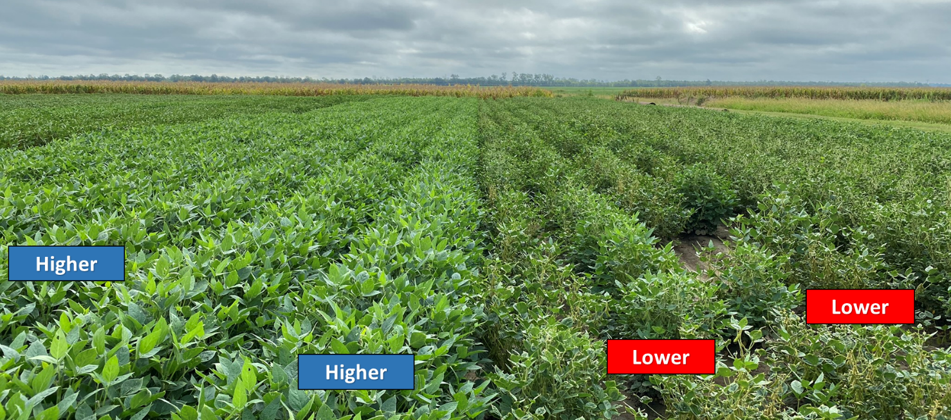
Dicamba field demonstration: As an attempt to reproduce and demonstrate natural performance of tolerant and sensitive soybeans in a farmer’s field, we grew two most tolerant and two most susceptible lines selected from 2019 in long-rows (220ft long). Also included in the strip demon plots were an Xtend check and a RR2 check. The difference between the tolerant and susceptible lines was visually impressive, with the first group showing healthy development throughout the season and the latter being severely hindered by the off-target damage (Figure 1).
Figure 1. Field demonstration of two tolerant and two susceptible soybean lines in 2020. ‘Higher’ indicates superior tolerance to off-target Dicamba damage whereas ‘Lower’ indicates susceptibility. Picture taken around the R5 growth stage.

Dicamba damage x Yield performance – a two-year confirmation: We observed strong and consistent negative correlation between off-target Dicamba damage and yield performance in 2019 and again in 2020 (Figure 2). These results were obtained across 4,841 yield plots in two years. Many advanced breeding lines with superior tolerance to off-target Dicamba damage were identified, of which several will be entered in the 2021 USDA uniform trials for extensive testing.
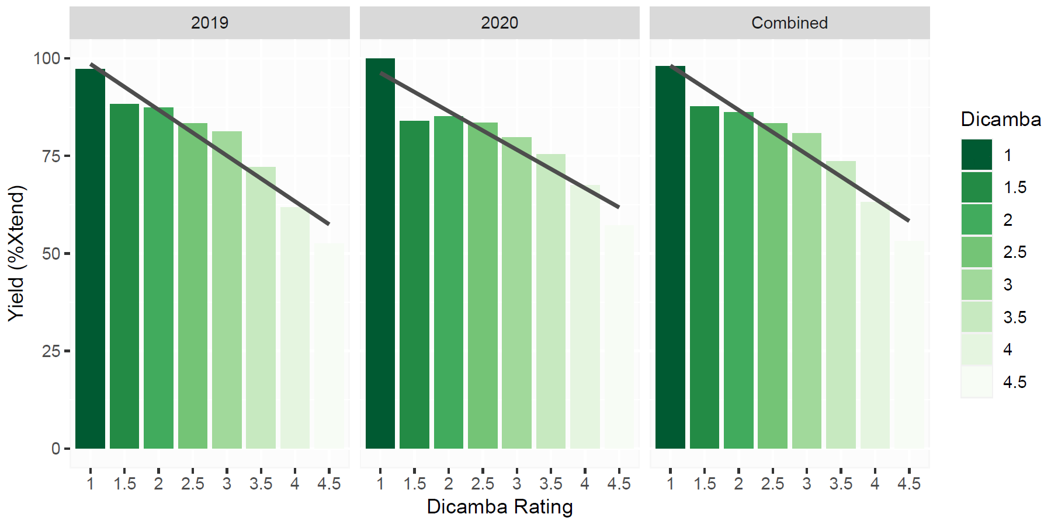
Figure 2. Yield performance x off-target Dicamba damage in advanced breeding lines in 2019 and 2020.

Exploring exotic soybeans for tolerance: We screened over 440 exotic soybean lines (PI – plant introductions) for off-target Dicamba tolerance and found extreme differential response to off-target Dicamba among them (Figure 3). As a result of a time-series study (rating in three different dates, roughly 14 days apart), we identified differential responses when exposed to Dicamba, where some genotypes show recovery, others worsening in symptoms over time, and some with consistent symptoms throughout the season (either tolerance or susceptibility) (Figure 3). All these lines have been genotyped with the Soy50K SNP chip, and the data will be used to perform molecular studies on the ability to recover or natural tolerance.

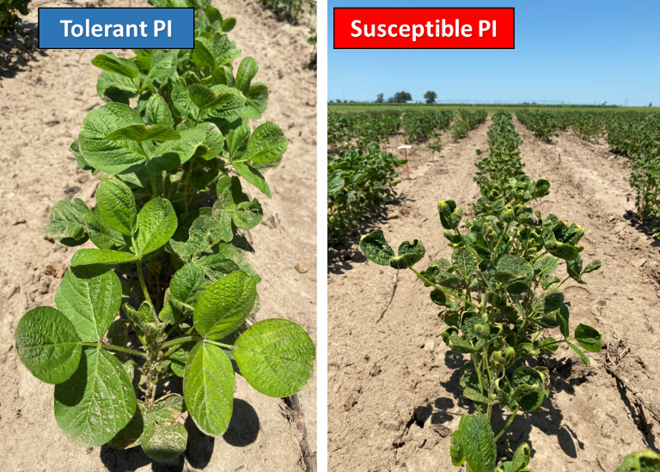
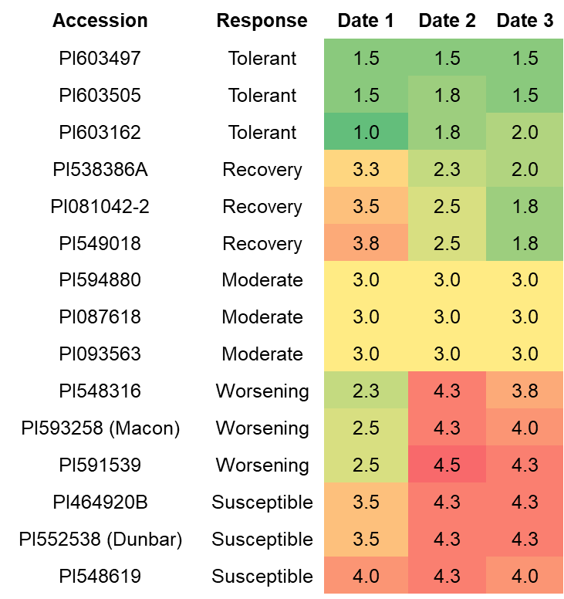
Figure 3. Differential response of PIs to off-target Dicamba damage throughout the season

In addition, two new mapping populations were developed by crossing a tolerant PI to a susceptible elite breeding line. The goal is to generate two segregating populations and identify genetic regions that are associated with the differential response to off-target Dicamba damage.

Greenhouse screening at the University of Illinois: A new experiment was initiated to determine if we can better replicate in the greenhouse the Dicamba tolerance observed in the field. The experiment included five rates of Dicamba plus a control and the plants were sprayed at two different growth stages. The rates were 1/500, 1/1,000, 1/5,000, 1/10,000 and 1/20,000 of the normal field rate plus a control with no Dicamba. The plants were sprayed at either V2 or V5/V6, the experiment included two tolerant genotypes and two sensitive genotypes, and it was replicated twice. Dicamba injury was rated approximately every four days for seven weeks after the initial application.
At the highest rates (1/500 and 1/1,000), there was little difference in injury observed between the two tolerant and the two sensitive genotypes. This is consistent with what we observed in our first experiment. At the lower rates of 1/5,000 and 1/10,000, a difference was observed between the tolerant and sensitive lines and this difference was greatest at 1/10,000. New experiments are planned to confirm this finding using the full set of tolerant and sensitive lines that we received from Missouri.

Non-technical summary:
Summary and Highlights:

- Over 7,400 plots screened visually and by drone equipped with multispectral camera for natural tolerance;
- Strong and consistent negative correlation between Dicamba damage and yield was confirmed;
- Many non-Xtend soybean lines with superior tolerance to off-target Dicamba damage were identified;
- Identification of high levels of tolerance in exotic germplasms (PIs);
- Developed two genetic mapping populations using tolerant PIs;
- New crosses made and populations being advanced to develop high-yielding tolerant lines;
- Presentations at multiple venues highlighting the findings of this project;
- Article at Farm Progress highlighting this project – “Soybeans show natural resistance to dicamba”

