***2023 Midsouth Soybean Board***

**PROPOSAL TITLE**: Enhancing the Prospects of Sustainable Weed Management and System Productivity through Wheat-Soybean Relay Intercropping in the Midsouth.

**INVESTIGATORS:**

Jason K. Norsworthy, Distinguished Professor and Elms Farming Chair of Weed Science, Department of Crop, Soil, and Environmental Sciences, University of Arkansas, Fayetteville, AR. Ph: 479-313-1265. Email: [jnorswor@uark.edu](mailto:jnorswor@uark.edu)

Jeremy Ross, Professor & Extension Soybean Specialist, of Crop, Soil, and Environmental Sciences, University of Arkansas Systems Division of Agriculture, Lonoke, AR. Ph: 501-944-0621. Email: [jross@uada.edu](mailto:jross@uada.edu)

**PROGRAM AREA (check all that apply):**

___ New Uses of Soybean

___ Food Grade Soybean

___ Soybean Fuel

___ Soybean Breeding and Genetics

_**X**_ Weed Management

___ Irrigation/Water Management

___ Seed Quality

___ Disease Management and Control

___ Fertility Management

___ Insect Management/Control

___ Harvest aids

___ Nematode Management/Control

___ Rotations using soybean

___ Research Validation or Demonstration

___ Producer Communications

___ Variety Trials

_**X**_ Economics

___ Other (*Identify*)

**PROJECT STATUS:**

New _**X**_

Renewal ____ (Year ____ of ____ )

Stand alone _**X**_ or cross-commodity.

**2023 TOTAL FUNDING REQUEST: $33,400**

|  |  |  |  |
| --- | --- | --- | --- |
| **2023 MSSB RESEARCH PROJECT PROPOSED BUDGET** | | | |
| **CATEGORY** | | **ORIGINAL** |  |
| **A.** | **Personnel** |  |  |
|  | **1. Salaries** | $22,500 | Post-doc |
|  | **2. Wages** |  |  |
|  | **3. GRA** |  |  |
| **B.** | **Fringe Benefits** | 7,110 |  |
| **C.** | **Travel** | 3,000 | Travel to test site |
| **D.** | **Contractual Services** |  |  |
| **E.** | **Subcontracts** |  |  |
| **F.** | **Commodities** |  |  |
| **G.** | **Publication Costs** | $2,500 |  |
| **H.** | Other Costs | $3,000 | (wheat seed, plot fees, bags, stakes, sprayer parts) |
| **TOTAL COST** | | $38,110 |  |
| (MSSB does not allow indirect costs/overhead charges) | | | |
| ***Personnel****: Show number of hours x hourly rate for each category. GRA cost to include tuition and books. MSSB does not pay salaries of principal investigators or cooperating scientists (USB Compliance Manual, Sect. 17, Part 2-D).*  ***Fringe Benefits:*** *Amount and rate for indicated salaries, wages, and GRAs must be shown.*  ***Travel****: Out-of-pocket and per diem expenses (hotel and meals) for site visits, travel to and from meetings (e.g. airfare, vehicle mileage not to exceed the IRS rate), etc.*  ***Contractual Services****: External lab fees, consultants, etc.*  ***Commodities****: Expenses related to the conduct of the project (e.g., seed, fertilizers, pesticides, lab supplies).*  ***Additional Details****: Provide for each budget category in addendum if necessary.*  ***Reminder****: All payments for project activities are on a reimbursable basis based on an itemized invoice submitted to MSSB each quarter along with a progress report.*  ***Budget Transfers****: The MSSB follows USB guidelines, which state “The PI may transfer funds amongst budget categories only with MSSB’s prior written consent if (i) the amount transferred exceeds 10% of any one general budget category (per annual period) or (ii) the funds transferred are travel related. PI shall request permission from MSSB for all budget reallocations and account for them in his/her financial report.”*  ***Additional Instructions:*** *See Addendum B.* | | | |

**TECHNICAL SUMMARY**

In response to the escalating prevalence of herbicide-resistant weeds, the conventional approach has been to employ a more diverse array of herbicides, which in essence is a one-dimensional course of action. However, there exists substantial evidence that a herbicide-centric strategy may prove insufficient for effective weed management, even to the prospects of catastrophic weed management failures, thereby demanding the adoption of a more multidimensional approach. Despite this, the development of such weed management methods has thus far been limited. Most cropping systems in the Midsouth today provide resources for plant growth that vastly exceed the needs of both crops and weeds for several weeks after planting. This allows weeds that escape management interventions to flourish before resources are monopolized by crops, replenishing the weed seedbank year after year. Relay intercropping, that creates a dense and diverse canopy, has the potential to deprive weeds of this opportunity. The resilience of cropping systems in the region, in terms of profitability and crop protection from pests, has also emerged as a pressing concern. Relay intercropping could be one of the viable contributing factors to address this issue.

Building upon the ongoing field research and outreach efforts, this project aims to develop and promote relay intercropping of wheat with soybean in the cropping systems of the Midsouth region, with the goal of achieving sustainable weed management, while enhancing system profitability, and bolstering resilience. This grant funding helps sustain ongoing relay intercropping research efforts. It is expected that this project will eventually promote robust production practices in the region, leading to increased stability and profitability of crop production systems. Specifically, this project will provide information on how wheat-soybean intercropping affects weed suppression, seed production, weed seed recruitment, and economic returns. The results will be shared with stakeholders at professional as well as growers’ meetings to increase awareness about this potentially more profitable and resilient cropping system for the region.**OUTLINE OF RESEARCH**

**RATIONALE/JUSTIFICATION FOR RESEARCH:**

Herbicide-resistant weeds threaten crop yields of major crops including soybean in the Midsouthern region. This project will build on our ongoing efforts to develop a resilient weed management strategy in response to the growing challenge of herbicide-resistant weeds, and to improve the overall crop production experience in the Midsouthern region. One of the strategies we have been exploring is relay intercropping wheat with soybean at multiple locations in Arkansas.Initiated last year, we are now requesting funding to continue this endeavor, which has potential to provide impetus for future explorations and progress towards achieving more sustainable and profitable crop production systems in the Midsouthern region.

Growing evidence suggests that relying solely on chemical solutions, even with a wide variety, is no longer sustainable, as the effectiveness of herbicides is being compromised by the development of resistance in weed populations (Landau et al. 2022; Heap 2023). The potential loss of crop yields due to key weeds of the region such as Palmer amaranth (Amaranthus palmeri S. Wats.) is estimated to be in the billions of dollars. Palmer amaranth is highly competitive, especially in row crops such as soybean, cross-pollinating and fecund weed species, and has remained one of the major management concerns in Midsouth agriculture. Many populations of Palmer amaranth in soybean and/or corn or rice production systems have already developed resistance to multiple herbicide modes of action (Heap 2023), leaving limited options for its control and further increasing the risk of resistance development. Furthermore, there are environmental consequences of resistant weeds. The resumption of intensive tillage practices as an imperative weed management intervention has consequently led to a marked increase in greenhouse gas emissions over the past 15 years (Lu et al. 2022).

The implementation of relay intercropping, whereby soybeans are sown into standing wheat, presents a promising component of sustainable weed management in the Midsouthern region. Wheat employed as a cover crop has been demonstrated to effectively suppress weed growth by more than 90% for up to 4 weeks following termination (Osipitan et al. 2019). Wheat-soybean relay intercropping has the potential to further curtail weed emergence and growth prior to soybean canopy closure, thereby depriving weeds of the resources requisite for their proliferation as evidenced in our preliminary research (**Figure 1.**) Additionally, the relay intercropping may confer benefits such as improved soil quality, increased net return, enhanced land equivalent ratio, and suppression of other pest infestations (Tanveer et al. 2017).

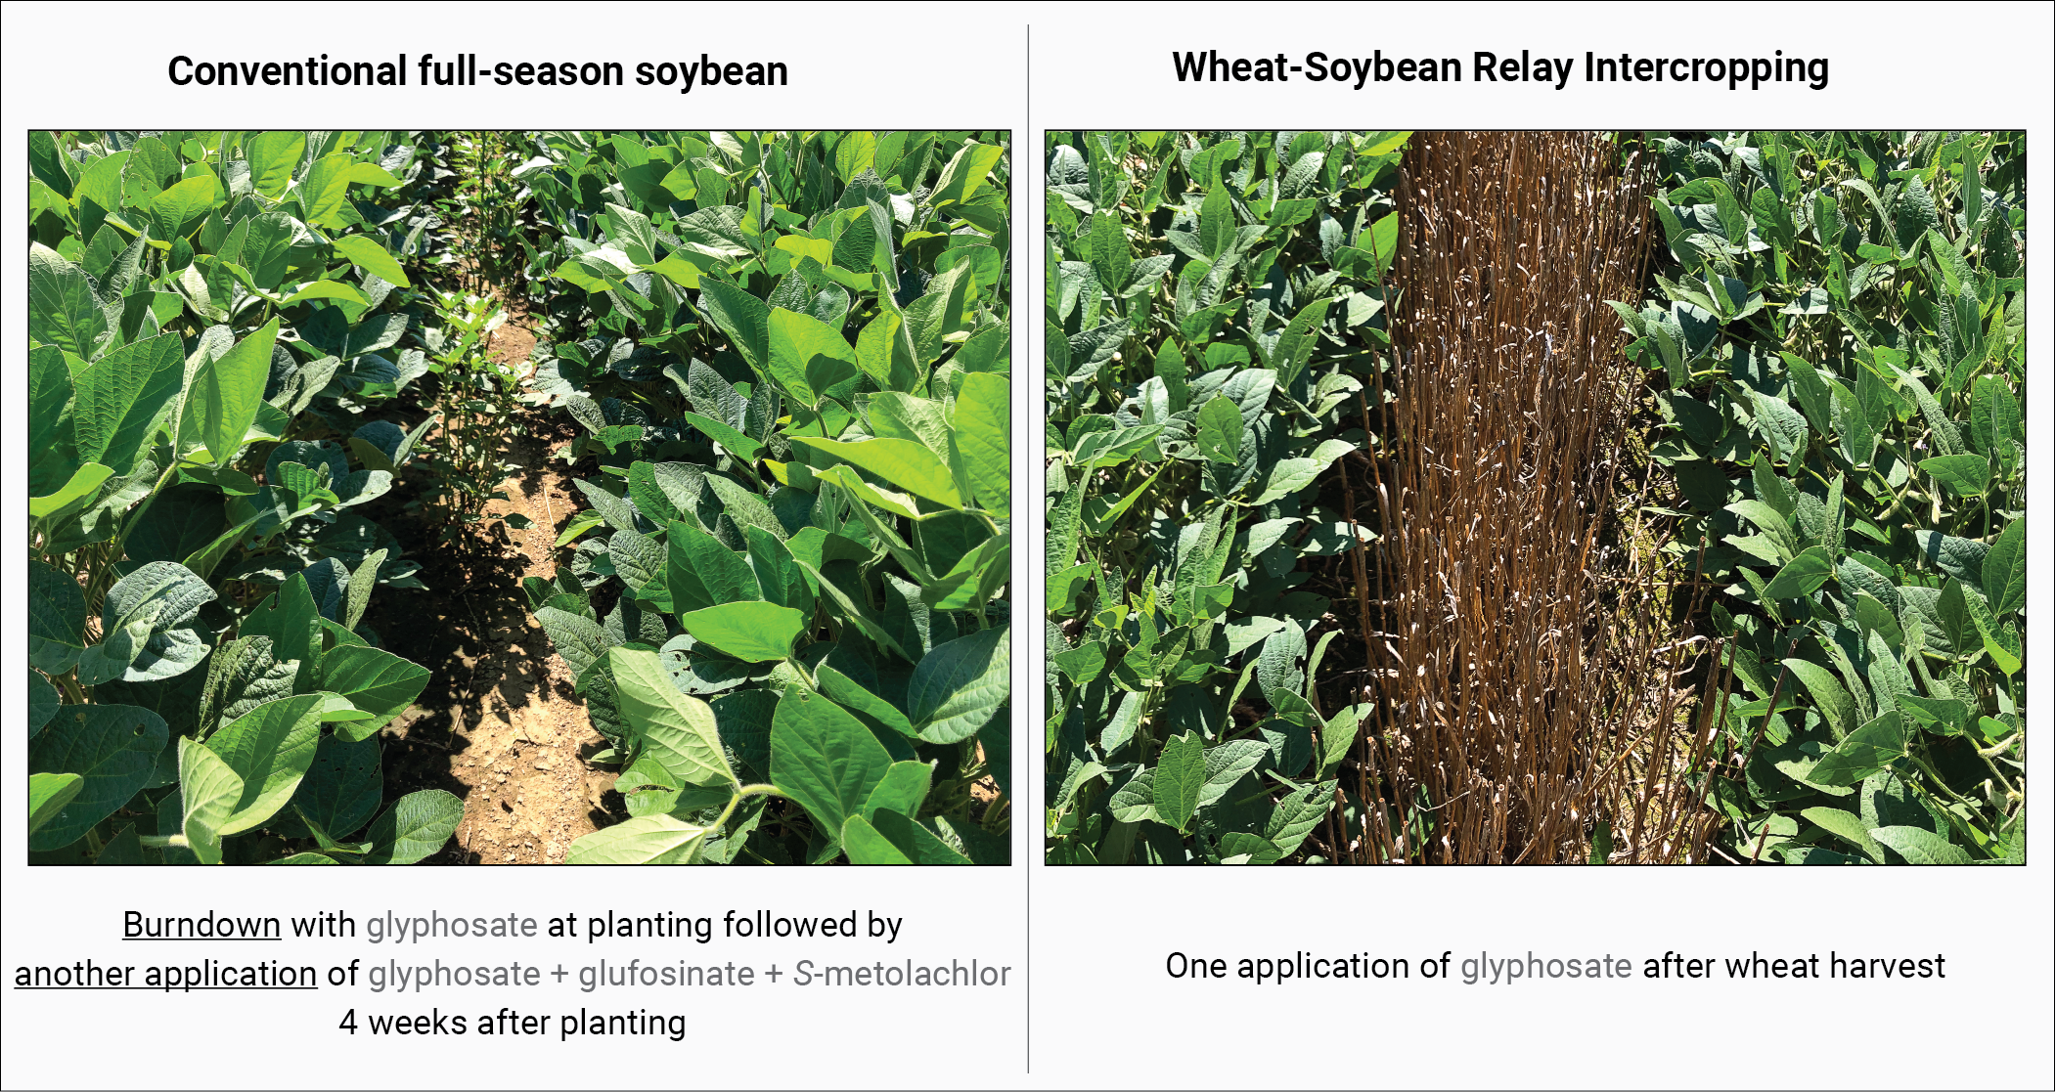

**Figure 1.** Comparison of Palmer amaranth control in conventional full-season soybean (left panel) versus wheat-soybean intercropping (right panel) following different herbicide applications. The images show the level of Palmer amaranth suppression achieved with each approach. Preliminary results from this particular study and other ongoing complementary research suggest that wheat-soybean intercropping can provide effective weed control with reduced reliance on herbicides and thus, mitigating the risk of rapid resistance development.

Various formal surveys from academic institutions from the region as well as PI’s direct interactions with the wide range of stakeholders over numerous professional occasions also converse to growing concerns over managing herbicide-resistant weeds in the region. Continuous exploration of opportunities around relay intercropping is thus an imperative opportunity which has the potential to impact multifaceted components of Midsouthern agriculture including effective weed management, enhanced economics, and preserved environment, all of which are often recognized as stakeholder-identified priorities in the region.

**OBJECTIVE(S):**

**Objective #1.** Determine the weed management outcome and the overall production economics of wheat-soybean relay intercropping in the Midsouth.

**Objective #2.** Conduct outreach activities to promote stakeholder awareness of relay intercropping as a sustainable weed management tool.

**APPROACH AND EXPERIMENT CONDUCT:**

**Field research (Objective #1):** The research protocol will involve a replicated experimental design conducted at multiple field locations in Arkansas. The study will compare the effectiveness of relay intercropped, full-season, and double-cropped soybean under various herbicide regimes in suppressing key weeds, including Palmer amaranth, as well as in terms of production economics and overall system profitability. Key biological metrics such as weed emergence patterns, weed density, weed seed recruitment, and crop yield and the relevant econometrics will be evaluated. For intercropped soybean plots, soybean will be planted in standing wheat, while for double-cropped soybean plots, soybean will be planted after wheat harvest. In-season assessments will be conducted on a weekly or biweekly basis from planting until the end of September and soybean will be harvested at maturity.

**Dissemination of the results (Objective #2):** The outreach of the research data and its implications will involve multiple efforts; presentations at growers’ meeting at multiple locations and at Southern Weed Science Society annual meeting, and creation of online resources. The presentation at the meetings and the online resources (text and video) will encompass:

* A brief historical context of weed management in the Midsouthern region.
* State of the current herbicide technology and future perspectives.
* Urgency of multidimensional approach to sustainable weed management.
* Relay intercropping as a practical as well as effective tool for weed management in the region as backed up by the research data.

Longer term research and outreach efforts, beyond this grant, will fully explore the opportunities around the relay intercropping through multidisciplinary efforts.

**PROJECTED IMPACT OF RESULTS ON MID-SOUTH SOYBEAN PRODUCTION**

The proposed research and outreach project represents a vital continuation of efforts to evaluate and promote wheat-soybean relay intercropping as an effective production practice for integrated weed management and overall enhancement of cropping systems in the Midsouthern region. This project aims to achieve the broader objective of increasing general awareness and understanding of non-chemical weed management tactics among crop growers and stakeholders. Specifically, it has the potential to deliver an effective management tool for addressing the current and future challenges posed by herbicide-resistant weeds. As such, the current project is specifically designed to develop and foster a culture of integrated weed management in the region. In addition to its primary goal, the project will also serve as a catalyst for further exploration of the far-reaching benefits of relay intercropping, such as improved soil health, reduced crop diseases, and increased crop productivity. Thus, this initiative will stimulate future research and extension efforts to promote relay intercropping in the region and to address the challenges and opportunities for region-wide adoption of this system in terms of agronomic, economic, and environmental aspects. The central premise of this initiative is to develop and showcase an effective relay intercropping practice that expands Midsouthern crop growers’ crop production options, allowing them to reduce the selection pressure of herbicides on weed populations while simultaneously enhancing the resilience and profitability of their production systems.

**EXPECTED END PRODUCT(S)**

The results and impact of this research project will be effectively communicated through a variety of end products, including PowerPoint and poster presentations. Additionally, we will produce engaging and informative multimedia content, including videos, pictures, and text, to provide a comprehensive overview of the project’s findings. By making these materials publicly available, we aim to ensure that our results are easily accessible to crop growers, stakeholders, and other researchers. Our goal is to provide a visually engaging and informative representation of our research, while also offering additional context and details through various media formats.

**LIERATURE CITED**

Heap, I. 2023. The International Survey of Herbicide Resistant Weeds. Online resource available online at http://www.weedscience.org (accessed: 03 August 2023).

Landau, C.A, A.G. Hager, and M.M. Williams. 2022. Deteriorating weed control and variable weather portends greater soybean yield losses in the future. Science of The Total Environment. 830:154764.

Lu, C., Z. Yu, D.A. Hennessy, H. Feng, H. Tian and D. Hui. 2022. Emerging weed resistance increases tillage intensity and greenhouse gas emissions in the US corn-soybean cropping system. Nature Food 3:266-274.

Osipitan, A.O., J.A. Dille, Y. Assefa, E. Radicetti, A. Ayeni, and S.Z. Knezevic. 2019. Impact of cover crop management on level of weed suppression: A Meta-analysis. Crop Science 59: 833-842.

Tanveer, M., S.A. Anjum, S. Hussain, A. Cerdà, and U. Ashraf. 2017. Relay cropping as a sustainable approach: Problems and opportunities for sustainable crop production. Environmental Science and Pollution Research 24:6973-6988.