Please use this form to clearly and concisely report on project progress. The information included should reflect quantifiable results that can be used to evaluate and measure project success. Comments should be limited to the designated boxes. Technical reports, no longer than 4 pages, may be attached to this summary report.

Project Number:
Project Title: | Screening and Selecting Non-Xtend Soybeans for Dicamba Tolerance
Organization: | University of Missouri
Principal Investigator Name: | Dr. Grover Shannon
Other investigators: | Caio Canella Vieira
Report Period: | September 16 to December 15, 2022
OBJECTIVE 1: Genomic studies to identify significant marker-trait associations
- Dicamba QTL mapping:
Two mapping populations derived from a dicamba tolerant PI and a susceptible breeding line for dicamba were visually phenotyped for dicamba tolerance around R3 stages. The data will be used to mat the region involved in dicamba tolerance. This experiment will be repeated in 2023 for confirmation. With the
- Genome wide association study for Dicamba (GWAS):
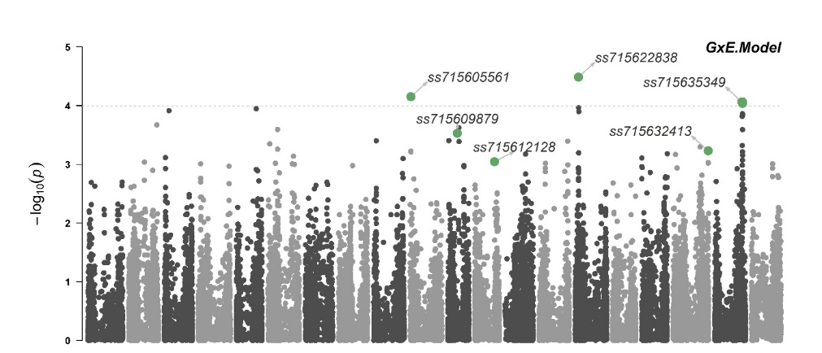
We identified genomic regions associated with dicamba tolerance using a panel of over 380 PIs genotyped and the Soy50K SNP chip from Soybase. We detected two genomic regions harboring a multidrug resistance gene and a glycosyl-transferase gene, both associated with plant detoxification from herbicides were (Figure 1). These results were published in Frontiers in Plant Science on December 09, 2022.
Figure 1: Manhattan plot highlighting significant marker-trait associations using the model that allows the inclusion of the population structure in interaction with environments (G×E)

OBJECTIVE 2: Identification and selection of high-yielding tolerant advanced lines

- Advanced yield trials: Off-target dicamba exposure has been more severe than in previous years, which could have been attributed to a late planting due to excessive rain (concentration of applications around mid-May to early-June) and nearly 60 days of intense drought. A total of 260 advanced breeding lines in our 2022 advanced yield trials (AYT) were grown in Portageville, MO (3 environments) and across different locations in AR, IL, LA, MS, MO, TN, and VA (6-8 environments). The breeding lines were phenotypically screened for dicamba tolerance around R3 stages. Based on dicamba tolerance as well as satisfactory multi-environment yield performance, the best performing lines will be put in our regional Uniform tests in 2023.
- Breeding populations advancements: About 1,000 F_{4:5} single plant progeny lines were grown in single rows in the progeny testing nursery in 2022 season. A total 63 promising high-yield potential lines and potentially dicamba tolerant from six crosses were selected and harvested in bulk for further evaluation. These lines will be yield-tested and rated for dicamba tolerance during the 2023 season.
- New Crosses in 2022 season: A total of seven new crosses between dicamba tolerant and elite breeding lines have been made to make with a view to develop new high-yielding and dicamba tolerant varieties. The F₁ seeds were sent in off-season nurseries in Puerto Rico and Costa Rica for generation advancement from the F₁ to the F₄ and will return to be planted in F_{4:5} progeny rows in 2024.

SUMMARY AND HIGHLIGHT:

- Published paper: Canella Vieira, C., Jarquin, D., Ferrari do Nascimento, E., Lee, D., Zhou, J., Smothers, S., ... & Nguyen, H. T. Identification of Genomic Regions Associated with Soybean Responses to Off-target Dicamba Exposure. Frontiers in Plant Science, 5101.
- Mapping populations derived from tolerant PIs are showing excellent differentiation to dicamba.
- High-yielding breeding lines with higher tolerance are being advanced throughout the pipeline.

