Project Title | Screening soybean germplasm and breeding soybeans for flood tolerance
PI’s Name | Pengyin Chen |  | E-mail |  | chenpe@missouri.edu
PI’s Title | Professor |  | Institution: |  | University of Missouri-Fisher Delta Research Center
Mailing Address | 147 W State Highway T,
City/State/Zip | Portageville, MO 63873
Phone number | 573-379-4030 ext. 230
Additional PIs  For this project | Leandro Mozzoni, University of Arkansas; Blair Buckley, Louisiana State University;  David Moseley, Louisiana State University; Daryl Chastain, Mississippi State University;  Tessie Wilkerson, Mississippi State University
Research locations (and states) | Portageville, Missouri; Stuttgart and Rohwer, Arkansas; Stoneville, Mississippi State University; Alexandria and Bossier City, Louisiana.
Timeline:  Current Year - FY22 |  |  |  | Multi-Year Project Information (if applicable)
 |  |  |  | Year 1 |  | Year 2 | Year 3
Start Date |  | March 1, 2022
End Date |  | Feb. 28, 2023
Funds Requested |  | $160,000 |  | $ |  | $ | $
Program Area (e.g., breeding, mngt.):Breeding
Objectives | 1. Screening soybean germplasm and commercial cultivars for flooding tolerance.  2. Incorporation of flood tolerance into elite cultivars and lines.
Justification | Flooding causes a big yield reduction to the US soybean. To support sustainable soybean production, the project aims to identify flooding-tolerant genetic resources and use them to develop high yielding flooding-tolerant cultivars.
Exp Setup | 1. Screening of soybean germplasm: New MO and AR breeding lines/cultivars, commercial cultivars and exotic PIs will be subjected to flooding stress for 7-10 days during R1/R2 stage to identify flood tolerant germplasm. The tolerant germplasm lines will be yield-tested (in flooded and non-flooded field).  2. Incorporation of flood tolerance to elite soybean lines/cultivars: Crossing between highly flood tolerant and elite high-yielding soybean lines/cultivars, selection of high-yield potential breeding lines and evaluation of flooding tolerance and yield under flooded and non-flooded condition in locations across 4 states (MO, AR, MS and LA).
Summary | The proposed research aims to identify flood-tolerant genetic resources to accelerate development of high-yielding flood-tolerant soybeans to combat yield reduction from water-logging conditions. The research strategies include screening of state commercial varieties, advanced breeding lines and exotic soybeans, and incorporate the tolerance into elite high-yielding soybean lines.
Key Metrics | I. Identification of advanced breeding lines with high yield and flooding tolerance with potential for release, 2. Identification of new highly flood tolerant breeding lines, commercial varieties and exotic soybeans as genetic resources.
Expected Deliverables | Identified new flooding tolerance genetic resources to incorporate into elite lines/cultivars, recommendation of flood tolerant varieties to producers, and enhanced genetic diversity on flooding tolerance in mid-south US cultivars.
Benefit to midsouth farmers | In mid-south soybean growing areas, yield losses up to 50% due to waterlogging are common because of clay soils, poor surface and internal drainage, and occasional high rainfall. Presently, there is no flood tolerant cultivar growing in this area. Using a flood tolerant variety to maintain a good yield under stress is most desirable.
Progress Made | 1. Seven new MO lines and 3 new AR lines, 6 MO commercial varieties, and 10 exotic soybeans exhibited strong flood tolerance response in 2020 test.  2. Four UM developed MG-4/5 lines yielded from 18.0 to 16.0 b/a while the commercial checks yielded from 5.0 to 2.0 b/a under severe flooding stress in 2020 tests. Three UA developed high-yielding lines showed high flood tolerance.  3. Sixty-one MO breeding lines derived from crosses involving flood tolerant and elite parents are in yield test in flooded and non-flooded field in 2021 season.  4. About 900 MO breeding lines are currently in progeny testing nursery for selection while breeding populations from 7 new crosses are under generation advance (F₂-F₄). A number of AR breeding populations are being grown for progeny testing.
Signature of Principle Investigator |  |  |  |  | Date:
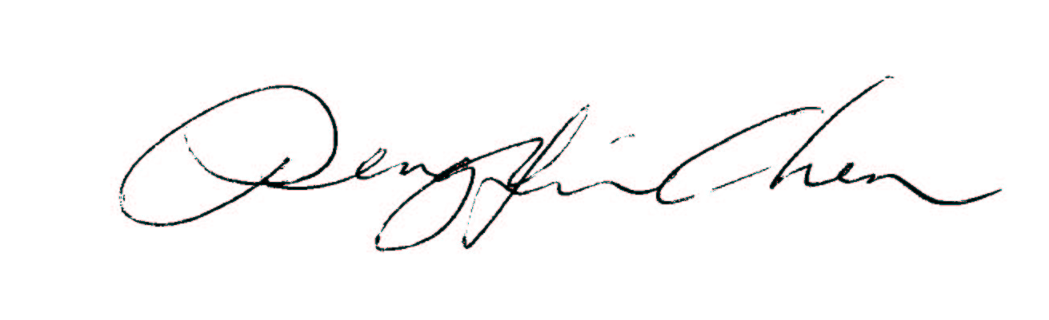 |  |  |  |  | 8-3-2021

