Please use this form to clearly and concisely report on project progress. The information included should reflect quantifiable results that can be used to evaluate and measure project success. Comments should be limited to the designated boxes. Technical reports, no longer than 4 pages, may be attached to this summary report.
Project Title: | Development of climate-smart high-yield practices associated with high-end biological treatments and soybean-related microbiome resiliency
Organization: | University of Texas-Arlington
Principal Investigator Name: | Woo-Suk Chang
Report Period: | 6/16/2024 – 9/15/2024

Project Status:
Since June 15th, we have made significant progress in our field trial, as outlined in Table 1. Soybeans were planted using conventional tillage and no-till methods across five states (AR, LA, MO, MS, and TX). Additionally, the soybeans were treated with the TXVA strain (drought-tolerant inoculant), TagTeam (a commercial inoculant), or no inoculant (control) in both conventional and no-tilled fields.

Approximately six to eight weeks after planting, we conducted plant sampling, including root nodules, whole soybean plants to assess nodulation, biomass and height. The results of the nodulation and biomass analyses are presented in Figures 1, 2, 3, and 4 for the fields in Port Lavaca, TX; Winnsboro, LA; Portageville, MO; and Colt, AR, respectively. Unfortunately, we were unable to compare all parameters between the conventional and no-till fields in Leland, MS due to unsuccessful no-till cultivation.

Table 1. Summary of 2024 field work.
Location | Collaborators | Planting Date | Mid-Harvest Sampling | Harvest Date | Cultivars Used | MG
Port Lavaca, TX | Dr. James Grichar | 3/28 | 5/21 | 8/26 | Lynda-GT, Pamela-GT | Indt, Indt
Winnsboro, LA | Dr. Trey Price | 5/16 | 7/11 | TBD | Ellis | 4L
Portageville, MO | Dr. Feng Lin | 5/30 | 7/12 | TBD | Ellis | 4L
Colt, AR | Dr. Shawn Clark | 6/13 | 8/1 | TBD | Ellis, S11-2024C* | 4L, 5
Leland, MS | Dr. Tessie Wilkerson | 6/14 | 8/2 | TBD | P49Z02E | 4.9
* drought-toletant cultivar
TBD: to be determined

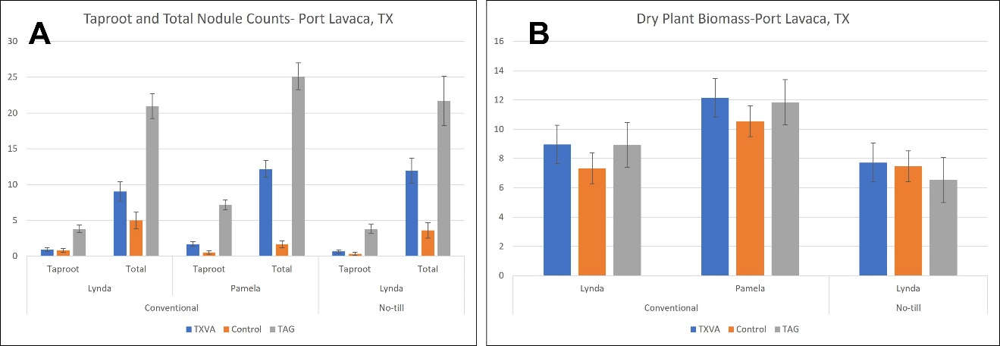

Figure 1. Nodule counts (A) and plant biomass (g) (B) in conventionally tilled vs. no-till soybean fields in Port Lavaca, TX. Two cultivars, Lynda-GT and Pamela-GT, were planted with three treatments: TXVA (a drought-tolerant inoculant), TAG (a commercial inoculant), and a Control (no inoculant).

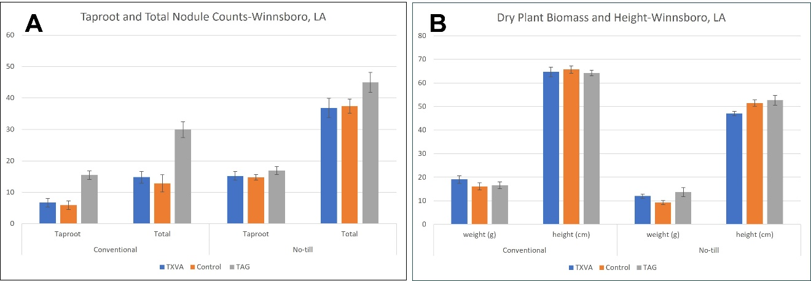
Figure 2. Nodule counts (A) and plant biomass (g) and height (cm) (B) in conventionally tilled vs. no-till soybean fields in Winnsboro, LA. The Ellis cultivar was planted with three treatments: TXVA (a drought-tolerant inoculant), TAG (a commercial inoculant), and a Control (no inoculant).

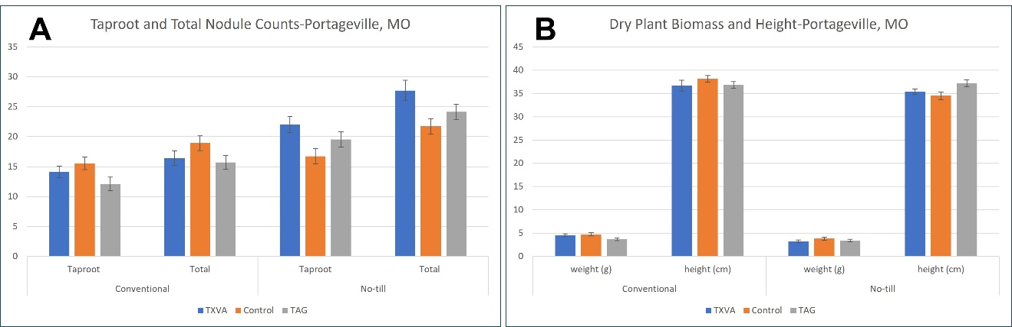
Figure 3. Nodule counts (A) and plant biomass (g) and height (cm) (B) in conventionally tilled vs. no-till soybean fields in Portageville, MO. The Ellis cultivar was planted with three treatments: TXVA (a drought-tolerant inoculant), TAG (a commercial inoculant), and a Control (no inoculant).

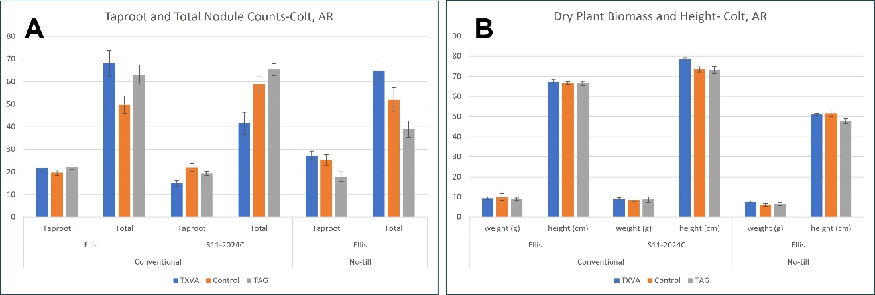
Figure 4. Nodule counts (A) and plant biomass (g) and height (cm) (B) in conventionally tilled vs. no-till soybean fields in Colt, AR. Two cultivars, Ellis and S11-2024C (drought-tolerant cultivar), were planted with three treatments: TXVA (a drought-tolerant inoculant), TAG (a commercial inoculant), and a Control (no inoculant).

In addition to the field trials described above, we are trying to find high-yield vs. low-yield soybean fields in the Mid-South to analyze soil microbiomes. Through this analysis, we aim to assess alpha and beta diversity and reveal co-occurrence networks associated with high-yield soybeans. Most importantly, we hope to identify key microorganisms and microbial communities that contribute to high soybean yields in the Mid-South.

