Please use this form to clearly and concisely report on project progress. The information included should reflect quantifiable results that can be used to evaluate and measure project success. Comments should be limited to the designated boxes. Technical reports, no longer than 4 pages, may be attached to this summary report.
Project Title: | Novel new functional edible protein films from soybean using innovative 3D printing technology
Organization: | Department of Food Science, Department of Biological and Agricultural Engineering, University of Arkansas Division of Agriculture
Principal Investigator Name: | Dr. Ali Ubeyitogullari
Report Period: | Final Report
Project Status: Completed (Year 2 of 2)
Objectives for the project:
1. Prepare soy protein isolate and hydrolysates from soybean seeds grown in Mid-South (lines R16-5065 from Arkansas and S17-17168 from Missouri).
2. Optimize conditions and prepare homogeneous film solutions with soy protein isolate, glycerol, malic acid and natural phenolic extract (antioxidant), and investigate flow properties.
3. Optimize conditions and extrude soy protein film using 3D printing technology, investigate the physical properties of the extruded films for color, tensile strength, and antioxidant activity of the extruded film.

Contents
NON-TECHNICAL PROJECT ABSTRACT 2
PEER-REVIEWED PUBLICATIONS RESULTED FROM THIS PROJECT 3
1. MATERIALS AND METHODS FOR OBJECTIVES 1 AND 2 3
2. RESULTS AND DISCUSSION FOR OBJECTIVES 1 AND 2 8
3. MATERIALS AND METHODS FOR OBJECTIVE 3 17
4. RESULTS AND DISCUSSION FOR OBJECTIVE 3 22
5. OVERALL CONCLUSIONS 39

NON-TECHNICAL PROJECT ABSTRACT
The project titled “Novel new functional edible protein films from soybean using innovative 3D printing technology” was completed following the proposed timeline. In this project, soybeans from mid-south USA: AR-R11-7999, MO-S17-19874R, and MO-S17-17168 were successfully used to extract proteins and generate edible films using a novel approach based on 3D printing. The physical properties such as thickness, color, tensile and puncture strength, water activity, density, and elongation at break were quantified for the extruded film. The 3D printing process was optimized using macro- and micro-scale printers with different resolutions. In addition, soy proteins along with 0, 1, 3, and 5% (w/w) of grape seed extract (GS) and green tea extract (GT) as natural antioxidants were used to develop edible active packaging materials using 3D printing technology. The effects of nozzle size (0.10, 0.25, and 0.33 mm) and pressure (0.020, 0.035, 0.048, and 0.062 MPa) on the 3D printing of the films were investigated. Compared to GT-loaded films, which showed a proper degree of shape preservation, the incorporation of 3 or 5% GS resulted in the deformation of the films during 3D printing. Soy protein edible films loaded with 1-3% (w/w) GS or GT were 3D-printed with high accuracy (>98%) at a printing pressure of 0.062 MPa and nozzle diameter of 0.25 mm. When higher concentrations (5%, w/w) of GS or GT were added, the 3D-printed films became thicker and less transparent. The tensile strength of the films was increased by the incorporation of extracts. The tensile strength of the GS-loaded films was higher than that of the GT-loaded films. Moreover, the addition of GS and GT reduced the water vapor permeability (WVP) of SPI by 61% and 56%, respectively. Overall, the proposed 3D printing approach can provide flexibility in generating edible films in different geometries and properties for on-line packaging applications. This newly produced environment-friendly soy protein-based edible films can serve as an alternate packaging to synthetic plastics and reduce the environmental landfill problem, has the potential of sharing the market with the plastic packaging industry and benefit the growers by fetching a higher price for value addition to promote soybean production at mid-south part of the USA.

PEER-REVIEWED PUBLICATIONS RESULTED FROM THIS PROJECT
- Ahmadzadeh, S., Hettiarachchy, N., Luthra, K., Chen, J., Seo, H.-S., Atungulu, G.G., & Ubeyitogullari, A.* (2023). Effects of polyphenol-rich grape seed and green tea extracts on the physicochemical properties of 3D-printed edible soy protein films, Food Packaging and Shelf Life, 40, 101184.
- Dey, S., Hettiarachchy, N., Bisly, A. A., Luthra, K., Atungulu, G. G., Ubeyitogullari, A.*, & Mozzoni, L. A. (2022). Physical and textural properties of functional edible protein films from soybean using an innovative 3D printing technology. Journal of Food Science, 87(11), 4808-4819.
*Corresponding author

1. MATERIALS AND METHODS FOR OBJECTIVES 1 AND 2
1.1 Materials
A total of three lots of soybean grown in mid-south (line AR-R11-7999 from Arkansas; MO-S17-19874R and MO-S17-17168 from Missouri) (Figure 1) were provided by Drs. Mozzoni and Chen from the Crop, Soil and Environmental Sciences, University of Arkansas, Fayetteville, AR and Fisher Delta Research Center, University of Missouri, Portageville, MO, respectively. Analytical grade glycerol was purchased from Fisher Scientific (Hampton, USA). Kjeldahl tablet catalysts used in this study were purchased from EMD Milipore (Billerica, USA). All standard chemicals used in this study were reagent grade and used as purchased.

Figure 1: Soybean lots used for isolation of protein.

1.2 Preparation of defatted soybean meal
The procedure reported by Sivarooban et al. was used to prepare the soybean meal (Sivarooban et al., 2008). In short, soybean seeds (Figure 1) were ground to a coarse powder using a pulverizer (Fritsch GmbH, Germany), further ground to a fine flour using a Vitamix grinder (Cleveland, USA), passed through a 60-mesh sieve to obtain uniform particle size, and suspended in n-hexane (1:2, w/v), stirred for 3h at ambient conditions to remove the oil. The suspension was filtered under vacuum, defatted again to remove the last traces of oil, filtered under vacuum and the residue was dried overnight under a hood (Fisher Hamilton, USA), and stored at 5 °C in an airtight container.
1.3 Preparation of soy protein isolate
The procedure reported by Sivarooban et al. was used to isolate the protein from the soybean meal (Sivarooban et al., 2008). In short, defatted soybean meal (60 mesh) was suspended in DI water (1:9, w/v) in a beaker. The pH of the mixture was adjusted to 9.5 using 3N NaOH solution and stirred for 3h to release the proteins in the soy meal, while maintaining the pH at 9.5. The resulting suspension was centrifuged at 3000xg for 15 minutes to remove fibers and other insoluble materials. This insoluble residue was re-extracted to solubilize the remaining proteins. The soluble supernatant containing the proteins was adjusted to 4.5 (isoelectric pH) to precipitate the protein. The precipitated proteins were stored at refrigerated temperatures overnight to facilitate further precipitation and centrifuged at 7000xg for 75 minutes at 5 °C. The residue containing the protein was washed with acidified water at pH 4.5 and suspended in distilled water (pH 7.0) before freeze drying to obtain the protein isolate. The soy protein isolates were combined and stored at 5 °C in an airtight container.
1.4 Protein content determination
Protein contents of soybean lots AR-R11-7999, MO-S17-17168, and MO-S17-19874R (on the dry weight basis) were determined by modified Kjeldahl’s method (AOAC 1997) in triplicate (Sivarooban et al., 2008). The protein percentage was calculated with a conversion factor of 6.25 for nitrogen. The moisture percentage of the flour was calculated based on the AACC official method (2000). The moisture percentage was used to calculate the protein content by dry weight for all the samples (Sivarooban et al., 2008).
$\% Nitrogen=\frac{Vol (HCl)X N\left(HCl\right)X14.007}{Sample weight (g)}X100$Eq. (1)

1.5 Preparation of 3-D printed edible films for statistical optimization
Solution preparation: Soy protein Isolate (5.72, 11.45, 17.182 g to account for 5, 10, and 15% soy protein) and de-ionized water (DI water, 95, 90, 85 g) were homogeneously mixed in a glass container for 15 minutes. The pH of the solution was adjusted to 8.5 with NaOH. The pH was re-adjusted if needed to ensure solubility. Resulting opaque yellowish to white solution was sonicated (Probe sonicator, Branson Ultrasonics, USA) for 20 minutes (duty cycle: 70%, output control: 9, frequency: 20 kHz, output power: 495 W) in ice to prevent overheating. To this solution, 2, 3.5, and 4 g of glycerol (2, 3.5, and 4% w/w) was added as a plasticizer and incubated for 30 minutes in a water bath at 85 °C. This heating step facilitated protein denaturation exposing more functional groups that can influence the protein inter-chain interactions. The yellowish transparent protein solution was cooled to ambient temperature and used for 3D printing. The prepared edible film solution was loaded into a stainless-steel capsule (volume of each capsule = 100 ml / 3.38 oz, fitted with a 4.0 mm nozzle) avoiding any air-bubble. The stainless-steel capsule was placed in the bay for printing.
Measurement of pH and density of the film-making solution:
pH measurement: Metler Toledo (Columbus, OH) S20 SevenEasy pH meter was used for the measurement of pH at 25 °C.
Density measurement: A premium vials (Tullytown, PA) calibrated 25 mL Pycnometer was used for the measurement of density at 25 °C.
3D printing of film: The film-making solutions were cast onto 19X28 cm mylar plastic sheets coated with silicone (Richard Mistler, Inc., USA) using a 3D printer (Natural machines, Spain). A clip-art available in the printer’s graphic user interface was used to create the shapes for the films to be printed. The printing parameters set on the 3D printer were as follows: nozzle size: 4.0 mm, print speed 2200 mm/minute, ingredient flow speed: 0.5, fill factor: 1, first ingredient hold: 4.2 mm, first layer nozzle height: 1.4 mm, ingredient hold 3 mm, minimum ingredient distance: 10 mm, pre-heat time: 0 seconds, line thickness: 3 mm, turning speed factor: 1, distance between layers: 1.4 mm, first ingredient flow: 5.9 mm, jump height: 10, pre-Heat temp: 0 °C, ingredient flow temp: 0 °C. the film was dried for 3, 4, and 5 h in a controlled humidity chamber (Hot Pack, USA) at 50°C and 45% RH. The dried films were then peeled and placed between wax-paper sheets and into a 25°C, 50% RH desiccator using NaBr-saturated solution (Sanplatec Corp., Japan) as humidity fixed points of binary saturated aqueous solutions for storage until testing of physical properties.
Similar preparative procedure was used to print the soy protein films for the verification of the RSM model using the final optimized condition. Amount of soy protein isolates used were calculated according to their protein content.
1.6 Experimental design, and optimization of the soy-protein film preparation conditions by RSM
The conditions for the 3D printing of edible films were optimized following the central composite design (CCD) using JMP Pro 16 software (JMP Statistical Discovery LLC, USA). A response surface was generated as a result, and the ideal value combinations for different parameters were determined. Protein concentration (%, X₁), plasticizer percentage (%, X₂), and drying time (h, X₃) were used as independent variables in the CCD. The influence of the independent variables on thickness of the 3D printed film (mm), tensile strength (MPa), and puncture strength (N) of the edible films were determined. Each of the three independent variables were evaluated at three levels (­1, 0, +1) with three replicates at the central point. Based on preliminary investigations, the range of the independent variables: protein concentration (%, X₁), plasticizer percentage (%, X₂), and drying time (h, X₃) were set as: 5-15%, 3–4%, and 3-5h, respectively (Das & Dewanjee, 2018). A total of 17 experiments (Table 1) were performed in triplicate. The outcomes were used to fit the following polynomial equation using regression analysis. Table 2 summarizes the effect summary, summary of fit and the analysis of variance from the CCD.
$$Y=A_{0}+\sum_{t=1}^{k}{A_{i}}x_{i}+\sum_{t=1}^{k}{A_{ii}}x_{i}^{2}+\sum_{i=1}^{k}{.}\sum_{j=1}^{k}{{A_{ij}x_{i}x}_{j}} Eq. (2)$$
Where, Y is the expected response value, x_{i} is the independent variable, A₀ is the independent variable linear parameter, A_{ii} is the secondary parameter of the independent variable, and A_{ij} is the interaction relation parameter between independent variables.
The optimum value for each factor toward the 3D-printed edible film with lowest thickness and highest tensile and puncture strength was obtained based on the solution determined by the optimization in the statistical analysis software.
1.7 Measurement of the thickness of films
The 3D-printed edible films were randomly peeled from three different locations of the mylar plastic sheets. The three values of thickness were measured for the sample films, averaged to determine the thickness of each film. These measurements were made to the nearest 2.5 μm using a micrometer (Model 2804-10, Mitutoyo, Japan) (Sivarooban et al., 2008).
1.8 Measurement of color attributes of the edible films
The procedure reported by Sivarooban et al. (2008) was used to determine the color of the edible film (Sivarooban et al., 2008). A Minolta CR-300 Chroma meter (Minolta Co., Ltd, Osaka, Japan) was used to analyze the color of the edible films. The color parameters: lightness/darkness (L*), greenness/redness (a*) and blueness/yellowness (b*) were measured. The L*, a*, b* color consists of a luminance or lightness component (L*) and two chromatic components: the (a*) component (from green to red) and the (b*) component (from blue to yellow) (CIELAB, 1976). The lightness component L* can range from 0 to 100, the a* component (green–red axis) and the b* component (blue–yellow axis) can range from +128 to -128 (Westland, 2012).
Brownness index (BI) was calculated according to the following equations (Shittu et al., 2007):
$BI=100×(x-0.31)∕0.17$ Eq. (3)
X= ((a*+1.75$×$L*))/((5.645L*+a*$-$3.012b*)) Eq. (4)
The films were allowed to reach room temperature at 50% RH for 48 h prior to color determination. The colorimeter was calibrated and the color for the film pieces (3 cm X 3 cm) determined in triplicate using a standard white plate as background (L = 97.10, a = +0.13, b = +1.88, c = 1.88 and h_{o} = 86.1).
1.9 Measurement of puncture and tensile strength and elongation at break
The puncture and the tensile strengths were quantified for the 3D-printed edible soy protein films to measure its ability to hold up under various stresses when used on the food product using a texture analyzer (TA-XT Plus, Texture Technologies Corp., Scarsdale NY). The film samples were allowed to reach room temperature and a RH of 50% for 48 h before the testing (Sivarooban et al., 2008).
Tensile strength and elongation at break measurement conditions:
Edible film strips in the dimension of exactly 40 mmX 15 mm were placed into the film extension grips of the texture analyzer. They were stretched 20 mm apart at a speed of 2 mm/s by the texture analyzer. The tensile strength (in MPa) was calculated by dividing the peak load given by the cross-sectional area of the film. Peak loads and extension at break were recorded. Percentage elongation at break values were determined by dividing with the initial grip separation followed by multiplying with 100.
Puncture strength testing conditions:
A 30-mm piece of film was placed on a 10-mm film-testing rig (TA- 108 S Mini) and punctured with a 2-mm probe (TA-52) with puncture speed of 100 mm/min. The puncture strength of the film (given as a force in Newtons) was measured at the point when the probe pierced the film.
1.10 Water activity of the 3D-printed edible films
Aqualab (Pullman, WA) water activity meter 4 TE was used for the determination of water activity of the 3D printed edible films. A 3cmX3cm portion of the edible film was placed in the water activity meter at 25 °C. The water activity values are determined as the average of the triplicate experiments.

2. RESULTS AND DISCUSSION FOR OBJECTIVES 1 AND 2
2.1 Response surface methodology
The range of values for the three independent factors (soy protein concentration (%, X1), plasticizer concentration (%, X2), and drying time (h, X3)) for the 3D printing of the edible soy-protein films were chosen based on the single-factorial experiments (Table 1). The value for Tensile strength, Puncture strength and the thickness was predicted from the second-order polynomial equations 5,6, and 7 below. The responses represented are thickness, tensile strength, and puncture strength, respectively. The independent variables X₁, X₂, and X₃ are the independent variables for soy protein concentration, plasticizer concentration, and drying time, respectively. The terms X₁₂, X₂₂, X₃₂, X₁X₂, X₂, X₂X₃ included in the regression model represents the cross-interaction between the independent variables.
CCD was used to determine the optimal values for the three independent factors for the 3D printing of edible soy protein films. The CCD, experimental results and the predicted results determined using the regression model (Figure 2, Figure 3). RSM was used to maximize the tensile and puncture strength and minimize the thickness of the 3D printed edible soy protein films (Figure 2).
The experimental thickness, tensile, and puncture values for the samples in CCD ranged from 0.056-0.232 mm, 1.55-12.18 MPa, and 1.05-11.85 N, respectively. The predicted values of the tensile strength, puncture strength and the thickness of the 3D printed edible from the CCD ranged from 0.054-0.225 mm, 1.06-10.67 MPa, and 1.29-9.79 N, respectively.
Thickness response: The thickness values of the film were predicted using the quadratic equation: 0.1401 + 0.0627 X₁ + 0.0150 X₂ – 0.0040 X₃– 0.0088 X₁X₂ – 0.0046 X₁X₃ - 0.0079 X₂ X₃ + 0.0048 X₁² + 0.0032 X₂² – 0.0002 X₃² Eq. (5)
The thickness of the edible film increased in a continuous fashion with the variation of X₁, X₂ and X₃) (Figure 2, Figure 3). The thickness of the 3D printed edible films increased in a significantly higher rate with protein concentration (slope: 0.0627, P<0.0001) than plasticizer percentage and drying time (slope: 0.0150 and 0.0040, respectively; P<0.0001).
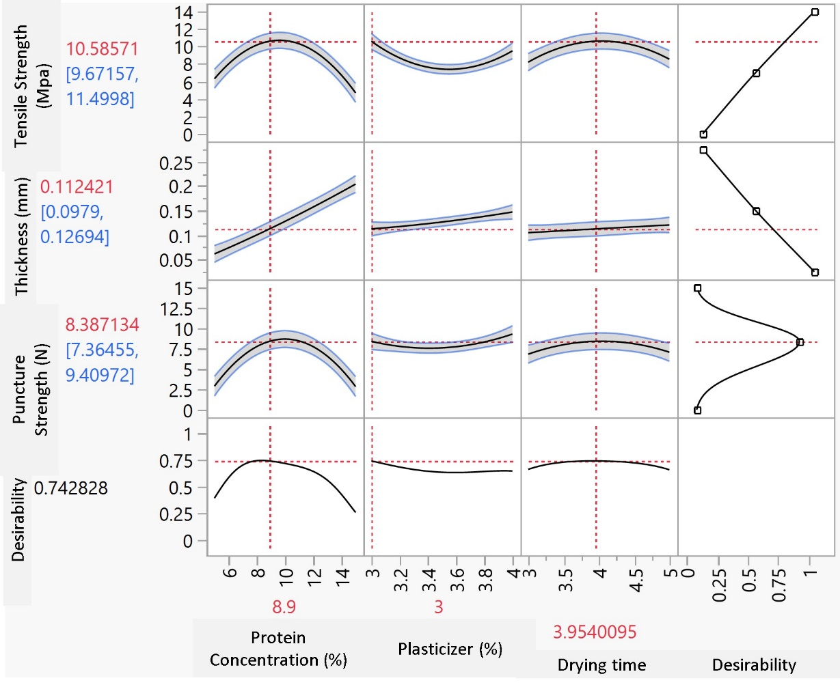
Figure 2: The prediction profiler showing the optimized conditions at the maximum desirability of the 3D printed edible films. Data had been generated using the software, JMP Pro. 16.

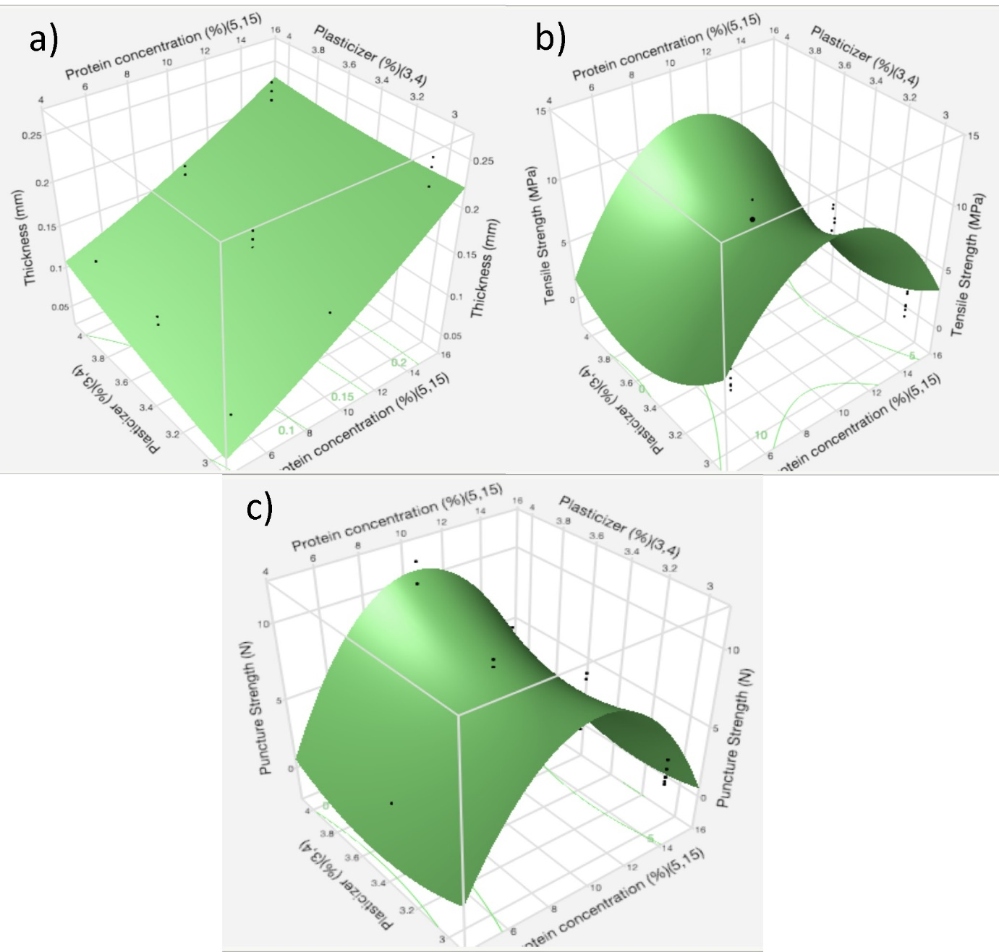
Figure 3: Response surface plots, from the experimental results of the central composite
design (CCD) representing the interactions between the independent variables and (a) Thickness, (b) Tensile strength, and (c) Puncture strength.

Tensile Strength response: The tensile strength values of the film were predicted using the quadratic equation: 7.7176+ 0.2862X₁- 0.3165X₂+ 0.1234 X₃+ 1.0952 X₁X₂ – 0.1543 X₁X₃ – 0.1718 X₂X₃- 5.1821 X₁² + 2.6372 X₂² – 2.2421 X₃² Eq. (6)
The tensile strength of the 3D printed edible films initially increased with the protein concentration and drying time. After reaching an extremum, soy protein concentration negatively affected the tensile strength of the 3D printed soy protein films, possibly due to the saturation in H-bonding and S-S bonding interactions (Figure 2, Figure 3). Mutual interactions between protein concentration and plasticizer percentage demonstrated a high correlation with the response (P<0.001). Tensile strength of the 3D printed films decreased with the increasing plasticizer percentage leading to a plateaued response at its higher values.
Puncture strength response: The puncture strength values of the film were predicted using the quadratic equation:7.9876 + 0.5421 X₁ + 0.5626 X₂ – 0.0096 X₃ + 0.5664 X₁X₂ – 0.1187 X₁X₃ – 0.1235 X₂X₃ – 5.8060 X₁² + 1.2466 X₂² – 1.4681 X₃² Eq. (7)
The puncture strength of the 3D printed edible soy protein films increased with the protein concentration and drying time initially, while after reaching an extremum, it started decreasing for the higher values of the above-mentioned independent variables (P<0.05 for protein concentration) (Figure 2, Figure 3). Cross-terms (mutual interactions) between protein concentration and plasticizer percentage (X₁ and X₂) showed high correlation (p<0.05). Tensile strength of the 3D printed films decreased with the increasing plasticizer percentage (p<0.05) and the response plateaued at the higher values, possibly due to the saturation of the H-bonding and S-S bonding interactions.
ANOVA: An ANOVA test (F-test) was performed to fit the response function to experimental results. The model has shown low probability value (P < 0.0001) for thickness, tensile and puncture strength, and low F ratio values of 59.9145, 48.6484, and 45.2844, respectively (Table 2). Hence, demonstratively the regression model was highly significant at a confidence level >99% (p<0.01). The predicted values and the experimental values demonstrated a high level of correlation in the data plots (p<0.01).
The linear and quadratic relationship between protein concentration, plasticizer concentration (X₁, X₂, X₁*X₂, X₁², X₂²) had a significant effect (p < 0.0001), while drying time (X₃) did not demonstrate a significant effect (p = 0.65) by itself, the quadratic terms (X₃², X₁X₃, X₂X₃) demonstrated a significant effect (p<0.05) on the model (Table 2).
Verification of the suitability of the model was performed using the coefficient of determination (R²) for all the responses. The value of R² were 0.91, 0.89, and 0.86: for thickness, tensile and puncture strengths, respectively (Table 2). The results indicated that the model could explain 91, 89 and 86% of the response variations attributed to the independent factors (Table 2). The high value of R² Adj (0.8918, 0.8696, and 0.8611 for thickness, tensile and puncture strengths, respectively) implied the contribution of the independent variables to the improvement of the model. The good fit and predictive quality of the model enabled the prediction of a new set of data.
Optimization: The polynomial equations (Equations 5-7) were used to generate the prediction profiler (Figure 2) and the 3D response surface plots (Figure 3a–c) to demonstrate the mutual interactions between the three independent variables (X₁, X₂, and X₃) on the three responses (Y) (thickness, tensile and puncture strength). The predicted responses demonstrated a high correlation (p<0.05) with the experimental values with a high desirability value of 0.7428.
The optimized preparative condition for 3D printed edible soy protein film obtained from the RSM was: 8.91%, 3.00%, and 3.98 h for soy protein concentration, plasticizer concentration, and drying time, respectively.
The optimized conditions resulting from the statistical model agreed with the results reported by using traditional methods (Nandane & Jain, 2018).
Table 1: The central composite design for the optimization of 3D printing conditions of soy protein-based edible films
Coded level of variables |  |  |  | Experimental values
Run | Soy protein concentration (X₁) | Plasticizer concentration (X₂) | Drying time (X₃) | Thickness of the film (mm)ª | Tensile strength of the film (MPa) ª | Puncture strength of the film (N) ª
1 | -1 | -1 | -1 | 0.064 ± 0.006 | 3.06 ± 0.24 | 1.43 ± 0.29
2 | -1 | -1 | +1 | 0.056 ± 0.006 | 4.74 ± 1.12 | 2.20 ± 0.18
3 | -1 | 0 | 0 | 0.106 ± 0.006 | 1.75 ± 0.13 | 1.50 ± 0.18
4 | -1 | +1 | +1 | 0.098 ± 0.008 | 1.70 ± 0.12 | 1.05 ± 0.23
5 | -1 | +1 | -1 | 0.098 ± 0.008 | 1.55 ± 0.13 | 1.12 ± 0.02
6 | 0 | -1 | 0 | 0.122 ± 0.008 | 12.18 ± 1.0 | 7.83 ± 0.22
7 | 0 | 0 | 0 | 0.13 ± 0.010 | 8.34 ± 0.92 | 7.38 ± 0.35
8 | 0 | 0 | 0 | 0.154 ± 0.006 | 6.89 ± 0.32 | 6.85 ± 1.11
9 | 0 | 0 | -1 | 0.142 ± 0.010 | 6.5 ± 0.44 | 7.40 ± 1.13
10 | 0 | 0 | +1 | 0.144 ± 0.009 | 5.29 ± 0.61 | 6.86 ± 0.83
11 | 0 | 0 | 0 | 0.13 ± 0.007 | 6.23 ± 0.24 | 7.29 ± 0.72
12 | 0 | +1 | 0 | 0.176 ± 0.009 | 9.36 ± 0.24 | 11.85 ± 1.44
13 | +1 | -1 | +1 | 0.232 ± 0.013 | 1.94 ± 0.84 | 1.37 ± 0.99
14 | +1 | -1 | -1 | 0.182 ± 0.013 | 1.72 ± 1.0 | 1.42 ± 0.34
15 | +1 | 0 | 0 | 0.184 ± 0.011 | 4.15 ± 0.94 | 4.07 ± 1.39
16 | +1 | +1 | -1 | 0.232 ± 0.008 | 3.74 ± 0.50 | 3.03 ± 2.14
17 | +1 | +1 | +1 | 0.2 ± 0.014 | 4.13 ± 1.13 | 2.83 ± 1.26
#Variable codes (- 1, 0, 1) of soy protein concentration level (5, 10, 15% respectively), plasticizer concentration (2, 3.5, 4%, respectively), and drying time (3, 4, 5 h respectively) represent for X₁, X₂, and X₃ respectively.
ªValues are means of three determinations ± standard deviation
2.2 Protein content determination of the edible film
The protein content in the soybean meal for the lots AR-R11-7999, MO-S17-17168, and MO-S17-19874R were 40.0, 39.1, 39.9%, respectively (Table 3). The protein content in the soy protein isolates for the lots AR-R11-7999, MO-S17-17168, and MO-S17-19874R were 84.5, 84.7, 87.3%, respectively (Table 3). The differences in the protein content for the soybean lots were non-significant (p<0.05). The Missouri soybean lot MO-S17-19874R was randomly chosen to run the central composite design optimization. The protein isolates from the soybean lots AR-R11-7999, MO-S17-19874R, and MO-S17-17168 were used for verification of the optimized condition determined by RSM. The soy protein content values determined in this report are comparable with the reports in literature (Rizzo & Baroni, 2018).
Table 2: Protein contents of ground soybean flour and protein isolate.
Lot number | Protein content (%) by Kjeldahl method (dry weight basis) #, *
 | Ground soybean flour | Soy-protein isolate
 | Protein content (dry weight basis) | Protein content (dry weight basis)
AR-R11-7999 | 40.0 ± 0.4ª | 84.5±2.5ª
MO-S17-17168 | 39.1 ± 1.0ª | 84.7±2.9ª
MO-S17-19874R | 39.9 ± 0.5ª | 87.3±0.5ª
# Data are represented as mean ± standard deviation from three independent experiments. Mean values of protein content in soy-protein isolate followed by same letters in the same column are not significantly different (P < 0.05).
* Protein content was determined from the total nitrogen determination by Kjeldahl method using Kjeldahl factor 6.25.

Table 3: Summary of fit, and analysis of variance for the experimental data in central composite design.
Summary of Fit |  |  | Analysis of Variance
Response | RSquare | RSquare Adj | Source | DF | Sum of Squares | Mean Square | F Ratio | Prob>F
Thickness | 0.9070 | 0.8918 | Model | 7 | 0.1284 | 0.0183 | 59.9145 | <0.0001
 |  |  | Error | 43 | 0.0131 | 0.0003
 |  |  | C. Total | 50 | 0.1416
Tensile  Strength | 0.8878 | 0.8696 | Model | 7 | 413.5499 | 59.0786 | 48.6484 | <0.0001
 |  |  | Error | 43 | 52.2191 | 1.2144
 |  |  | C. Total | 50 | 465.7690
Puncture  Strength | 0.8805 | 0.8611 | Model | 7 | 481.7104 | 68.8158 | 45.2844 | <0.0001
 |  |  | Error | 43 | 65.3443 | 1.5196
 |  |  | C. Total | 50 | 547.0547

2.3 pH and density of the edible film making solution
The soy protein isolate contains approximately 58% polar amino acids, making it extremely sensitive to pH and water in general. Therefore, pH plays an important role in protein films. As the solubility of these proteins depend on their isoelectric point (pI), for a protein film to be edible, the pH must maintain a fine balance between neutrality and the pI. Uniform solubilization of the macro molecules and the cohesive substances by the solvent molecules are important to obtain a film with good physical properties and elongation at break values. The cohesion properties in an edible film depends on the hydrogen and S-S bonding between the unfolded protein macro molecules. The pH value was set to 8.5 for the protein solutions during the initial solution preparation. Addition of proteogenic plasticizers and unfolding of protein molecules due to heat and sonication caused the pH values of the final solutions for the lots AR-R11-7999, MO-S17-17168, and MO-S17-19874R to range between7.78-7.93 in the 3D printing solution. The density of the film preparation solution for the lots AR-R11-7999, MO-S17-17168, and MO-S17-19874R ranged between 1.07-1.10 g/mL.
2.4 Verification of the optimum conditions for the physical properties in 3D printed edible films
The preparative conditions for the 3D printed edible film with minimum thickness, maximum tensile and puncture strength determined by CCD and RSM were evaluated to ascertain the estimation capacity for the model. The 3D printed edible soy protein films obtained in this study had a faint yellow color possibly due to the soy-related flavonoid compounds (Figure 4) (Nandane & Jain, 2018). The visible texture of the of the prepared films were smooth (Figure 4).
The verification of the optimized conditions was performed on soy-protein isolated from MO-S17-19874R. The thickness of the 3D printed edible film from Lot MO-S17-19874R were effectively minimized and revealed (0.108 mm, Table 4) non-significant difference (p<0.05) to the predicted value (0.112 mm, Figure 2) from RSM using the same lot. The thickness of the 3D printed edible soy-protein films using the optimized condition were comparable to the commercially available Mylar® films (0.11 mm).
The experimental tensile strength value for Lot MO-S17-19874R (14.79MPa, Table 4) were higher than the predicted values from RSM (10.58 MPa, Figure 3) using the same lot of soy protein, which can be attributed to the high quadratic coefficient (Coeff for X₁X₂ = 1.0952, Equation 6). Since the optimization aimed for maximization of the tensile strength, this value demonstrates the success of the model by unleashing secondary interaction between the protein structures and plasticizers. The experimental puncture strength value (8.20 N, Table 4) for Lot MO-S17-19874R was effectively maximized and revealed a statistically non-significant (p<0.05) difference to the predicted value (8.38 N, Figure 2) by RSM using the same lot. The soy-protein isolates from lots of AR-R11-7999 and MO-S17-17168 with a non-significant (p<0.05) difference in protein content were also used to prepare edible 3D printed films and physical properties were measured in triplicate for further verification of the optimized conditions in different varieties of soybean found in mid-south USA. The thickness, tensile and puncture strength values for the films made using the soybeans ranged from 0.108-0.114 mm, 14.79-16.07 MPa, and 6.97-8.20 N, respectively (Table 4). The minimal variation in the experimental physical properties of 3D printed edible films caused due to the difference in the source of soybean produce used. The successful experimental verification for the physical properties proved the efficacy for the RSM model (Desirability: 0.7428, Figure 2).
Table 4: Physical properties of the final 3D printed edible soy-protein films.

Sample # | Thickness (mm) # | Tensile Strength (MPa) # | Puncture strength (N) # | Water activity (a_{w}) (Measured at 25 °C) # | Density (g/cm³) (Measured at 27 °C) # | Elongation at break (%)#
AR-R11-7999 | 0.110 ± 0.010ª | 14.89±0.49ª | 7.12±0.32^{b} | 0.34 ± 0.01ª | 1.22 ± 0.07^{b} | 105.7±1.3ª
MO-S17-19874R | 0.108 ± 0.008ª | 14.79±0.93ª | 8.20±0.46^{b} | 0.33 ± 0.02ª | 1.36 ± 0.09ª | 104.4±0.5ª
MO-S17-17168 | 0.114 ± 0.005ª | 16.07±1.89ª | 6.97±0.58ª | 0.31 ± 0.01ª | 1.28 ± 0.03^{a,b} | 104.7±0.8ª
# Data are represented as mean ± standard deviation from three independent experiments. Mean values of physical properties in soy-protein isolate followed by same superscripted letters in the same column are not significantly different (P < 0.05).
* Identical portions of mylar plastic sheets coated with silicone (Richard Mistler, Inc., Morris-ville, Penn.) was used for comparison.
‡ Mylar®, also known as BoPET (Biaxially-oriented polyethylene terephthalate) is a polyester film made from stretched polyethylene terephthalate (PET) and is used for its high tensile strength, chemical and dimensional stability, transparency, reflectivity, gas and aroma barrier properties, and electrical insulation.

Nandane and Jain (2018) used RSM to optimize the soy protein concentration, pH and plasticizer percentage to obtain the edible films prepared in traditional way to maximize the tensile strength and elongation at break and minimize the thickness (Nandane & Jain, 2018). Their optimization of protein concentration results was highly comparable (SPI concentration: 8.39%) to this study. The pH value was not considered as one of the optimizable parameters in this study because of the observation in the initial studies that the window of the pH values had to be within 7.5-8.5 to obtain quality edible soy protein films, due to their solubility characteristics. The preparative pH values of the solutions were determined using their optimized values. The tensile strength for the edible 3D printed soy-protein films in the current study was approximately 7-8-fold higher than that of the study reported by Nandane and Jain in 2018 possibly due to a better RSM optimization and the standardization in the preparative process by additive manufacturing (Table 4). Also, the edible films, prepared in a traditional method, had a higher thickness (0.149 mm) compared to this study (0.108-0.114 mm), proving that 3D printing is more effective in preparing thinner, stronger films compared to the traditional methods.

2.5 Water activity (a_{w}) and density
Water activity is the major factor in edible products to modulate the food stability, microbial response, and determining the type of microorganisms encountered in food. Specially the products with a neutral pH are especially vulnerable (Tapia et al., 2020). There is no visible microorganism growth on products with a_{w} of 0.4 or below. The edible soy protein films prepared by 3D printing in this study had a water activity value range of 0.31-0.34 (Table 4). It can be concluded that despite the favorable pH of the edible film preparation solutions, there is no possibility of any microbial growth on these films.
The density of the soy protein films using the optimized conditions are reported in Table 4.
Density determines the weight of a material for unit volume. Density of the edible films can be a crucial parameter depending on the application. The density of the soy protein films for the soybean lots ranged from 1.22-1.36 g/cm³ (Table 4). The average density value (1.22 g/cm³) (Table 4) for the edible soy protein film produced from soybean lot AR-R11-7999 were lower than the other two lots, despite the statistically non-significant difference of protein content between the soybean Lots (p<0.05) (table 3). This study can be helpful in choosing the soybean lines with the lightest density while maintaining the statistically significant similarity in other physical properties.
2.6 Elongation at break
The elongation at break ratios for 3D printed edible films ranged from 104.4-105.7% (Table 4) for the soybean lots under investigation. Plasticizer percentage, pH and drying time are traditionally known to affect the elongation at break values for a soy protein edible film (Cao & Chang, 2002). Possibly the difference in the S-S and H-bonding interaction between the unfolded protein and plasticizer causes the difference. Elongation at break values of traditionally prepared soy protein films reported by Nadane and Jain was comparable (104.79%) to the current study (Nandane & Jain, 2018). This result further proves that preparation of edible films using additive manufacturing obtains films with competitive physical properties with the traditional ones.
2.7 Color attributes of the 3D-printed edible films
Color of an edible film is one of the most important aspects of the edible soy protein films for customer acceptability (Jiang et al., 2019; Sivarooban et al., 2008). The L*, a*, and b* values of the analyzed 3D printed edible film samples ranged from 90.81-91.53 (100 represents the brightest white), (-)1.89- (-) 1.31 (higher value represents a more intense redness), 14.85-17.25 (higher value represents a more intense yellowness), respectively (Table 5). The color of the films from all three-soy protein lots were very close, visually (Figure 4). The color of soy protein films reported by Rhim et al. (2000) (L*, a* and b* values as 89.8-93.7, (-)2.44-(-) 1.08, 10.03-25.96, respectively) were very similar to the values reported in this study (Rhim et al., 2000). Sivarooban et al. reported edible soy protein films in 2008 with L*, a* and b* value ranges of: 77.47-95.36, (-)20-10.0, 4.68-29.06 (Sivarooban et al., 2008). Hence it can be concluded that 3D printing can produce soy protein films with comparable color to that of traditional methods.
Table 5: Color parameters of the 3D-printed edible soy-protein films.
Sample # | L*ª | a*ª | b*ª | Browning Indexª
AR-R11-7999 | 91.30±0.18 | -1.31±0.06 | 14.85±0.20 | 16.25±0.22
MO-S17-19874R | 90.81±0.20 | -1.89±.05 | 17.25±0.36 | 18.98±0.49
MO-S17-17168 | 91.53±0.44 | -1.74±0.08 | 16.13±.33 | 17.56±0.38
ª Data are represented as mean ± standard deviation from three independent experiments.

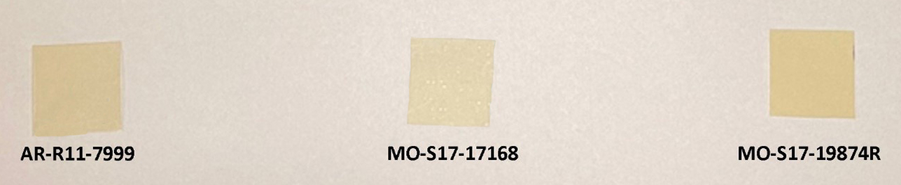
Figure 4: The edible 3D-printed edible soy-protein films using protein from the three different soybean lots.

3. MATERIALS AND METHODS FOR OBJECTIVE 3
3.1 Materials
Soybeans (line MO-S17-17168) were kindly supplied by Fisher Delta Research Center at the University of Missouri (MO, USA), which was used to prepare SPI (protein content: % 84.7 ± 2.9) for 3D printing and manufacturing edible films (Dey et al., 2022). Glycerol (analytical grade) was supplied by Fisher Scientific (NH, USA). GS and GT extracts were purchased as powder from Danisco (Copenhagen, Denmark). All other chemicals used in this study were of analytical grade and used as received.
3.2 Viscosity measurement
The SPI-GS and SPI-GT solutions were prepared using the method described in Section 3.3, where they were treated at 85 °C for 30 min and cooled down to 25 °C. The apparent viscosity was measured at 25 °C in shear rates ranging from 0.1 to 100 1/s using a controlled-stress rheometer (AR 2000 Rheometer, TA Instruments, New Castle, DE, USA). The rheometer was equipped with a Peltier Plate system for temperature control and a parallel-plate geometry (40 mm), and a gap of 1000 μm (Dey et al., 2022; Ahmadzadeh & Ubeyitogullari, 2022).
3.3 3D printing of SPI films
An aqueous suspension of 11% SPI was homogenized at 6500 rpm using an adaptable homogenizer (VWR VDI 25, PA, USA) in a glass container for 15 min. The pH of the solution was set to 8.5 using 1 M NaOH solution. GT or GS (0, 1, 3, and 5%, w/w based on SPI content) were added and mixed at room temperature (23 °C) for 15 min. The prepared solution was then sonicated (Probe sonicator Branson Ultrasonics, CT, USA) for 5 min (output control: 9, duty cycle: 70%). The samples were kept in an ice bath to prevent overheating. Next, glycerol (30%, w/w based on SPI content) was added as a plasticizer and then degassed under the vacuum. The final solution with the composition of SPI (11% of initial protein suspension), GS or GT (0, 1, 3, 5 % w/w based on SPI content), glycerol (30%, w/w based on SPI content), and water (89% of initial protein suspension) was employed as the ink for printing. 3D printing was conducted using an Allevi 2 Bioprinter (Allevi, Inc., PA, USA). The printer was equipped with two extruders (10 mL each) (Fig. 3.1). The developed film-forming solution was loaded into a 10-mL cartridge and transferred to one of the extruders that was beforehand warmed up to 85 °C, sustained at this temperature for 30 min. The extruder was then cooled down to room temperature (23 °C). The SPI-based ink was next extruded through the different nozzles (i.e., 23, 25, and 30 G equivalent to 0.330, 0.250, and 0.152 mm internal diameters, respectively). The extrusion pressure was optimized in the range of 0.020 and 0.062 MPa. The nozzle height (the nozzle leveling gap) and printing speed were kept constant at 0.2 mm and 5 mm/s, respectively. The samples were printed on 10 cm × 10 cm mylar plastic sheets as the bed surface. The square-shaped printed films (5 cm × 5 cm) were dried for 4 h at 50 °C and 45% RH in a controlled humidity chamber (Hotpack, PA, USA). In addition, an .stl file of the same size (5 cm × 5 cm) but with nine openings (diameter of 8 mm) was created to show the accuracy in 3D printing. The dried films were placed between wax-paper sheets in a chamber at 25 °C, 50% RH for 48 h before further experiments. The 3D-printed films were hereafter labeled as SPI-C and SPI-GS or GT-1/3/5, where “C” indicates the control sample, “GS or GT” shows the extract type, and “1/3/5” demonstrates the concentration of extract.
The printing accuracy and shape retention were assessed by comparing the photos that were taken after 3D printing with the digital 3D geometry. The areas of the 3D-printed films were measured using ImageJ software (public domain, National Institutes of Health, USA), and specifically compared to that of the digital geometry. A ruler was used as a reference to create the scale bar in the photos.
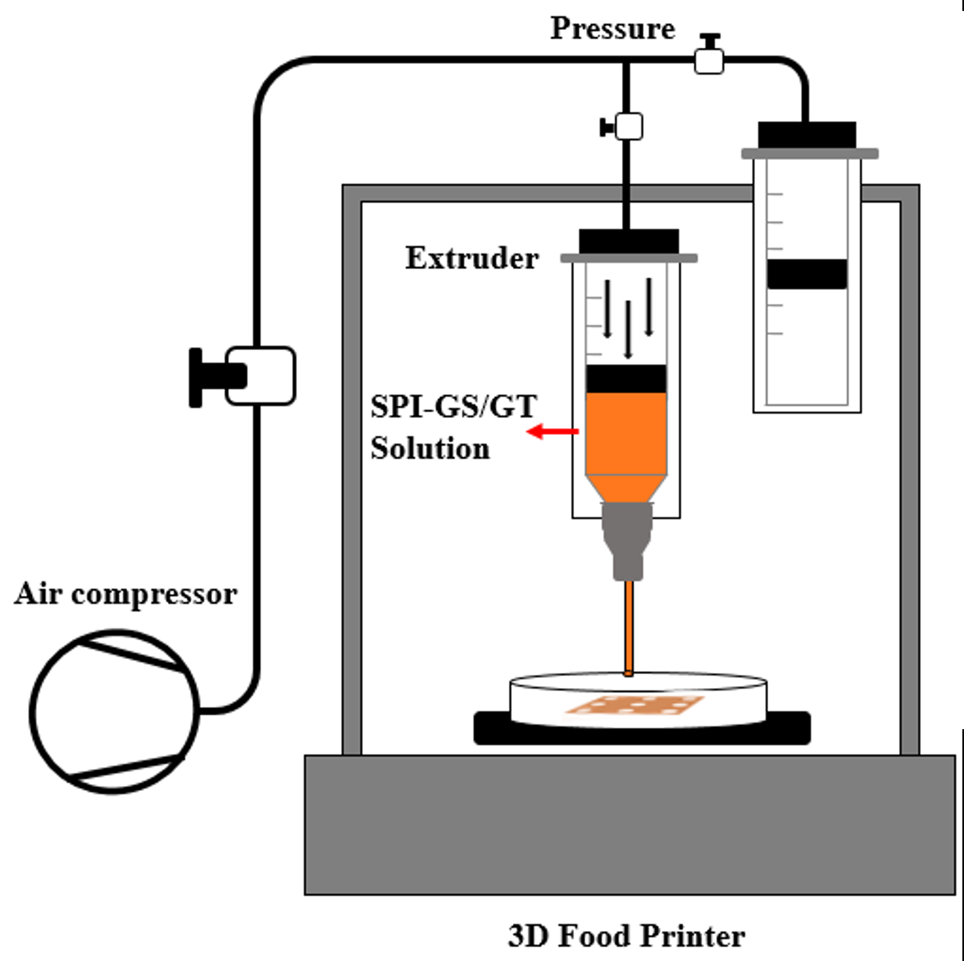
Figure 3.1. Schematic diagram of the 3D printing of edible films.

3.4 Film thickness
The film thickness was measured using a digital Caliper (Mitutoyo Corporation, Absolut Digimatic Caliper, Japan), with an accuracy of 0.01 mm. The thickness of each film was determined in 5 randomly chosen locations. The average values of the measurements were reported.
3.5 Mechanical properties
The tensile and puncture strength of the 3D-printed films were calculated using a texture analyzer (TA-XT Plus, Texture Technologies Corp., NY, USA). (Sivarooban et al., 2008).
3.5.1 Tensile strength (TS) and elongation at break (EB) determination
Film strips with accurate measurements of 40 mm by 15 mm were inserted into the texture analyzer’s film extension grips (initial grip separation of 20 mm). The texture analyzer moved them apart at a rate of 2 mm/s for 20 mm. The TS and EB were calculated using the following equations:
$Tensile strength \left(MPa\right)=\frac{Peak load (N)}{Film cross-sectional area ({mm}^{2})}$ (1)
$Elongation at break \left(\%\right)=\frac{Initial grip distance \left(mm\right)- Grip distance at break (mm)}{Initial grip distance (mm)}*100$ (2)
where the peak load is the maximum force applied to the film until it breaks.
3.5.2 Puncture strength (PS) determination
Using the TA-108S film-testing apparatus, a 30-mm x 30-mm piece of film was mounted, and a 2-mm probe (TA-52) perforated it at a speed of 100 mm per min. At the spot where the probe punctured the film, the puncture strength of the film (expressed as a force in N/mm) was measured. To eliminate the effect of thickness variation, the ratio of puncture strength and thickness (N/mm) was calculated (Azevedo et al., 2017).
3.6 Fourier-transform infrared (FTIR) spectroscopy
SPI, GT, GS, and 3D-printed films were investigated for their structural properties and the interactions between the components using an FTIR spectrometer (IRAffinity-1S Fourier transform infrared spectrometer, SHIMADZU Corp., Japan) with attenuated total reflectance (ATR) accessory. The spectra were collected with 64 scans in the range of 4000 to 400 cm−1 (Ahmadzadeh & Ubeyitogullari, 2022).
3.7 Microstructural analysis
The surface and cross-section structures of the 3D-printed films were observed using an FEI NovaNanolab200 Dual-Beam system. Small pieces of the films were fixed on the stub and coated with gold via a sputter-coater (EMITECH SC7620 Sputter Coater, MA, USA). SEM images were then taken at 15 kV and 10 mA (Ahmadzadeh & Ubeyitogullari, 2022).
3.8 Thermal stability
Thermogravimetric analysis (TGA) (TA Q5, TA Instruments, DE, USA) was used to evaluate the thermal stability of 3D-printed films and measure their non-isothermal degradation. First, approximately 10 mg sample was weighed in an aluminum pan using a microbalance. After a 10 min equilibration period at 30 °C, the sample was heated from 30 to 600 °C at a rate of 10 °C/min. A nitrogen atmosphere (20 mL/min) was used to prevent thermo-oxidative reactions.
3.9 Water vapor permeability (WVP)
The WVP of the 3D-printed films was measured using the standard method (ASTM E96/E96M-10). First, 0.5 g calcium chloride was weighed into 20 mL vials (2.2 cm in diameter and 5.5 cm in height). Films were cut into 2 cm2 squares and placed over the opening of the vial’s lid. In a desiccator, the vials were kept at 23 °C and 50% RH controlled using a saturated magnesium nitrate solution. The weight of the vials was measured at various time intervals over the period of 24 h and used to calculate the WVP using the following equation:
$WVP=\frac{Weigth difference \left(g\right)×Film thickness (m)}{ Exposed area \left(m^{2}\right)×Time\left(s\right)×Pressuredifference (Pa)}$ (3)
3.10 Color
The color of the films was analyzed using a MINOLTA CR-300 colorimeter (KONICA MINOLTA, NJ, USA) with diffuse illumination/0° viewing geometry. The L* a* b* color space was used, in which L* shows the lightness/darkness, and a* and b* give the redness/greenness and yellowness/blueness, respectively. L* values indicate lightness. Negative and positive a* values indicate greenness and redness, respectively. Negative b* values show blueness, and positive b* values imply yellowness. The colorimeter was calibrated in triplicate using a white calibration plate (L* = 97.12, a* = +5.25, b* = -3.49).
3.11 Antioxidant activity
3.11.1 Total phenolic content
Phenolic compounds were extracted from GS (5 mg), GT (5 mg), or SPI films (0.25 g) in 3 mL of 70% ethanol for 24 h. A 0.3 mL of ethanol solution was then added to the Folin Ciocalteu reagent (10%, v/v; 2.5 mL), followed by the addition of 2 mL of 7.5% (w/v) sodium carbonate solution. The resulting mixture was then incubated for 5 min at 50 °C. Afterward, the absorption was determined at 760 nm using a UV-vis spectrophotometer (Milton Roy Spectronic 1201, PA, USA). The standard curve was obtained using gallic acid solutions (0–1000 mg/L; R2 = 0.99). The result was reported as µg gallic acid equivalent per g film or extract (μg GAE/g film or extract) (Maryam Adilah et al., 2018).
3.11.2 DPPH radical scavenging assay
DPPH (2,2-diphenyl-1-picrylhydrazyl) free radical scavenging assay was performed to assess the antioxidant activity of the films and extracts. First, 25 mg of the film or 2 mg of the extract (GS or GT) was immersed in 3 mL of 70% ethanol, labeled as film extract and extract solution, respectively, and kept overnight for extraction. A 1 mL of 0.1 mM ethanolic DPPH solution was mixed with 0.3 mL of the film extract. After mixing, the sample was incubated for 30 min at 23 °C in the dark, and the absorbance was determined at 517 nm. Finally, Eq. 1 was used to calculate the DPPH radical scavenging activity (Maryam Adilah et al., 2018).
$Radical Scavenging Activity (\%)=\frac{\left( DPPH absorbance- sample extract absorbance\right)*100}{DPPH absorbance}$ (4)
3.11.3 ABTS radical scavenging assay
ABTS radical scavenging activity was measured following the method of Maryam Adilah et al. (2018). First, 7 mM ABTS was combined with 2.45 mM potassium persulfate (1:1, v/ v) to generate ABTS radical cations. Next, the mixture was kept in the dark for 16 h at room temperature (23 °C). Ethanol was then added to the ABTS radical solution to achieve an absorbance of 0.7 ± 0.02 at 734 nm. Afterward, 40 μL of film extracts and extract solution (in 70% ethanol, as explained in Section 2.11.2), or gallic acid solutions as the standard solutions (0-0.001 mg/mL), were added to the diluted ABTS solution (3960 μL). The samples were kept in the dark for 6 min at room temperature (23 °C), and then the absorbance was determined at 734 nm. The results were given in µg gallic acid equivalent per g film or extract (mg GAE/g film or extract) (Maryam Adilah et al., 2018).
3.11.4 FRAP assay
The FRAP assay was performed in accordance with the method of Maryam Adilah et al. (2018). The film extract and extract solution (see section 2.11.2) were obtained by immersing 25 mg of 3D-printed films or 2 mg of extracts (GS or GT) in 3 mL of 70% (v/v) ethanol solution and kept overnight. To prepare the FRAP solution, acetate buffer (pH 3.6), FeCl3 solution, and TPTZ solution were mixed in a ratio of 10:1:1, respectively. After 30 min of incubation at 37 °C, 2850 µL of the FRAP solution was put into a vial, mixed with 150 µL of the film extract, and vortexed. It was then incubated for 30 min at ambient temperature (23 °C) in the dark. Finally, the absorbance was measured at 593 nm. The standard curve was obtained using gallic acid solutions (0–1000 mg/L; R2 = 0.99). The results were reported as microgram gallic acid equivalent per gram film or extract (mg GAE/g film or extract) (Maryam Adilah et al., 2018).
3.12 Statistical analysis
ANOVA was performed using SPSS Statistics software (IBM Inc., IL, USA), followed by the LSD's multiple comparison test at p < 0.05. All experiments were conducted in triplicates.

4. RESULTS AND DISCUSSION FOR OBJECTIVE 3
4.1 Viscosity
Viscosity presents the printability of the ink and the system’s efficiency in printing films with high resolution. The viscosity of SPI-based ink as a function of extract type and concentration at 25 °C is depicted in Fig. 4.2, where the results revealed shear-thinning properties of the inks regardless of the concentration of GS or GT. The addition of extracts reduced the viscosity of the protein solution, confirming the weakening effect of GS or GT on protein-protein interactions in the system. When compared to GT, GS significantly reduced ink viscosity, which affected the printability, as shown in Fig. 4.3. This observation could be attributed to GS and SPI having a stronger affinity than GT and SPI, resulting in a strong interaction between them and reducing the viscosity. Overall, the apparent viscosity indicated that the addition of a high concentration of GS prevented the proper gelation of soy proteins upon thermal treatment.
Long-range (> 5 nm) and short-range (ca. 0.1 nm) interactions directly alter the viscosity in protein solutions with more than 10% (w/v) protein concentration (Jöbstl et al., 2004). Long-range interactions are mostly electrostatic, while short-range interactions include hydrogen bonding, dipole-dipole interactions, hydrophobic interactions, and van der Waals attractions. Polyphenols most likely weaken such interactions by attaching to the protein surface, increasing the distance between protein molecules, and shielding the side groups on the protein chain, which make protein interactions more susceptible to shear rate. Furthermore, reducing the volume fraction of the protein by tightly coiling protein chains around polyphenols may reduce the viscosity (Jöbstl et al., 2004). Polyphenols are multidentate ligands that can attach to many sites on the protein strand via various phenolic groups, causing the protein to coil around the polyphenols, according to Jöbstl et al. (2004). As a result, the physical size of the protein decreases, and its structure becomes more compact. Casein/epigallocatechin gallate interactions were investigated by Jöbstl et al. (2004), who reported that the reduced viscosity of casein/epigallocatechin gallate solutions compared to casein solutions was caused by the casein chains coiling up around the epigallocatechin gallate molecules, which reduced the size of the casein chains' molecules (Jöbstl et al., 2004). As previously stated, proanthocyanidins are the major compounds of GS, whereas GT contains catechins and flavanol monomers. Procyanidins are made up of catechin and/or epicatechin. It has been reported that large procyanidins have a higher affinity for protein binding than small compounds, which may be related to their multidentate structure, which allows them to bind multiple protein sites at the same time. As a result, the considerable effect of GS on ink viscosity compared to GT can be related to the type of polyphenols in GS (proanthocyanidins), which results in a strong protein-polyphenol binding, reducing the size of the protein chains and lowering the viscosity of the protein solution (Prigent et al., 2009; Jöbstl et al., 2004).

Figure 4.2. The viscosity of SPI-based inks as a function of extract type and concentration at 25 °C. GS: Grape Seed extract; GT: Green Tea extract. SPI: soy protein isolate; SPI-C: 3D-printed control SPI film; SPI-GS1,3,5: 3D-printed SPI film loaded with 1%, 3%, and 5% (w/w) GS; SPI-GT1,3,5: 3D-printed SPI film loaded with 1%, 3%, and 5% (w/w) GT.
4.2 Printing performance
The accuracy of the 3D-printed films is determined by the parameters influencing ink extrudability. These factors include the rheological properties of the ink as well as the printing parameters, such as printing pressure and nozzle size. Under- or over-extrusion is one of the most common defects related to extrusion-based 3D printing (Ma et al. 2023). Therefore, optimizing the extrusion pressure and using the correct nozzle is essential to obtain the desired resolution. The preliminary experiments and the viscosity measurements revealed that SPI-GT3 provided better printability compared to SPI-C at the same printing conditions. Therefore, the printing parameters were optimized for SPI-GT3 instead of SPI-C (Fig. 4.3). First, the minimum pressure required to achieve continuous printing of SPI-GT3 was established for a nozzle size of 0.25 mm. The minimum extrusion pressure required was determined at 0.062 MPa (Fig. 3B). Next, we evaluated 0.062 MPa pressure for the nozzles with the inner diameters of 0.10 and 0.33 mm to indicate the effect of nozzle size. The best printing pressure and nozzle diameter were determined to be 0.062 MPa and 0.25 mm, respectively (Fig. 4.3). For each nozzle, the minimum extrusion pressure should be applied as the optimal pressure. In the following steps, to print the films and examine the influence of ink properties, the extrusion pressure and nozzle size were set to 0.062 MPa and 0.25 mm, respectively.
The high shape retention of the SPI film printed without the incorporation of GS or GT demonstrated that the soy protein isolate provided adequate printing performance. When 3 and 5% GS were added to the SPI matrix, the film deformed while printing, indicating low printability of the ink. Conversely, the ink with 3 and 5% GT exhibited a higher strength, resulting in a significantly higher degree of shape preservation. This observation demonstrated the importance of the interactions between SPI and GS or GT in determining the ink rheological properties, which influence the printing quality. According to the literature, GS polyphenols and SPI have a high affinity, and the interaction between them is quite strong (Zou et al., 2019), affecting the physicochemical properties of SPI solution. It has been reported that catechin, the main polyphenol in GT extract, and SPI interact non-covalently, causing SPI to create a network-like structure (Dai et al., 2022). However, increased concentrations of catechin resulted in a more disordered protein structure (Dai et al., 2022). As a result, the difference between the 3D-printed films loaded with GS and GT can be explained by the intensity of their interactions with SPI. As presented in Fig. 4.3, the surface of the GS-loaded films was smoother than the control and GT-loaded films, which was due to the lower viscosity of the inks prepared with GS (Fig. 4.3). Overall, the GS or GT affected the protein-protein interactions, resulting in a change in SPI gel properties and printing quality.
When the layers were straight, and the area of the printed film was comparable to the .stl file area, the print was considered successful. The .stl file's area was 25 cm². The 3D-printed film’s areas are reported in Table 4.1. It was found that the printed films loaded with 5% extracts; specifically SPI-GS5, had areas that were higher than the area specified by the .stl file, resulting in poor printing quality. In addition, the 3D-printed perforated films with nine openings geometry showed high printing accuracy and flexibility for potential future applications in foods with complex geometries (Fig. 4.3C).
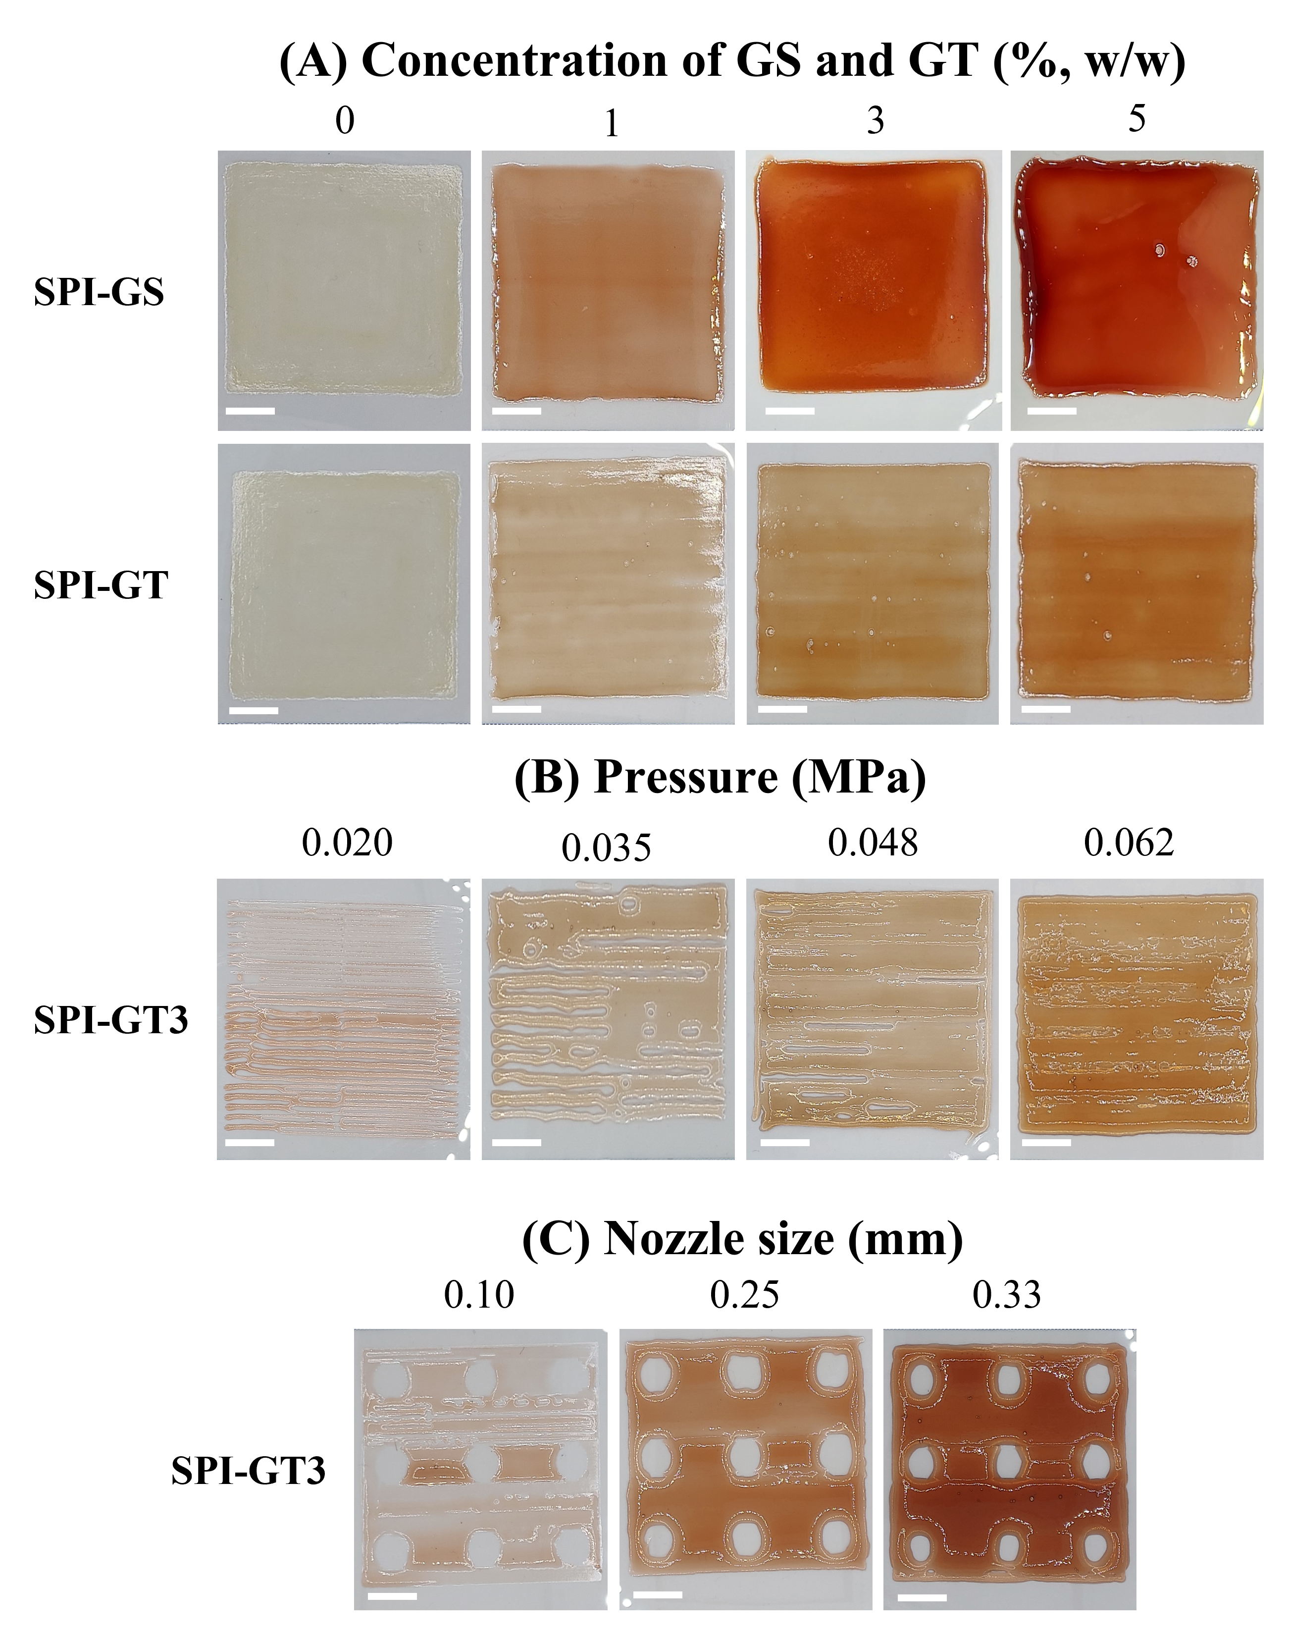

Figure 4.3. 3D printability of SPI-based inks (11% concentration): (A) The effects of GS and GT concentrations at the same printing conditions: pressure of 0.062 MPa and nozzle size of 0.25 mm, (B) the effects of printing pressures on SPI-GT3 with the nozzle size of 0.25 mm, and (C) the effects of nozzle sizes on SPI-GT3 with the pressure of 0.062 MPa, The scale bars represent 1 cm.
SPI: soy protein isolate; GS: grape seed extract; GT: green tea extract; SPI-GS: 3D-printed SPI film loaded with GS; SPI-GT: 3D-printed SPI film loaded with GT. SPI-GS3: 3D-printed SPI film loaded with 3% (w/w) GS; SPI-GT3: 3D-printed SPI film loaded with 3% (w/w) GT.
4.3 Thickness and mechanical properties
Flexibility, strength, and elastic properties are essential for the fabrication of food packaging materials. The mechanical properties of packaging materials should be able to help preserve the quality of packaged food products. The effects of GS or GT on 3D-printed SPI films were determined by evaluating mechanical parameters, such as EB, TS, Young's modulus (YM), and PS, which for SPI-C were in good agreement with the results reported in our previous study for 3D-printed soy protein films (Dey et al., 2022).
The thickness and mechanical properties (EB, TS, YM, and PS) of the 3D-printed SPI films are listed in Table 4.1. The results showed that adding GS or GT to SPI films increased film thickness significantly, with GS having a greater effect than GT. The reported results can be due to the effect of extracts on ink viscosity; lower viscosity resulted in more ink deposited during 3D printing at the same printing pressure. When compared to SPI-C, PS increased for films containing 1% GS or GT. Higher GS concentrations resulted in a decrease in PS; however, the PS of SPI-GT3/5 remained higher than SPI-C. Hydrogen bonding and hydrophobic interactions were the primary reasons for the formation of SPI films (Sivarooban et al., 2008). The increased thickness, PS, and TS of SPI- GS/or GT films could be attributed to cross-links generated by the high molecular size phenolic components. Polyphenols mainly interact with soy protein molecules via hydrogen bonding. The protein-protein interactions in the SPI film-forming solutions may have been influenced by the different structures of polyphenols (Sivarooban et al., 2008). Protein structure, temperature, and the type and concentration of the phenolic compounds all affect the protein-phenolic interactions (Sivarooban et al., 2008). As demonstrated in Table 1, the effects of GS and GT on the 3D-printed SPI film properties were different. The fracture resistance of SPI-based films was reflected by the TS. The TS significantly increased by increasing the concentration of the extract (Table 4.1). The addition of 3% GS and GT increased the TS of the 3D-printed SPI films by 197% and 42%, respectively, due to the development of strong hydrogen bonds among -OH groups on SPI and phenolic compounds. YM indicates the stiffness of the films, which significantly increased by the incorporation of 5% GS or GT, resulting in significantly higher YM compared to SPI-C (p<0.05). This also agreed with the results reported for the films’ TS. Furthermore, the EB of the SPI films loaded with 1% GS or GT was reduced by more than 50% compared to that of SPI-C (Table 1). However, the EB of the 3D-printed films increased with increasing the phenolic extract concentration (i.e., GS and GT) from 1 to 5%. Under alkaline conditions, polyphenols can be oxidized to quinones, which can cross-link with the nucleophilic amino groups of proteins, affecting the EB of the films (Rattaya et al., 2009). Thus, interactions due to polyphenols altered the mechanical characteristics of SPI films (Yu et al., 2018). In this study, compared to SPI-C, improved TS and YM were seen in SPI films with GS or GT (Table 4.1), which was in good agreement with the results reported by Wang et al. (2012). Another study reported that incorporating grape seed extract (1%) into SPI film significantly increased TS but had no effect on the EB. Overall, phenolics were assumed to be the predominant compounds in the extracts responsible for the changes in mechanical properties of the protein-based films (Wang et al., 2012; Sivarooban et al., 2008).
Table 4.1. Thickness, area, and mechanical properties of the 3D-printed SPI films.
Sample label | Thickness (mm) | Area (cm²) | EB (%) | TS (MPa) | YM (MPa) | PS (N/mm)
SPI-C | 0.10 ± 0.00^{d} | 25 ± 0.6^{b} | 117.93 ± 10.70ª | 4.62 ± 0.61e | 192.94 ± 19.58^{d} | 58.63 ± 0.22^{d}
SPI-GS1 | 0.19 ± 0.01^{c} | 24.9 ± 0.8^{ab} | 61.39 ± 10.23^{d} | 10.91 ± 1.12^{b} | 363.46 ± 36.72^{c} | 80.21 ± 3.20ª
SPI-GS3 | 0.25 ± 0.01^{b} | 25.4 ± 0.4^{ab} | 94.35 ± 16.0^{bc} | 13.76 ± 1.64ª | 592.12 ± 52.15ª | 40.90 ± 0.24e
SPI-GS5 | 0.31 ± 0.00ª | 26.4 ± 0.7ª | 95.52 ± 3.84^{bc} | 8.33 ± 0.95^{c} | 519.58 ± 43.71^{b} | 29.52 ± 0.15^{f}
SPI-GT1 | 0.15 ± 0.01^{c} | 25.1 ± 0.5^{b} | 88.90 ± 12.91^{c} | 6.38 ± 0.55^{d} | 340.49 ± 47.06^{c} | 71.45 ± 1.86^{b}
SPI-GT3 | 0.17 ± 0.00^{c} | 25.4 ± 0.2^{b} | 101.47 ± 9.32^{b} | 6.59 ± 0.88^{d} | 581.40 ± 52.15^{ab} | 69.02 ± 0.17^{c}
SPI-GT5 | 0.17 ± 0.01^{c} | 26.0 ± 0.3ª | 105.58 ± 15.43^{b} | 6.99 ± 0.39^{cd} | 513.74 ± 10.84^{b} | 59.58 ± 1.32^{d}
Means within the same column with different superscript letters are significantly different (p < 0.05). Data are given as the means ± standard deviations. TS: tensile strength, EB: Elongation at break, YM: Young’s modulus, PS: puncture strength.
SPI: soy protein isolate; GS: grape seed extract; GT: green tea extract; SPI-C: 3D-printed SPI film; SPI-GS1,3,5: 3D-printed SPI film loaded with 1, 3, and 5% (w/w) GS; SPI-GT1,3,5: 3D-printed SPI film loaded with 1, 3, and 5% (w/w) GT.
4.4 FTIR spectra
The FTIR spectrum of the SPI-C film (Fig. 4.4A) indicated an absorption band at 3270 cm⁻¹, associated mainly with the free O–H groups and amine N–H stretching (Denavi et al., 2009). The bands that appeared at 1640 cm⁻¹, 1530 cm⁻¹, and 1232 cm⁻¹ corresponded to amide I (C=O stretching), amide II (N–H bending), and amide III (C–N stretching), respectively, which were consistent with findings of other studies (Tian et al., 2011). The asymmetric stretch vibrations of =C–H and –NH3⁺ indicated a peak at around 2928 cm⁻¹ (Ahmad et al., 2016). The peak at ~1039 cm⁻¹ was associated with C–H and C–O–H deformations (Liang & Wang, 2018).
By inspecting the frequencies of amide bonds, FTIR spectroscopy can determine the effect of phenolic compounds on the structure of proteins. Amide band I is the most sensitive spectral region for protein structure. Therefore, the second derivatives were calculated to elucidate the spectral differences at the amide band I region (wavelength range 1600-1700 cm⁻¹) of SPI-C and SPI–GT/GS films, enabling to estimate the effect of the GS/or GT on the secondary structure of SPI. FTIR analysis revealed that the addition of GS/or GT affected the secondary structure of SPI by modifying the β-sheet, β-turn, α-helix, and random coil, leading to a more disordered structure. Our findings were consistent with the results reported in previous studies (Kanakis et al., 2011; Hasni et al., 2011), which indicated the interactions between SPI and polyphenols impacted the SPI’s secondary structures. Non-covalent polyphenol-protein interactions have previously been reported between blackcurrant polyphenols and flour proteins (Sivam et al., 2012). According to Hasni et al. (2011) and Kanakis et al. (2011), the interaction between SPI and polyphenols affected the protein’s secondary structure by modifying the α-helix, β-sheet, and random coil (Zou et al., 2019).
The calculation of the second derivative spectra showed the components of the amide-I (Fig. 4.4B). The spectra of SPI-GS or GT displayed significant changes in the bands that corresponded to the SPI-C structure due to the interactions between SPI and extracts that disordered the protein structure and changed the protein-protein interactions. According to the literature, the peaks that appeared at 1618-1640 cm⁻¹ were associated with β-sheets, the peaks at 1650-1660 cm⁻¹ were attributed to α-helix, and the peaks at 1680-1695, 1665 cm⁻¹ were ascribed to β-turns (Zhao et al., 2008).
The major secondary structure components (β-sheets and α-helical conformations) in SPI-GS3 and SPI-GT3 revealed different absorption intensities. The spectra of SPI films showed considerable changes in the bands associated with the original SPI structure as a result of protein denaturation, which disrupted the structure and affected the protein-protein interactions. The intensity and position of peaks associated with β-sheet, β-turn, and α-helical conformations shifted in SPI- GS/or GT compared to SPI-C (Fig. 4B). By comparing the representative spectra of SPI-C and SPI-GS or GT, significant differences were observed, confirming the interactions between SPI and extracts and the effect of extracts on SPI gel formation. The incorporation of extracts also caused a considerable alteration in the intramolecular β-sheet (1640 and 1618 cm⁻¹). The addition of extracts caused a similar shift in the location and intensity of 1650 cm⁻¹, indicating a change in the α-helical structure. Moreover, compared to SPI, a shift in the position of the major protein secondary structural components (α-helix and β-sheet) reflects protein denaturation after heating, which is accompanied by an increase in the absorption intensity at 1695 cm⁻¹, associated with the antiparallel β-sheets (Zhang et al., 2021), indicating protein gelation after cooling. However, when compared to SPI-C, the intensity of the band at 1695 cm⁻¹ was significantly lower for SPI-GS3, indicating that the GS extract prevented gel formation. In the presence of GS and GT, the intensity of the bands at 1618 and 1640 cm⁻¹ decreased, confirming a more disordered structure. These bands were associated with intermolecular β-sheet (Zhang et al., 2021).

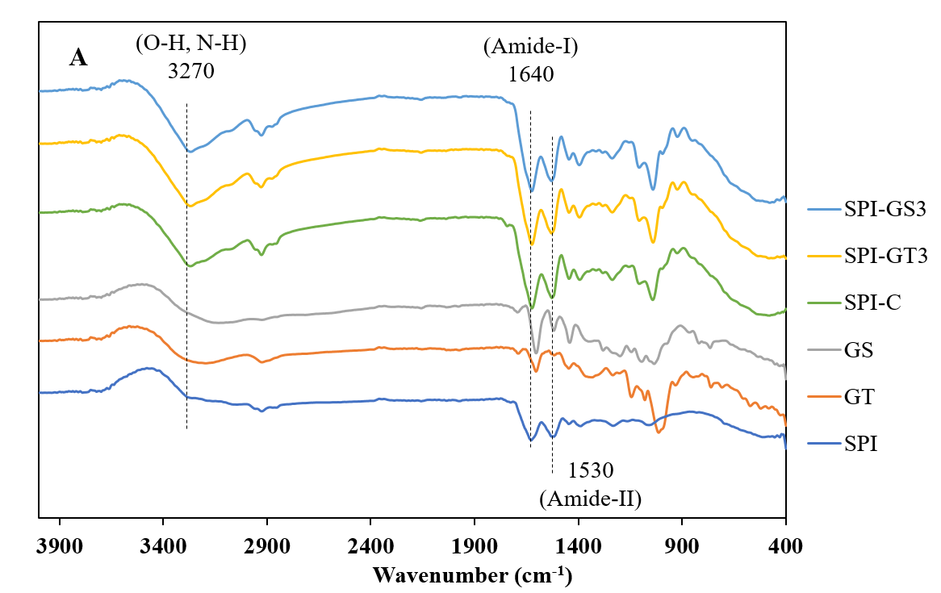
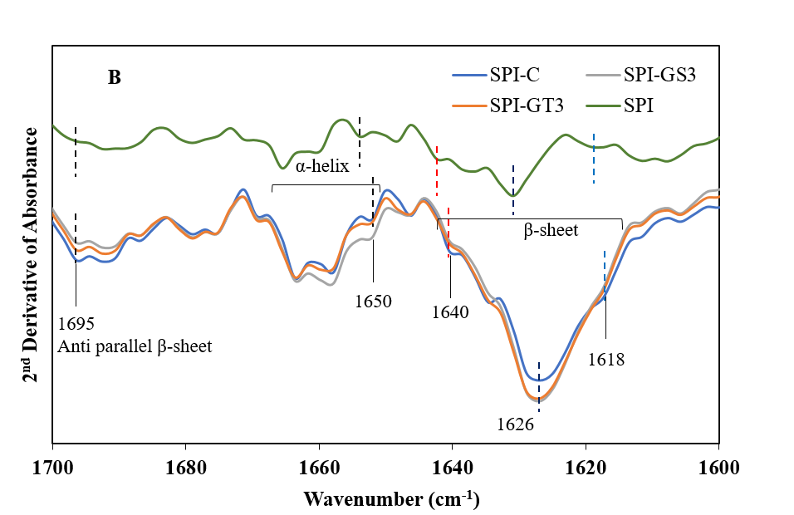
Figure 4.4. (A) ATR-FTIR spectra of the SPI, GT, GS, SPI-C, SPI-GS3 and SPI-GT3; (B) Second-derivative spectra of the original ATR-FTIR spectra of SPI, SPI-C, SPI-GS3 and SPI-GT3 from 1600 to 1700 cm⁻¹. SPI: soy protein isolate; GS: grape seed extract; GT: green tea extract; SPI-C: 3D-printed SPI film; SPI-GS3: 3D-printed SPI film loaded with 3% GS; SPI-GT3: 3D-printed SPI film loaded with 3% GT.
4.5 Microstructure of the 3D-printed films
Fig. 4.5 shows SEM micrographs of the surface and cross-sectional planes of the GS or GT-incorporated films and control SPI film. The GT- or GS-loaded films exhibited a smoother and less porous surface than the control film (SPI-C). Additionally, cross-sectional micrographs of SPI-C showed higher porosity compared to the GS/or GT -loaded films (i.e., SPI-GS and SPI-GT) (Fig. 4.5). When compared to SPI-C, the films loaded with GS or GT had a more compact cross-sectional structure, suggesting compatibility, entanglement and interactions between the GS or GT and SPI, as supported by FTIR results (Section 4.4) and mechanical properties (Section 3.3). Polyphenols may bind to the hydrophobic side chains of protein, resulting in chain entanglement between nearby molecules (Wang et al., 2012). With the addition of GS or GT, such interactions may cause more compact microstructures of the SPI films. The extract-loaded films were considerably homogenous. No aggregates were seen in GS- or GT-loaded SPI films, implying that the extracts were dispersed uniformly throughout the matrix. When using 3D printing, the ink material is thicker than when using the film-casting method (Kim et al. 2022). After extrusion, the printing ink should immediately recover its high viscosity to hold the shape of the printed film. As a result, the interior porosity of the polymer network can be a factor affecting the permeability of 3D-printed film. Furthermore, the film thickness is precisely controlled, and the gel network evenly distributes the loaded component. The more homogeneous microstructure resulted in better mechanical and barrier properties, as discussed above.

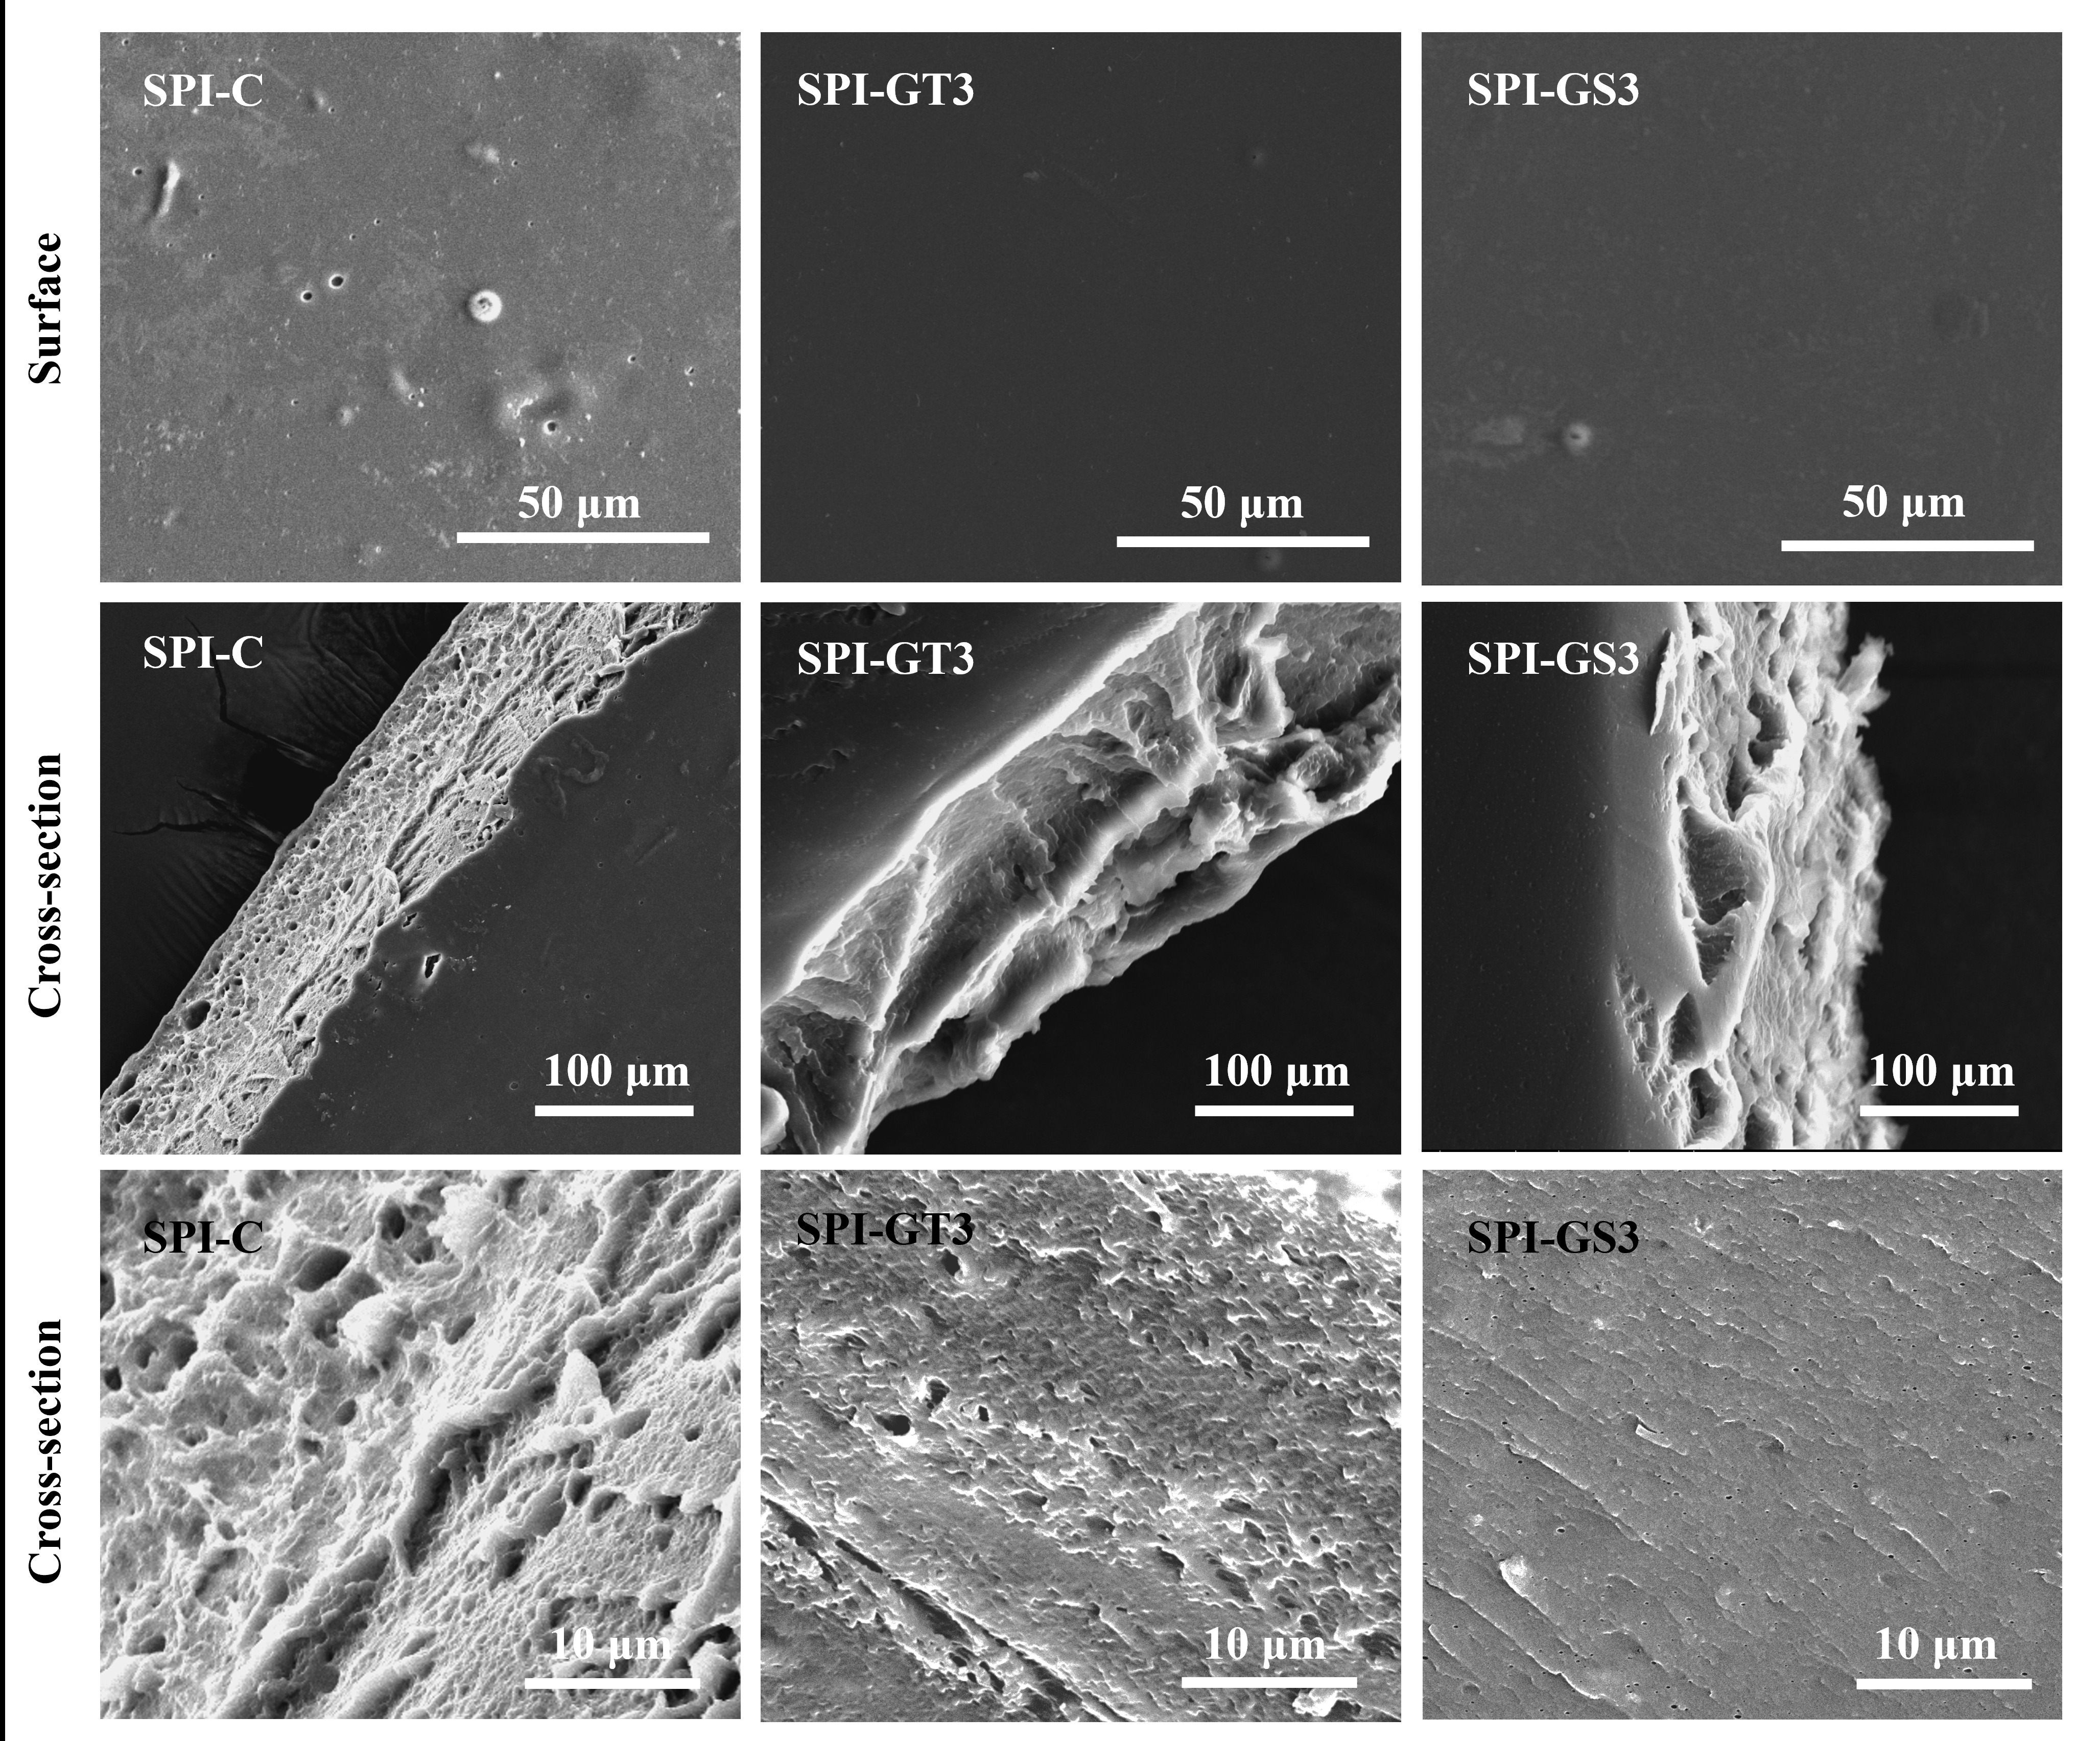
Figure 4.5. SEM images taken from surfaces (A1, B1, C1) and cross-sections (A2, B2, C2) of the 3D-printed films: (A) SPI-C, (B) SPI-GT3, and (C) SPI-GS3.
SPI: soy protein isolate; GS: grape seed extract; GT: green tea extract; SPI-C: 3D-printed SPI film; SPI-GS3: 3D-printed SPI film loaded with 3% GS; SPI-GT3: 3D-printed SPI film loaded with 3% GT.
4.6 Thermal properties
The thermal stabilities of the 3D-printed SPI- GS/or GT films were determined using TGA. The corresponding weight loss and derivative thermogravimetric (DTG) profiles are shown in Fig. 4.6. According to the DTG curves, all films responded similarly to thermal treatments, implying a three-stage weight loss mechanism. The first stage (between 30-130 °C) involved a 10% weight loss due to the evaporation of absorbed and bound water (Liao et al., 2022). The second interval of weight loss occurred between 130 and 270 °C, owing mostly to the dissociation of SPI protein chains from GS/or GT (Xu et al., 2015; Liao et al., 2022). After adding GS and GT, this dissociation peak shifted to a higher temperature by roughly 2 and 3 °C in comparison to the SPI control film. The third step (270-450 °C) might be associated with the breakdown of peptide bonds and the rupture of the primary protein skeleton (Liu et al., 2017). As a result, the difference in degradation temperature between the control film and the films incorporated with GS or GT, and higher residual weight after the addition of GS or GT demonstrated improved thermal stability owing to the interactions between SPI and GS or GT. There was a non-significant difference between the thermal stabilities of SPI-GT3 and SPI-GS3 (Fig.5 A, B) (p>0.05). This could be because protein-extract interactions are non-covalent, with just their strength varying. According to Zhou et al. (2020), non-covalent interactions of polyphenols with proteins result in lower increases in their heat stability than covalent bonding (Zhou, Lin, Xu, Meng, & Dong, 2020). Furthermore, as described for WVP, if higher extract concentrations result in saturation of active cites, no significant difference between the two extracts at higher concentrations may be expected.
B
A

Figure 4.6. (A) TGA and (B) DTG patterns of SPI-C, SPI-GS3, and SPI-GT3 films.
SPI: soy protein isolate; GS: grape seed extract; GT: green tea extract; SPI-C: 3D-printed SPI film; SPI-GS3: 3D-printed SPI film loaded with 3% GS; SPI-GT3: 3D-printed SPI film loaded with 3% GT.
4.7 Water vapor permeability (WVP)
When most food products are exposed to high moisture levels, they become more prone to deterioration. As a result, food packaging must have effective water vapor barrier properties. According to the results in Table 4.2, the WVP of GS or GT-loaded films was reduced in a concentration-dependent manner as compared to the control films. By the addition of 5% GS or GT, WVP was reduced by around 60% and 56%, respectively, compared to the SPI-C. Table 2 reveals that the SPI film that served as a control indicated a WVP value of around 9.57 × 10⁻⁶ g m⁻¹ s⁻¹ Pa⁻¹. When the extract concentration was 1%, WVP was reduced by 53% for GS and 43% for GT. The drop in WVP following the addition of the GS or GT could be attributed to interactions between the SPI and GS or GT. This result is comparable to those reported for SPI film incorporated with red raspberry extract (Wang et al., 2012) and seaweed extract-loaded fish skin gelatin film (Rattaya et al., 2009). In general, the presence of hydroxyl groups in hydrophilic substances such as phenolic compounds should improve the WVP of the films. However, by cross-linking with protein, phenolic compounds produced a more compact film structure (Section 3.5), which increased the tortuosity of the water molecule’s pathway across the matrix, resulting in less water diffusion through the film (Cao et al., 2007). Therefore, the change in the WVP of the film is caused by the phenolic compounds’ protein cross-linking abilities (Nie et al., 2015). Similarly, Wang et al. (2012) found lower WVP in films containing red raspberry anthocyanin compared to the control. Table 4.2 shows a significant difference between the WVP of SPI-GT1 and SPI-GS1 (p<0.05). However, increasing the concentration of extracts resulted in no significant difference between the extracts at the same concentration, which could be because the active sites are saturated at higher concentrations, and the higher concentration of polyphenols does not significantly affect the physical properties of the film.
4.8 Color
Color is an important aspect of food packaging design because it influences the consumer acceptability of foods. Table 4.2 shows the color parameters of 3D-printed SPI-C and SPI- GS/or GT films. The L* value indicated the lightness of the film, which decreased significantly by increasing the concentration of GT and GS extracts (p < 0.05). The SPI-GT5 was significantly brighter, with an L*-value of 68.42 compared to 45.60 for SPI-GS5, suggesting that increasing the concentration of GS turned the film darker. As reported by Hopkins et al. (2015), the extract droplets could scatter light, which produces darker films (Hopkins, Chang, Lam, & Nickerson, 2015). SPI-C film indicated a yellow color due to its inherent protein. Although the redness (a* value) was significantly higher for SPI-GS5, the yellowness (b*-value) of SPI-GS5 was significantly lower than that of SPI-GT5 (p<0.05), demonstrating the effect of extract type on the film's appearance. Overall, the color of the edible films can impact consumer acceptability and specific food applications, where darker films can provide advantages when packaging light-sensitive foods (Yang et al., 2015).
Table 4.2. Color parameters and water vapor permeability (WVP) of the 3D-printed SPI films.
Sample label | L* | a* | b* | WVP ( × 10⁻¹⁰ g m⁻¹ s⁻¹ Pa⁻¹)
SPI-C | 90.83 ± 1.55ª | 3.19 ± 0.05^{f} | 10.67 ± 0.06e | 9.6 ± 0.6ª
SPI-GT1 | 76.78 ± 0.90^{b} | 10.11 ± 0.56e | 21.71 ± 0.36^{d} | 5.4 ± 0.2^{b}
SPI-GT3 | 69.45 ± 0.37^{d} | 15.84 ± 0.09^{d} | 37.83 ± 0.48^{b} | 4.5± 0.3^{c}
SPI-GT5 | 68.42 ± 0.96^{d} | 16.82 ± 0.43^{c} | 43.72 ± 0.55ª | 4.2 ± 0.1^{cd}
SPI-GS1 | 74.89 ± 0.32^{c} | 15.85 ± 0.05^{d} | 21.19 ± 0.18^{d} | 4.4 ± 0.2^{c}
SPI-GS3 | 52.44 ± 0.57e | 27.76 ± 0.28ª | 20.36 ± 0.08^{d} | 4.0 ± 0.2^{cd}
SPI-GS5 | 45.60 ± 0.46^{f} | 26.18 ± 0.27^{b} | 29.17 ± 0.53^{c} | 3.7 ± 0.1^{d}
Means within the same column with different superscript letters are significantly different (p < 0.05). Data are given as the means ± standard deviations.
SPI: soy protein isolate; GS: grape seed extract; GT: green tea extract; SPI-C: 3D-printed SPI film; SPI-GS1,3,5: 3D-printed SPI film loaded with 1, 3, and 5% (w/w) GS; SPI-GT1,3,5: 3D-printed SPI film loaded with 1, 3, and 5% (w/w) GT.
4.9 Antioxidant activity
In order to achieve the desired concentrations of active compounds on food surfaces, release through food packaging materials is a crucial characteristic that depends on the film porosity and asymmetrical degree. Such morphological features can be modulated by the film preparation method and the composition of the film-forming solution (Gemili et al. 2010). In this work, 3D printing allowed the control of the porous structure in several ways, including the use of polymers with inherent porosity. The change in morphological properties subsequently affects the antioxidant properties of the film.
Total phenolic content (TPC) and three types of antioxidant activity assays (i.e., ABTS radical scavenging assay, DPPH radical scavenging assay, and FRAP) were employed to determine the antioxidant activity. The phenolic compounds contribute to antioxidant activity by donating hydrogen from hydroxyl groups. TPC is a preliminary indication of the GT and GS extracts' and the films' antioxidant activities (Genskowsky et al., 2015; Viuda-Martos et al., 2011). The TPC of GS was nearly triple as high as that of GT (Fig. 4.7A). As expected, the TPC of the GT-loaded SPI films increased significantly with increasing the GT concentration (p ˂ 0.05). However, the SPI-GT films had higher TPC than SPI-GS films at 5% concentration that might be due to weaker interactions between GT and SPI, which was consistent with the FTIR data given below. Furthermore, it was observed that the TPC for SPI-GT films increased significantly when 5% GT was incorporated into the film, implying that the interactions between GT and SPI might become weaker as GT concentration in the film matrix increased owing to the saturation of active sites (Yu et al., 2018).
As shown in Fig. 4.7B, there were no significant differences between the DPPH radical scavenging activities of GS and GT (p>0.05). Similarly, the DPPH radical scavenging activities of the 3D-printed films loaded with GS or GT at the same concentrations were not significantly different (p>0.05). By increasing the concentration of the extract, DPPH radical scavenging capacity also increased as expected. As illustrated in Fig. 4.7B, 3D-printed SPI films incorporated with 5% GS or GT demonstrated up to 57% DPPH radical scavenging activity.
The SPI control films showed weak free radical scavenging activities against ABTS and DPPH (Fig. 4.7B,C). Likewise, Wang et al. (2016) reported weak DPPH scavenging effects of SPI films, which was consistent with our findings (Wang et al., 2016). In addition to DPPH scavenging activity measurement, the improvement in scavenging effects on free radicals by incorporating GS or GT in the 3D-printed films was also observed with the ABTS scavenging capacity. When GS or GT (1-5%) was incorporated into the films, a concentration-dependent improvement in their antioxidant activities was also detected by ABTS assay (Fig. 4.7C). Specifically, when 5% GS was loaded in the 3D-printed films, the DPPH scavenging percentage increased from 24 to 57% (p ˂ 0.05), while the ABTS scavenging capacity increased from 9 to 22 µg GAE/g film (p ˂ 0.05). As illustrated in Fig. 4.7C, GS exhibited higher ABTS radical scavenging capacity than GT, while the difference between the ABTS scavenging capacities of SPI-GS3 and SPI-GT3 was not significant (p>0.05), which might be related to the strong interactions between GS and SPI, which is in agreement with the DPPH scavenging activity. Similarly, several studies have discovered that incorporating natural extracts into film materials can improve free radical scavenging rates (Roy & Rhim, 2021; Saberi et al., 2017; Sogut & Seydim, 2018).
According to the FRAP experiment (Fig. 4.7D), GS extract demonstrated 61% higher antioxidant activity (550 μg GAE/g film) than GT (210 μg GAE/g extract). Fig. 7D indicates that even low concentrations of GS or GT incorporated into the SPI films reduced the ferric ion to ferrous significantly (p ˂ 0.05). At the same concentration (5%), GS demonstrated 51% higher antioxidant activity (6.7 μg GAE/g sample) than GT (3.3 μg GAE/g film).

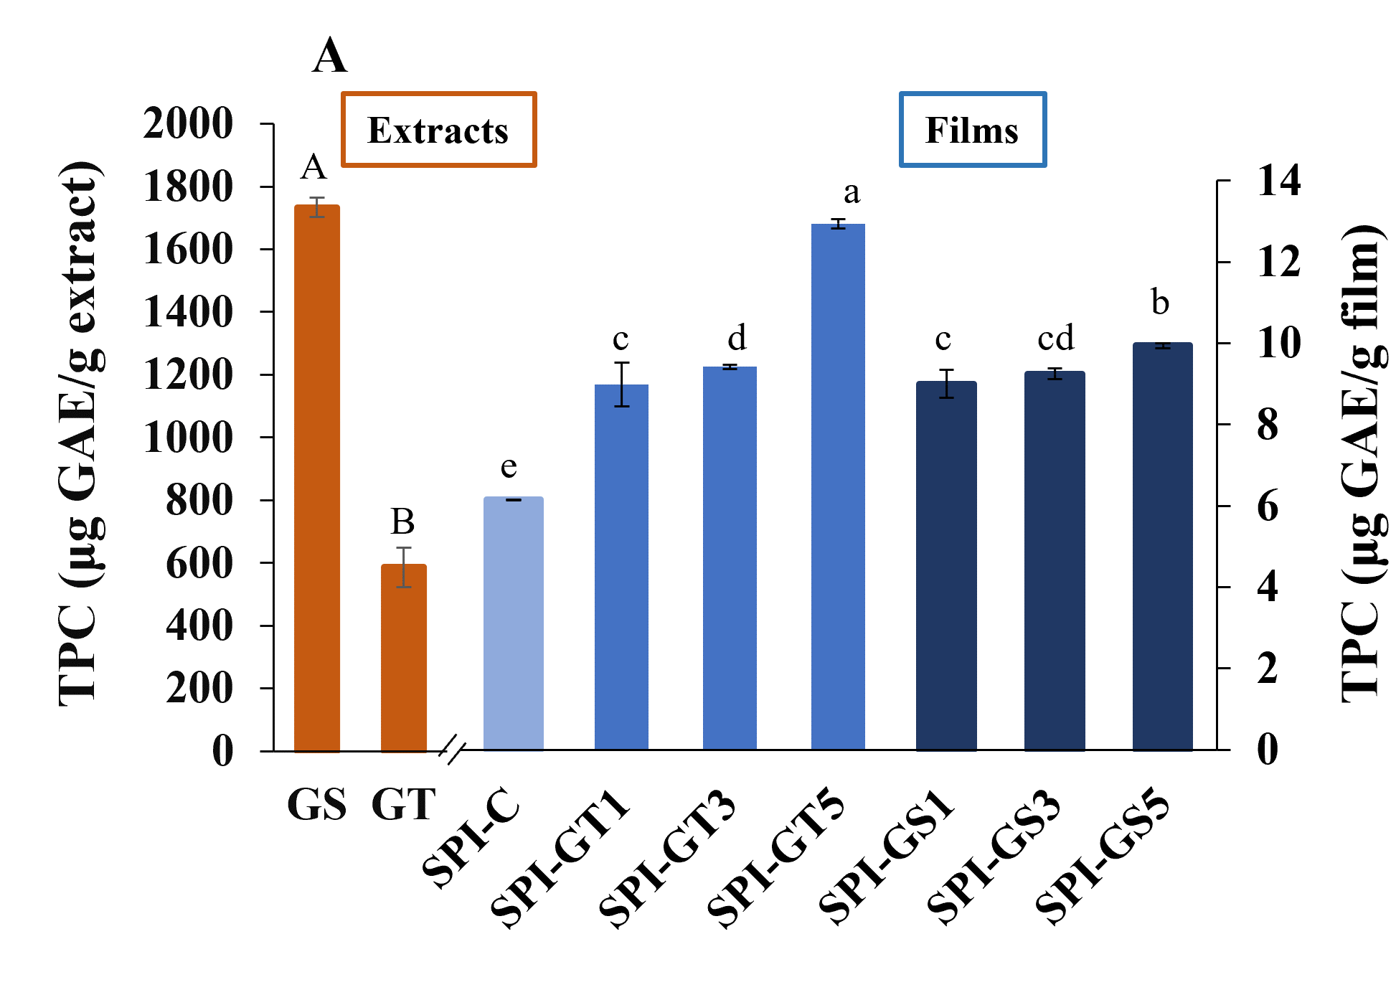
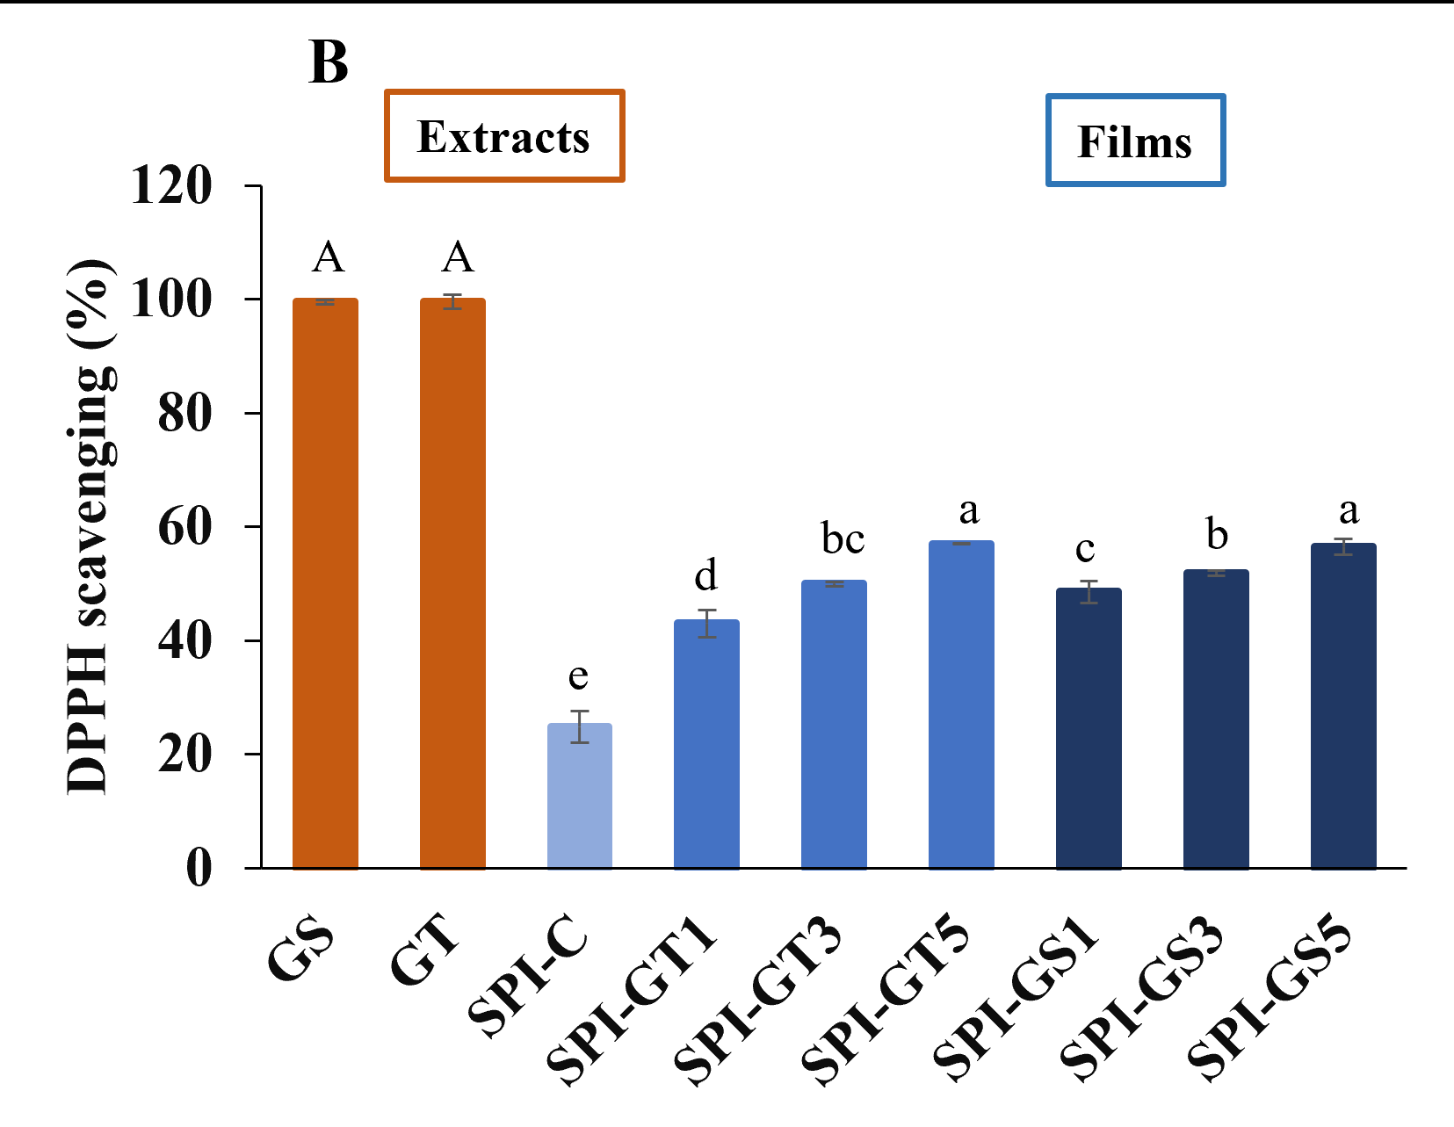

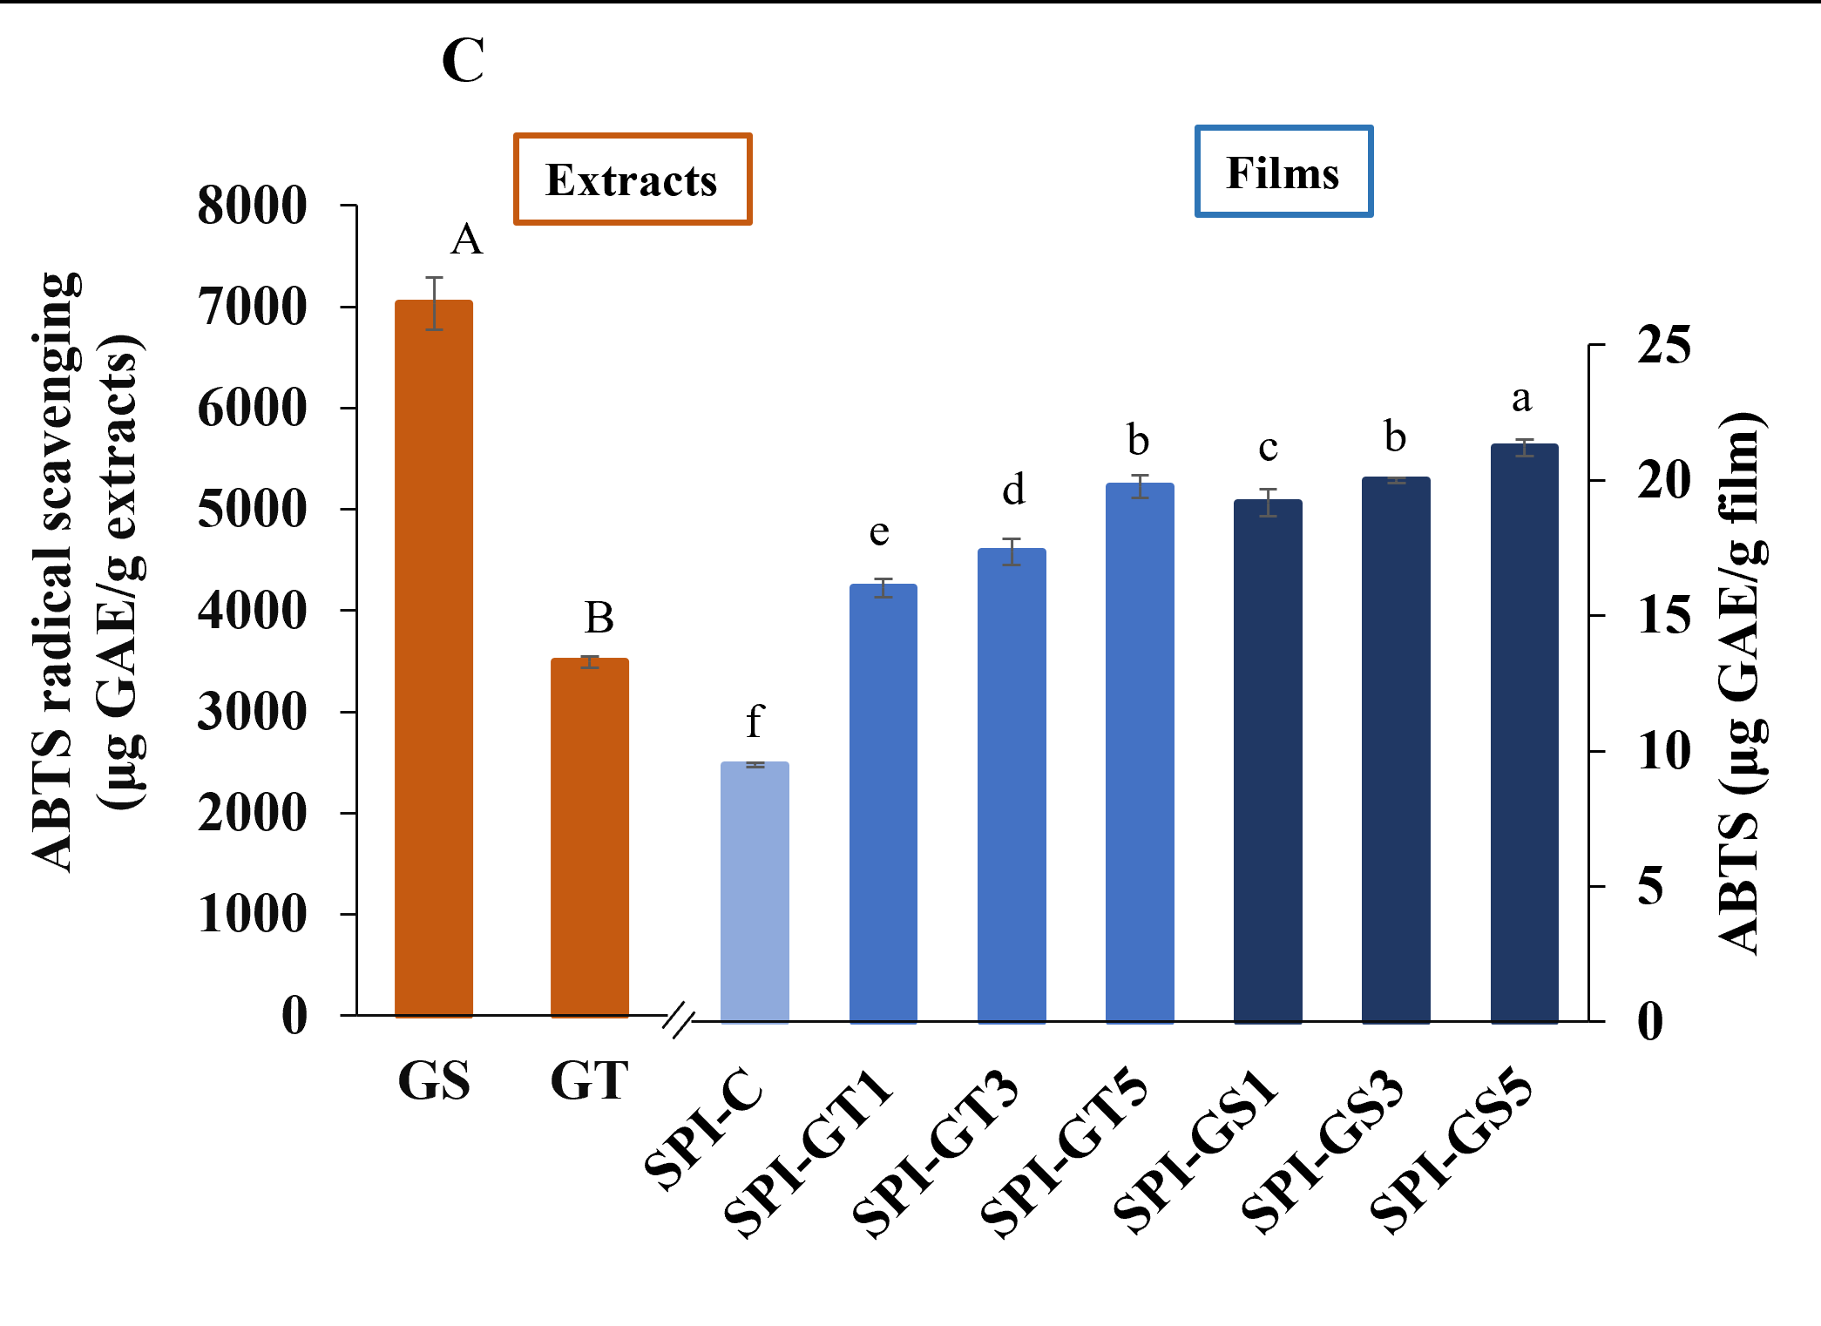
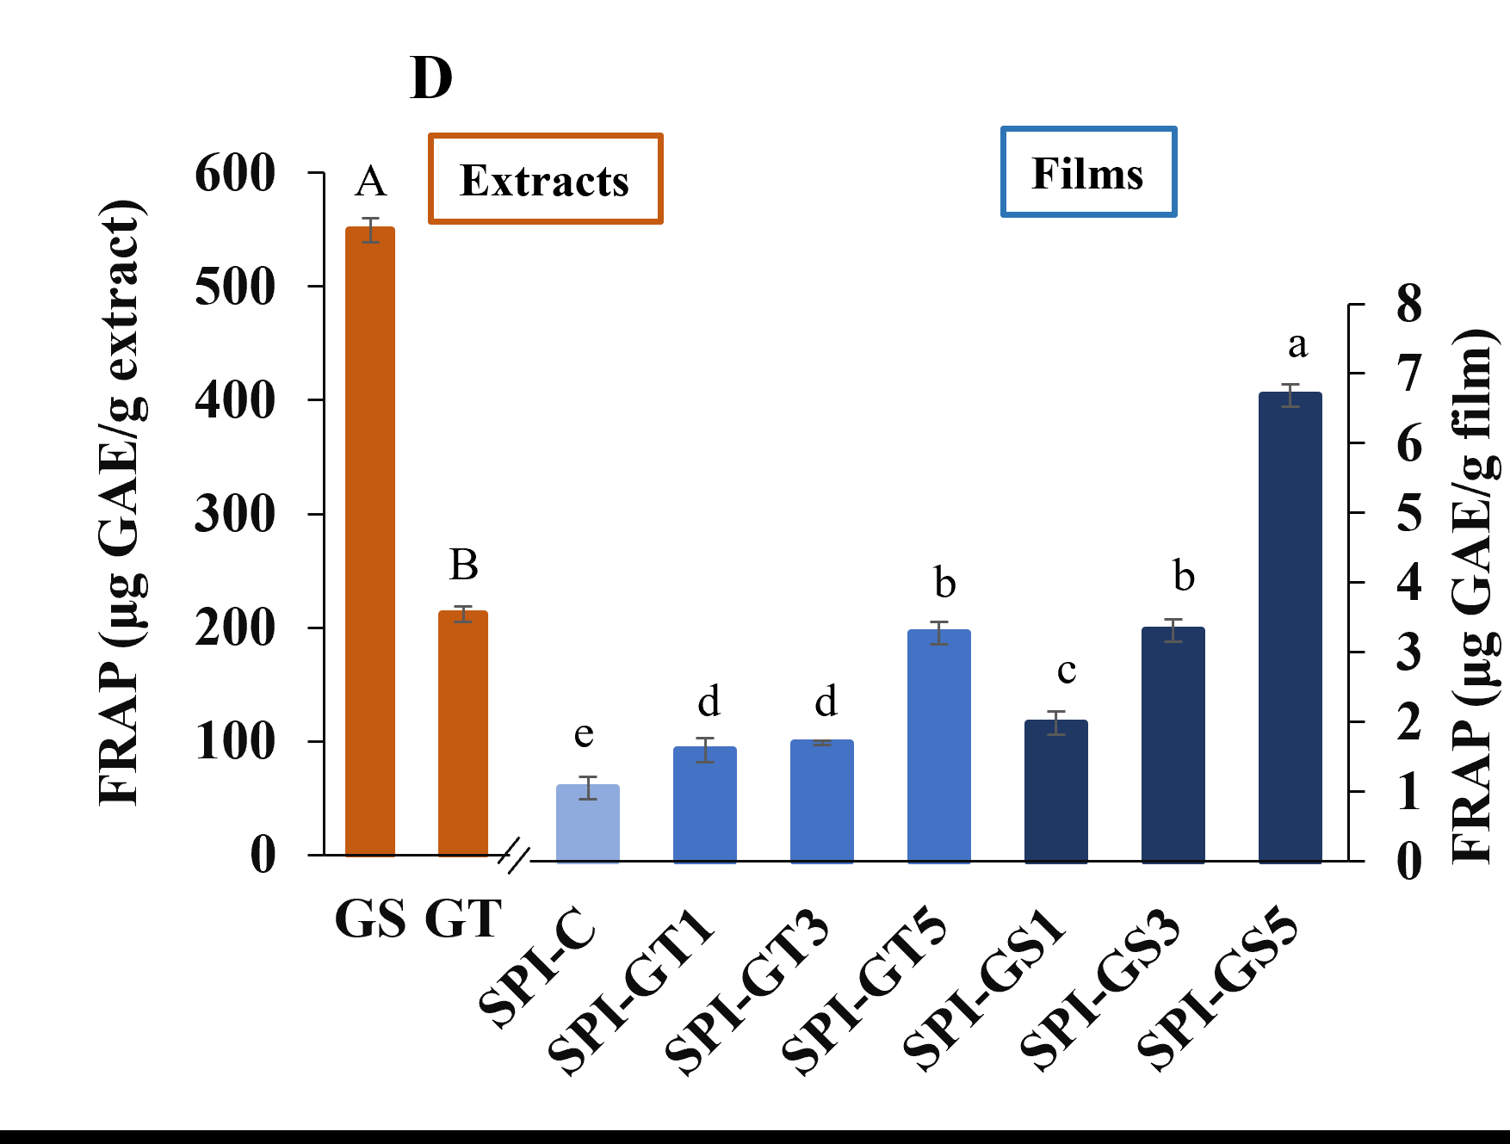

Figure 4.7. (A) Total phenolic content (TPC), (B) DPPH, (C) ABTS, and (D) FRAP antioxidant activities of the GS and GT extracts, and 3D-printed SPI films. Lowercase letters (comparison between 3D printed films); uppercase letters (comparison between pure extracts).
SPI: soy protein isolate; GS: grape seed extract; GT: green tea extract; SPI-C: 3D-printed SPI film; SPI-GS1,3,5: 3D-printed SPI film loaded with 1, 3, and 5% (w/w) GS; SPI-GT1,3,5: 3D-printed SPI film loaded with 1, 3, and 5% (w/w) GT.

5. OVERALL CONCLUSIONS
The soybean lots from mid-south USA: AR-R11-7999, MO-S17-19874R, and MO-S17-17168 were successfully used to prepare 3D printed edible soy protein films. The optimized condition from the RSM using the CCD were obtained for the soybean lot MO-S17-18874R. The verification of the optimized condition was performed with soybean lot MO-S17-19874R. The optimized condition was also used to prepare edible films using AR-R11-7999, and MO-S17-17168 for comparison purposes. The physical properties such as thickness, color, tensile and puncture strength, water activity, density, and elongation at break were quantified for the extruded film. While all the soy protein lots revealed statistically non-significant difference in physical properties of the 3D printed edible protein films, notably, AR-R11-7999 produced edible 3D printed soy protein films with the least average density value and MO-S17-19874R produced the highest average puncture strength value among the three lots. The water activity values of all the soy protein edible films proved that the resulting 3D printed films are food safe and resistant toward microbial growth.
In addition, the performance of 3D printing in generating edible soy protein films was examined as a function of phenolic extract type and concentration. The use of extracts altered the structural, mechanical, and antioxidant properties of SPI films by influencing protein-protein interactions and changing the rheological properties of SPI-based ink used in 3D printing. The effects of GS and GT on protein-protein interactions have been evaluated by FTIR. The second derivative of the FTIR spectra displayed changes in the absorption intensities of secondary structure components upon the addition of extracts. The incorporation of GS significantly affected the viscosity of the SPI-based ink, resulting in low printability of GS-loaded inks. The incorporation of GS or GT to SPI films considerably enhanced thickness, tensile strength, and antioxidant activity. Overall, this study describes a new flexible approach for fabricating edible films with high precision and flexibility while overcoming the limitations of the solution casting method. The discussion with local companies and Technology Commercialization Office at UADA are ongoing for patent application. Despite the advantages of 3D printing, information on the 3D printability of different biopolymers at different concentrations/temperatures is still scarce. Further research is needed to investigate the process scale-up, and the research team is looking for additional funding sources to bring this technology to the market that can add value to soy proteins from the Mid-South region.

