This report and any technical reports (no longer than 4 pages) or final deliverables (e.g., studies, reports, etc.) need to be uploaded to Smartsheet. These reports and deliverables are viewable by USB staff only.

For Progress Reports: You are also required to provide a Progress Summary. This item will be shared publicly, so it should contain non-proprietary, non-confidential information.

For Final Reports: You are also required to provide a Final Summary and Benefits to Soybean Farmers. These items will be shared publicly, so they should contain non-proprietary, non-confidential information.

The boxes to enter the summary/benefits information and to upload reports to Smartsheet can be accessed by clicking the “Open Request” button located in your Smartsheet email notification.
Project Title: | Development of climate-smart high-yielding practices associated with high-end biological treatments and soybean-related microbiome resiliency
Organization: | University of Texas at Arlington
Project Lead Name: | Woo-Suk Chang
Reporting Period:  Please select the appropriate reporting period for this report. | ☒ December ☐ March ☐ June ☐ September ☐ Final
During the 2025 growing season, we evaluated soybean performance under conventional tillage vs. no-till management across four states (TX, MS, MO, and AR) as shown in Table 1. Across sites, we examined soybean responses to three inoculant treatments (TXVA [drought-tolerant inoculant], First Up [commercial inoculant], and uninoculated control). We also quantified and compared the following parameters: biomass, plant height, and nodulation. Overall, the 2025 field season generated multi-state datasets that support direct comparisons of inoculation effects on soybean growth, nodulation, and yield performance under conventional tillage and no-till management. Harvest was not feasible at the Texas location due to Dicamba damage, and the no-till field in Arkansas was unsuitable for final yield assessment, presumably because of late planting. Nevertheless, both locations provided valuable in-season measurements that strengthen our evaluation of management impacts across diverse environments.

Table 1. Summary of the 2025 field trials (as of December 15, 2025).
Location | Collaborators | Planting Date | Sampling Date | Harvest Date | Cultivar Used | MG
Port Lavaca, TX | Dr. James Grichar | 4/9 | 7/1 | No Harvest* | Lynda-GT | INDT
Leland, MS | Dr. Tessie Wilkerson | 6/5 | 8/21 | 10/16 | AG49XF4 | 4L
Portageville, MO | Dr. Feng Lin | 6/11 | 8/20 | 11/5 | Ellis | 4L
Colt, AR | Dr. Shawn Clark | 6/25 | 8/20 | 11/15# | Ellis | 4L
* Due to the Dicamba damage, the both conventional tillage and no-till fields produced no yield.
# No harvest for the no-till field, presumably due to late planting.
At the field site in Portageville, MO, plants and root nodules were sampled on August 20 for nodulation and plant biomass assays (Figs. 1 and 2). Harvest has been completed; however, we are still in the process of calculating the final yield. In addition, plant biomass, plant height, and nodulation were analyzed for the Leland, MS, and Colt, AR sites (Figs. 3 - 6). As with Portageville, MO, final yield data for these locations will be reported in the next quarterly report.

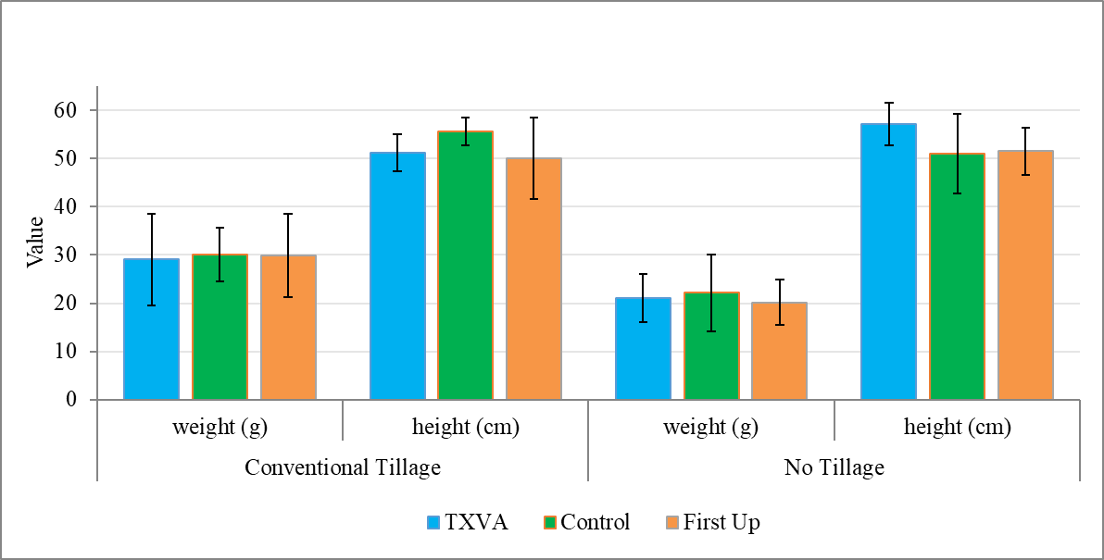
Figure 1. Soybean plant biomass (dry weight, g) and height (cm) in conventional tillage and no-till plots at Portageville, MO. The Ellis cultivar was planted under three treatments: TXVA (drought-tolerant inoculant), First-Up (commercial inoculant), or control (no inoculant).

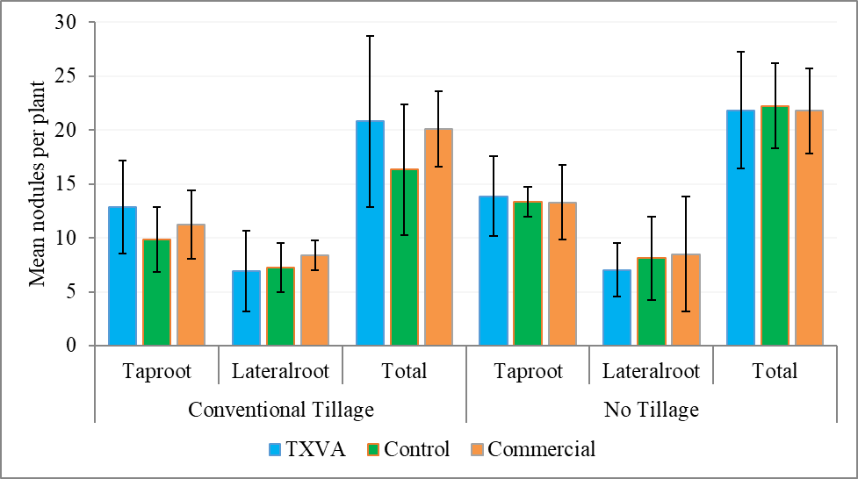
Figure 2. Soybean taproot, lateral root, and total nodule counts in conventional tillage and no-till plots at Portageville, MO. The Ellis cultivar was planted under three treatments: TXVA (drought-tolerant inoculant), First-Up (commercial inoculant), or control (no inoculant).

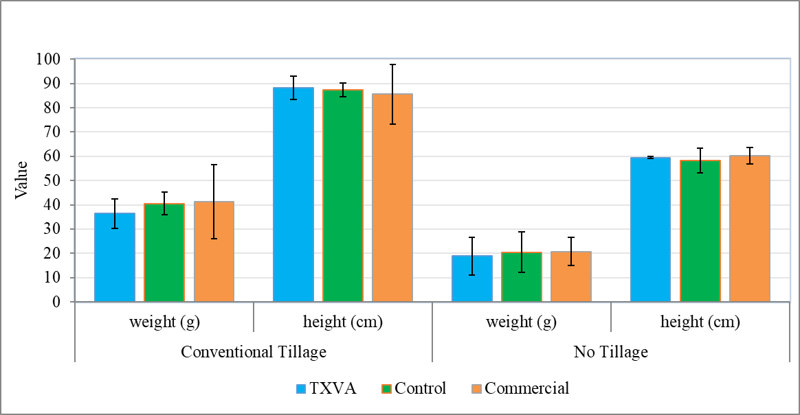
Figure 3. Soybean plant biomass (dry weight, g) and height (cm) in conventional tillage and no-till plots at Leland, MS. The AG49XF4 cultivar was planted under three treatments: TXVA (drought-tolerant inoculant), First-Up (commercial inoculant), or control (no inoculant).

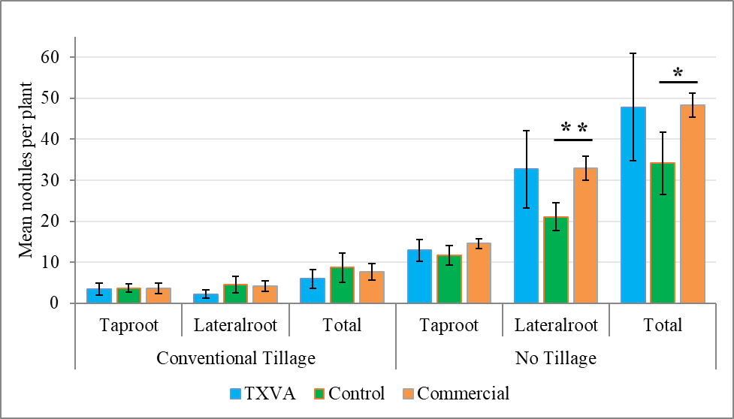
Figure 4. Soybean taproot, lateral root, and total nodule counts in conventional tillage and no-till plots at Leland, MS. The AG49XF4 cultivar was planted under three treatments: TXVA (drought-tolerant inoculant), First-Up (commercial inoculant), or control (no inoculant).

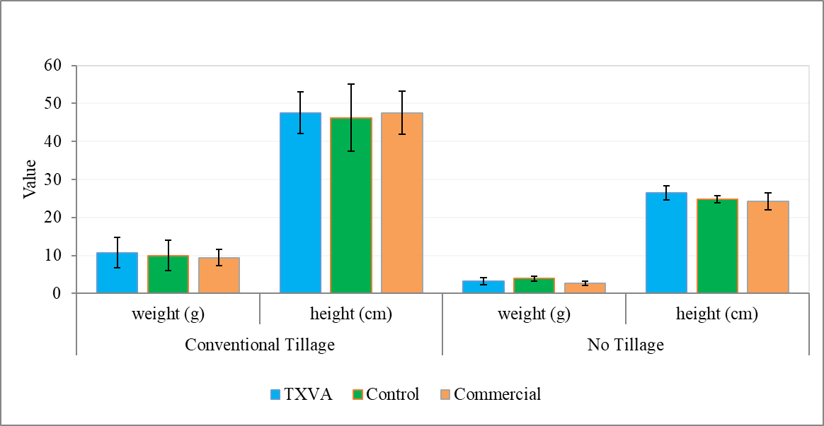

Figure 5. Soybean plant biomass (dry weight, g) and height (cm) in conventional tillage and no-till plots at Colt, AR. The Ellis cultivar was planted under three treatments: TXVA (drought-tolerant inoculant), First-Up (commercial inoculant), or control (no inoculant).

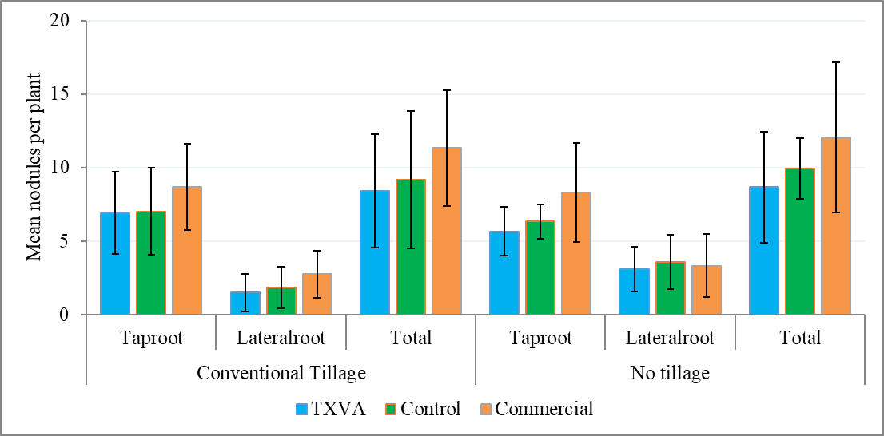

Figure 6. Soybean taproot, lateral root, and total nodule counts in conventional tillage and no-till plots at Colt, AR. The Ellis cultivar was planted under three treatments: TXVA (drought-tolerant inoculant), First-Up (commercial inoculant), or control (no inoculant).

