Project Number: | 1720-172-0122
Project Title: | Effects of the Introduction of Feed Grains into Mid-South Soybean Production Systems
Organization: | Mississippi State University
Principal Investigator Name: | John Orlowski and Bobby Golden

Project Status - What key activities were undertaken and what were the key accomplishments during the life of this project? Please use this field to clearly and concisely report on project progress. The information included should reflect quantifiable results (expand upon the KPIs) that can be used to evaluate and measure project success. Technical reports, no longer than 4 pages, may be included in this section.
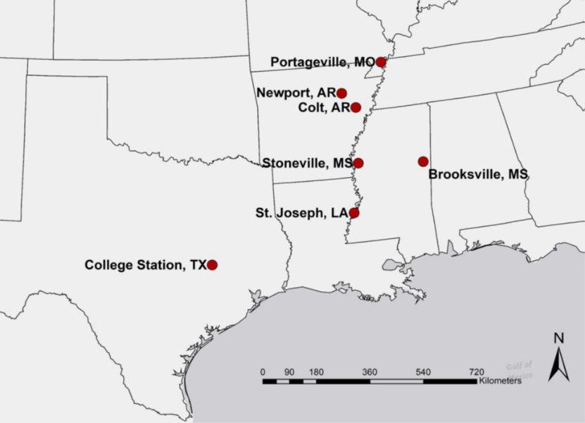
This project was started in 2014 and completed 4 years by 2017. During this period the rotational studies were established at seven locations across five states in the Mid-South Unites States (Figure 1).
Figure 1. Map of Mid-south US showing study locations
Twelve rotations were established including both irrigated and dryland rotations (Figure 2). Two residue management treatments were also included in this study. Corn and sorghum residues were either burned or left as it is after crop harvest. The rotations included in study were:
- Irrigated Continuous Corn- corn planted every year
- Irrigated Continuous Soybean- MG 4 soybean planted every year
- Irrigated 1:1 Soybean to Corn- MG 4 soybean planted in one year followed by corn the next year
- Irrigated 2:1 Soybean to Corn- MG 4 soybean planted two years in a row followed by corn
- Irrigated 1:2 Soybean to Corn- MG 4 soybean planted one year followed by two years of corn
- Dryland Continuous Corn- corn planted every year
- Dryland Continuous Soybean- MG 4 soybean planted every year
- Dryland 1:1 Soybean to Corn- MG 4 soybean planted in one year followed by corn the next year
- Dryland 1:1 Soybean to Grain Sorghum- MG 4 soybean planted one year followed by grain sorghum the next year
- Dryland Continuous Grain Sorghum- grain sorghum planted every year
- Corn/Wheat/DC Soybean- Corn planted in the first year. After corn harvest wheat is planted and the harvested the following year. After wheat is harvested, double crop soybeans are planted and harvested in the same year.
- Corn/Soybean/Wheat/DC Soybean- Corn is planted the first year. Soybeans are planted the second year. Following soybean harvest, wheat is planted. The wheat is harvested in the third year and then double crop soybeans are planted after wheat harvest.
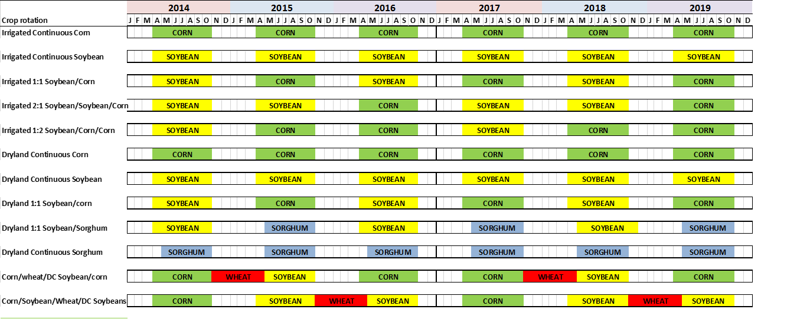
Figure 2. Crop rotations used in this study

The 2-yr crop rotations including 1:1 Soybean/Corn and 1:1 Soybean/Sorghum, completed 2 rotation cycles by 2017. The three year rotations (Irrigated 2:1 Soybean to Corn and Irrigated 1:2 Soybean to Corn) completed only first rotation cycle in 2016 and second rotation cycle will be completed in 2019. All crop rotations do not have each crop every year. Consequently, the yields were compared separately across crop rotation for each year and location.

Results
Corn and Soybean Yields
The crop yields from 2014 are not included in this report as it was the first year of all rotations and no comparisons can be made for rotation effect in 2014. Data was averaged over residue management treatments due to absence of any interaction between crop rotations and residue management treatments. Only corn and soybean yield data is presented in this report.
- Portageville, MO
No significant differences were obtained for corn yields in Portageville, MO across crop rotations in 2015 and 2017 (Table 1). In 2016, the irrigated continuous corn rotation had 2.2 Mg ha⁻¹ greater corn yield than the dryland continuous corn rotations. Soybean responded to irrigation application in 2015 and 2016 which resulted in higher yields from irrigated crop rotations compared to dryland crop rotation (Table 2). Among dryland crop rotations in 2016 (third year of rotation), the 1:1 soybean/corn and 1:1 soybean/sorghum rotations resulted into 0.9-1.2 Mg ha⁻¹ greater yield than the continuous soybean rotation. Soybean yield data from 2017 growing season is not included in Table 2 as 2017 soybean yield data is not received from cooperators from Missouri.
- Colt, AR
Corn and soybean yields responded to irrigation application in 2015. As a result, the irrigated crop rotations had higher yields than the dryland rotations. In 2016, the irrigated 2:1 Soybean/Corn rotation increased corn yield by 0.2 Mg ha⁻¹ than the 1:2 Soybean/Corn rotation. The soybean yield was increased by 0.6 Mg ha⁻¹ when soybean followed corn (1:1 Soybean/Corn) compared to rotation where soybean followed sorghum (1:1 Soybean/Sorghum) under dryland production conditions. However, none of these rotations yielded greater than the dryland continuous soybean rotation.
- Newport, AR
Similar to Colt, AR, the irrigated 2:1 Soybean/Corn rotation increased corn yield by 1.0 Mg ha⁻¹ than the 1:2 Soybean/Corn rotation in 2016. Soybean yields responded to irrigation application in 2015 and 2016. As a result, the irrigated crop rotations had higher soybean yields than the dryland rotations. The corn and soybean yields from 2017 season are not presented in tables 1 and 2 because data is not yet received from the AR.
- Stoneville, MS
Only differences obtained for corn grain yields in 2015 and 2016 was due to irrigation, with irrigated crop rotations having higher yields than the dryland rotations (Table 1). Similar to Portageville, MO, the dryland 1:1 Soybean/Corn rotation had 2.3 Mg ha⁻¹ greater corn yield than the dryland continuous corn rotation by the fourth year of the rotations in 2017. Soybean yields also responded to irrigation in all years of this study. Irrigated rotations had higher soybean yields than the dryland rotations (Table 2).
- St. Joseph, LA
The irrigated 1:1 Soybean/Corn rotation had 2.0 and 0.7 Mg ha⁻¹ greater corn yield than the irrigated continuous corn rotation in 2015 and 2017, respectively (Table 3). No differences were found for corn yields in 2016 among crop rotations. During the first years of this study, the soybean yields showed no differences between the crop rotations. However, the soybean following corn had 0.4 Mg ha⁻¹ greater yield than the soybean following soybean under irrigated conditions (Table 4).
- College Station, TX
The irrigated 1:1 Soybean/Corn rotation had 2.5 and 0.8 Mg ha⁻¹ greater corn yield than the irrigated continuous corn rotation in 2015 and 2017, respectively (Table 3). Also, 1:2 Soybean/Corn rotation resulted into 2 Mg ha⁻¹ greater yield than irrigated continuous corn rotation in 2016. Corn plants suffered from waterlogged soils in 2016 and consequently, corn yields were low compared to previous years. However, no such benefit of crop rotation compared to continuous rotation was obtained under dryland conditions. In 2017, the dryland crop rotations had higher corn grain yields than irrigated crop rotations.
Soybean yields were affected by dicamba drift in 2014. In 2015, excessive rainfall in the spring delayed planting and plant development which pushed flowering and seed development as much as 2 weeks back and into the hottest part of July and August that reduced soybean yields significantly (Table 4). In 2016, excessive rainfall during period of 3-weeks caused rotting of seed in the pod which resulted into extremely low soybean yields (Table 4). Wet soil conditions and hurricane Harvey in August this year caused complete yield loss for soybean crop. The plots had 18” of standing in plots due to 20” of rain from hurricane Harvey. Soybean plants had pods, but mostly they were flat, seedless and whatever seed was there is rooted due to wet conditions (Figure 3).
Economic Analysis
Economic analysis is conducted for only Stoneville, MS location. Net returns were calculated by subtracting total specified cost from gross revenue. Gross revenue was calculated by multiplying crop yields with crop prices obtained from USDA-NASS for Mississippi state. The total specified cost per acre were obtained from the Mississippi State University Budgets for delta region prepared by the Department of Agricultural Economics (Budget report 2015, 2016, 2017). The total specified cost included costs for all field operations and crop inputs used.
After 2 complete cycles of 2-yr rotations, the 1:1 Soybean/Corn rotation provided same net returns as obtained from the continuous corn and continuous soybean rotation under irrigated conditions (Table 5). Under dryland conditions, the 1:1 Soybean/Corn rotation provided $537 and $419 higher net return than the continuous soybean and 1:1 Soybean/Sorghum rotations in Stoneville, MS. The 3-yr rotation 1:2 Soybean/Corn provided similar net returns as obtained from continuous corn or soybean rotations. However, the 2:1 Soybean/Corn rotation had $465 and $270 less net returns than the irrigated continuous corn and continuous soybean rotations, respectively (Table 6).
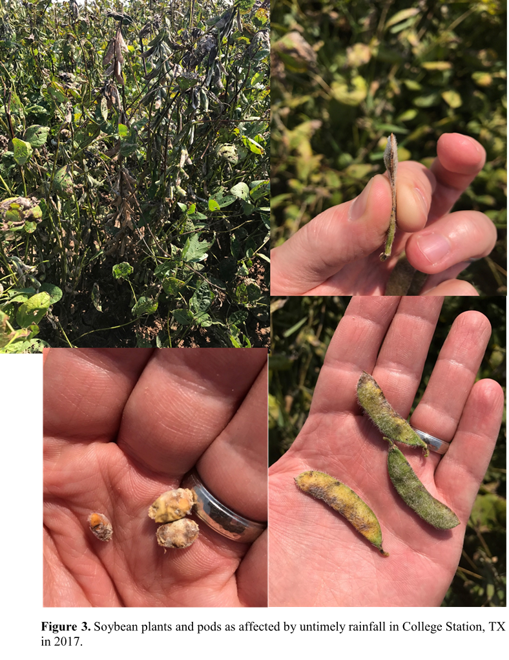

Table 1. Corn grain yields as affected by the crop rotations at different locations in MO, AR and MS.
Location | Crop Rotation | Years of Rotation
 |  | 2nd | 3rd | 4th
 |  | (2015) | (2016) | (2017)
 |  | --------------------------Mg ha⁻¹----------------------------
Portageville, MO | Irrigated Continuous Corn | 7.6a* | 10.0a | 11.2a
 | Irrigated 1:1 Soybean/Corn | 9.7a | - | -
 | Irrigated 2:1 Soybean to Corn | - | 10.1a | -
 | Irrigated 1:2 Soybean to Corn | 8.8a | 9.0ab | -
 | Dryland Continuous Corn | 7.1a | 7.8b | 10.7a
 | Dryland 1:1 Soybean/Corn | 8.9a | - | -
Colt, AR | Irrigated Continuous Corn | 9.0a | 10.1ab
 | Irrigated 1:1 Soybean/Corn | 9.4a | -
 | Irrigated 2:1 Soybean to Corn | - | 10.4a
 | Irrigated 1:2 Soybean to Corn | 9.7a | 10.2b
 | Dryland Continuous Corn | 7.2b | 1.7c
 | Dryland 1:1 Soybean/Corn | 6.9b | -
Newport, AR | Irrigated Continuous Corn | 9.3ab | 4.1ab
 | Irrigated 1:1 Soybean/Corn | 9.9a | -
 | Irrigated 2:1 Soybean to Corn | - | 4.8a
 | Irrigated 1:2 Soybean to Corn | 10.0a | 3.8b
 | Dryland Continuous Corn | 8.0b | 0.8c
 | Dryland 1:1 Soybean/Corn | 8.2ab | -
Stoneville, MS | Irrigated Continuous Corn | 11.8a | 11.8a | 10.8ab
 | Irrigated 1:1 Soybean/Corn | 11.4a | - | 9.4b
 | Irrigated 2:1 Soybean to Corn | - | 10.1ab | -
 | Irrigated 1:2 Soybean to Corn | 11.7a | 10.4a | -
 | Dryland Continuous Corn | 9.3ab | 7.7b | 9.8b
 | Dryland 1:1 Soybean/Corn | 8.5b | - | 12.1a
*Means within a column followed by the same letter are not significantly different at P ≤ 0.05.
Table 2. Soybean yields as affected by the crop rotations at different locations in MO, AR and MS.
Location | Crop Rotation | Years of Rotation
 |  | 2nd | 3rd | 4th
 |  | (2015) | (2016) | (2017)
 |  | --------------------------Mg ha⁻¹----------------------------
Portageville, MO | Irrigated Continuous Soybean | 4.6a* | 2.9a
 | Irrigated 1:1 Soybean/Corn | - | 3.1a
 | Irrigated 2:1 Soybean to Corn | 4.6a | -
 | Irrigated 1:2 Soybean to Corn | - | -
 | Dryland Continuous Soybean | 3.4b | 2.1b
 | Dryland 1:1 Soybean/Corn | - | 3.0a
 | Dryland 1:1 Soybean/Sorghum | - | 3.3a
Colt, AR | Irrigated Continuous Soybean | 3.0a | 3.6a
 | Irrigated 1:1 Soybean/Corn | - | 3.6a
 | Irrigated 2:1 Soybean to Corn | 3.0a | -
 | Irrigated 1:2 Soybean to Corn | - | -
 | Dryland Continuous Soybean | 1.4b | 2.4bc
 | Dryland 1:1 Soybean/Corn | - | 2.4b
 | Dryland 1:1 Soybean/Sorghum | - | 1.8c
Newport, AR | Irrigated Continuous Soybean | 3.9a | 3.5a
 | Irrigated 1:1 Soybean/Corn | - | 3.8a
 | Irrigated 2:1 Soybean to Corn | 3.9a | -
 | Irrigated 1:2 Soybean to Corn | - | -
 | Dryland Continuous Soybean | 3.1b | 1.6b
 | Dryland 1:1 Soybean/Corn | - | 1.6b
 | Dryland 1:1 Soybean/Sorghum | - | 1.6b
Stoneville, MS | Irrigated Continuous Soybean | 2.4a | 4.6a | 3.6a
 | Irrigated 1:1 Soybean/Corn | - | 5.1a | -
 | Irrigated 2:1 Soybean to Corn | 2.4a | - | 4.0a
 | Irrigated 1:2 Soybean to Corn | - | - | 3.5a
 | Dryland Continuous Soybean | 1.3b | 3.5b | 1.7b
 | Dryland 1:1 Soybean/Corn | - | 3.9b | -
 | Dryland 1:1 Soybean/Sorghum | - | 4.0b | -
*Means within a column followed by the same letter are not significantly different at P ≤ 0.05.

Table 3. Corn grain yields as affected by the crop rotations at St. Joseph, LA and College Station, TX.
Location | Crop Rotation | Years of Rotation
 |  | 2nd | 3rd | 4th
 |  | (2015) | (2016) | (2017)
 |  | --------------------------Mg ha⁻¹----------------------------
St. Joseph, LA | Irrigated Continuous Corn | 9.3c* | 9.3a | 11.8b
 | Irrigated 1:1 Soybean/Corn | 11.3ab | - | 12.5a
 | Irrigated 2:1 Soybean to Corn | - | -
 | Irrigated 1:2 Soybean to Corn | 10.0bc | 11.3a
 | Dryland Continuous Corn | 12.3a | 10.9a | 11.8b
 | Dryland 1:1 Soybean/Corn | - | -
College Station, TX | Irrigated Continuous Corn | 6.3b | 6.2b | 10.4c
 | Irrigated 1:1 Soybean/Corn | 8.8a | - | 11.2b
 | Irrigated 2:1 Soybean to Corn | - | -
 | Irrigated 1:2 Soybean to Corn | 8.3a | 8.2a
 | Dryland Continuous Corn | 5.4b | 7.4ab | 11.1a
 | Dryland 1:1 Soybean/Corn | 6.1b | - | 12.3a
*Means within a column followed by the same letter are not significantly different at P ≤ 0.05.

Table 4. Soybean yields as affected by the crop rotations at St. Joseph, LA and College Station, TX.
Location | Crop Rotation | Years of Rotation
 |  | 2nd | 3rd | 4th
 |  | (2015) | (2016) | (2017)
 |  | --------------------------Mg ha⁻¹----------------------------
St. Joseph, LA | Irrigated Continuous Soybean | 3.3a* | 1.9a | 3.8b
 | Irrigated 1:1 Soybean/Corn | - | 2.0a | -
 | Irrigated 2:1 Soybean to Corn | 3.3a | - | -
 | Irrigated 1:2 Soybean to Corn | - | - | 4.2a
 | Dryland Continuous Soybean | 3.6a | 1.9a | 3.6b
 | Dryland 1:1 Soybean/Corn | - | - | -
 | Dryland 1:1 Soybean/Sorghum | - | - | -
College Station, TX | Irrigated Continuous Soybean | 2.1a | 0.13 | -
 | Irrigated 1:1 Soybean/Corn | - | 0.12 | -
 | Irrigated 2:1 Soybean to Corn | 2.1a | - | -
 | Irrigated 1:2 Soybean to Corn | - | - | -
 | Dryland Continuous Soybean | 1.4a | 0.13 | -
 | Dryland 1:1 Soybean/Corn | - | 0.10 | -
 | Dryland 1:1 Soybean/Sorghum | - | 0.08 | -
*Means within a column followed by the same letter are not significantly different at P ≤ 0.05.

Table 5. Net returns of different crop rotation in Stoneville, MS.
Crop Rotation | Years of rotation |  |  |  | Total Net Returns
 | 1st | 2nd | 3rd | 4th | 2 yrs | 4 yrs
 | (2014) | (2015) | (2016) | (2017) | (2014, 2015) | (2014 to 2017)
 | ----------------------------------------------------$ Acre⁻¹---------------------------------
Irrigated Continuous Corn | 516 | 291 | 238 | 194 | 807a* | 1239a
Irrigated Continuous Soybean | 379 | 70 | 401 | 258 | 448c | 1107ab
Irrigated 1:1 Soybean/Corn | 387 | 262 | 472 | 109 | 649ab | 1230a
Dryland Continuous Corn | 566 | 222 | 100 | 215 | 788a | 1103ab
Dryland Continuous Soybean | 390 | -2 | 322 | 62 | 388c | 772c
Dryland 1:1 Soybean/Corn | 401 | 169 | 387 | 352 | 570bc | 1309a
Dryland 1:1 Soybean-Sorghum | 377 | 28 | 391 | 94 | 405c | 890bc
*Means within a column followed by the same letter are not significantly different at P ≤ 0.05.
Table 6. Net returns of 3-yr crop rotations as compared to continuous crop rotation in Stoneville, MS.
Crop Rotation | Years of rotation |  |  | Total Net Returns
 | 1st | 2nd | 3rd | 3 yrs
 | (2014) | (2015) | (2016)
 | -----------------------------------------$ Acre⁻¹-----------------------------------------
Irrigated Continuous Corn | 516 | 291 | 238 | 1044a*
Irrigated Continuous Soybean | 379 | 70 | 401 | 849ab
Irrigated 2:1 Soybean/Corn | 380 | 65 | 133 | 579c
Irrigated 1:2 Soybean/Corn | 393 | 285 | 155 | 834abc
Dryland Continuous Corn | 566 | 222 | 100 | 888ab
Dryland Continuous Soybean | 390 | -2 | 322 | 710bc
*Means within a column followed by the same letter are not significantly different at P ≤ 0.05.

Did this project meet the intended Key Performance Indicators (KPIs)? List each KPI and describe progress made (or not made) toward addressing it, including metrics where appropriate.
- Rotational partners influence on soybean yield stability in the Mid-South is determined by the end of FY2017 and documented through published manuscripts, extension materials, and meeting presentations.
Since the final yield data from 2017 has not yet been received from all study locations, manuscripts and extension materials cannot be finalized. Crop inputs data needed for economic analysis and soil samples for 2017 season is not yet received from all study locations. To publish this crop rotation data in peer-reviewed journals, data for >2 complete rotation cycles is needed. The most up-to-date data was presented at the American Society of Agronomy conference in Tampa, Florida and was also published as extension article in Delta Research and Extension Center 2017 annual report. Data will also be presented at the extension meetings across the states participating in the study.
- The influence of various soybean rotational partners on economic stability in the Mid-South is determined during FY2017 and documented through publications and extension materials
Crop yields and field operations or inputs data needed for economic analysis for 2017 season is not yet received from all study locations. Therefore, manuscripts cannot be finalized at this time. The most up-to-date data was presented at the American Society of Agronomy conference in Tampa, Florida.
- Complete observations of crop development, weather data, management history, yield, and shifting pest pressures for all locations for the 6-year study are provided as supplementary material to the published manuscripts.
This information is currently being collected and archived. It will be made available with the appropriate manuscripts and publications.
- All data is made available on the MSSB and participating QSSBS websites by the end of FY 2017.
When the final yield data is collected and verified for 2017, we will begin the process of posting the relevant information to both the MSSB and QSSB websites.
- The economic risk assessment of achieving various yield levels for different soybean rotational partners is defined at representative sites using long-term weather data, trial yields, and commodity input tracking.
This is in the process of being completed.
- Farmer-friendly summary of the project is prepared by the end of FY 2017 that can serve as a decision-making guide for soybean rotation partner selection for the mid-south and for a particular location based on agronomic and economic information obtained from the trial.
When the final yield data from 2017 will be received and verified from all rotations, the project summary for the first three years of the rotation will be finalized.

Expected Outputs/Deliverables - List each deliverable identified in the project, indicate whether or not it was supplied and if not supplied, please provide an explanation as to why.
- Determine the optimum agronomic rotation for sustainable Mid-South soybean production.
This deliverable is in the process of being supplied. Being a rotation study, multiple cycles of the rotational systems need to be evaluated. The second rotational cycles for 2-yr rotations are being completed this fall, so we will be able to draw some initial conclusions about the optimum rotations for Mid-South soybean production systems. The next 3 to 6 years of this study will be key to fully supplying this deliverable.
- Build an economic database to describe the risk associated with each soybean rotation system commonly used in the Mid-South.
Similar to the first deliverable, this deliverable is in the process of being supplied. Evaluation of risk requires information from multiple rotational cycles across multiple environments. The database is currently being complied and additional data will be added to the database as the study progresses. The next 3 to 6 years of this study will be key to fully supplying these deliverables.
- Define the influence of feed grain residue management on succeeding soybean yield and pest pressures.
Similar to the other deliverables, this is in the process of being supplied. Aside from the yield and economic analysis being collected, residue samples have been collected from corn and grain sorghum plots at multiple locations over the past years and will be processed to determine the amount of nutrients lost when residue is burned.

Describe any unforeseen events or circumstances that may have affected project timeline, costs, or deliverables (if applicable.)

What, if any, follow-up steps are required to capture benefits for all US soybean farmers? Describe in a few sentences how the results of this project will be or should be used.

So far, we only have data for 2 complete cycles of 2-yr rotations (1:1 soybean/corn and 1:1 soybean/sorghum) and 1 complete cycle of three rotations (2:1 or 1:2 soybean/corn). We have started seeing beneficial effects of crop rotations mostly at all locations by fourth year (2017) of this study. Therefore, the major follows up step for this project is the continuation of the project for multiple rotational cycles for next 3 to 6 years to provide strong conclusions about the impact of crop rotations in the mid-south US. More data is needed to confirm the long-term effects of crop rotation on yields and soil properties.
List any relevant performance metrics not captured in KPI’s.

