Please use this form to clearly and concisely report on project progress. The information included should reflect quantifiable results that can be used to evaluate and measure project success. Comments should be limited to the designated boxes. Technical reports, no longer than 4 pages, may be attached to this summary report.
Project Title: | Evaluation of a novel drought-tolerant inoculant on soybean yield in the Mid-South
Organization: | University of Texas at Arlington
Principal Investigator Name: | Woo-Suk Chang
Report Period: | June 16, 2019 – September 15, 2019

Project Status - What key activities were undertaken and what were the key accomplishments during this quarter? Please use this field to clearly and concisely report on project progress. Limit 5,000 characters.
During this report period, we finally set up the field trial in Stuttgart, AR on July 2nd. The planting date has been delayed due to the weather condition. Detailed plot design and experimental conditions are described in the Technical Report attached. In addition to that, we collected root nodule samples from Yoakum in TX, Jackson in TN, Clarkton in MO, Winnsboro in LA, Stoneville in MS, and Stuttgart in AR. Sampling date for each location is described in Technical Report attached. We are in the process of data analysis for properties of nodules (e.g., nodule numbers, nodule locations, and nodule size).

The objective of this project is to evaluate the effects of the TXVA strain (a drought-tolerant inoculant) on soybean yield in comparison to the commercial inoculant Cell-Tech™ and a non-inoculated control under irrigated and non-irrigated conditions. It has been well established that the microorganism Bradyrhizobium japonicum has a beneficial impact on soybean plants. Previously, we isolated TXVA strain that showed outstanding performance in nodulation, nitrogen fixation, and enhancing plant growth and production. To improve the inoculants’ performance and optimize the benefits of biological nitrogen fixation in the Mid-South, we set up field trials to evaluate the effects of the drought-tolerant inoculant on soybean yield at drought-prone sites. For the first year trial (year 2019), three inoculation treatments (drought-tolerant inoculant TXVA, commercial inoculant Cell-Tech, and no inoculation) will be compared under irrigated vs. non-irrigated conditions at drought prone sties in the Mid-South. At the first sampling, the number of nodules per plant will be counted and nodule size will be measured. A second harvest of plants will be performed to evaluate final soybean seed production. The climate and weather factors (e.g., precipitation, temperature, and humidity) for each location will also be monitored.

At the completion of the proposed research, we expect to provide positive effects of the drought-tolerant inoculant on soybean profitability and aid Mid-South producers in better understanding of the potential benefits for biological nitrogen fixation. We believe that providing such information will allow soybean producers to advance the management of soybean plants and inoculants for economical and ecological benefits.

Technical Report

Texas A&M AgriLife Research Plot – Yoakum, Texas.
- Plant date: 4/2
- Nodule harvest date: 5/22
- Final harvest date: 9/6
- Soil type: Tremona loamy fine sand
- Seed variety: S52RS86
- Previous crop: Peanuts
- Row spacing: 38”
- Treatments: TXVA, Cell-Tech, no inoculant in both irrigation and non-irrigation conditions.

In collaboration with Dr. James Grichar, a senior research scientist at Texas A&M AgriLife research, we collected nodule samples from each plot. Sampling was done randomly. Figure 1 shows plot design and figures 2, 3, and 4 show nodule enumeration, size measurement, and representative images of root nodules formed by rhizobia, respectively.
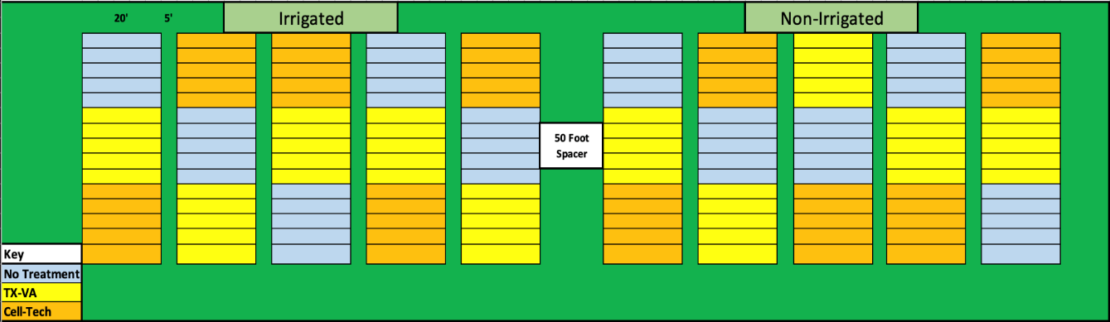
Figure 1. Plot layout in Yoakum, TX

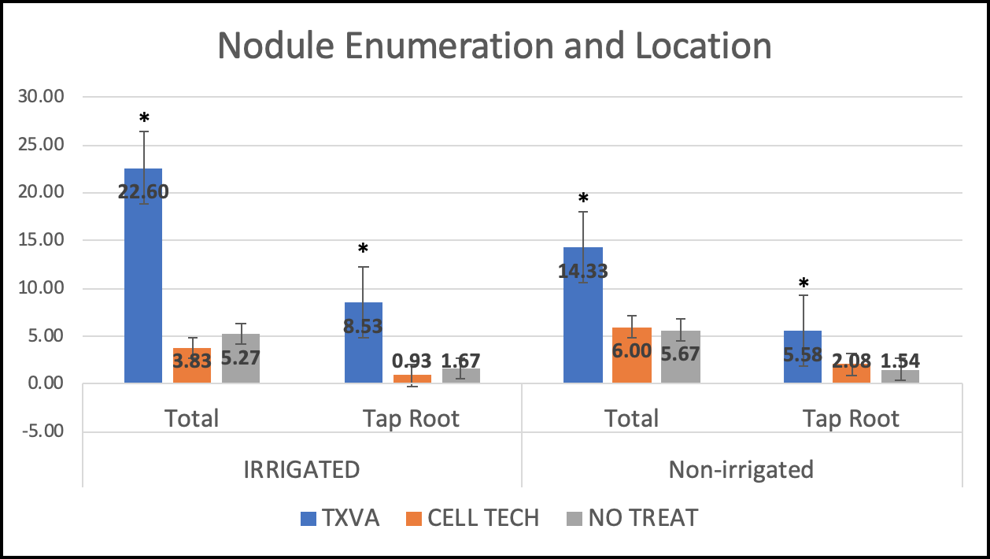

Figure 2. Nodule enumeration shows significantly more nodules for TXVA under both conditions on root mass itself as well as Taproot, which is indicative of proper inoculation. Asterisk indicates P < 0.05.

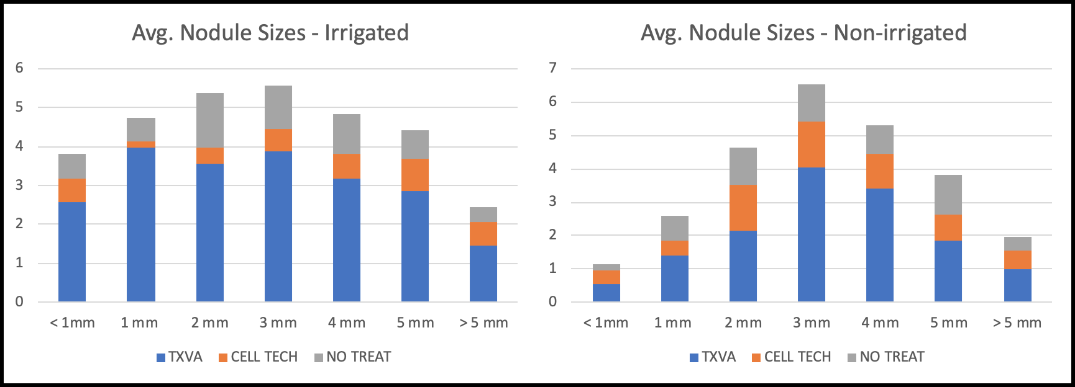

Figure 3. Nodule sizes from each treatment. Note that TXVA establishes larger nodules (1 and 3 mm in irrigated, 3 mm in non-irrigated) as compared to Cell-Tech which has an even disbursement of nodule.

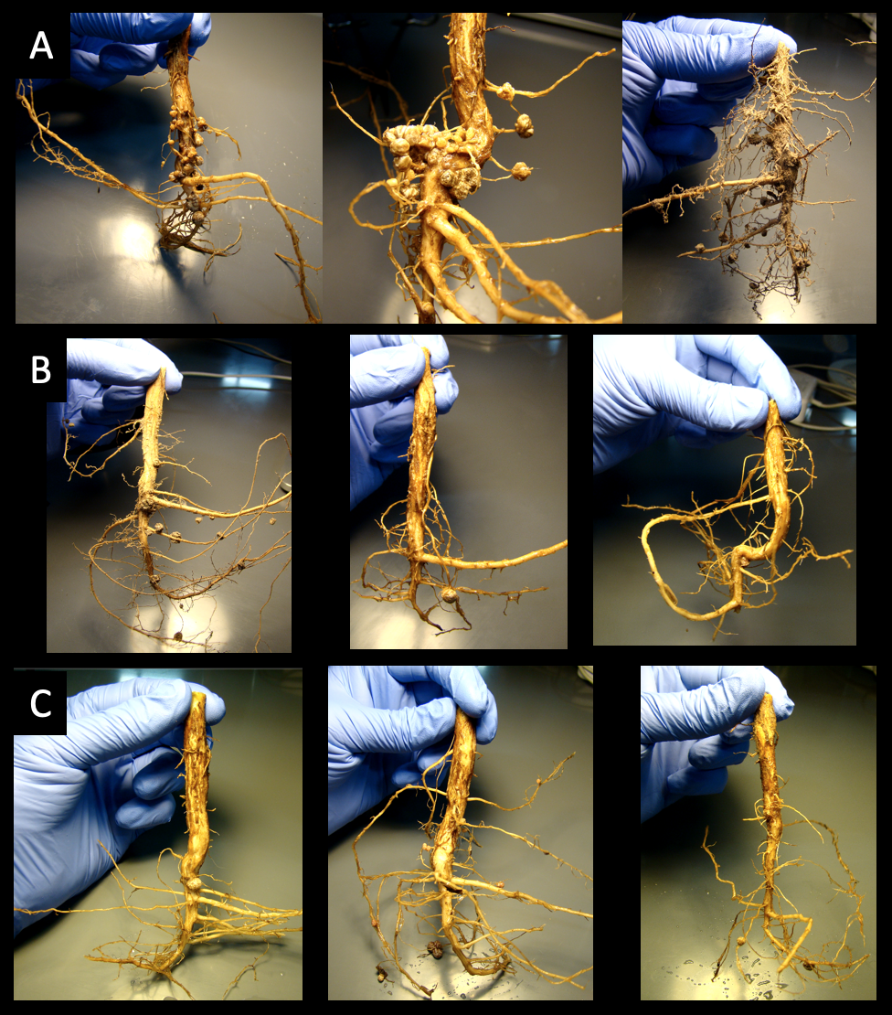

Figure 4. TXVA root nodule formation (A). Cell Tech root nodule formation (B). No treatment shows indigenous rhizobia root nodule formation (C).
Tennessee Agricultural Experiment Station – Jackson, Tennessee.
- Plant Date: 5/6
- Nodule harvest date: 6/25
- Final harvest date: TBD
- Soil type: Ayuka
- Seed variety: TN 16 520
- Previous crop: Soybeans 2+ years
- Row spacing: 30”
- Treatments: TXVA, Cell-Tech, no inoculant in the non-irrigation condition.

In collaboration with Drs. Vince Pantalone and Avat Shekoofa at the University of Tennessee, we collected nodule samples from each plot. Sampling was done randomly. Measurements of nodule properties have been performed, but are yet to be analyzed. Figure 5 shows plot design.
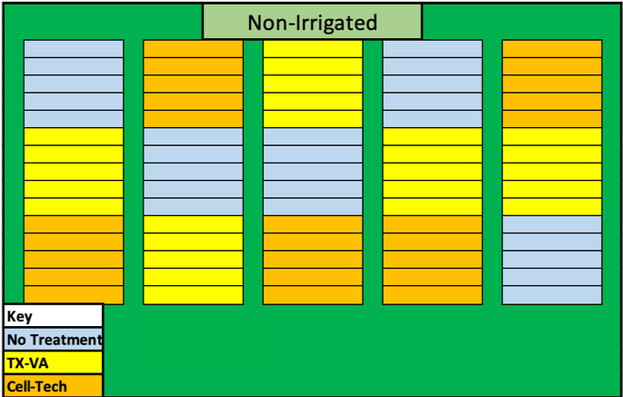

Figure 5. Plot layout in Jackson, TN

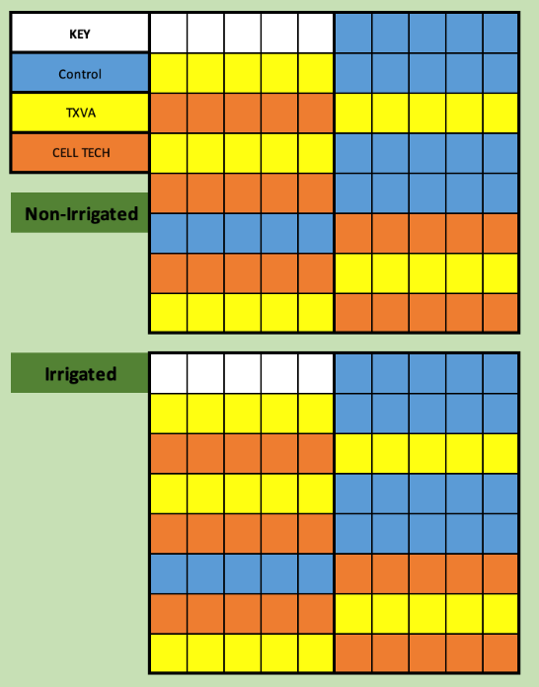
T.E. “Jake” Fisher Delta Research Center – Portageville, Missouri.
- Plant date: 5/7
- Nodule harvest: 7/10
- Final harvest: TBD
- Soil type: Malden fine sand
- Seed variety: TN 16 520
- Previous crop: Cotton
- Row spacing: 30”
- Treatments: TXVA, Cell-Tech, no inoculant in both irrigation and non-irrigation conditions.

In collaboration with Dr. Pengyin Chen at the University of Missouri, we collected nodule samples from each plot. Sampling was done randomly. Measurements of nodule properties have been performed, but are yet to be analyzed. Figure 6 shows plot design.
Figure 6. Plot layout in Clarkton, MO

Macon Ridge Research Station – Winnsboro, Louisiana.
- Plant date: 5/16
- Nodule harvest date: 7/12
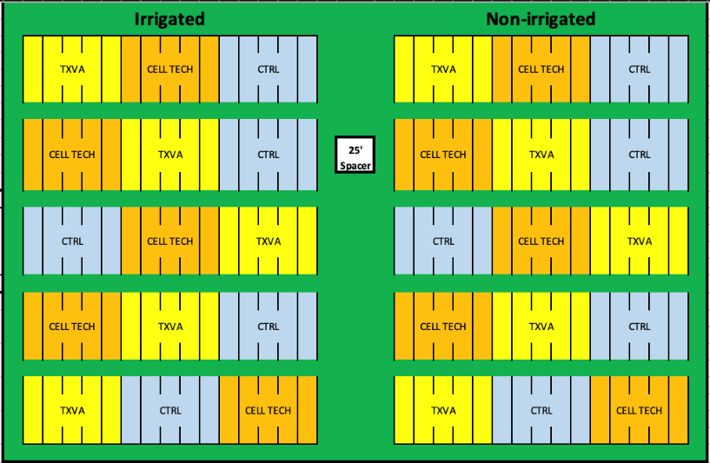
- Final harvest date: TBD
- Soil type: Jigger-Gilbert silt loam
- Seed variety: TN 16 520
- Previous crop: Soybeans
- Row spacing: 40”
- Treatments: TXVA, Cell-Tech, no inoculant in both irrigation and non-irrigation conditions.

In collaboration with Dr. Trey Price at Louisiana State University AgCenter, we collected nodule samples from each plot. Sampling was done randomly. Measurements of nodule properties have been performed, but are yet to be analyzed. Figure 7 shows plot design.

Figure 7. Plot layout in Winnsboro, LA

Stoneville USDA Agricultural Research Site – Leland, Mississippi.
- Plant date: 5/17
- Nodule harvest date: 7/11
- Final harvest date: TBD
- Soil type: Commerce silty clay loam
- Seed variety: TN 16 520
- Previous crop: Soybeans
- Row spacing: 38”
- Treatments: TXVA, Cell-Tech, no inoculant in both irrigation and non-irrigation conditions.

In collaboration with Dr. Rusty Smith at USDA, we collected nodule samples from each plot. Sampling was done randomly. Measurements of nodule properties have been performed, but are yet to be analyzed. Figure 8 shows plot design.
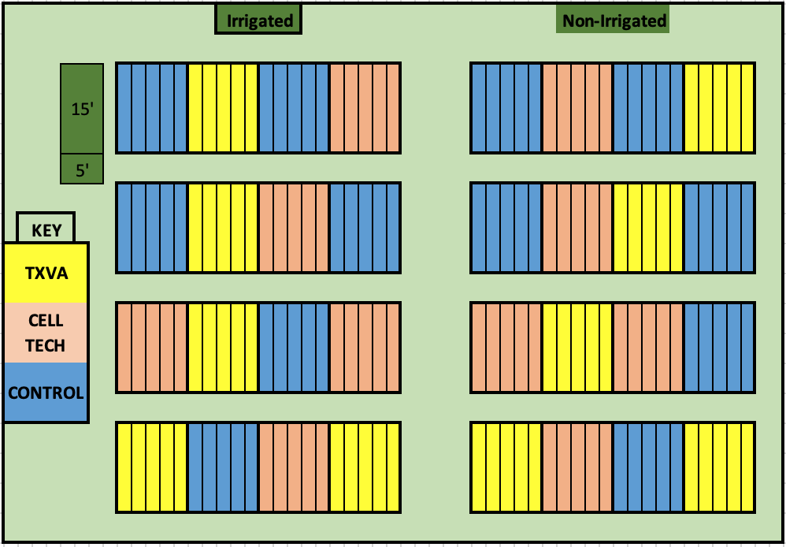

Figure 8. Plot layout in Stoneville, MS
Rice Research and Extension Center- Stuttgart Arkansas.
- Plant date: 7/2
- Nodule harvest date: 8/28
- Final harvest date: TBD
- Soil type: Dewitt silt loam
- Seed variety: TN 16 520
- Previous crop: Soybeans
- Row spacing: 30”
- Treatments: TXVA, Cell-Tech, no inoculant in both irrigation and non-irrigation conditions.

In collaboration with Dr. Leandro Mozzoni from the University of Arkansas, we planted soybeans with three treatments (TXVA, Cell-Tech, and no inoculant) for the irrigation condition as well as non-irrigation conditions. Plot layout is shown in Figure 9. Planting was severely delayed due to rain (Fig. 10). Sampling was completed for measurements of root nodule properties on 8/28, but has not been analyzed yet.
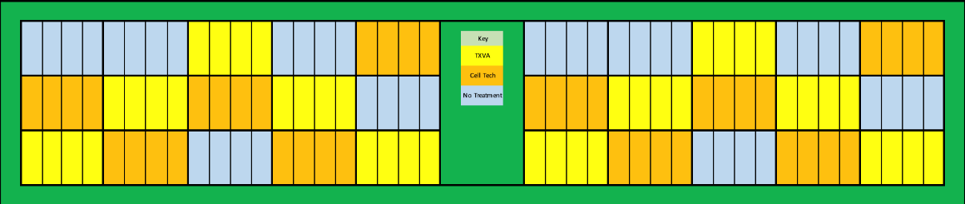

Figure 9. Plot layout in Stuttgart, AR

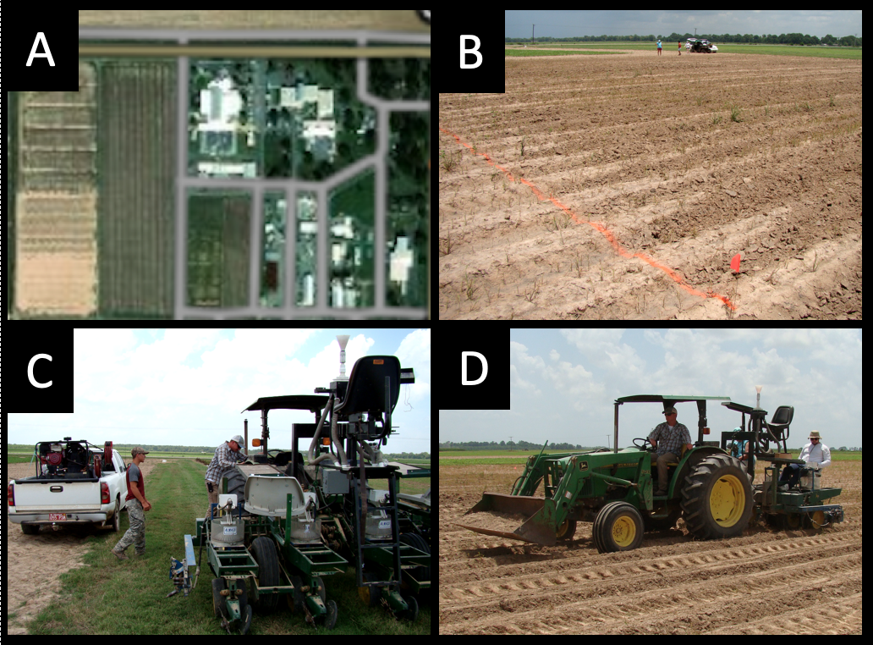

Figure 10. Above shot of the AR research station (A). Image of the plot after planting (B). Sterilization of the planter between treatments (C). Planting the irrigated portion (D).

In summary, we have planted Soybean research plots in 6 states testing our novel Texas-native drought-tolerant Bradyrhizobium inoculant in the irrigated and non-irrigated condition across drought prone regions. Below is a summary of general site specifics with planting and sampling dates (Table 1).

Table 1. General site characteristics that summarize each plant completed this year.
Location | Planting date | Sampling date | Soil type | Cultivar | MG
Yoakum, TX | 4/2 | 5/22 | Tremona loamy fine sand | S52RS86 | 5E
Jackson, TN | 5/6 | 6/25 | Ayuka | TN16520 | 4L
Clarkton, MO | 5/7 | 7/10 | Malden fine sand | TN16520 | 4L
Winnsboro, LA | 5/16 | 7/12 | Jigger-Gilbert silt loam | TN16520 | 4L
Stoneville, MS | 5/17 | 7/11 | Commerce silty clay loam | TN16520 | 4L
Stuttgart, AR | 7/2 | 8/28 | Dewitt silt loam | TN16520 | 4L

