|  |  |
| --- | --- |
| Project Title: | **Evaluation of a novel drought-tolerant inoculant on soybean yield in the Mid-South (Year 2)** |
| Organization: | **University of Texas at Arlington** |
| Principal Investigator Name: | **Woo-Suk Chang** |
| Collaborators | **James Grichar (TX), Pengyin Chen (MO), Leandro Mozzoni (AR), Trey Price (LA), Avat Shekoofa (TN), Tessie Wilkerson (MS)** |
| Report Period: | **June 16, 2020 – September 15, 2020** |
|  | |
| The objective of this project is to evaluate the effects of the TXVA strain (a drought-tolerant inoculant) on soybean yield in comparison to the commercial inoculant Cell-Tech™ and a non-inoculated control under non-irrigated conditions. For the 2nd year trial (Year 2020), we set up the field trials in TX, TN, MO, LA, MS, and AR. Unlike the 1st year trial (2019), we included drought-sensitive and drought-tolerant cultivars to test the effects of TXVA strain further. The mid-sampling has been completed for all six states and currently we are analyzing nodule properties (i.e., nodule numbers, location, and size). Detailed plot design, planting dates, mid-sampling dates, and experimental conditions are described in the Technical Report attached.  It has been well established that the microorganism *Bradyrhizobium japonicum* has a beneficial impact on soybean plants. Previously, we isolated TXVA strain that showed outstanding performance in nodulation, nitrogen fixation, and enhancing plant growth and production. To improve the inoculants’ performance and optimize the benefits of biological nitrogen fixation in the Mid-South, we set up field trials to evaluate the effects of the drought-tolerant inoculant on soybean yield at drought-prone sites. For the first year trial (year 2019), three inoculation treatments (drought-tolerant inoculant TXVA, commercial inoculant Cell-Tech, and no inoculation) will be compared under irrigated vs. non-irrigated conditions at drought prone sties in the Mid-South. At the first sampling, the number of nodules per plant will be counted and nodule size will be measured. A second harvest of plants will be performed to evaluate final soybean seed production. The climate and weather factors (e.g., precipitation, temperature, and humidity) for each location will also be monitored.  At the completion of the proposed research, we expect to provide positive effects of the drought-tolerant inoculant on soybean profitability and aid Mid-South producers in better understanding of the potential benefits for biological nitrogen fixation. We believe that providing such information will allow soybean producers to advance the management of soybean plants and inoculants for economical and ecological benefits. | |

**Technical Report**

**Texas A&M AgriLife Research Plot – Yoakum, Texas.**

This site is in collaboration with James Grichar, a senior research scientist at Texas A&M AgriLife research. Planting was done on April 1st, the mid-sampling was done on June 8th, and harvest was done on September 2nd. The plot layout that we designed here has 3 treatments, 3 cultivars, and 4 replicates (Fig. 1). The cultivars used here were last year’s variety TN-16, commercial seed CZ5515, and a Texas-specific variety Otoño. Plant dry weight, nodule enumeration and final yield are in process.

**Figure 1.** Plot layout in Yoakum, TX

**Macon Ridge Research Station – Winnsboro, Louisiana.**

This site is in collaboration with Dr. Trey Price at Louisiana State University AgCenter. Planting was done on May 11th and the mid-sampling was done on July 14th. The plot layout for Winnsboro is shown in Fig. 2. This is a non-irrigated site with 3 cultivars, 3 treatments, and 5 replicates. The cultivars used were TN-16, drought-sensitive USG-7496XTS, and commercial line CZ5515. At this site, all of the seeds were treated at once and packed so that there was 9 seeds/foot. On July 14th, a total of 6 plants per block were sampled, giving a total sample size of n=216. Plant dry weight and nodule enumeration are in process.

**Figure 2.** Plot layout in Winnsboro, LA

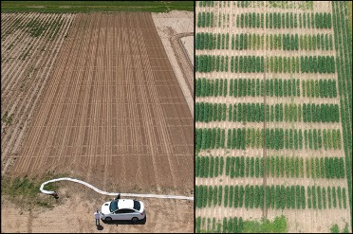

**Tennessee Agricultural Experiment Station – Jackson, Tennessee.**

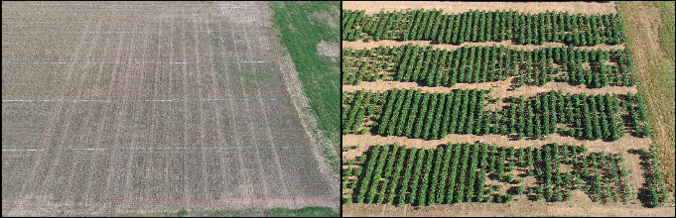

This site is in collaboration with Dr. Avat Shekoofa at the University of Tennessee. Planting was done on May 15th and the mid-sampling was done on July 27th. The plot layout for TN (Fig. 3) is non-irrigated with 3 treatments and 2 cultivars with 4 replicates. The cultivars used were TN-16 and drought-sensitive line USG-7496XTS. On July 27th, a total of 4 plants per block were sampled, giving a total sample size of n=96. Plant dry weight and nodule enumeration are in process.

**Figure 3.** Plot layout in Jackson, TN

**T.E. “Jake” Fisher Delta Research Center – Portageville, Missouri.**

This site is in collaboration with Dr. Pengyin Chen at the University of Missouri. This site was planted on June 2nd and sampled on July 28th. The plot layout for MO was shown in Fig. 4. The plot contains 3 cultivars, 3 treatments, and 6 replicates. The cultivars used were TN-16, S11-20242C drought-tolerant line, and S14-9017R drought-sensitive line. Mid-harvest sampling was performed, giving a total sample size of n=324. Plant dry weight and nodule enumeration are in process.

**Figure 4.** Plot layout in Clarkton, MO

**Stoneville USDA Agricultural Research Site – Leland, Mississippi.**

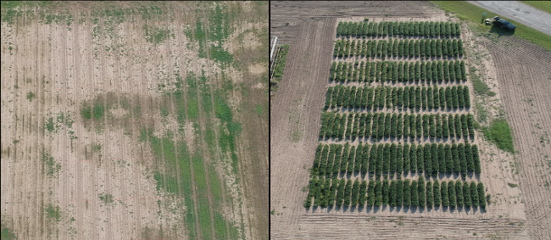

This site is in collaboration with Dr. Tessie Wilkerson with Mississippi state. This site was planted on June 29th and sampled on September 9th. The plot layout for our MS plot shown in Fig. 5 reflects the same RCB design with 2 cultivars, 3 treatments, and 6 replicates. The cultivars used were TN-16 and drought-sensitive S14-9017R. Each block contains 4 rows of 15’ with a 5’ spacer row between blocks and a 38” row width. Mid-harvest sampling was performed so that 4 plants from each outside row were taken, giving a total sample size of n=144. Plant dry weight and nodule enumeration are in process.

**Figure 5.** Plot layout in Stoneville, MS

**Rice Research and Extension Center- Stuttgart Arkansas.**

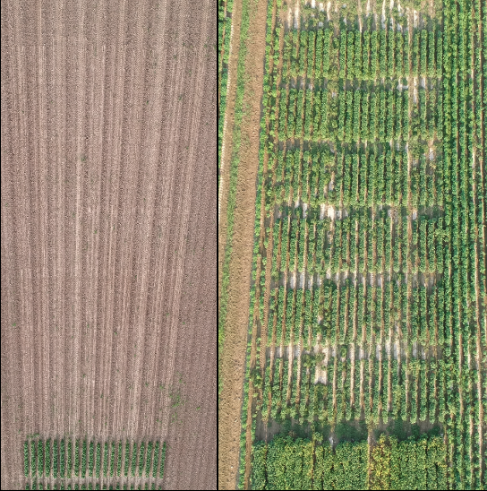

Our Arkansas site is in collaboration with Dr. Leandro Mozzoni from the University of Arkansas. Planting was done on July 1st and sampling was done on September 10th. The plot layout is shown in Fig. 10 and reflects the same RCB design with 2 cultivars, 3 treatments, and 5 replicates. The cultivars used were TN-16 and drought-sensitive S14-9017R. Each block contains 4 rows of 15’ and 30” row width. Mid-harvest sampling was performed such that 4 plants from the outside rows of each plot were taken. Plant dry weight and nodule enumeration are in process.

**Figure 6.** Plot layout in Stuttgart, AR

In summary, we have planted soybean research plots and collected mid-samples in all six states (TX, LA, TN, MO, MS, and AR) for testing our novel Texas-native drought-tolerant *Bradyrhizobium* inoculant with numerous soybean cultivars under the non-irrigated condition across drought prone regions. We also completed harvesting soybeans for the TX plot on September 2nd. For the other states, we are in progress to analyze nodule properties as well as plant dry weight. Below is a summary of planting dates, mid-sampling dates, and harvesting dates (Table 1).

**Table 1.** Summary of each filed site in 2020.

|  |  |  |  |  |  |
| --- | --- | --- | --- | --- | --- |
| **Location** | **Planting date** | **Nodule Sampling** | **Harvest** | **Cultivar used** | **Maturity Group** |
| Yoakum, TX | 4/1 | 6/6 | 9/2 | TN16, CZ5515, Otoño | 4L, 5, N/A |
| Winnsboro, LA | 5/11 | 7/14 | TBD# | TN16, USG-7496*, CZ5515 | 4L, 4L, 5 |
| Jackson, TN | 5/15 | 7/27 | TBD | TN16, USG-7496* | 4L, 4L |
| Portageville, MO | 6/2 | 7/28 | TBD | TN16, S1120242C**, S14-9017R* | 4L, 5, 5 |
| Stoneville, MS | 6/29 | 9/9 | TBD | TN16, S14-9017R* | 4L, 5 |
| Stuttgart, AR | 7/1 | 9/10 | TBD | TN16, S14-9017R* | 4L, 5 |
|  |  |  |  | * = drought-sensitive |  |
|  |  |  |  | ** = drought-tolerant |  |

# To Be Determined.