Please use this form to clearly and concisely report on project progress. The information included should reflect quantifiable results that can be used to evaluate and measure project success. Comments should be limited to the designated boxes. Technical reports, no longer than 4 pages, may be attached to this summary report.
Project Title: | Evaluation of a novel drought-tolerant inoculant on soybean yield in the Mid-South
Organization: | University of Texas at Arlington
Principal Investigator Name: | Woo-Suk Chang
Report Period: | September 16, 2019 – December 15, 2019

Project Status - What key activities were undertaken and what were the key accomplishments during this quarter? Please use this field to clearly and concisely report on project progress. Limit 5,000 characters.
During this report period, we finished harvesting seeds from six research locations (Yoakum in TX, Jackson in TN, Clarkton in MO, Winnsboro in LA, Stoneville in MS, and Stuttgart in AR). We are in the progress of yield data analysis. In addition, plant and root nodule samples that we collected at R1-R2 stage have been analyzed for nodule numbers, nodule size, and nodule locations (distribution). Detailed plot design, experimental conditions, and harvesting date are described in the Technical Report attached.

The objective of this project is to evaluate the effects of the TXVA strain (a drought-tolerant inoculant) on soybean yield in comparison to the commercial inoculant Cell-Tech™ and a non-inoculated control under irrigated and non-irrigated conditions. It has been well established that the microorganism Bradyrhizobium japonicum has a beneficial impact on soybean plants. Previously, we isolated TXVA strain that showed outstanding performance in nodulation, nitrogen fixation, and enhancing plant growth and production. To improve the inoculants’ performance and optimize the benefits of biological nitrogen fixation in the Mid-South, we set up field trials to evaluate the effects of the drought-tolerant inoculant on soybean yield at drought-prone sites. For the first year trial (year 2019), three inoculation treatments (drought-tolerant inoculant TXVA, commercial inoculant Cell-Tech, and no inoculation) will be compared under irrigated vs. non-irrigated conditions at drought prone sties in the Mid-South. At the first sampling, the number of nodules per plant will be counted and nodule size will be measured. A second harvest of plants will be performed to evaluate final soybean seed production. The climate and weather factors (e.g., precipitation, temperature, and humidity) for each location will also be monitored.

At the completion of the proposed research, we expect to provide positive effects of the drought-tolerant inoculant on soybean profitability and aid Mid-South producers in better understanding of the potential benefits for biological nitrogen fixation. We believe that providing such information will allow soybean producers to advance the management of soybean plants and inoculants for economical and ecological benefits.

Technical Report

Texas A&M AgriLife Research Plot – Yoakum, Texas.
- Plant date: 4/2
- Nodule harvest date: 5/22
- Final harvest date: 9/6
- Soil type: Tremona loamy fine sand
- Seed variety: S52RS86
- Previous crop: Peanuts
- Row spacing: 38”
- Treatments: TXVA, Cell-Tech, no inoculant in both irrigation and non-irrigation conditions.

In collaboration with Dr. James Grichar, a senior research scientist at Texas A&M AgriLife research, we finished harvesting seeds on Sep. 6th. The harvesting was done using a gas-powered STIHL hedge clipper and samples were bagged in paper bags for drying, threshing, and then weighing. Weights for each treatment are shown below. Irrigation was applied three times this year. Figure 1 shows plot design, and Figure 2 shows yield data in both irrigation and non-irrigation conditions. While irrigated plots all fared about the same (no statistical significance), TXVA allowed the non-irrigated plot to yield statistically significant more overall weight than other treatments under the same condition.
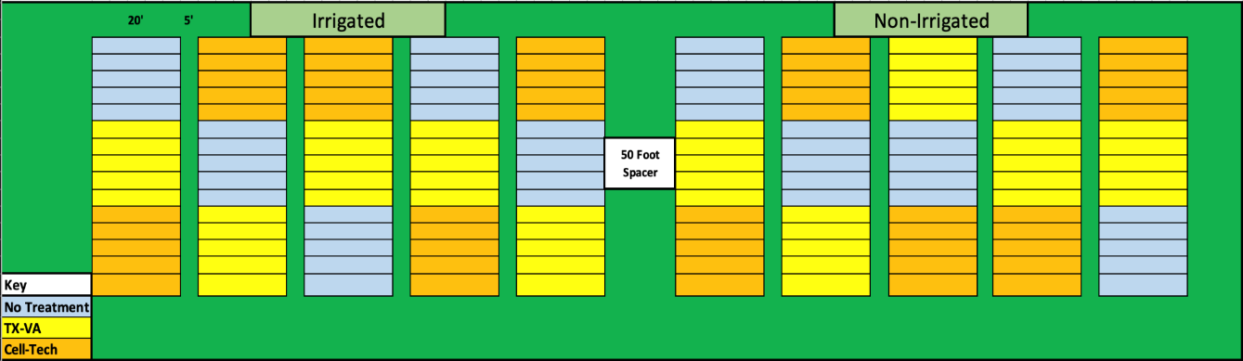
Figure 1. Plot layout in Yoakum, TX

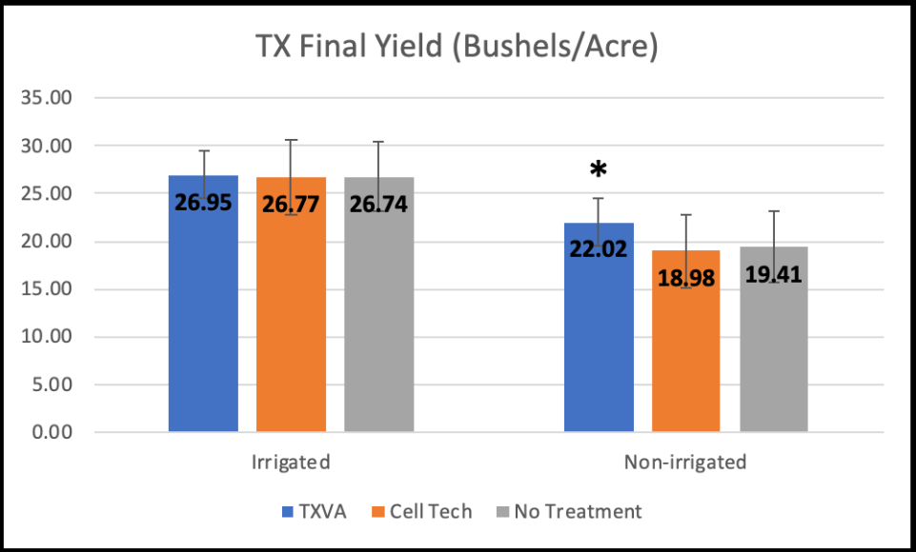

Figure 2. Yield (bushels/acre) comparison among three treatments (TXVA, Cell-Tech, and no inoculant) in both irrigated and non-irrigated conditions. An asterisk indicates P < 0.05.
Tennessee Agricultural Experiment Station – Jackson, Tennessee.
- Plant Date: 5/6
- Nodule harvest date: 6/25
- Final harvest date: 10/4
- Soil type: Ayuka
- Seed variety: TN 16 520
- Previous crop: Soybeans 2+ years
- Row spacing: 30”
- Treatments: TXVA, Cell-Tech, no inoculant in the non-irrigation condition.

In collaboration with Drs. Vince Pantalone and Avat Shekoofa at the University of Tennessee, we finished harvesting seeds on Oct. 4th. Nodule samples collected on Jun. 25th have been analyzed for nodule properties (nodule numbers and size distribution). Figures 3, 4, and 5 shows the plot design, nodule numbers, and nodule distribution, respectively. In addition, yield comparison among three treatments (TXVA, Cell-Tech, and no inoculant) under the non-irrigated condition is shown in Table 1. The final yield captures the trend that we observed in Texas under the non-irrigated condition, with increasing the productivity by TXVA compared to Cell-Tech or no inoculant.
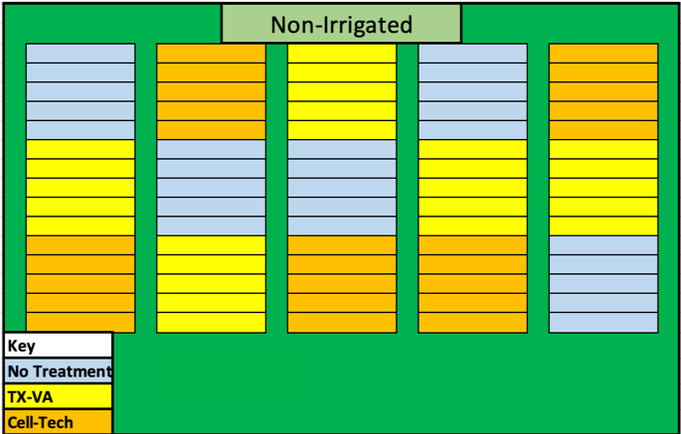

Figure 3. Plot layout in Jackson, TN

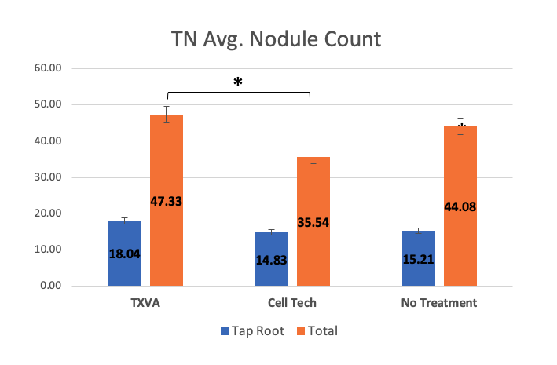

Figure 4. Comparison of nodule numbers among three treatments (TXVA, Cell-Tech, and
no inoculant) under the non-irrigated condition. An asterisk indicates P < 0.05.

Figure 5. Comparison of nodule size distribution among three treatments (TXVA, Cell-Tech, and
no inoculant) under non-irrigated condition.

Table 1. Yield comparison among three treatments under the non-irrigated condition.

Treatments | Yield (bushels/acre)
TXVA | 55.18 ± 0.39
Cell-Tech | 52.60 ± 0.47
No inoculant | 52.65 ± 0.40

* Values are means ± standard errors

T.E. “Jake” Fisher Delta Research Center – Portageville, Missouri.
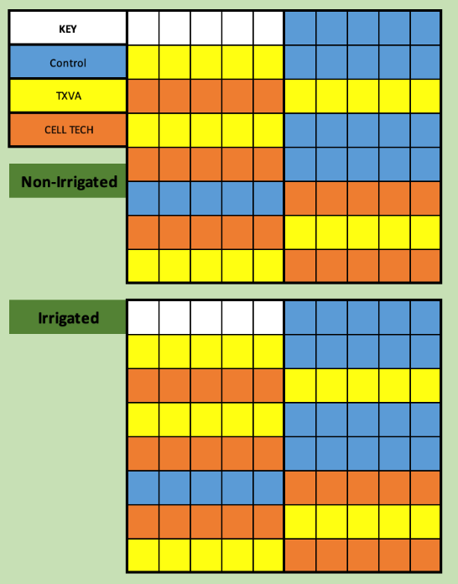
- Plant date: 5/7
- Nodule harvest: 7/10
- Final harvest: 10/9
- Soil type: Malden fine sand
- Seed variety: TN 16 520
- Previous crop: Cotton
- Row spacing: 30”
- Treatments: TXVA, Cell-Tech, no inoculant in both irrigation and non-irrigation conditions.

In collaboration with Dr. Pengyin Chen at the University of Missouri, we finished harvesting seeds on Oct. 9th. Nodule samples collected on Jul. 10th have been analyzed for nodule properties (nodule numbers and size distribution). Figures 6 and 7 shows the plot design and nodule numbers, respectively. Analysis of nodule size distribution is in progress. The final yield comparison among three treatments (TXVA, Cell-Tech, and no inoculant) under both irrigated and non-irrigated conditions is shown in Figure 8. Unfortunately, dicamba pressure introduced uncontrolled variables to each individual plot, which results in wide ranging yield data under each treatment. Moreover, overall yield (bushels/acre) seems to be very low in both irrigated and non-irrigated conditions.
Figure 6. Plot layout in Clarkton, MO

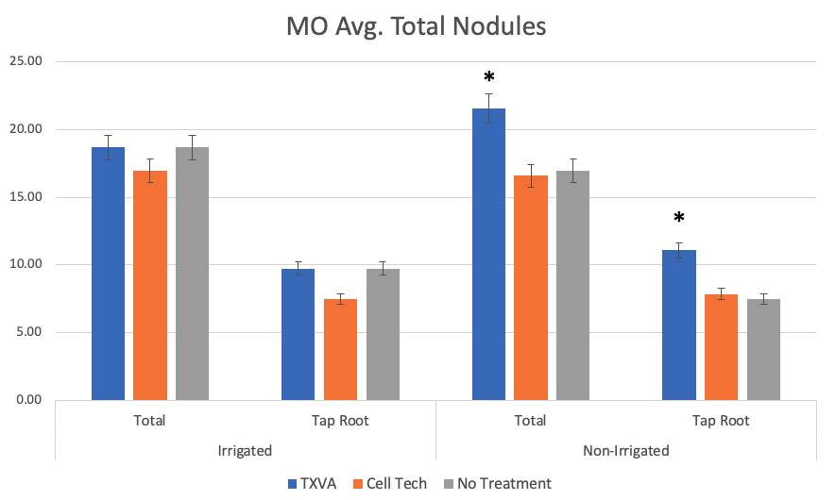

Figure 7. Comparison of nodule numbers among three treatments (TXVA, Cell-Tech, and no inoculant) under non-irrigated condition. Asterisks indicate P < 0.05.

Figure 8. Yield (bushels/acre) comparison among three treatments (TXVA, Cell-Tech, and no inoculant) in both irrigated and non-irrigated conditions. Note that Dicamba pressure affected yield.

Macon Ridge Research Station – Winnsboro, Louisiana.
- Plant date: 5/16
- Nodule harvest date: 7/12
- Final harvest date: 9/16
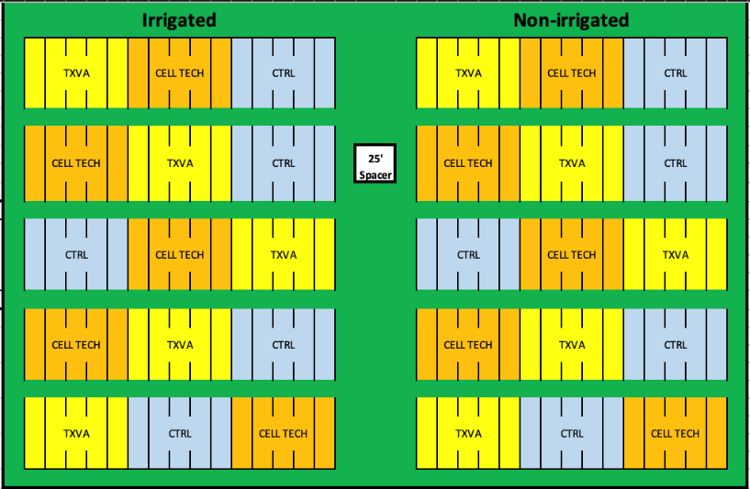
- Soil type: Jigger-Gilbert silt loam
- Seed variety: TN 16 520
- Previous crop: Soybeans
- Row spacing: 40”
- Treatments: TXVA, Cell-Tech, no inoculant in both irrigation and non-irrigation conditions.

In collaboration with Dr. Trey Price at Louisiana State University AgCenter, we finished harvesting seeds on Sep. 16th. We are in progress of analyzing nodule properties (nodule numbers, nodule size, and distribution) as well as soybean yield. Figure 9 shows plot design.
Figure 9. Plot layout in Winnsboro, LA

Stoneville USDA Agricultural Research Site – Leland, Mississippi.
- Plant date: 5/17
- Nodule harvest date: 7/11
- Final harvest date: 10/2
- Soil type: Commerce silty clay loam
- Seed variety: TN 16 520
- Previous crop: Soybeans
- Row spacing: 38”
- Treatments: TXVA, Cell-Tech, no inoculant in both irrigation and non-irrigation conditions.

In collaboration with Dr. Rusty Smith at USDA, we finished harvesting seeds on Oct. 2nd. Figure 10 shows plot design. While we are still in progress of analyzing nodule properties (nodule numbers, nodule size, and distribution), we are able to analyze yield data (Fig. 11). There is no significant difference in soybean yield among the three treatments. This result could suggest unnecessary of an inoculant because the clay-rich soils of the MS delta region have very thriving microbial abundance and richness.

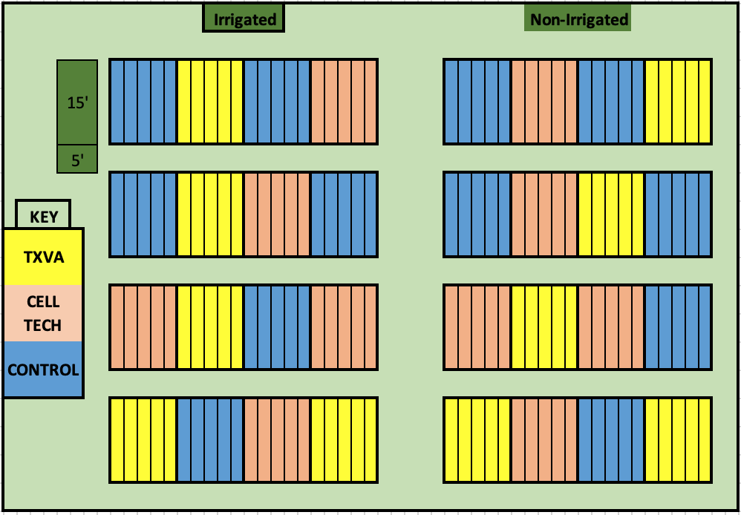

Figure 10. Plot layout in Stoneville, MS

Figure 11. Yield (bushels/acre) comparison among three treatments (TXVA, Cell-Tech, and no inoculant) in both irrigated and non-irrigated conditions.

Rice Research and Extension Center- Stuttgart Arkansas.
- Plant date: 7/2
- Nodule harvest date: 8/28
- Final harvest date: 10/23
- Soil type: Dewitt silt loam
- Seed variety: TN 16 520
- Previous crop: Soybeans
- Row spacing: 30”
- Treatments: TXVA, Cell-Tech, no inoculant in both irrigation and non-irrigation conditions.

In collaboration with Dr. Leandro Mozzoni from the University of Arkansas, we finished harvesting seeds on Oct. 23rd. Plot layout is shown in Figure 12. This was very late planting due to rain delays. While we are still in progress of analyzing nodule properties (nodule numbers, nodule size, and distribution), we are able to analyze yield data (Fig. 13). Although statistically not significant, there is the same trend observed in Texas that plants inoculated with TAVA seem to produce more yield compared to those with Cell-Tech or uninoculated under both irrigated and non-irrigated conditions.
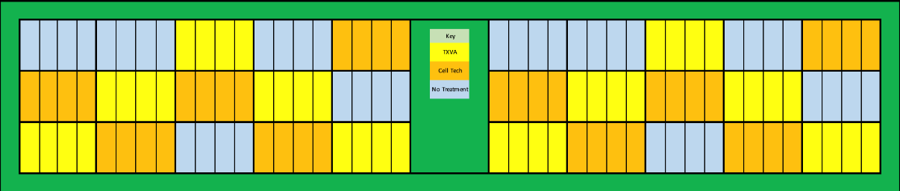

Figure 12. Plot layout in Stuttgart, AR

Figure 13. Yield (bushels/acre) comparison among three treatments (TXVA, Cell-Tech, and no inoculant) in both irrigated and non-irrigated conditions.

In summary, we have finished harvesting seeds from soybean research plots in 6 states testing our novel Texas-native drought-tolerant Bradyrhizobium inoculant in the irrigated and non-irrigated condition across drought prone regions. Taken together, there is a trend that plants inoculated with TAVA seem to show higher yield under the non-irrigated condition in TX, TN, and AR compared to those with Cell-Tech or uninoculated, although there is no difference in MS. In MO, Dicamba pressure does not allow us to compare the final yield among the three treatments. Lastly, we are still in progress of analyzing yield data in LA.

Below is a summary of general site specifics with planting, sampling, and harvesting dates (Table 2).

Table 2. General site characteristics that summarize each plant completed this year.
Location | Planting date | Sampling date | Harvesting date | Soil type | Cultivar | MG
Yoakum, TX | 4/2 | 5/22 | 9/6 | Tremona loamy fine sand | S52RS86 | 5E
Jackson, TN | 5/6 | 6/25 | 10/4 | Ayuka | TN16520 | 4L
Clarkton, MO | 5/7 | 7/10 | 10/9 | Malden fine sand | TN16520 | 4L
Winnsboro, LA | 5/16 | 7/12 | 9/16 | Jigger-Gilbert silt loam | TN16520 | 4L
Stoneville, MS | 5/17 | 7/11 | 10/2 | Commerce silty clay loam | TN16520 | 4L
Stuttgart, AR | 7/2 | 8/28 | 10/23 | Dewitt silt loam | TN16520 | 4L

