Please use this form to clearly and concisely report on project progress. The information included should reflect quantifiable results that can be used to evaluate and measure project success. Comments should be limited to the designated boxes. Technical reports, no longer than 4 pages, may be attached to this summary report.
Project Title: | Breeding Maturity Group 4 Soybean with Enhanced Resistance to Southern Root-knot Nematode by Reducing Galling and Nematode Reproduction
Organization: | University of Arkansas
Principal Investigator Name: | Caio Canella Vieira
Report Period: | January - March, 2026

Project Status:
Objective 1 - Characterization of the mechanism of resistance. Characterize the response of lines carrying different combinations of the resistance regions on chromosomes 10 and 13, as well as genetically diverse accessions for nematode reproduction and root galling.

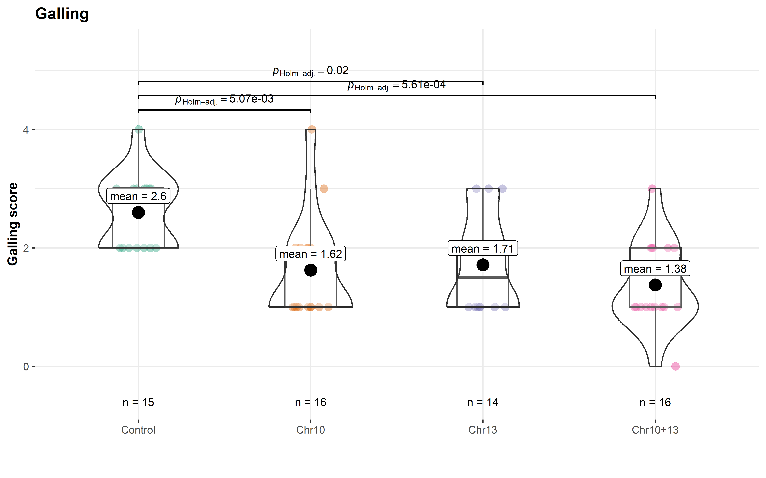
In this reporting period, recombinant inbred lines (RILs) carrying SRKN resistance QTLs on Chr. 10, Chr. 13, and their combination were evaluated to assess potential additive effects. While agronomic performance remained comparable across all genetic backgrounds, clear differences were observed for galling response following SRKN inoculation. Lines carrying individual QTLs showed similar galling levels (Chr. 10: 1.62; Chr. 13: 1.71), whereas lines combining both QTLs exhibited reduced galling (1.3), indicating a beneficial stacking effect (Figure 1). These results support the strategy of pyramiding resistance loci to enhance SRKN resistance and highlight the importance of combining multiple genomic regions to achieve more effective and potentially durable resistance.
Figure 1. Differences in root galling based on combinations of resistance regions on chromosomes 10 and 13.

Objective 2 – Development of SRKN-resistant breeding populations. Develop MG 4 breeding populations and varieties with SRKN resistance suitable for production in the Mid-South.

Vieira, University of Arkansas:
Planting preparations for the 2026 season are ongoing, including experimental design, sorting, inventory, and packaging for all yield trials.
2025–2026 Potential Release: The SRKN-resistant line R21KB-05522 will continue evaluation in the 2026 PCM yield trial across 16 locations, including five internal Arkansas locations (Jonesboro, Marianna, Pine Tree, Rohwer, and Stuttgart), as well as Starkville, MS; Leland, MS; Cleveland, MS; Maysville, KY; Sharon, TN; Pocahontas, AR; Junction City, KS; St. George, KS; Altamont, IL; Salem, IL; and Princeton, IN.
2026 Pre-Commercial Stage: Forty-six advanced lines will be evaluated across 16 locations (mentioned above), including the SRKN-resistant lines R20-1429 and R21KB-03720. These lines will also enter the 2026 Uniform Yield Trials. Additionally, line R21KB-03720 will be evaluated in the Arkansas Variety Testing Program.
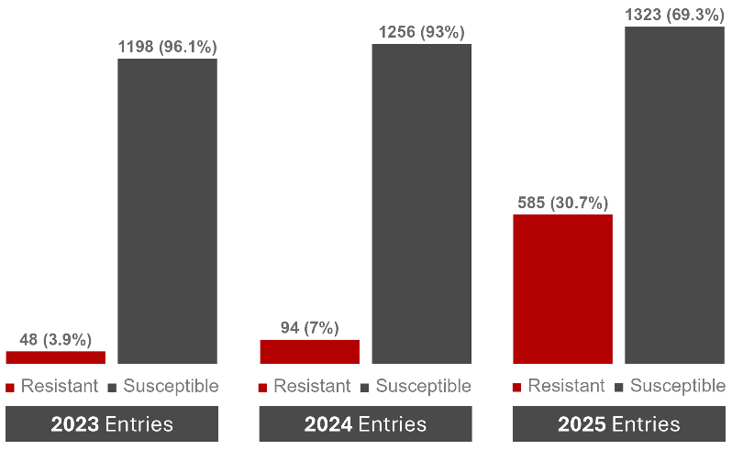
2026 Preliminary Stage: Forty-four yield trials comprising 1,866 lines from maturity groups 3L through 5E will be evaluated in duplicated yield trials across three Arkansas locations (Pine Tree, Rohwer, and Stuttgart, AR). All lines will undergo genotyping, and DNA extraction is currently underway. DNA will be sent to the USDA Molecular Lab in Maryland, and the genomic data will be used in genomic prediction studies. Additionally, lines were screened using the proprietary disease panel, which included the SRKN-resistant trait. In total, 585 lines (30.7%) of the tested lines possess the SRKN resistance trait, representing a marked increase compared with 2023 and 2024, when only 3.9% and 7.0% of the selected progenies were resistant, respectively (Figure 2).
Figure 2. Proportion of SRKN-resistant and susceptible progeny rows planted in 2023, 2024, and 2025 and advancing to the 2024, 2025, and 2026 preliminary yield trials, respectively.

2026 Progeny Rows and Crossing Block: Early generation materials continue to be grown in the winter nursery. Progeny rows (F₄) are expected to arrive on the mainland by the first week of April. Approximately 15,000 progeny rows will be planted in Stuttgart, AR. Crossing block combination planning is still underway. Genomic selection will be used to identify potential best crosses, including materials carrying the SRKN-resistant trait.
Introducing New Genetic Diversity: Egg inoculation and host materials for SRKN (Tomato and Williams 82) are currently being grown under greenhouse conditions. Egg inoculation to propagate nematodes for line screening was performed on May 13th. Lines in advanced yield trials (PCM and Finals) will be screened for galling, and the results will be presented in the upcoming reports.
Usovsky – University of Missouri:

2026 USDA Yield Trials: The seeds have been shipped. Preliminary Uniform Trials (26UPs) - one soybean line with SRKN resistance was selected. Advanced Uniform Trials (26UTs) - one soybean line with SRKN resistance was selected. Resistance in these lines was confirmed using both molecular markers and phenotypic bioassays. The selected lines represent maturity groups (MG) 4L.
University of Missouri Yield Trials: Planting is expected to begin in mid-April. Preliminary Yield Trials (26PYTs): Approximately 300 lines representing maturity groups 4E to 4L will be evaluated across two locations with two replications. Each line has at least one parent with confirmed SRKN resistance; however, the entries have not yet been genotyped, and their SRKN allelic status remains unknown. Advanced Yield Trials (26AYT): A total of 30 lines representing maturity groups 4E to 4L were selected for yield evaluation across five locations with three replications. These lines will be screened for SRKN resistance using molecular markers.

Early generation advancements: Crossing Block (26CB): Parent selection for the 2026 crossing block was based on yield performance and SRKN resistance validated through molecular markers and phenotypic evaluation. We are planning to introduce marker-assisted selection (MAS) for SRKN resistance, starting with the assay testing in summer 2026. MAS is projected to be introduced in genotyping selected F₄ generations grown in Costa Rica starting in winter 2026/2027. Progeny rows (26PRs): More than 2,000 progeny rows representing 33 diverse pedigrees will be planted in Portageville, MO, for visual selection. Most populations were developed using at least one parent with confirmed SRKN resistance.

