Please use this form to clearly and concisely report on project progress. The information included should reflect quantifiable results that can be used to evaluate and measure project success. Comments should be limited to the designated boxes. Technical reports, no longer than 4 pages, may be attached to this summary report.
Project Title: | Development of climate-smart high-yielding practices associated with high-end biological treatments and soybean-related microbiome resiliency
Organization: | University of Texas at Arlington
Principal Investigator Name: | Woo-Suk Chang
Report Period: | ☐ December ☒ March ☐ June ☐ September ☐ Final

Project Status:
In the field experiments conducted during the 2025 growing season, we compared soybean performance under conventional tillage and no-till/reduced tillage management across four states (TX, MS, MO, and AR; Table 1). Three inoculation treatments were tested at each site: TXVA, a drought-tolerant Bradyrhizobium inoculant; First Up, a commercial inoculant; and a non-inoculated control. The data analysis of yield performance from these trials has been completed, providing an assessment of treatment effects on soybean yield across the multi-state fields (Figs. 1, 2, and 3). We were unable to collect yield data from the TX site because of severe dicamba damage, and the no-till site in AR was excluded from the final yield comparison, presumably due to late planting.

Microbiome and network analyses are currently in progress to characterize the microbial communities in the soybean rhizosphere, with the goal of understanding how inoculation and tillage practices shape microbial composition and potential functional interactions with the host plant. We expect to provide complete data analysis in the final report.

Table 1. Final summary of the 2025 field trials.
Location | Collaborators | Planting Date | Sampling Date | Harvest Date | Cultivar Used | MG
Port Lavaca, TX | Dr. James Grichar | 4/9 | 7/1 | No Harvest* | Lynda-GT | INDT
Leland, MS | Dr. Tessie Wilkerson | 6/5 | 8/21 | 10/16 | AG49XF4 | 4L
Portageville, MO | Dr. Feng Lin | 6/11 | 8/20 | 11/5 | Ellis | 4L
Colt, AR | Dr. Shawn Clark | 6/25 | 8/20 | 11/15# | Ellis | 4L
* Due to the Dicamba damage, the both conventional tillage and no-till fields produced no yield.
# No harvest for the no-till field, presumably due to late planting.

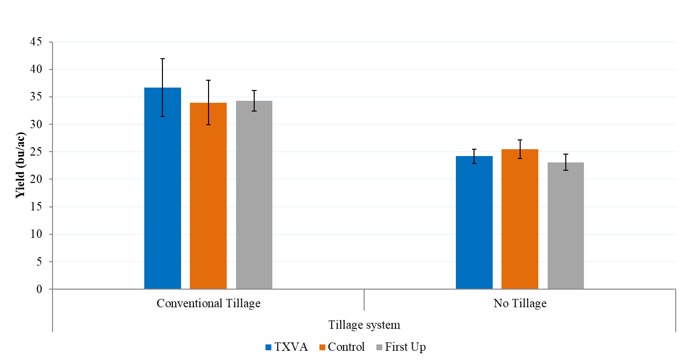
Figure 1. Yield comparisons between conventionally tilled and no-till soybean fields in Leland, MS. The AG49XF4 cultivar was planted with three treatments: TXVA (a drought-tolerant inoculant), First-Up (a commercial inoculant), or control (no inoculant).

Figure 2. Yield comparisons between conventionally tilled and no-till soybean fields in Portageville, MO. The Ellis cultivar was planted with three treatments: TXVA (a drought-tolerant inoculant), First-Up (a commercial inoculant), or control (no inoculant).

Figure 3. Soybean yield (bu/ac) in conventional tillage plots in Colt, AR. The Ellis cultivar was planted with three treatments: TXVA (a drought-tolerant inoculant), First-Up (a commercial inoculant), or control (no inoculant). There was no harvest for the no-till field, presumably due to late planting.

