Please use this form to clearly and concisely report on project progress. The information included should reflect quantifiable results that can be used to evaluate and measure project success. Comments should be limited to the designated boxes. Technical reports, no longer than 4 pages, may be attached to this summary report.
Project Title: | Development of climate-smart high-yield practices associated with high-end biological treatments and soybean-related microbiome resiliency
Organization: | University of Texas-Arlington
Principal Investigator Name: | Woo-Suk Chang
Report Period: | 3/16/2025 – 6/15/2025

Project Status:
Since March 15th, we have begun planting field trials (no-till vs. conventional tillage) in the Mid-South, which are summarized in Table 1. In addition to the different tillage practices, we used three inoculant conditions: i) TXVA strain (drought-tolerant inoculant), ii) First-Up (a commercial inoculant), and iii) no inoculant (control) for all conventionally tilled and no till research fields.

Table 1. Summary of the 2025 field trials (as of June 15, 2025).
Location | Collaborators | Planting Date | Tentative Mid-Sampling Date | Cultivar Used | Maturity Group
Port Lavaca, TX | Dr. James Grichar | 4/9 | 6/16 – 6/20 | Lynda-GT | INDT
Leland, MS | Dr. Tessie Wilkerson | 6/5 | 8/4 – 8/8 | Asgrow 49XF4 | 4L
Portageville, MO | Dr. Feng Lin | 6/11 | 8/11 – 8/15 | Ellis | 4L
Colt, AR | Dr. Shawn Clark | TBD | TBD | Ellis | 4L
TBD: to be determined.

Below is the summary of each field trial.
1. Port Lavaca, TX:
- 4 x 30 ft rows plot.
- 3 inoculant conditions: TXVA, First UP, and no treatment (control).
- Conventional tillage: 5 reps. x 3 treatments.
- No-till: 5 reps. x 3 treatments.

2. Leland, MS:
- 4 x 20 ft rows plot.
- 3 inoculant conditions: TXVA, First UP, and no treatment (control).
- Conventional tillage: 4 reps. x 3 treatments.
- No-till: 4 reps. x 3 treatments.

3. Portageville, MO:
- 4 x 20 ft rows plot.
- 3 inoculant conditions: TXVA, First UP, and no treatment (control).
- Conventional tillage: 6 reps. x 3 treatments.
- No-till: 6 reps. x 3 treatments.

4. Colt, AR: Due to unusually heavy rainfall, planting has been delayed.

We had planned to plant soybeans in Winnsboro, LA, in collaboration with Dr. Trey Price. Unfortunately, due to unfavorable field conditions, we missed the optimal planting window. As it is now too late to proceed, we have decided to exclude Winnsboro, LA from this year’s field trials.

Additionally, we have completed the initial analysis of the microbiome data, comparing microbial compositions between high-yield (>100 bushels/acre) and low-yield (~35 bushels/acre) soybean fields in Arkansas. As shown in Fig. 1, there is a significant difference between the microbial communities in low-yield rhizosphere (LYR) and high-yield rhizosphere (HYR) soils.

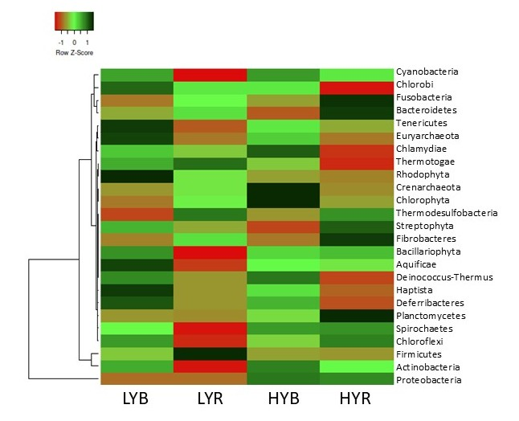
Figure 1. Relative abundance of the microbial phyla across the low yield and high yield fields. LYB, Low-yield Bulk soil; LYR, Low-yield Rhizosphere soil; HYB, How-yield Bulk soil; HYR, High-yield Rhizosphere soil. Dark green indicates higher abundance (positive Z-scores up to +1), whereas red represents lower abundance of microbial phyla (negative Z-scores down to -1).

More detailed data analyses are currently underway to identify key microorganisms associated with high soybean yields in the Mid-South. We also aim to construct co-occurrence networks linked to high-yielding soybeans, which will be included in the next quarterly report.

