Please use this form to clearly and concisely report on project progress. The information included should reflect quantifiable results that can be used to evaluate and measure project success. Comments should be limited to the designated boxes. Technical reports, no longer than 4 pages, may be attached to this summary report.
Project Title: | Leveraging Photosynthetic Efficiency traits for improving soybean productivity in the Mid-South
Organization: | University of Missouri
Principal Investigator Name: | Feng Lin
Report Period: | June 2025

Project Status: New
The project aims to improve soybean yield by leveraging photosynthetic efficiency. We identified key traits such as SPAD, FvP/FmP, leaf thickness, and light intensity that are linked to higher seed yield. A diverse panel of 250 lines is being re-evaluated this year at Ridgway, IL and Fisk, MO to identify candidate genes. Advanced breeding lines are also being tested at three locations to develop predictive models using multi-location yield data combined with soil and weather information. Three new crosses were made using parents with high photosynthetic efficiency. All trials have been planted, and data will be collected using MultispeQ and drone imaging during flowering to early pod stages. Seed yield and agronomics traits will also be recorded. The effort and work on this project have been shared through poster presentations, and two publications are underway to report the preliminary results.

PRESENTATIONS
- From Sky to Canopy: Integrating UAV Imaging and Photosynthetic signatures for Soybean Drought-Resilience Breeding- National Association of Plant Breeding Annual Meeting (2025)
- Leveraging UAV and Photosynthetic Traits to Enhance Soybean Drought Resilience Breeding- Missouri Soybean Symposium (2025)
- Smart Leaves, Strong Yields: Unlocking Drought Tolerance in Soybean Through Integrated Trait Selection- Soybean Breeders Workshop (2025)
- Exploring Physiological traits and their correlations with Soybean (Glycine max) seed yield under Field-based Drought Stress- ASA, CSSA and SSSA Annual Meeting

PUBLICATIONS
- Harnessing Photosynthetic and Morpho-Physiological Traits for Drought-Resilient Soybean: Integrating Field Phenotyping and Predictive Approaches (Submitted)

- Assessing variation in photosynthetic performance of soybean (Glycine max) using MultispeQ phenotyping (In Progress)

OBJECTIVE(S):
1. Identify the photosynthesis related traits strongly correlated with higher seed yield in soybean
We identified several key photosynthetic and other physiological traits associated with seed yield in soybean based on replicated field trials. These traits include SPAD (Chlorophyll content), FvP/FmP (an indicator of photosystem efficiency), leaf thickness, and light intensity. These preliminary results will be validated by ongoing years field evaluation and photosynthetic phenotyping.
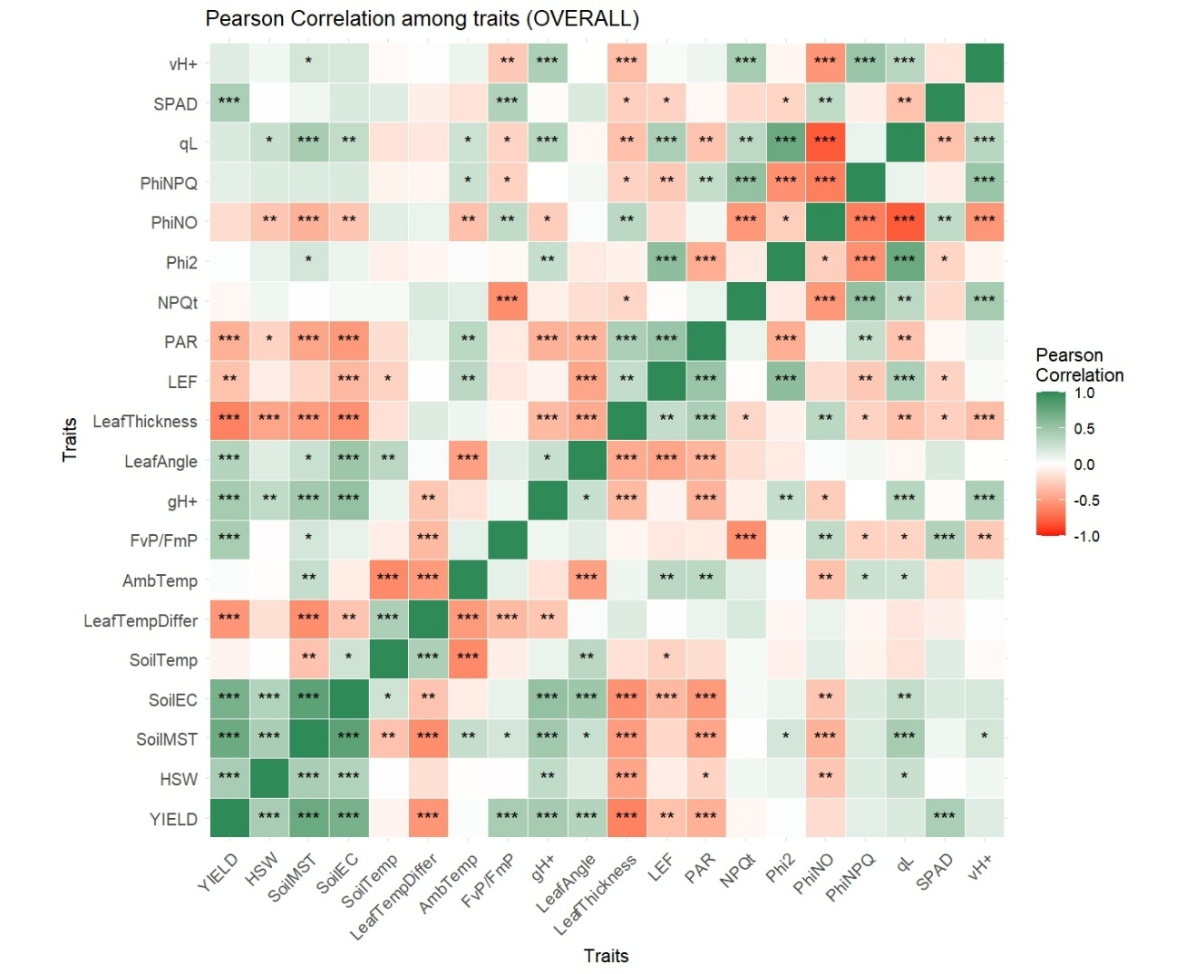
Figure 1. Pearson correlation matrix of different photosynthetic traits, seed yield and soil parameters
2. Identify candidate genes for photosynthetic efficiency traits correlated with high seed yield in soybean

We evaluated a diverse panel of 250 soybean lines at two locations last season: Lee Farm (Portageville, MO) and Rhodes Farm (Clarkton, MO) with three replications. This year, we are re-evaluating the same panel at Ridgway IL, and Fisk, MO, also with three replications, to perform association analysis and identify candidate loci and genes related to key photosynthetic traits. The panel has already been planted at both location for the 2025 season.

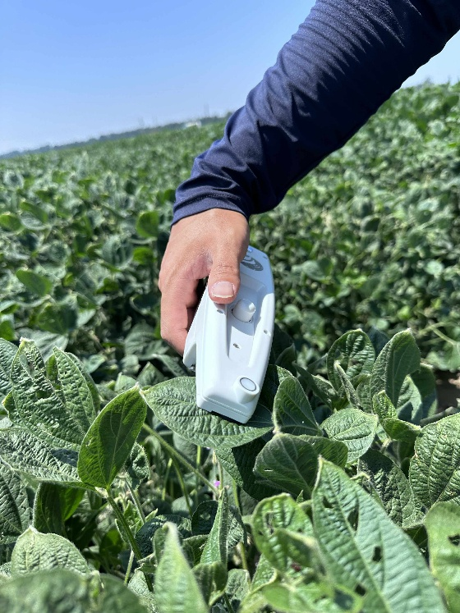

Figure 2. MultispeQ for measuring different various photosynthetic traits in soybean (Lee Farm Portageville, MO 2024)

3. Develop a predictive breeding pipeline in soybean using photosynthetic efficiency towards the release of soybean varieties with high yield potential

We evaluated all advanced breeding lines at three location last season. Soil samples were collected and analyzed, and weather data were recorded. Drone imaging (RGB + multispectral images) were used to collect data. Multi location field data from last year is being analyzed by coupling with soil and weather parameter to develop preliminary models. Additional data from this season will be incorporated to refine and optimize these models. Based on data last season, we initiated three crosses by selecting parents with high photosynthetic efficiency.

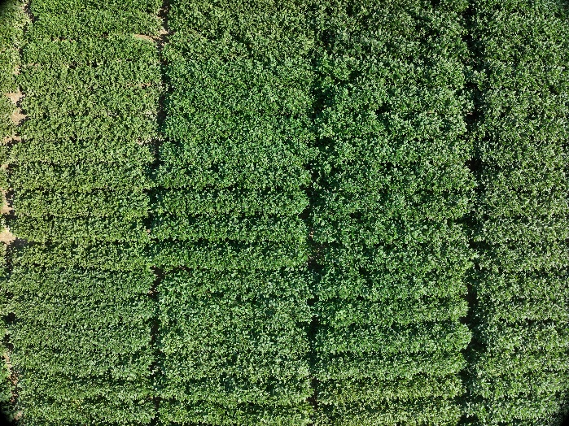

Figure 3. Drone-captured imaged of field plots at Fisk, MO in 2024

