Please use this form to clearly and concisely report on project progress. The information included should reflect quantifiable results that can be used to evaluate and measure project success. Comments should be limited to the designated boxes. Technical reports, no longer than 4 pages, may be attached to this summary report.
Project Title: | Screening and Selecting Non-Xtend Soybeans for Dicamba Tolerance
Organization: | University of Arkansas
Principal Investigator Name: | Caio Canella Vieira
Report Period: | March to June, 2025

Project Status:
Objective 1: Fine-mapping genomic regions associated with off-target dicamba tolerance

Dicamba QTL mapping populations: A RIL mapping population derived from a tolerant PI and a susceptible breeding line was visually phenotyped at the R3-R4 growth stages for dicamba tolerance during the summer of 2024 in Arkansas and Missouri. This was also conducted in 2023. The genotyping of the populations was conducted in collaboration with a seed company using a proprietary panel of 5,000 SNPs. We have received the genotypic data and a new post-doctoral researcher in Arkansas is currently working on QTL mapping.

Objective 2: Development of breeding populations (Enlist-E3 and conventional) stacking various sources of tolerance

Vieira: Seven populations derived from an elite Enlist-E3 line and a dicamba-tolerant source are being advanced in off-season nursery, with return expected by Spring 2026 (Figure 1). Populations are showing excellent agronomic traits and may serve as a unique combination of Enlist-E3 on an off-target dicamba tolerance genetic background.

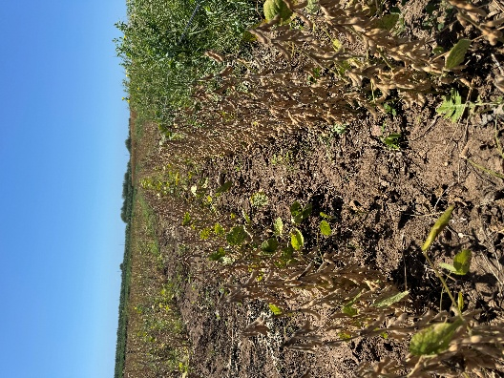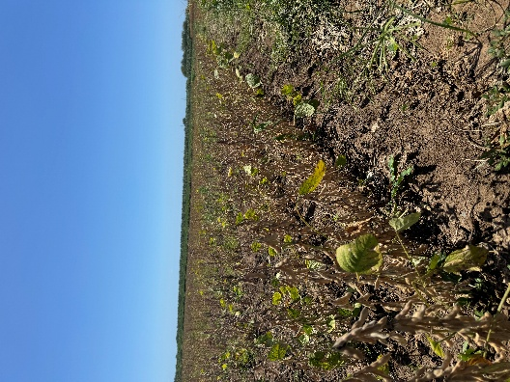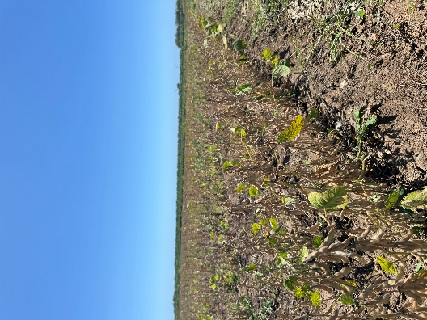
Figure 1. Populations of Enlist-E3 parental lines crossed to an off-target dicamba tolerant source. These are F_{2:3} populations and will return to Fayetteville in Spring 2026.

Lin: Sixteen conventional breeding populations to improve off-target damage from dicamba are being advanced from F₁-F₄ in winter nursery in Costa Rica, which are expected to produce at least 1,600 new breeding lines to be evaluated in progeny rows in 2025.

