Please use this form to clearly and concisely report on project progress. The information included should reflect quantifiable results that can be used to evaluate and measure project success. Comments should be limited to the designated boxes. Technical reports, no longer than 4 pages, may be attached to this summary report.
Project Title: | Enhanced Synthetic Microbiome Communities to Managed Sudden Death Syndrome
Organization: | Arkansas State University
Principal Investigator Name: | Asela Wijeratne and Scott Mangan
Report Period: | April – June 15, 2025

Project Status: On going
- Background
Sudden Death Syndrome (SDS), a devastating disease caused by the soilborne fungal pathogen Fusarium virguliforme, poses a significant threat to soybean production across the United States, particularly in the Mid-South region. The pathogen infects soybean roots and produces toxins that lead to foliar symptoms, ultimately causing substantial yield losses. Traditional management strategies, including the use of fungicides and SDS-tolerant soybean cultivars, often show inconsistent performance due to environmental variability, pathogen adaptation, and limitations in genetic resistance. As the disease continues to challenge growers, there is an increasing need for sustainable and biologically driven approaches to enhance plant resilience.
- Research Justification and Rationale
Emerging research in plant-microbe interactions suggests that beneficial rhizosphere microbes can improve plant health and increase tolerance to both biotic and abiotic stresses. In particular, certain bacteria and fungi associated with the soybean rhizosphere have shown potential in suppressing F. virguliforme through competitive exclusion, antibiosis, and induction of systemic resistance. Building on these insights, this research project aims to develop Synthetic Microbial Communities (SynComs) composed of naturally occurring beneficial microbes that can be introduced into the soybean rhizosphere as a novel strategy to manage SDS. By isolating and characterizing these organisms, we aim to lay the foundation for future SynCom formulations that can be field-tested and eventually integrated into sustainable crop management practices.

- Objectives and Approaches – Year 1
The primary objective for Year 1 is to isolate and identify beneficial rhizosphere-associated microbes—both bacterial and fungal—that exhibit antagonistic activity against F. virguliforme. This includes three major components (Fig. 01):
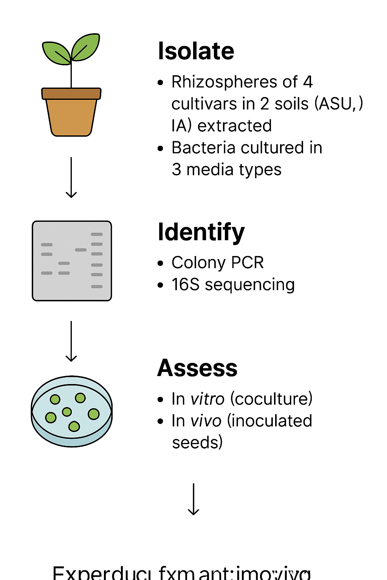
Figure. 01. Schematic showing the workflow.

- Rhizosphere Sampling and Microbial Isolation:
Two soybean cultivars with contrasting responses to Fusarium virguliforme: XO 04312 (tolerant) and XO 3752 (susceptible) were planted in pots filled with one of two distinct agricultural soils—Grundy/Haig soil from Iowa and Collins silt loam from Arkansas—chosen for their differing physical and chemical characteristics. A total of ten seeds per cultivar were grown in a controlled environment chamber under saturated watering conditions. Root systems were harvested at two time points: approximately 30 and 60 days after germination.
At each timepoint, plants were removed and processed under sterile conditions. From each cultivar, four root samples were collected and stored for DNA extraction, while the remaining roots and attached rhizosphere soil (~3 grams) were reserved for microbial culturing. Bacteria and fungi were isolated using serial dilutions and plating on selective and non-selective media (LB, R2A, and PDA).
To isolate rhizosphere microbial communities for DNA-based analysis, root-soil samples were vortexed in sterile PBS buffer containing a surfactant to detach microbes from root surfaces. The resulting suspension was filtered and centrifuged to collect microbial pellets, which were then resuspended, further purified by high-speed centrifugation, and stored at −80°C.
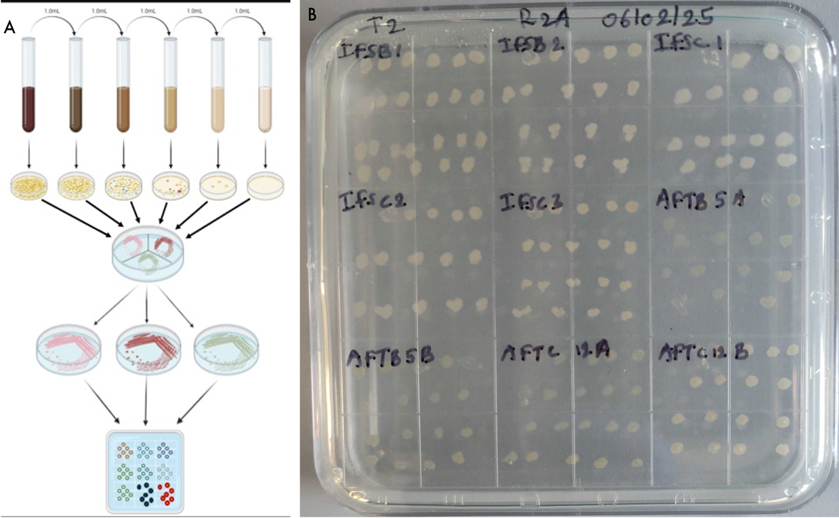
- Microbial Identification and Cataloging:
Bacterial isolates obtained from the rhizosphere samples are being cataloged and morphologically characterized based on colony appearance, growth patterns, and media-specific traits (Fig. 02). A total of 121 isolates were successfully cultured from T2 timepoint. We have extracted DNA from 90 samples and performed PCR amplification of 16S rRNA gene for bacterial identification. For the initial round of sequencing, a subset of 28 high-quality samples was selected and sequenced using Oxford Nanopore sequencing technology. The sequencing data is being analyzed. These results will provide species-level taxonomic resolution and support the identification of bacterial candidates for further functional analysis and SynCom development.
Figure 02. A. Schematic showing bacterial culturing process. B. A subset of cultured bacterial on a plate

- Community analysis of soil fungi and bacteria:
To investigate the composition of microbial communities associated with soybean rhizospheres, we amplified the 16S rRNA gene from DNA extracted from rhizosphere soil samples. These amplified products were prepared for high-throughput sequencing using Oxford Nanopore technology. Sequencing has been successfully completed, and we are currently in the data analysis phase. This analysis will provide insights into the bacterial diversity and relative abundance of microbial taxa present in each soil and cultivar treatment. The resulting profiles will also support the identification of naturally occurring beneficial microbes and their potential interactions with antagonistic isolates identified in vitro.

- Progress Summary
As of this reporting period, over 400 bacterial isolates have been successfully cultured from soybean rhizosphere samples across two cultivars and two soil environments. A subset of these isolates is undergoing DNA-based identification. The rhizosphere processing, culture methods, and antagonism screening pipeline have been standardized and optimized for reproducibility. All materials, including protocols and microbial isolate metadata, are being recorded in a centralized digital lab notebook using Benchling.

- Next Steps (Q2 Goals)
In the upcoming quarter, our primary focus will be on completing the molecular identification of the bacterial isolates collected during Q1. This will involve DNA extraction and sequencing, primarily targeting the 16S rRNA gene to determine the taxonomic identity of each isolate. Following identification, we will conduct in vitro antagonism assays to assess the inhibitory activity of these isolates against F. virguliforme.
In parallel, we will perform microbial community analysis using DNA extracted from the same rhizosphere soil samples to gain insight into the broader microbial landscape. This metagenomic data will allow us to evaluate how the antagonistic isolates function within the native microbial community context, including potential synergistic or competitive interactions. The combined results from isolate screening and community profiling will inform the design of preliminary Synthetic Microbial Communities (SynComs), composed of candidate beneficial microbes with potential biocontrol activity against SDS.

