Please use this form to clearly and concisely report on project progress. The information included should reflect quantifiable results that can be used to evaluate and measure project success. Comments should be limited to the designated boxes. Technical reports, no longer than 4 pages, may be attached to this summary report.
Project Title: | Screening and Selecting Non-Xtend Soybeans for Dicamba Tolerance
Organization: | University of Arkansas
Principal Investigator Name: | Caio Canella Vieira
Report Period: | June to September, 2025

Project Status:
Objective 1: Fine-mapping genomic regions associated with off-target dicamba tolerance
Dicamba QTL mapping populations:

With 2-yr off-target dicamba scores and genotypic data, we performed QTL analysis using a RIL mapping population. We identified two major QTLs on chromosomes 9 and 13 and four minor QTLs on chromosomes 6, 10, 19, and 20 (Figure 1). The favorable alleles of the most significant SNP markers for each QTL were tested for the variation of dicamba scores based on the number of favorable alleles and the allele combinations (Figure 2). It demonstrated that the RILs with more favorable alleles showed better tolerance to off-target dicamba, ranging from 3.5 (none) to 2.1 (all) on average (Figure 2A). Notably, the favorable allele on chromosome 13 (qDIC_13.1) appeared most frequently in the top half of the combinations (21 out of 28), whereas it was found in only seven out of the 28 combinations in the bottom half (Figure 2B). The top 10 RILs for potential germplasms for off-target dicamba tolerance are shown in Table 1.
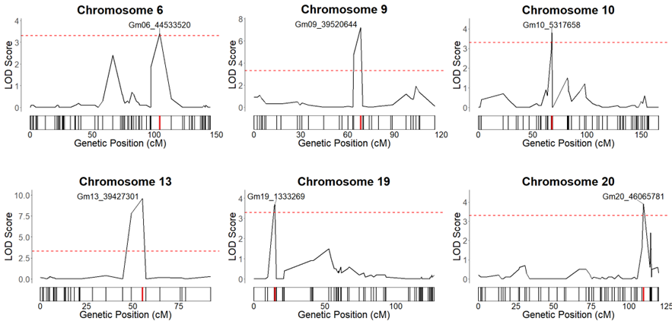
Figure 1. Results of QTL analysis for off-target dicamba tolerance in RIL populations. The most significant SNP markers for each QTL were labeled and highlighted in red on the genetic map. The dotted red line indicates the significance threshold of 3.3.

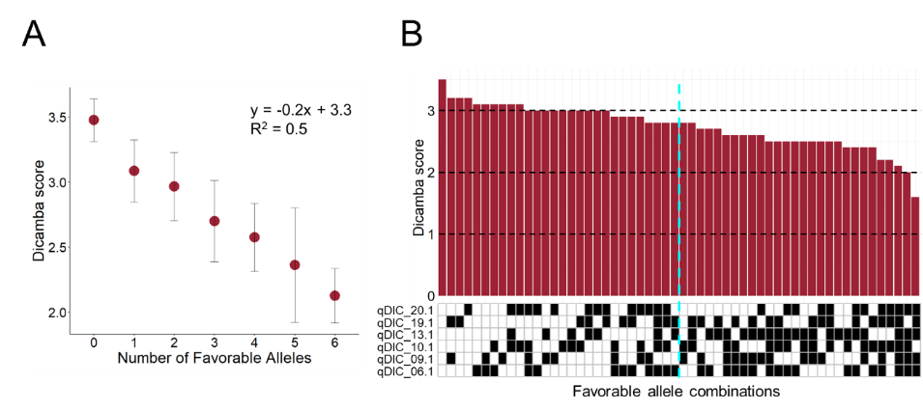
Figure 2. The average dicamba scores of RILs based on the number of favorable alleles of the most significant SNP markers for each QTL (A). The average dicamba scores based on the observed combinations of favorable alleles within the population (B). The black and white boxes indicate favorable alleles and unfavorable alleles, respectively. The dotted turquoise line indicates the threshold between the top and bottom halves of the dicamba scores.

Table 1. A list of RILs for potential germplasm for off-target dicamba tolerance in soybean
Name | Mariana  (2023) | Portageville  (2023) | Mariana  (2024) | Portageville  (2024) | Average
CR20_182_56 | 1.5 | 2.0 | 1.0 | - | 1.6
CR20_182_292 | 1.5 | 1.5 | 2.0 | 1.75 | 1.7
CR20_182_200 | 1.5 | 1.5 | 2.0 | 2.25 | 1.8
CR20_182_301 | 2.0 | 1.5 | 2.25 | 1.75 | 1.9
CR20_182_250 | 1.75 | 1.75 | 1.75 | 2.5 | 1.9
CR20_182_91 | 1.5 | 2.25 | 1.75 | 2.5 | 2.0
CR20_182_319 | 1.5 | 2.75 | 1.75 | 2.25 | 2.1
CR20_182_342 | 2.25 | 2.0 | 2.5 | 2.0 | 2.2
CR20_182_252 | 2.0 | 2.0 | 2.25 | 3.0 | 2.3
CR20_182_348 | - | - | 2.0 | 2.5 | 2.3

Objective 2: Development of breeding populations (Enlist-E3 and conventional) stacking various sources of tolerance

As previously reported, seven populations derived from an elite Enlist-E3 line and a dicamba-tolerant source are being advanced in off-season nursery, with return expected by Spring 2026. Populations will undergo another round of Enlist application in Puerto Rico before returning to Arkansas.

In Missouri, roughly 1,600 F_{4:5} progeny rows with dicamba-tolerant pedigrees are being evaluated. Selected materials will be moved into preliminary yield trials in 2026.

