Project Number:
Project Title: | LADDER (Large Agricultural Database that Drives Extension and Research)
Organization: | Mississippi Water Resources Research Institute (MWRRI); Mississippi State University
Project Lead Name: | Dave Spencer (Zach Reynolds)
Reporting Period:  Please select the appropriate reporting period for this report. | ☐ December ☐ March ☐ June ☒ September ☐ Final

The information included in this detailed report should reflect quantifiable results that can be used to evaluate and measure project success.

If Progress Report – What key activities were undertaken and what were the key accomplishments during this reporting period? List each key deliverable from the proposal and describe progress made (or not made) toward achieving it, including metrics were appropriate.

If Final Report – What were the key accomplishments during the life of the project? List each deliverable from the proposal and describe progress made (or not made) toward achieving it, including metrics where appropriate.
Objective 1: Determine the effects of environment, i.e., CEC, pH, slope, climatic data, and agronomic practices including irrigation, precision ag technology, nutrient management, planting systems, and tillage systems on soybean productivity and profitability at the farm scale.
The latest iteration of LADDER now has the ability to plot 3D heatmaps of data. It was determined that adding this could be beneficial for viewing field slopes and planning irrigation system layouts. Most harvest and planting files acquired through MyJohnDeere’s user portal include an elevation column, thus, users can investigate a field’s elevation map without the need to physically survey the field. Furthermore, users can do a historical analysis to observe field elevation change over time due to erosion and gain insight on how the field’s contours affect plant health and yield.

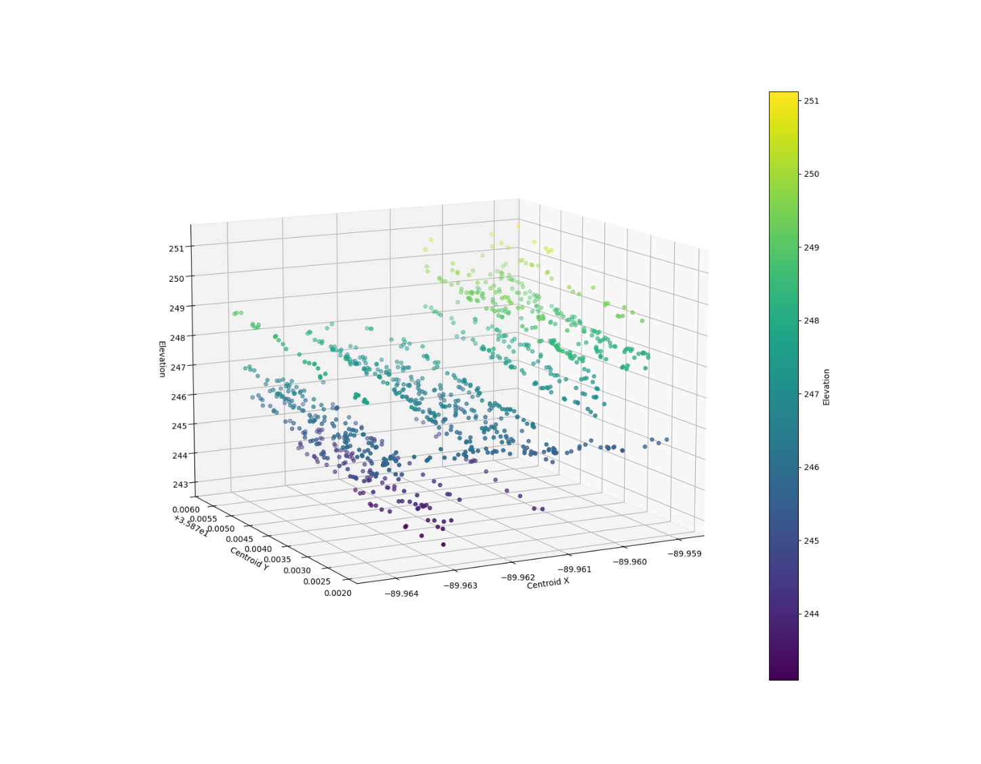
Figure 1: 3D heatmap of Elevation
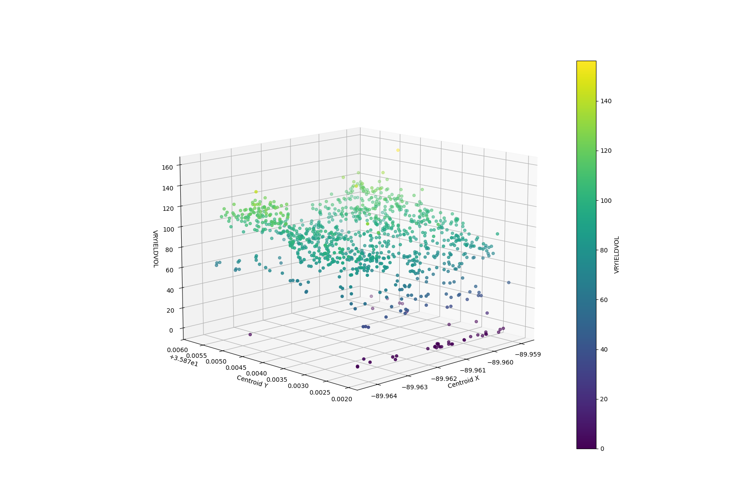
Figure 2: 3D heatmap of Yield
Any numerical column present in the file can be plotted as a 3D heatmap and the view of the plot can be cropped and rotated in 3D-space by the end-user.

Examples of how 3D heatmaps can be leveraged by the end-user:
- Compare yield and elevation heatmaps side by side to determine if field contours are causing changes in yield
- Observe how soil analytes are affected by elevation changes (pH, CEC, Ca, Organic Material, etc.)
- Utilize elevation heatmaps to determine the best course of action to implement irrigation infrastructure
- Observe vehicle speed across different parts of a field such as low spots or turnrows and observe how changes in planter and harvester vehicle speeds affect yield and fuel consumption.

Objective 2: Deliver research-based Extension programing to soybean producers in the Mid-South to stimulate the adoption and proper implementation of geospatially specific agronomic practices that improve grain yield, net returns, and sustainability.

LADDER now has added functionality to allow the user to apply a custom filter to the output data during plotting. This feature enables users the ability to filter out categorical information such as, but not limited to, crop type, crop varieties, soil type, and weather data.

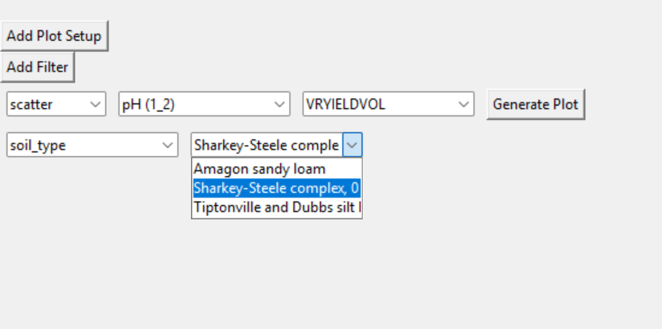
Figure 3: User-interface for selecting filter options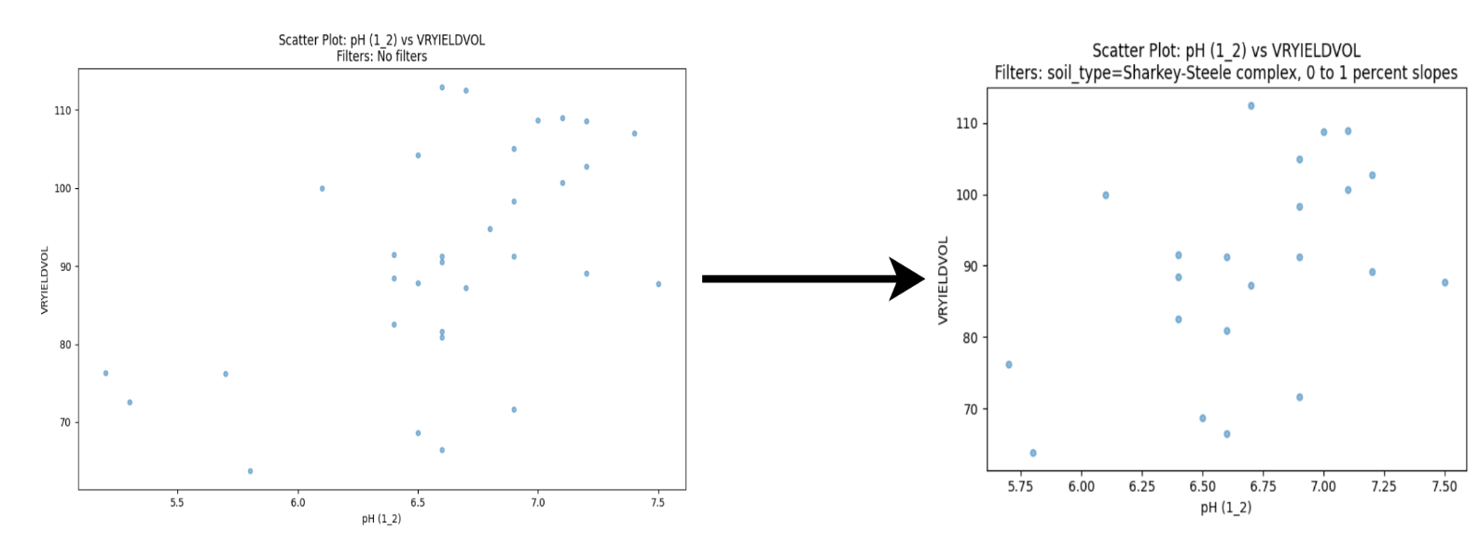
Figure 4: Plot of pH vs Yield before and after filtering soil types to only include Sharkey-Steel complex
On LADDER’s plotting page, the user can select what column they’d like to filter data from, then select the data they’d like to filter. Multiple filters can be applied at once giving users the flexibility to filter out very specific data they’re interested in.

Examples of how LADDER’s filter function can be utilized:
-Filter crop varieties and view how different varieties respond to soil analytes
-Filter soil types and observe how different soil types effect yield
-During historical analysis, filter crop year to compare and visualize data from previous years.
-Apply filters to observe pH vs Yield in each soil type.

Currently, LADDER’s filter functionality allows for one “category” to be filtered from a column, however, future iterations of LADDER will have checkboxes to allow users to filter multiple “categories” from a column. Future iterations of LADDER will also have filtering options to apply comparison operators such as less than (<), greater than (>), less than or equal to (<=), greater than or equal to (>=), and equal to (==). Users will be able to apply these comparison operators on numerical columns to further tailor their filters to fit their data analysis needs.

With its constantly improving capabilities, LADDER can integrate harvest, planting, and soil data through spatial joins to generate a unified dataset. This empowers users to evaluate how soil analytes, soil types, and seeding rates influence yield. By offering flexible customization options and intuitive visualizations, LADDER equips farmers with actionable insights and supports data-driven decision-making to improve productivity, profitability, and sustainability in the fields.

