This report and any technical reports (no longer than 4 pages) or final deliverables (e.g., studies, reports, etc.) need to be uploaded to Smartsheet. These reports and deliverables are viewable by USB staff only.

For Progress Reports: You are also required to provide a Progress Summary. This item will be shared publicly, so it should contain non-proprietary, non-confidential information.

For Final Reports: You are also required to provide a Final Summary and Benefits to Soybean Farmers. These items will be shared publicly, so they should contain non-proprietary, non-confidential information.

The boxes to enter the summary/benefits information and to upload reports to Smartsheet can be accessed by clicking the “Open Request” button located in your Smartsheet email notification.
Project Title: | Expanding Potential Market Demand for and Access to Whole Soy Foods through Nutrition Education
Organization: | University of Arkansas Division of Agriculture and University of Missouri
Project Lead Name: | Leigh Ann Bullington
Reporting Period:  Please select the appropriate reporting period for this report. | ☐ December ☐ March ☐ June ☒ September ☐ Final

The information included in this detailed report should reflect quantifiable results that can be used to evaluate and measure project success.

If Progress Report – What key activities were undertaken and what were the key accomplishments during this reporting period? List each key deliverable from the proposal and describe progress made (or not made) toward achieving it, including metrics were appropriate.

If Final Report – What were the key accomplishments during the life of the project? List each deliverable from the proposal and describe progress made (or not made) toward achieving it, including metrics where appropriate.
Objective 1. Increase awareness about soy milk and whole / minimally processed (w/mp) soy foods in school and early childcare centers through a multipronged intervention involving taste tests and work with educational influencers.
Missouri –
4-H led a summer school program at Halfway R-3 school in Halfway, MO. Ten students participated in a soy butter and sourdough challenge. Students learned about the nutritional value of soybeans, where they are grown, and how they can be used for food. Students had full access to the school kitchen. They roasted soybeans then used a food processor to make soy nut butter. Students were able tasted the roasted soybeans. Then they compared the soy nut butter they made, and soy nut butter purchased from the store. They discussed the differences in processed vs. homemade foods and the benefits of making food from scratch.
Arkansas –
A fact sheet entitled "Arkansas Foods – Let’s Eat Some Soybeans” has been created and waiting on final edits before printing. It was written for a youth audience and contains information about why we want to eat soybeans, how they are grown, purchasing, storing, and preparing along with youth friendly recipes. A companion instructor lesson plan guide has also been written. These will be used with school and other youth audiences.
FCS agents in Poinsett, Independence, and Ashley counties are in the planning process with local school districts to conduct soy smoothie tastings.
FCS agents in Woodruff, Cross, Crittenden, Lonoke, Randolph, and Monroe counties are in the planning process of working with local school districts to conduct roasted nut and soymilk tastings during the school year.
Planning for Best Care FCS Agent train the trainer training to be held in November 2025. The newly developed trifold adult educational displays and the new adult soy nutrition fact sheet will be utilized to teach over sixty seventy county family and consumer sciences agents about the importance of soy in the diet. These agents will in turn teach approximately 1,500 early childhood caregivers about soy nutrition and how it can be incorporated into their centers’ snacks and meals times. This will also include a recipe and tasting activity.

Objective 2. Improve access to soy milk and (w/mp) soy foods in school and early childcare centers.
Arkansas -
This objective will be worked on next year after this fall’s Best Care train the trainer program delivery on soy nutrition.

Objective 3. Increase the availability of soy foods in local food systems while exploring viable connections between producers and consumers
Missouri –
Farm field days are planned in September and October where upwards of 300-500 high school students will learn about various topics related to agriculture to include soy nutrition education.

Objective 4. Increase appeal and demand for soy foods through education that includes local demonstrations for consumers and producers.
Missouri –
August 1-2 the Norborne Soybean Festival was held in Norborne, MO with over 850 in attendance.
The grant supported soy cooking demonstrations and a cooking competition with adult and youth divisions. Prior to the festival, community members were asked to send their favorite soy food recipe for a chance to compete in a cook off against an Extension faculty member. A Cajun Soybean and Rice recipe and a Cowboy Caviar recipe that included cooked soybeans were demonstrated. Attendees had the opportunity to sample both recipes. We provided recipe cards for each. Roasted soy nuts also sampled. (MO will supply #s reached but has not currently.)
Missouri is also working with another multi-state team to create educational resources related to alpha-gal syndrome and incorporating soy recipes into the plan. Nutrition specialists plan to provide sessions on alpha-gal syndrome and tick bite prevention and will provide samples of trail mix made with roasted soy nuts. Soy recipes are being included in the resources being created on alpha-gal safe cooking.
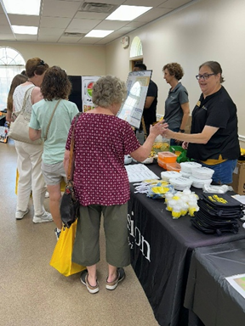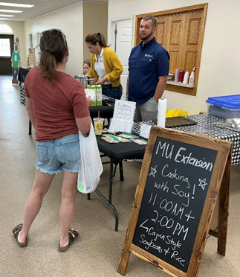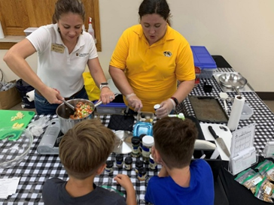

Arkansas –
A new adult fact sheet on soy nutrition has been written and is currently being formatted for printing. It should be ready to print by the 2nd week of October. A new trifold educational display board is being created to be a companion to the fact sheet and will be used with producer audiences during the upcoming winter production meetings as well as at the Arkansas Farm Bureau statewide meeting and other trade shows and meetings.

