Please use this form to clearly and concisely report on project progress. The information included should reflect quantifiable results that can be used to evaluate and measure project success. Comments should be limited to the designated boxes. Technical reports, no longer than 4 pages, may be attached to this summary report.
Project Title: | Enhanced Synthetic Microbiome Communities to Managed Sudden Death Syndrome
Organization: | Arkansas State University
Principal Investigator Name: | Asela Wijeratne and Scott Mangan
Report Period: | June 15 – Sept 15, 2025

Project Status: On going
- Background
Sudden Death Syndrome (SDS), a devastating disease caused by the soilborne fungal pathogen Fusarium virguliforme, poses a significant threat to soybean production across the United States, particularly in the Mid-South region. The pathogen infects soybean roots and produces toxins that lead to foliar symptoms, ultimately causing substantial yield losses. Traditional management strategies, including the use of fungicides and SDS-tolerant soybean cultivars, often show inconsistent performance due to environmental variability, pathogen adaptation, and limitations in genetic resistance. As the disease continues to challenge growers, there is an increasing need for sustainable and biologically driven approaches to enhance plant resilience.
- Research Justification and Rationale
Emerging research in plant-microbe interactions suggests that beneficial rhizosphere microbes can improve plant health and increase tolerance to both biotic and abiotic stresses. In particular, certain bacteria and fungi associated with the soybean rhizosphere have shown potential in suppressing F. virguliforme through competitive exclusion, antibiosis, and induction of systemic resistance. Building on these insights, this research project aims to develop Synthetic Microbial Communities (SynComs) composed of naturally occurring beneficial microbes that can be introduced into the soybean rhizosphere as a novel strategy to manage SDS. By isolating and characterizing these organisms, we aim to lay the foundation for future SynCom formulations that can be field-tested and eventually integrated into sustainable crop management practices.

- Objectives and Approaches – Year 1
The primary objective for Year 1 is to isolate and identify beneficial rhizosphere-associated microbes—both bacterial and fungal—that exhibit antagonistic activity against F. virguliforme. This includes three major components (Fig. 01):
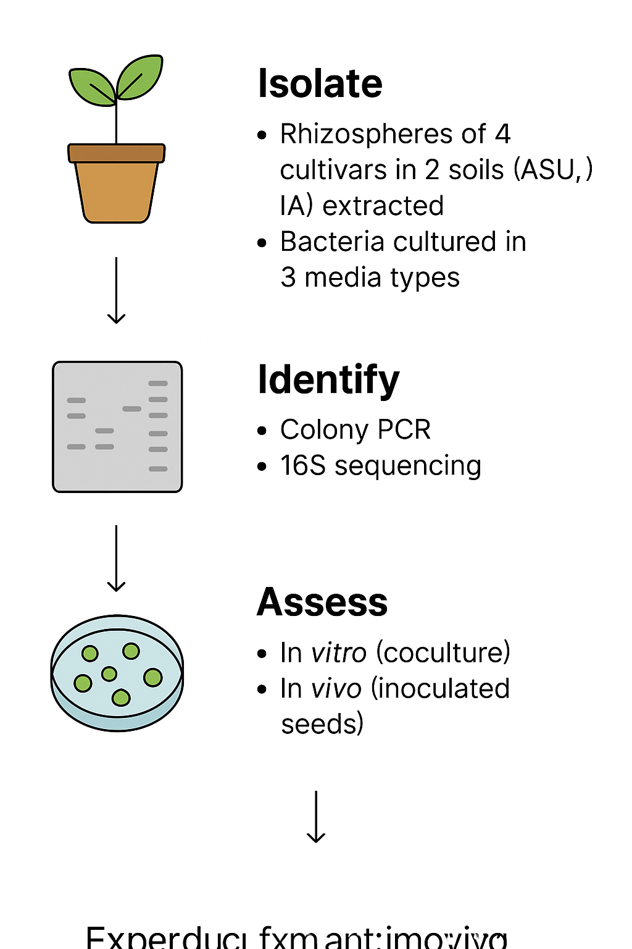
Figure. 01. Schematic showing the workflow.

- Rhizosphere Sampling and Microbial Isolation (Figure 1):
Two soybean cultivars with contrasting responses to Fusarium virguliforme: XO 04312 (tolerant) and XO 3752 (susceptible) were planted in pots filled with one of two distinct agricultural soils—Grundy/Haig soil from Iowa and Collins silt loam from Arkansas—chosen for their differing physical and chemical characteristics. A total of ten seeds per cultivar were grown in a controlled environment chamber under saturated watering conditions. Root systems were harvested at two time points: approximately 30 and 60 days after germination.
At each timepoint, plants were removed and processed under sterile conditions. From each cultivar, four root samples were collected and stored for DNA extraction, while the remaining roots and attached rhizosphere soil (~3 grams) were reserved for microbial culturing. Bacteria and fungi were isolated using serial dilutions and plating on selective and non-selective media (LB, R2A, and PDA).
To isolate rhizosphere microbial communities for DNA-based analysis, root-soil samples were vortexed in sterile PBS buffer containing a surfactant to detach microbes from root surfaces. The resulting suspension was filtered and centrifuged to collect microbial pellets, which were then resuspended, further purified by high-speed centrifugation, and stored at −80°C.

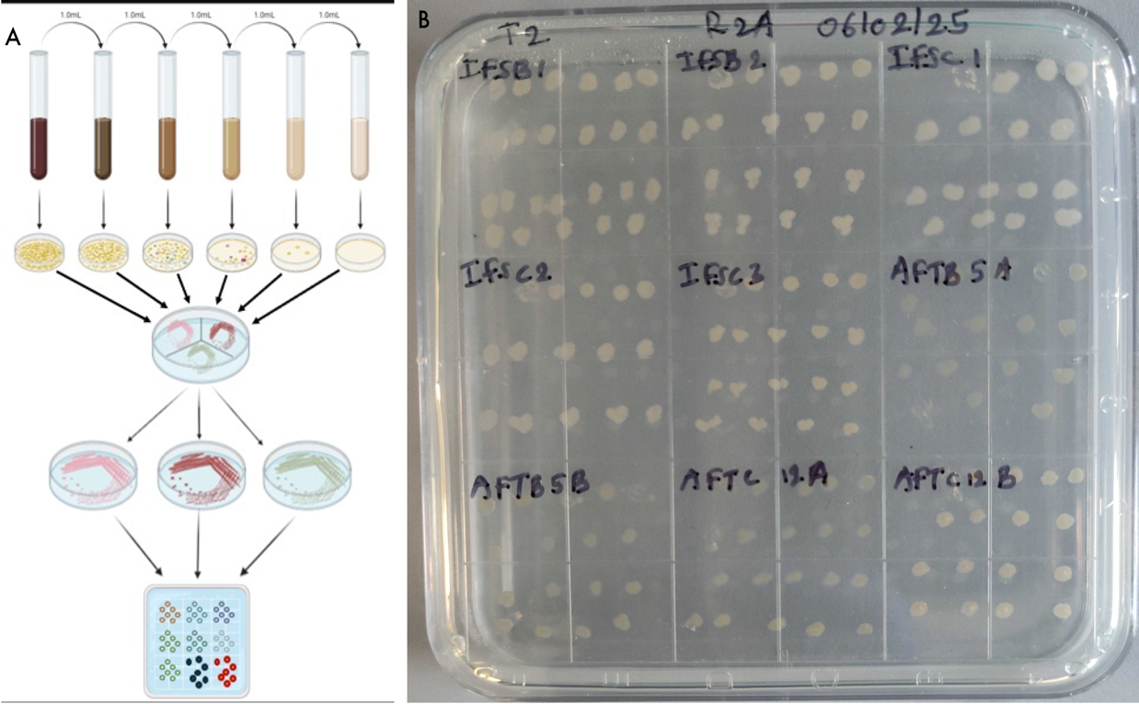
- Microbial Identification and Cataloging:
Bacterial isolates obtained from the rhizosphere samples are being cataloged and morphologically characterized based on colony appearance, growth patterns, and media-specific traits (Fig. 02). A total of 459 isolates were successfully cultured from T2 timepoint. We have extracted DNA from 223 samples and performed PCR amplification of 16S rRNA gene for bacterial identification. For the initial round of sequencing, a subset of 74 high-quality samples was selected and sequenced using Oxford Nanopore sequencing technology. The sequencing data is being analyzed. These results will provide species-level taxonomic resolution and support the identification of bacterial candidates for further functional analysis and SynCom development.
Figure 02. A. Schematic showing bacterial culturing process. B. A subset of cultured bacterial on a plate

- Community analysis of soil fungi and bacteria:
To investigate the composition of microbial communities associated with soybean rhizospheres, we amplified the 16S rRNA gene from DNA extracted from rhizosphere soil samples. These amplified products were prepared for high-throughput sequencing using Oxford Nanopore technology. Sequencing has been successfully completed, and we are currently in the data analysis phase. This analysis will provide insights into the bacterial diversity and relative abundance of microbial taxa present in each soil and cultivar treatment. The resulting profiles will also support the identification of naturally occurring beneficial microbes and their potential interactions with antagonistic isolates identified in vitro.
d). Literature based plant-beneficial traits relevant to growth promotion and biocontrol potential. Several strains exhibited multiple key traits:
- IAA Production (Plant Hormone Synthesis): Detected in numerous isolates, including Bacillus velezensis, Priestia aryabhattai, Achromobacter animicus, and Bacillus cereus, indicating potential to enhance root development and plant growth.
- Siderophore Production (Iron Acquisition): This trait was widespread, found in over half of the isolates, suggesting strong capacity for iron mobilization—an important mechanism for outcompeting pathogens in the rhizosphere.
- Nutrient Solubilization (Phosphate Mobilization): Several isolates, including Bacillus pseudomycoides, Bacillus cereus, and Priestia megaterium, demonstrated this capability, enhancing nutrient availability to plants.
- Biocontrol Potential: Only a subset of isolates (e.g., Bacillus velezensis, Pseudomonas plecoglossicida, Bacillus pseudomycoides, and Priestia aryabhattai) displayed a combination of functional traits associated with antagonism against F. virguliforme, highlighting them as promising biocontrol candidates.

e). In Vitro Screening of Biocontrol Candidates Against SDS Pathogen
In an in vitro antagonism assay against F. virguliforme, several bacterial isolates exhibited strong inhibitory activity, notably Bacillus cereus (85.92%), Bacillus velezensis (80.10%), Pseudomonas nicosulfuronedens (73.17%), and Bacillus pseudomycoides (71.73%). Moderate inhibition was observed in strains like Bacillus paramycoides, Priestia megaterium, and Priestia aryabhattai. In contrast, some isolates, including Hydrogenophaga palleronii, Achromobacter animicus, and Variovorax paradoxus, showed negative inhibition values, indicating they promoted pathogen growth. A synthetic microbial community (SynCom), composed of five candidate strains (Bacillus velezensis, Stenotrophomonas maltophilia, Pseudomonas plecoglossicida, Bacillus pseudomycoides, and Priestia aryabhattai), demonstrated strong biocontrol potential with 80.89% inhibition, suggesting synergistic effects among its members.

- Progress Summary
As of this reporting period, over 400 bacterial isolates have been successfully cultured from soybean rhizosphere samples across two cultivars and two soil environments. A subset of these isolates is undergoing DNA-based identification. The rhizosphere processing, culture methods, and antagonism screening pipeline have been standardized and optimized for reproducibility. All materials, including protocols and microbial isolate metadata, are being recorded in a centralized digital lab notebook using Benching.

- Next Steps (Q3 Goals)
In the upcoming quarter, complete microbial community analysis to better understand the structure and dynamics of rhizosphere microbial populations. In parallel, laboratory assays will be conducted to evaluate key plant-beneficial traits of selected bacterial isolates, including:
- IAA production – synthesis of a plant growth hormone
- Siderophore production – enhancement of plant iron uptake
- Nutrient solubilization – improved availability of essential nutrients
These analyses aim to identify microbes with strong potential for promoting plant health and growth.
We will also create a machine learning algorithm to select candidate for SynCom optimization.

