This report and any technical reports (no longer than 4 pages) or final deliverables (e.g., studies, reports, etc.) need to be uploaded to Smartsheet. These reports and deliverables are viewable by USB staff only.

For Progress Reports: You are also required to provide a Progress Summary. This item will be shared publicly, so it should contain non-proprietary, non-confidential information.

For Final Reports: You are also required to provide a Final Summary and Benefits to Soybean Farmers. These items will be shared publicly, so they should contain non-proprietary, non-confidential information.

The boxes to enter the summary/benefits information and to upload reports to Smartsheet can be accessed by clicking the “Open Request” button located in your Smartsheet email notification.
Project Title: | Leveraging Photosynthetic Efficiency traits for improving soybean productivity in the Mid-South
Organization: | University of Missouri
Project Lead Name: | Feng Lin
Reporting Period:  Please select the appropriate reporting period for this report. | ☐ December ☐ March ☐ June ☒ September ☐ Final

The information included in this detailed report should reflect quantifiable results that can be used to evaluate and measure project success.

If Progress Report – What key activities were undertaken and what were the key accomplishments during this reporting period? List each key deliverable from the proposal and describe progress made (or not made) toward achieving it, including metrics were appropriate.

If Final Report – What were the key accomplishments during the life of the project? List each deliverable from the proposal and describe progress made (or not made) toward achieving it, including metrics where appropriate.
The project aims to improve soybean yield by leveraging photosynthetic efficiency. We identified key photosynthetic traits in our big panel of advanced breeding lines that are linked to higher seed yield. A diverse panel of 250 lines is being evaluated this year at two different locations (Fisk, MO and Ridgway, IL). We are exploring these multi-location datasets to develop predictive models combined with soil and weather information. Three new crosses which were made using parents with high photosynthetic efficiency, will be harvested soon. All the data has been collected using MultispeQ and UAV drone imaging during flowering to early pod stages. Seed yield and agronomic traits will also be recorded. The effort and work on this project have been shared through poster presentations. Two publications have been already out and third is underway to report the preliminary results.

PRESENTATIONS
- From Sky to Canopy: Integrating UAV Imaging and Photosynthetic signatures for Soybean Drought-Resilience Breeding- National Association of Plant Breeding Annual Meeting (2025)
- Leveraging UAV and Photosynthetic Traits to Enhance Soybean Drought Resilience Breeding- Missouri Soybean Symposium (2025)
- Smart Leaves, Strong Yields: Unlocking Drought Tolerance in Soybean Through Integrated Trait Selection- Soybean Breeders Workshop (2025)
- Exploring UAV assisted Physiological insights for improving soybean drought resilience, MU-FDREEC Field day, Portageville, MO (2025)

PUBLICATIONS
- Harnessing Photosynthetic and Morpho-Physiological Traits for Drought-Resilient Soybean: Integrating Field Phenotyping and Predictive Approaches. Front Plant Physio
- Assessing variation in photosynthetic performance of soybean (Glycine max) using MultispeQ phenotyping (IPPS proceeding)
- Dissecting Photosynthetic Traits Variation and their association with seed yield in Soybean across developmental stages (In preparation)

OBJECTIVE(S):
1. Identify the photosynthesis related traits strongly correlated with higher seed yield in soybean

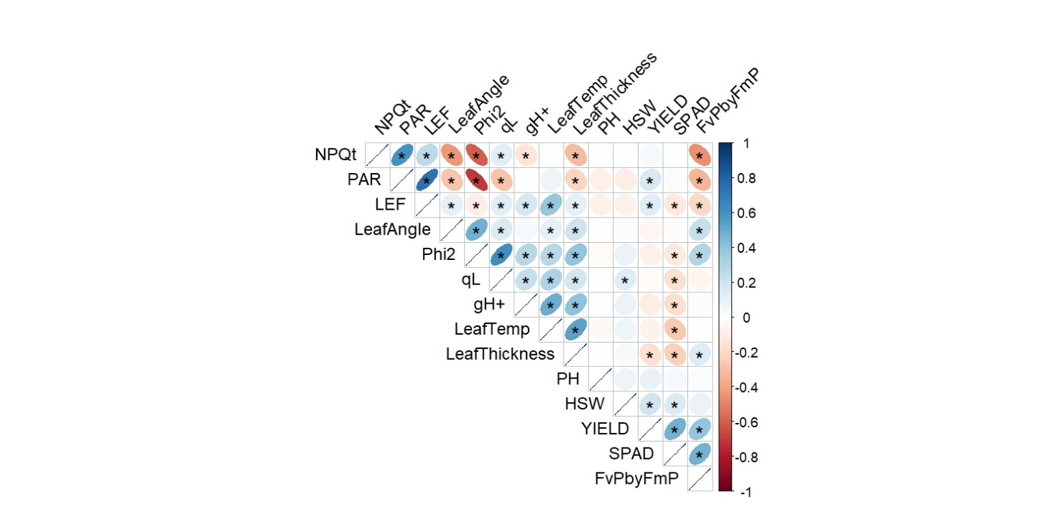
We evaluated more than 100 advanced breeding lines (MG 3 Late, 4 early and 4 late) from MU-FDREEC program last year and collected their photosynthetic and seed yield response across two locations (Portageville, MO and Fisk, MO). We analyzed the data from both locations and identified several traits showing significant association with seed yield in our experiments. We also observed that maturity group does not have significant impact on several photosynthetic traits. We also found that photosynthetic performance during R3-R4 stages showed better correlation with final yield, compared to R1-R2 stage. Currently, we are finalizing these analyses and results for our manuscript to publish in a reputed journal.

Figure 1. Relationship between seed yield and photosynthetic traits in MU-FDREEC breeding lines

2. Identify candidate genes for photosynthetic efficiency traits correlated with high seed yield in soybean
We already finished collecting photosynthetic and other physiological parameters in the diverse panel from both the locations (Fisk, MO and Ridgway, IL). We have already extracted all the data from the MultispeQ cloud source and started pre-processing it for quality control. It will be used for downstream phenotypic analysis followed by genomic associations. We observed a very good variability in several photosynthetic and other physiological traits including leaf characters and relative chlorophyll content.
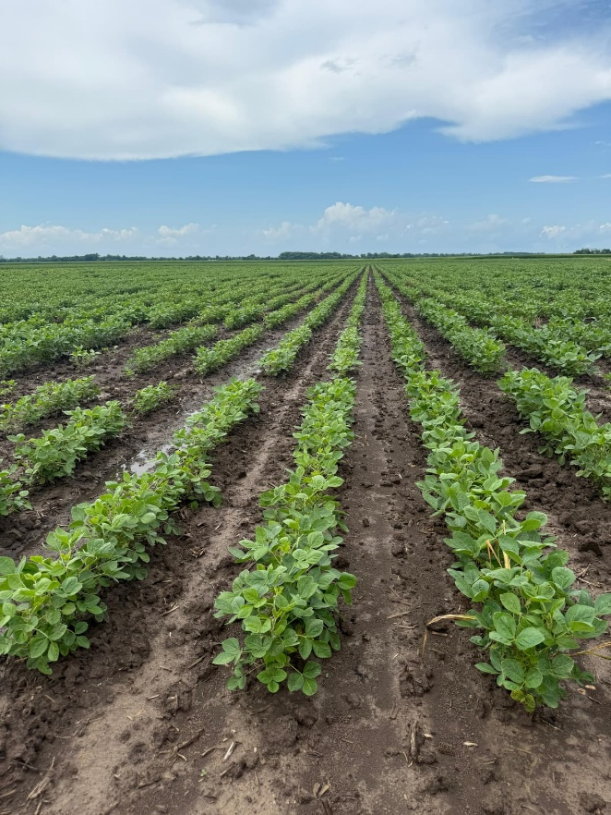
Figure .2 MU-FDREEC soybean diversity panel at Fisk, MO location

3. Develop a predictive breeding pipeline in soybean using photosynthetic efficiency towards the release of soybean varieties with high yield potential
For our predictive breeding objective, we already extracted and processed all our UAV imaging data for advanced yield trials last year. Preliminary results show that several indices from multispectral imaging show significant correlation with photosynthetic performance and seed yield. We will be working further explore several statistical and machine learning models to predict soybean yield in this advance breeding germplasm using UAV derived indices and photosynthetic performance.

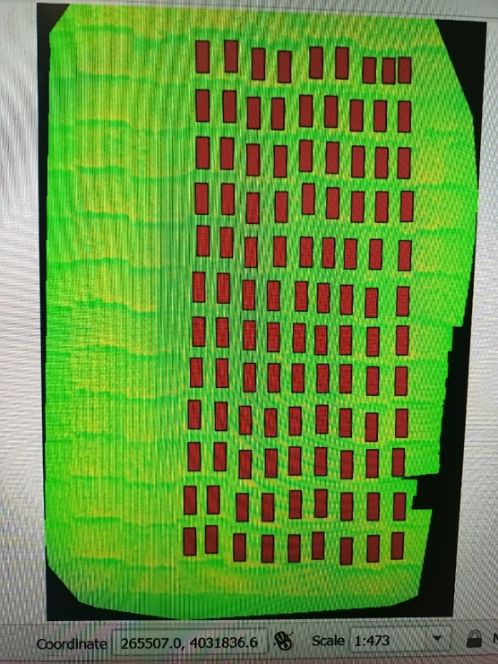
Figure 3. UAV imaging data analysis from advanced breeding lines at MU-FDREEC trials

