Project Number:
Project Title: | LADDER (Large Agricultural Database that Drives Extension and Research)
Organization: | Mississippi Water Resources Research Institute (MWRRI); Mississippi State University
Project Lead Name: | Dave Spencer
Reporting Period:  Please select the appropriate reporting period for this report. | ☒ December ☐ March ☐ June ☐ September ☒ Final

The information included in this detailed report should reflect quantifiable results that can be used to evaluate and measure project success.

If Progress Report – What key activities were undertaken and what were the key accomplishments during this reporting period? List each key deliverable from the proposal and describe progress made (or not made) toward achieving it, including metrics were appropriate.

If Final Report – What were the key accomplishments during the life of the project? List each deliverable from the proposal and describe progress made (or not made) toward achieving it, including metrics where appropriate.
Objective 1: Determine the effects of environment, i.e., CEC, pH, slope, climatic data, and agronomic practices including irrigation, precision ag technology, nutrient management, planting systems, and tillage systems on soybean productivity and profitability at the farm scale.
Currently, LADDER is at a point in development where a majority of the core geospatial functionalities have been written, tested, and implemented. The next phase in LADDERS development lifecycle will be focused around improving LADDERs portability, making LADDER platform agnostic, and enabling multi-user functionalities.
The current version of LADDER is implemented by using python natively installed on a machine. The primary limitation of this approach is limited portability. When it’s time to distribute the software, the end-user will have to ensure they have all of the dependencies, correct python versions, and correct module versions that will allow the program to run as expected. As time goes on, developers may update python’s modules and deprecate certain functions that LADDER was previously relying on. To avoid the aforementioned conflicts, the app can be containerized using Docker. Docker’s platform encapsulates an application, it’s dependencies, and it’s runtime environment into a single image. This ensures that LADDER will run the same way every time regardless of what system it’s on; essentially making LADDER platform agnostic. By explicitly defining Python versions, library versions, and environment settings, Docker eliminates issues pertaining to dependency drift, module depreciation, and environment mismatches.
An additional benefit of using Docker is that it streamlines the process for deploying an app into a server. If LADDER is functional on a desktop using Docker, moving the app to a server requires only installing docker onto a server and configuring the network/ports. There’s no need to manage virtual environments, track python versions, or manually resolve dependency conflicts.
Using Docker will improve LADDER’s portability, ensure it runs the same on every system, and enables a pathway to deploy LADDER on a server with minimal effort.

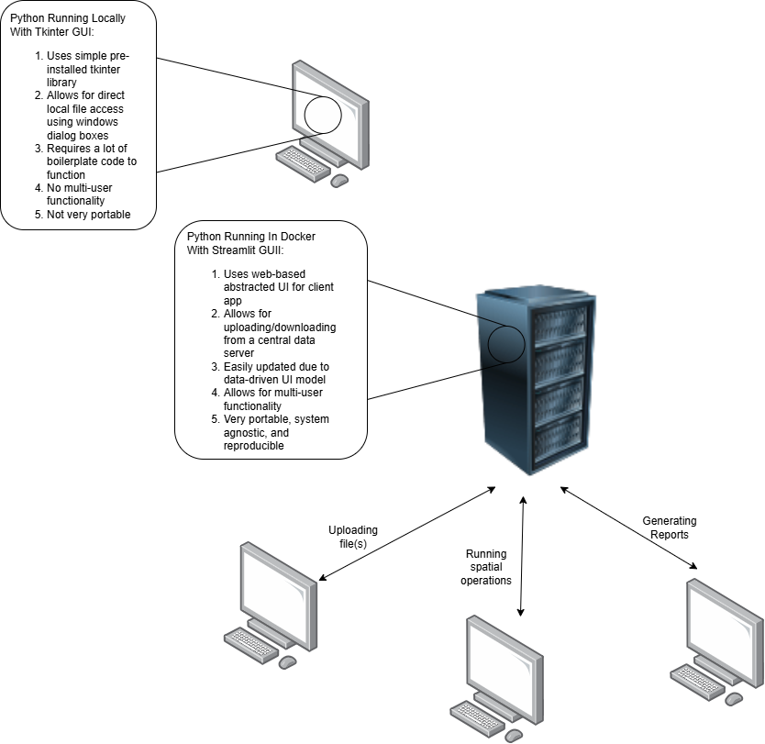
Figure 1: Locally Installed App Schema
Figure 2: Docker Server app schema

Objective 2: Deliver research-based Extension programing to soybean producers in the Mid-South to stimulate the adoption and proper implementation of geospatially specific agronomic practices that improve grain yield, net returns, and sustainability.
LADDER’s current GUI is implemented using Tkinter and while it has served it’s purpose thus far, moving forward LADDER will use an alternative GUI library; most likely Streamlit. Python’s pre-installed tkinter package is suitable for basic GUI applications, however, when trying to implement dynamic content, menus, and aesthetically pleasing GUI layouts, tkinter requires a lot of boilerplate code that is often unwieldy to update or modify. Furthermore, tkinter uses an event-driven UI model that further complicates dynamic content updates. Moving to Streamlit’s much more abstracted UI library makes developing GUIs with dynamic content trivial due to the fact that Streamlit is a declarative, data-driven UI model.
This means when any change occurs in the applications, the GUI is also updated. Previously in tkinter, labels for buttons, menus, and other UI content could only be changed if an event was triggered to change them due to Tkinters event-driven application loop. This required a lot of extra code just to update button labels as every modification to a GUI element needed to be triggered by an event that needed to be individually written.
In contrast, Streamlit allows users to define GUI elements in-line with application variables. If an application variable changes, Streamlit automatically reruns and displays the new GUI state without relying on a button press or other event-triggers. Another benefit of using Streamlit is that it is a web-based UI model. Instead of rendering it’s own window like tkinter, Streamlit opens a webpage already nicely formatted using CSS/HTML. This web-based UI setup will also be useful when LADDER is implemented on a server as the user can just access the software by using a webpage. It would be impossible to implement this same server-client functionality using tkinter as a server application running tkinter would not be able to render the GUI on the end-users machine.
Changing from tkinter to streamlit will drastically improve development speed, allow for much more aesthetically pleasing user-interfaces, and supports server-client use cases due to Streamlit’s web-based UI model.
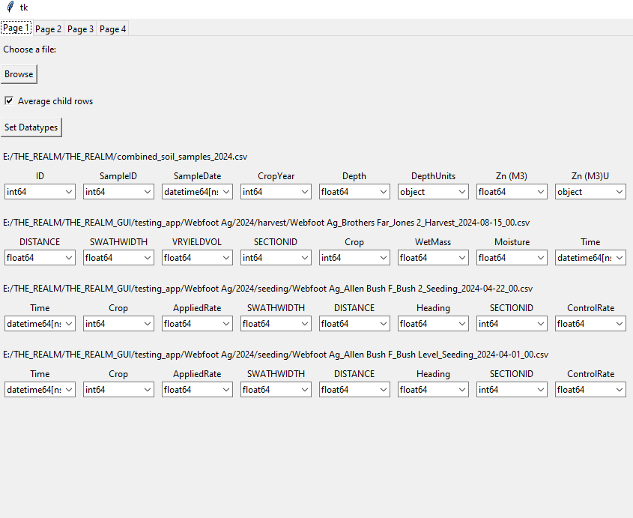
Figure 3: Tkinter GUI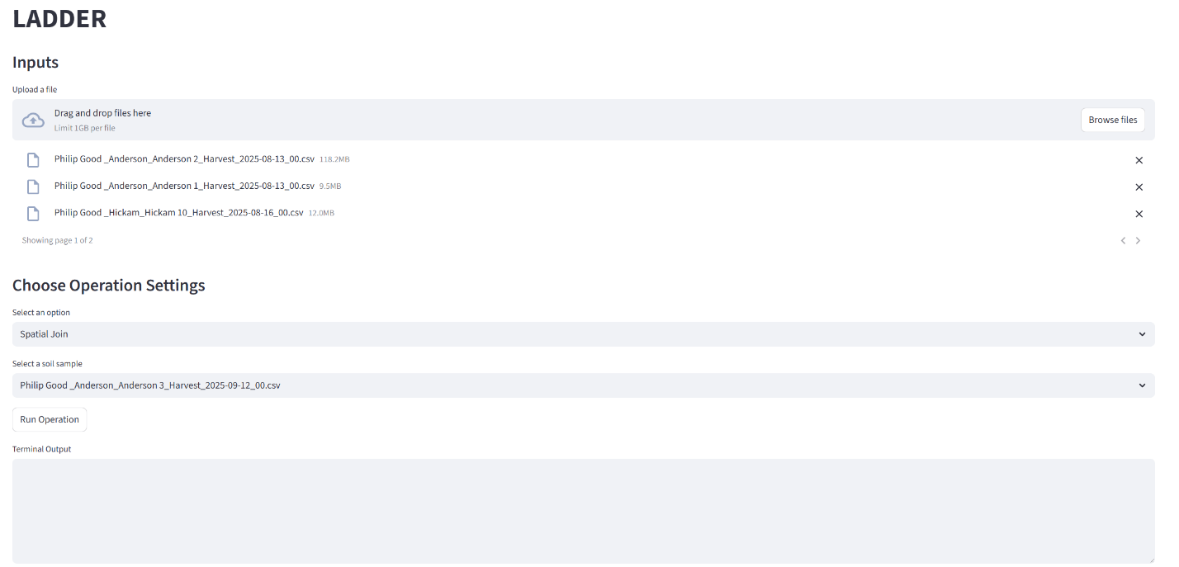
Figure 4: LADDER's latest Streamlit.io GUI

