Project Number:
Project Title: | LADDER (Large Agricultural Database that Drives Extension and Research)
Organization: | Mississippi Water Resources Research Institute (MWRRI); Mississippi State University
Project Lead Name: | Zach Reynolds
Reporting Period:  Please select the appropriate reporting period for this report. | ☐ December ☐ March ☒ June ☐ September ☐ Final

The information included in this detailed report should reflect quantifiable results that can be used to evaluate and measure project success.

If Progress Report – What key activities were undertaken and what were the key accomplishments during this reporting period? List each key deliverable from the proposal and describe progress made (or not made) toward achieving it, including metrics were appropriate.

If Final Report – What were the key accomplishments during the life of the project? List each deliverable from the proposal and describe progress made (or not made) toward achieving it, including metrics where appropriate.
Objective 1: Determine the effects of environment, i.e., CEC, pH, slope, climatic data, and agronomic practices including irrigation, precision ag technology, nutrient management, planting systems, and tillage systems on soybean productivity and profitability at the farm scale.
Generalize the current “LADDER” software so it can be used for any tabular data to allow users to merge their data together into one output file based on geometry, date/time, and attributes.

-In the previous iteration of LADDER, the user was required to provide a soil sample file, harvest data file, and seeding data file for the program to run properly. In addition to this, much of the functionality of the previous program used “hard coded” solutions that worked exclusively on John Deere datasets with specific data column names.
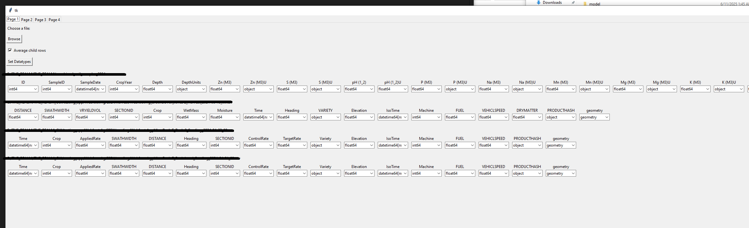
Figure 1: File selection page with options for column datatypes.
-The newest iteration of LADDER has been written to offer more flexibility by allowing any tabular data to be imported and analyzed. When a user imports data, the file’s column’s datatypes are detected, and the user may modify the selected datatype or ignore columns to reduce the final files size.

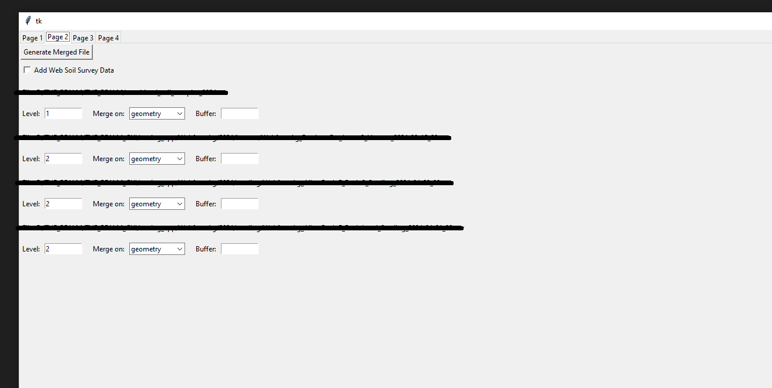
Figure 2: LADDER's new hierarchical data merging setup page
-A new hierarchical system of merging data files has been created. After importing the data and setting up the datatypes for each column, the user is prompted to choose what “level” each file is and what method of merging they wish to use (geometry, date/time, or attribute). While merging, the “child” file with the highest level is selected first and this data gets merged with its respective “parent” file. As each child file gets merged with its parent file, the successfully matched data propagates upwards through the operation queue and eventually gets filtered out completely or appended to the final output file. This new system of merging files together has also been optimized to complete operations much faster with less memory overhead by reducing the number of spatial joins used.

Examples of how this new generalized system can be utilized:
-Combine weather data, harvest data, and soil data together into one file
-Analyze how treatment impacts yield by merging planting/application files with harvest files
-Run historical field analysis by combining multiple years of harvest files together
-Utilize remote sensing by combining canopy cover/imagery data with harvest files to see the effects on yield

-Yield x variety
-Yield x seeding rate
-Yield x planting date
-Yield x soil type
-Yield x weather data (temp, soil temp, humidity, etc)
-Can analyze multiple things at once also: Yield x variety x seeding rate x planting date x soil type x weather data
-Anything else recorded on planter or combine

If a grower has soil data, they can benefit from everything listed above in addition to any recorded soil metric. An example of this could be yield by p level, or yield x p level x soil type, etc.

Objective 2: Deliver research-based Extension programing to soybean producers in the Mid-South to stimulate the adoption and proper implementation of geospatially specific agronomic practices that improve grain yield, net returns, and sustainability.
Add functionality to “LADDER” to allow users to further tailor their data analysis for their application.

-In the previous LADDER software update, majority of the data analysis, data merging, and plotting functions were hard coded. This required specific columns and data to work properly.
Figure 3: LADDER's checkbox to append WSS data to its output file
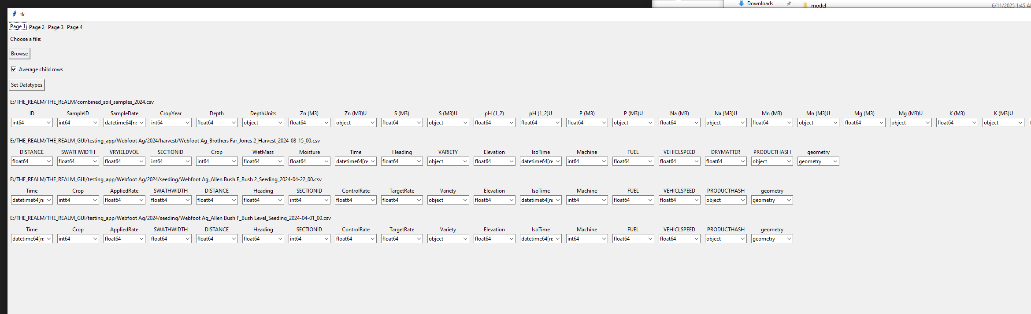
Figure 4: LADDER's checkbox for enabling aggregation of child rows
-The newest LADDER software additions now allow users to quickly choose to append Web Soil Survey data to their output file. Users can also now aggregate data points within their geometric merge buffers to allow users to either reduce file size by averaging numeric points together or forego aggregation all together to allow for a more granular dataset (previously, aggregation was required).

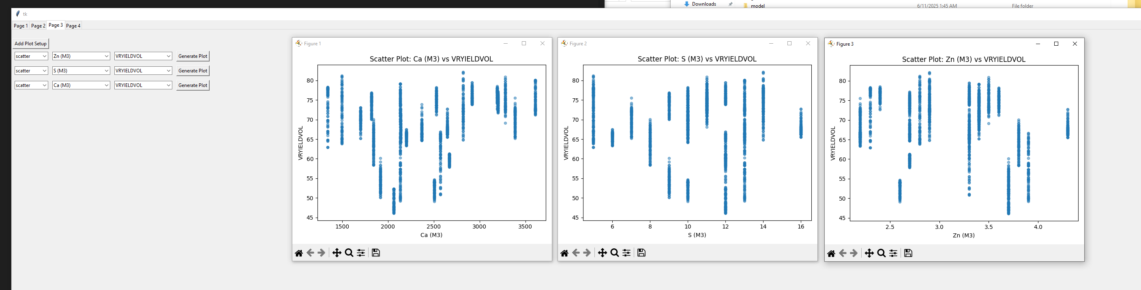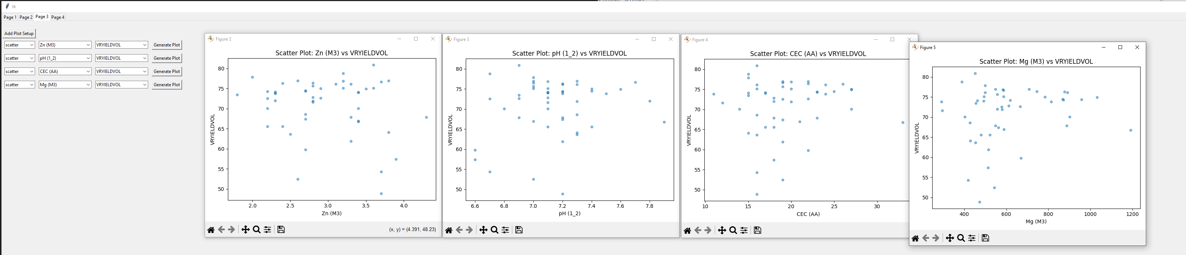
Figure 5: Zn vs Yield prior to aggregation Figure 6: Zn vs Yield after aggregation

Figure 7: LADDER's plot selection with Ca vs Yield displayed
-Users now have more control over what graphs they wish to generate with their output file. Selections for graph type, X axis column, and Y axis column have been added. The currently supported graph types are scatter, bar, and correlation heatmap.

-An extended presentation of results and status of LADDER will be presented at the MSSB meeting in August along with a field visit. This presentation will cover the design of LADDER, results that are possible, along with field trials that work congruently with the database.

-While LADDER will continue to improve and evolve, we are to a point where we can efficiently ingest large quantities data for analysis (machine data, weather data, Web soil survey, etc.). The goal is to provide producers with key agronomic changes that provide increased soybean productivity and profitability.

