This report and any technical reports (no longer than 4 pages) or final deliverables (e.g., studies, reports, etc.) need to be uploaded to Smartsheet. These reports and deliverables are viewable by USB staff only.

For Progress Reports: You are also required to provide a Progress Summary. This item will be shared publicly, so it should contain non-proprietary, non-confidential information.

For Final Reports: You are also required to provide a Final Summary and Benefits to Soybean Farmers. These items will be shared publicly, so they should contain non-proprietary, non-confidential information.

The boxes to enter the summary/benefits information and to upload reports to Smartsheet can be accessed by clicking the “Open Request” button located in your Smartsheet email notification.
Project Title: | Leveraging Photosynthetic Efficiency traits for improving soybean productivity in the Mid-South
Organization: | University of Missouri
Project Lead Name: | Feng Lin
Reporting Period:  Please select the appropriate reporting period for this report. | ☒ December ☐ March ☐ June ☐ September ☐ Final

The information included in this detailed report should reflect quantifiable results that can be used to evaluate and measure project success.

If Progress Report – What key activities were undertaken and what were the key accomplishments during this reporting period? List each key deliverable from the proposal and describe progress made (or not made) toward achieving it, including metrics were appropriate.

If Final Report – What were the key accomplishments during the life of the project? List each deliverable from the proposal and describe progress made (or not made) toward achieving it, including metrics where appropriate.
The project aims to improve soybean yield by leveraging photosynthetic efficiency. We identified key photosynthetic traits linked to higher seed yield in a large panel of advanced breeding lines that are. A diverse panel of 250 lines is evaluated this year at two different locations (Fisk, MO and Ridgway, IL). We are exploring these multi-location datasets to develop predictive models combined with soil and weather information. The new crosses which were made using parents with high photosynthetic efficiency are harvested. All the data has been collected using MultispeQ and UAV drone imaging during flowering to early pod stages. Project outcomes have been shared through poster presentations, with three peer-reviewed publications completed and fourth is in preparation, and one graduate student has successfully completed the program.

PRESENTATIONS
- Exploring UAV assisted Physiological insights for improving soybean drought resilience, MU-FDREEC Field day, Portageville, MO (2025)
- Coupling Photosynthetic traits and yield for drought resilience in Soybean (G. max). Soy 2025: 19th Biennial Conference on Molecular & Cellular Biology of the Soybean, University of Wisconsin-Madison (2025)
- Mapping the Light: Genomic Dissection of Photosynthesis-related traits in Soybean (Glycine max). CANVAS- ASA, CSSA, SSSA International Annual Meeting, Salt Lake City, Utah (2025)

PUBLICATIONS
- Harnessing photosynthetic and morpho-physiological traits for drought-resilient soybean: integrating field phenotyping and predictive approaches. 2025 Front. Plant Physiol. 3:1591146.
- Assessing variation in photosynthetic performance of soybean (Glycine max) using MultispeQ phenotyping (2025 IPPS proceeding)
- Photosynthetic and Canopy Trait Characterization in Soybean (Glycine max L.) using Chlorophyll Fluorescence and UAV Imaging. Agriculture 2025, 15(24), 2576

OBJECTIVE(S):
1. Identify the photosynthesis related traits strongly correlated with higher seed yield in soybean

We evaluated 108 advanced breeding lines (MG III late, IV early and IV late) from MU-FDREEC program for photosynthetic traits variation across two field environments (LEE and FISK) and two growth stages (early and mid reproductive). Broad-sense heritability (H²) estimates indicated dynamic, stage dependent genetic control, generally higher (0.20–0.81) at the mid-reproductive stage. Traits like SPAD and FvP/FmP exhibited the highest heritability and significant association with seed yield, suggesting their potential as useful physiological indicators for selection. Overall, stronger trait-yield correlations at mid reproductive stage underscores the importance of sustained photosynthetic efficiency during pod formation. Environmental effects were significant for almost all photosynthetic traits, indicating strong environmental sensitivity expected in the field. In contrast, genotypic and GxE effects were trait-dependent, reflecting environmental-dependent expressions.
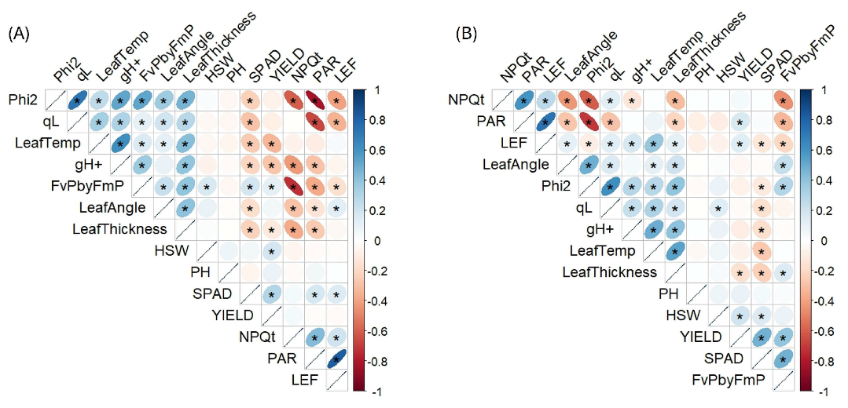
Fig.1 Relationship between seed yield and photosynthetic traits in MU-FDREEC breeding lines during early (A), and mid (B) reproductive stages

2. Identify candidate genes for photosynthetic efficiency traits correlated with high seed yield in soybean
We evaluated photosynthetic traits in a soybean diversity panel across two locations (Fisk and Ridgway). Substantial phenotypic variation was observed for multiple photosynthetic traits. The panel was genotyped using SoySNP50K, and genome wide association analysis identified 55 significant marker-trait associations across FvP/FmP, Phi2, NPQt, LEF and SPAD traits. Two pleiotropic loci on chromosome 10 and 18 were consistently detected across multiple models (GLM, MLM and FarmCPU), with additional key loci on identified on chromosome 1, 5 and 15.
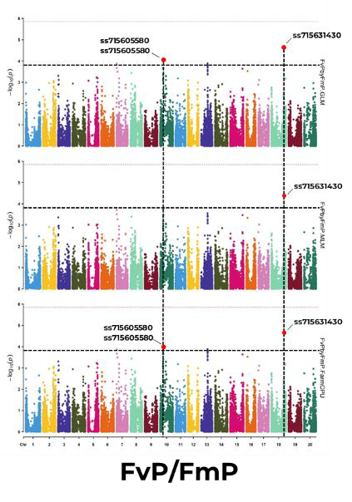
Fig.2 Manhattan plots showing significant SNPs associated with photosynthesis-related traits in soybean diversity panel.

3. Develop a predictive breeding pipeline in soybean using photosynthetic efficiency towards the release of soybean varieties with high yield potential
We analyzed UAV RGB and multispectral imaging data from advanced yield trials and observed that several multispectral indices were significantly associated with photosynthetic performance and seed yield. PCA at the mid reproductive stage showed that first two components (> 67% of total variation) driven majorly by greenness and canopy color-structure related indices. Correlation analysis confirmed strong positive relationships between key UAV indices (MTCI, NDRE, CIRE) and photosynthetic traits, as well as yield, indicating that UAV imaging effectively captures yield related physiological variation. Ongoing work is integrating spectral, photosynthetic and soil-weather data using machine learning approaches to improve yield prediction.

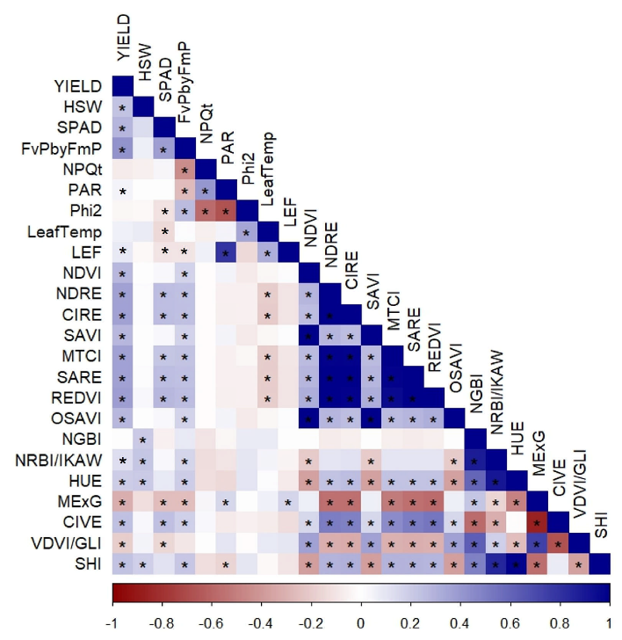
Fig.3 Correlation heatmap among yield, photosynthetic traits and UAV-derived vegetation indices (both Multispectral and RGB) at the S2 stage. (* p < 0.05)

