Please use this form to clearly and concisely report on project progress. The information included should reflect quantifiable results that can be used to evaluate and measure project success. Comments should be limited to the designated boxes. Technical reports, no longer than 4 pages, may be attached to this summary report.
Project Title: | Characterizing Soybean Genotypes for Phosphorus Efficiency
Organization: | University of Arkansas
Principal Investigator Name: | Caio Canella Vieira
Report Period: | April 1 to 15 June, 2026

Project Status: Ongoing (Year 1)
Objective 1: Screening genetically diverse soybean accessions in MG 3-5 for phosphorus use efficiency under different phosphorus conditions

Selection of genetically diverse soybean accessions: We performed principal component analysis (PCA) using a set of genomic markers (2546 SNPs) of 8410 USDA germplasms and 2535 UA breeding lines with MG 3-5 to evaluate genetic distance and diversity. The PCA result showed seven distinct clusters based on genetic similarity (Fig. 1A). However, most breeding lines were tightly clustered in Cluster 6, demonstrating extremely narrow genetic diversity (Fig. 1B). Based on the genetic distance from breeding lines and diverse accessions, we selected 220 genetically diverse USDA germplasms for our study (Fig. 1C).
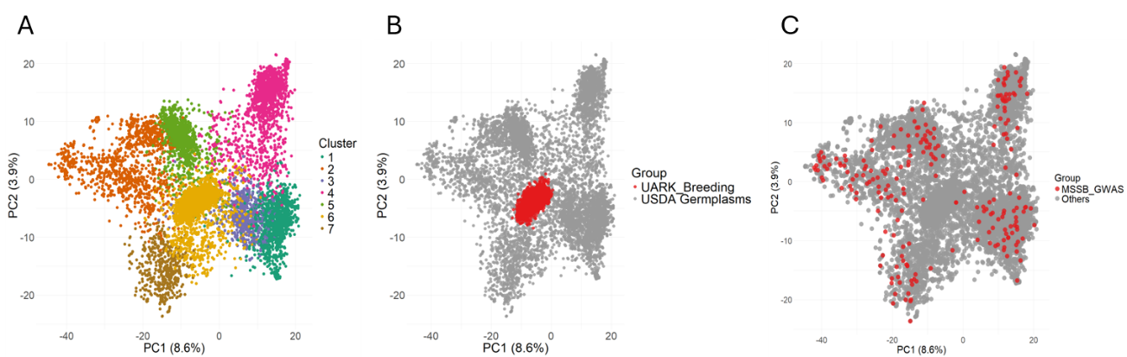
Figure 1. Principal component analysis (PCA) of genetic diversity between the USDA Soybean Germplasm Collection and the UA breeding lines. The analysis shows (A) the seven clusters of 10,945 lines, including 8410 USDA germplasms and 2535 UA breeding lines. The subsets are highlighted to show (B) UA breeding lines and (C) 220 genetically diverse USDA germplasms selected for this study.

The first batch of greenhouse experiments: A total of 224 genotypes, including 220 diverse germplasms and four checks (two public elite breeding lines and two commercial checks), are currently growing in cone-tainers under two phosphorus (P) concentration conditions with three replications in the greenhouse (Fig.1). The two P concentration conditions are created by applying 10ml of two different nutrient solutions (1000ppm N + 50ppm P + 1700ppm K; low P condition vs. 1000ppm N + 200ppm P + 1700ppm K; optimal P condition) once a week using MicroLAB controller (HAMILTON Co.) (Fig. 2). The first batch was planted on May 15, and the plants are currently at V4-5 (as of Jun 11).
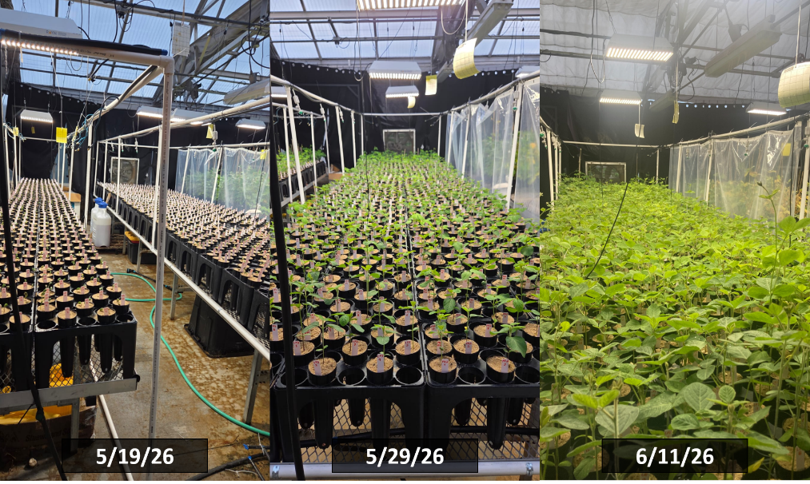
Figure 1. Pictures of the first batch of the greenhouse experiment. The 220 genetically diverse USDA germplasms and four checks (two public elite breeding lines and two commercial checks) are growing under two phosphorus concentration conditions (low P vs. optimal P) with three replications. The planting date is May 15.
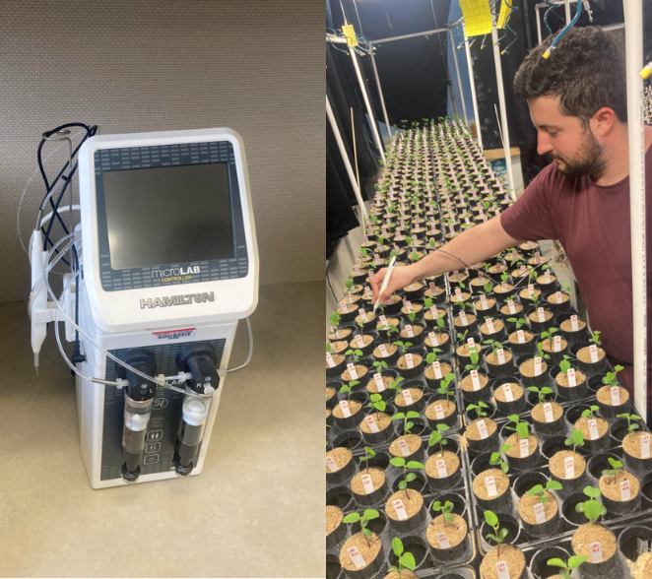
Figure 2. Pictures of a MicroLAB controller we are using to apply nutrient solutions to each cone-tainer, and of a graduate student, Jose Eduardo Vilela Almeida, applying the nutrient solution in the greenhouse.

Upcoming activities for next quarter: We will collect aboveground tissues and roots at V5-6 growth stage to evaluate 1) fresh/dry biomass weight of aboveground tissues; 2) P concentration in aboveground tissues; 3) fresh/dry biomass weight of root tissues; and 4) root system architecture traits (total root length, root volume, root surface area, and the number of tips and forks). The fresh aboveground biomass will be dried in the dryer for 3-4 days and delivered to the Soil Fertility/Testing Laboratory to quantify the P concentration. The root system architecture traits will be measured using an Epson scanner (13000XL) and Rhizovision software.

