Please use this form to clearly and concisely report on project progress. The information included should reflect quantifiable results that can be used to evaluate and measure project success. Comments should be limited to the designated boxes. Technical reports, no longer than 4 pages, may be attached to this summary report.
Project Title: | Breeding Maturity Group 4 Soybean with Enhanced Resistance to Southern Root-knot Nematode by Reducing Galling and Nematode Reproduction
Organization: | University of Arkansas
Principal Investigator Name: | Caio Canella Vieira
Report Period: | April 1 – June 15, 2026

Project Status:
Objective 1 - Characterization of the mechanism of resistance. Characterize the response of lines carrying different combinations of the resistance regions on chromosomes 10 and 13, as well as genetically diverse accessions for nematode reproduction and root galling.

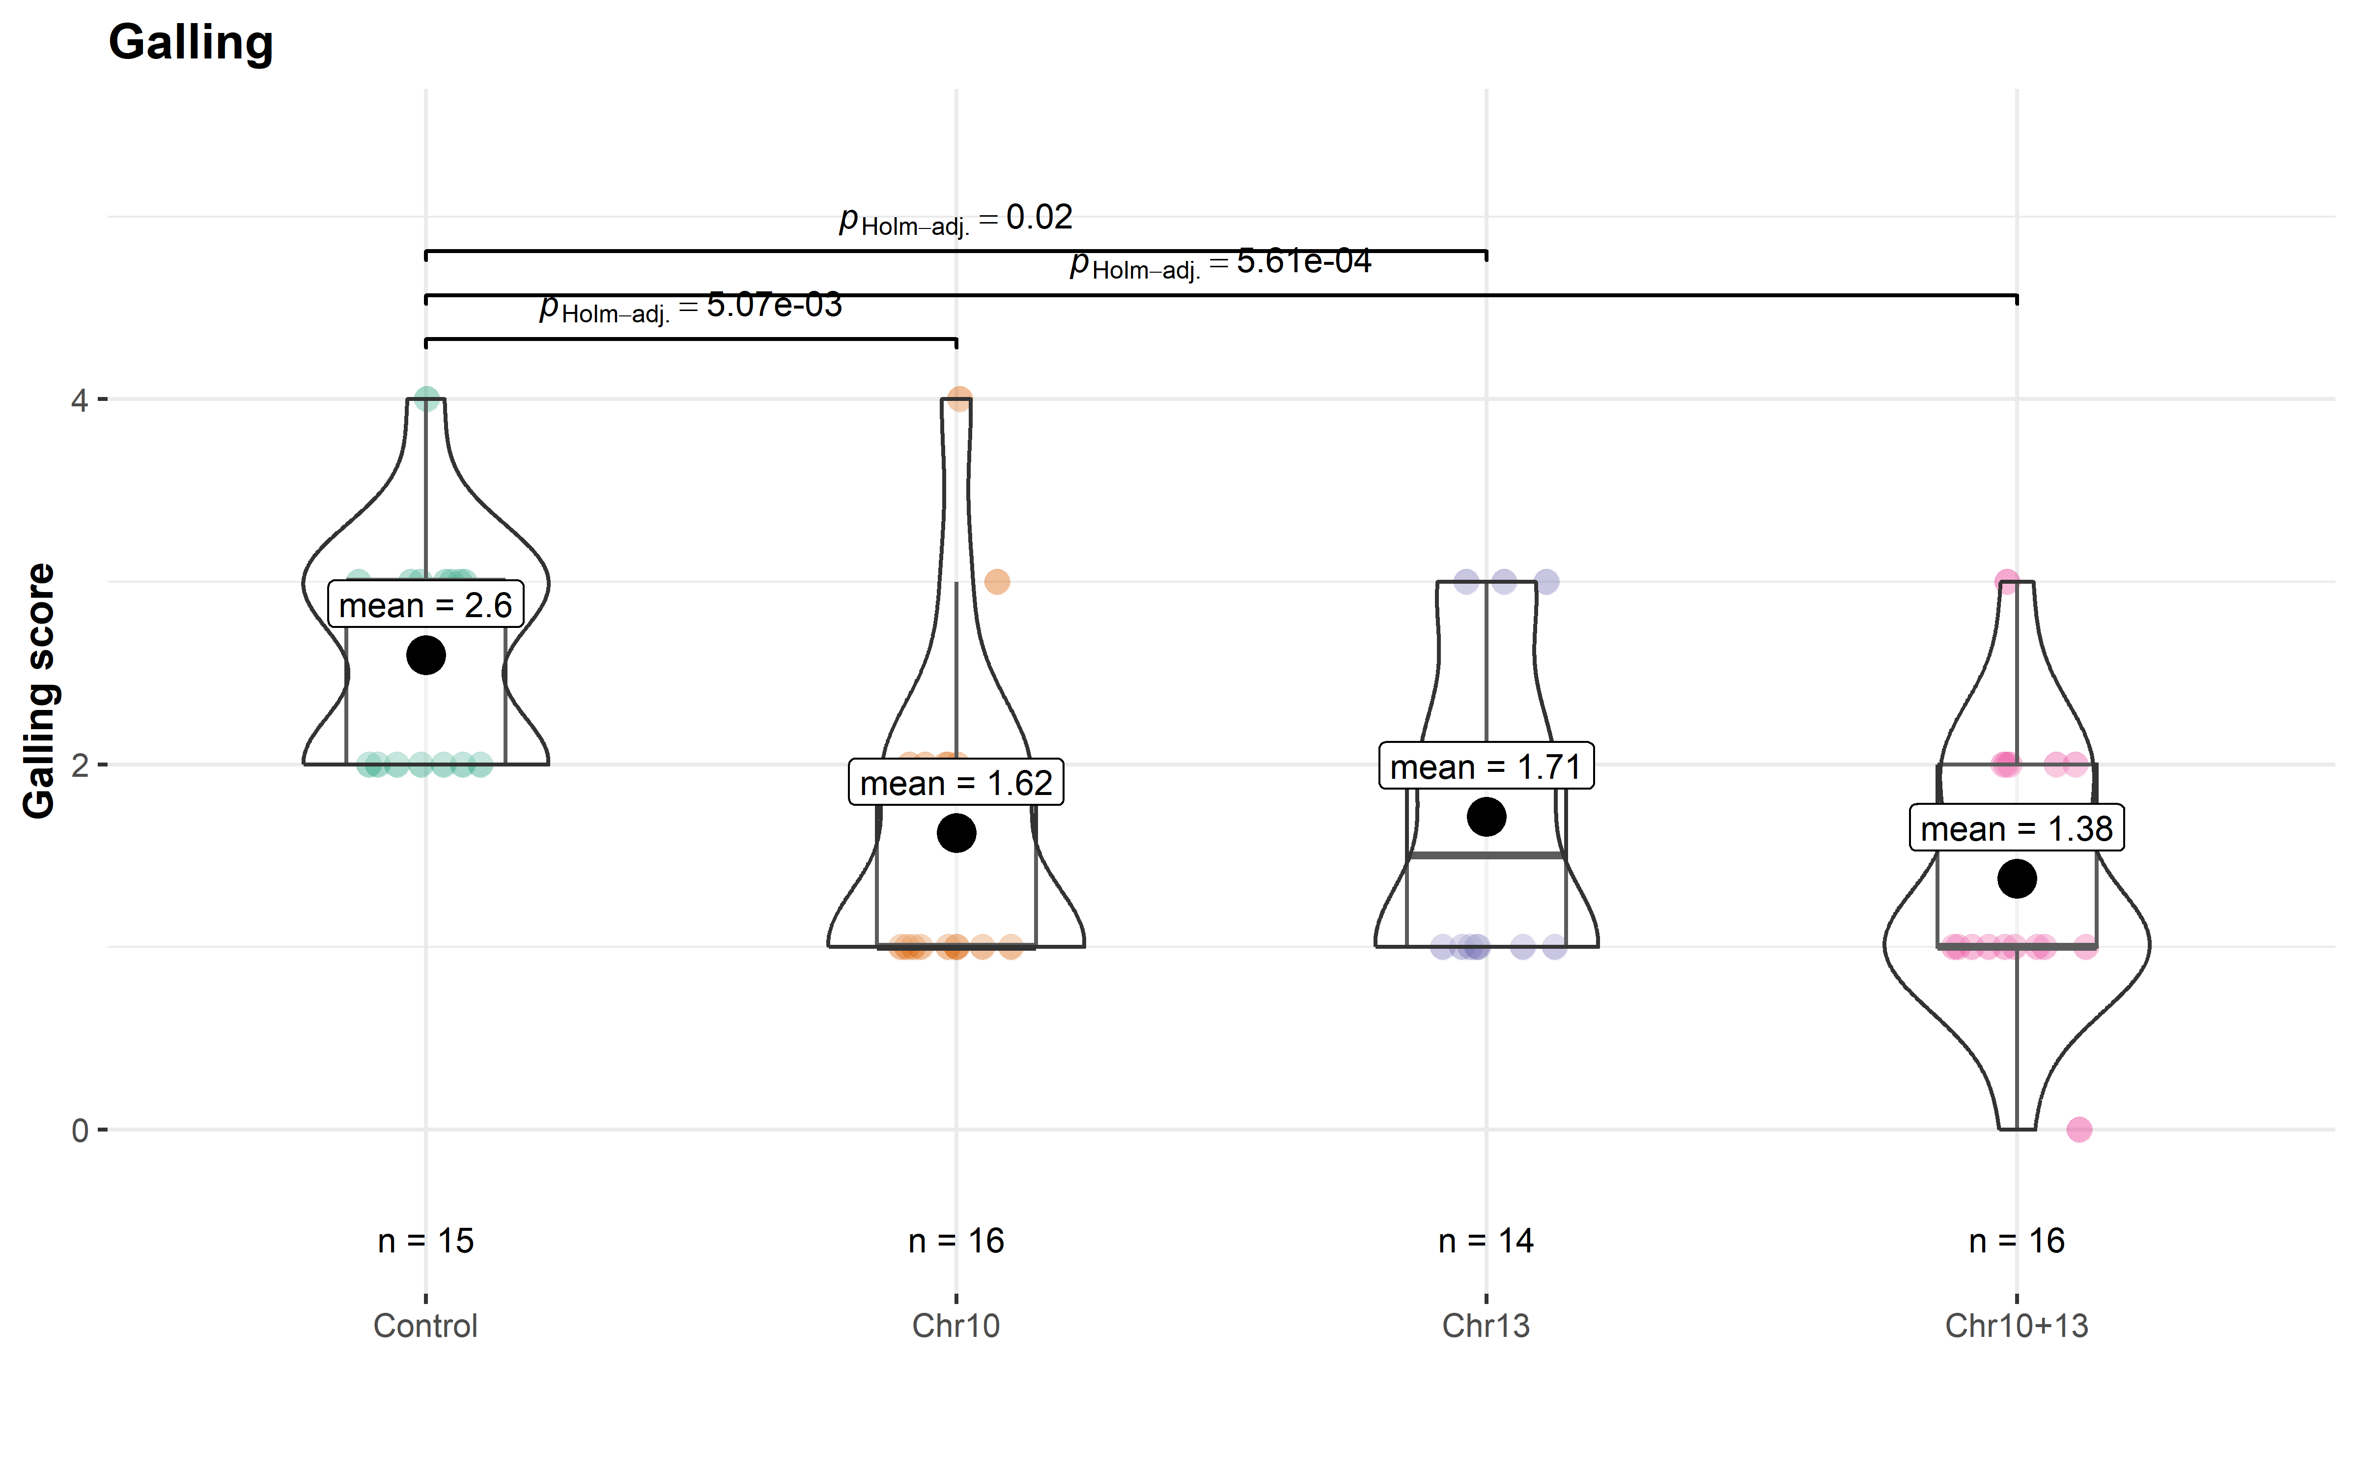
In this reporting period, recombinant inbred lines (RILs) carrying SRKN resistance QTLs on Chr. 10, Chr. 13, and their combination were evaluated to assess potential additive effects. While agronomic performance remained comparable across all genetic backgrounds, clear differences were observed for galling response following SRKN inoculation. Lines carrying individual QTLs showed similar galling levels (Chr. 10: 1.62; Chr. 13: 1.71), whereas lines combining both QTLs exhibited reduced galling (1.3), indicating a beneficial stacking effect (Figure 1). These results support the strategy of pyramiding resistance loci to enhance SRKN resistance and highlight the importance of combining multiple genomic regions to achieve more effective and potentially durable resistance.
Figure 1. Differences in root galling based on combinations of resistance regions on chromosomes 10 and 13.

To further validate these findings, the 16 RILs are being evaluated in yield trials at Pine Tree and Stuttgart, AR, to assess yield performance and potential effects of the resistance loci on yield and other agronomic traits. In addition, the same lines are being evaluated under heavy nematode pressure at Kerr, AR. Greenhouse evaluations consisting of three replications per line will also be conducted by Dr. Travis Faske at the University of Arkansas Southwest Research and Extension Center in Hope, AR. Galling response will be assessed across field and greenhouse environments to provide a comprehensive evaluation of SRKN resistance.

Objective 2 – Development of SRKN-resistant breeding populations. Develop MG 4 breeding populations and varieties with SRKN resistance suitable for production in the Mid-South.
Trials for the 2026 season have been successfully established. Final and pre-commercial yield trials were planted across five Arkansas locations: Jonesboro, Marianna, Pine Tree, Rohwer, and Stuttgart. Preliminary materials are being evaluated in replicated yield trials at Pine Tree, Rohwer, and Stuttgart. Planting began during the last week of April, allowing for timely establishment of the trials. To date, crop growth and development have progressed uneventfully across all locations.
2025–2026 Potential Release: The SRKN-resistant germplasm R21KB-05522 will continue evaluation in the 2026 PCM yield trial across 16 locations, including five internal Arkansas locations (Jonesboro, Marianna, Pine Tree, Rohwer, and Stuttgart), as well as Starkville, MS; Leland, MS; Cleveland, MS; Maysville, KY; Sharon, TN; Pocahontas, AR; Junction City, KS; St. George, KS; Altamont, IL; Salem, IL; and Princeton, IN.
2026 Pre-Commercial Stage: Forty-six advanced lines are being evaluated across 16 locations (mentioned above), including the SRKN-resistant lines R20-1429 and R21KB-03720. These lines also entered the 2026 Uniform Yield Trials. Additionally, line R21KB-03720 is being evaluated in the Arkansas Variety Testing Program.
2026 Preliminary Stage: Forty-four yield trials comprising 1,866 lines from maturity groups 3L through 5E are being evaluated in replicated yield trials across three Arkansas locations: Pine Tree, Rohwer, and Stuttgart. Genotyping of these lines is currently underway. DNA has been extracted and submitted to the laboratory of Dr. Song at the USDA-ARS Soybean Genomics and Improvement Laboratory for marker analysis. In parallel, the same set of lines is being screened using a proprietary disease panel which includes the evaluation of the SRKN resistant trait. Results from both analyses will be included in the final report.
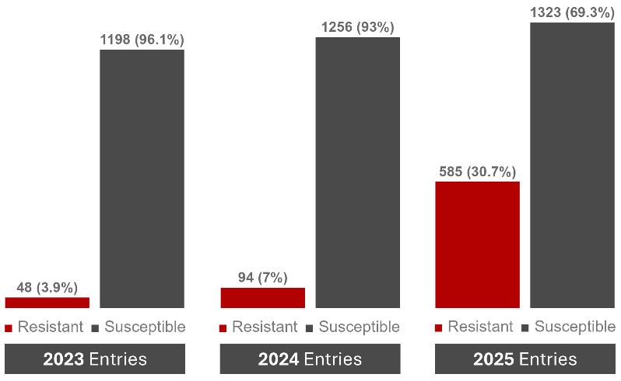
Additionally, breeding lines selected in 2023, 2024, and 2025 were screened using a proprietary disease panel that included the SRKN resistance trait. Substantial progress has been made in increasing the frequency of SRKN resistance within the breeding program. The proportion of lines carrying the SRKN resistance trait increased from 3.9% in the 2023 entries to 7.0% in the 2024 entries and 30.7% in the 2025 entries. In total, 585 of the 1,906 lines evaluated in 2025 were identified as carrying the SRKN resistance trait (Figure 2).
Figure 2. Proportion of SRKN-resistant and susceptible progeny rows planted in 2023, 2024, and 2025 and advancing to the 2024, 2025, and 2026 preliminary yield trials, respectively.
2026 Progeny Rows and Crossing Block: Early-generation materials were received from the winter nursery, and approximately 15,000 progeny rows were planted in Stuttgart, AR, during the second week of May. In addition, materials from the Enlist backcross project are expected to be received by mid-June and will also be planted in Stuttgart, AR. Drone-based image collection has been initiated for the materials already planted, and plant growth and development are progressing as expected.
All three planting dates of the crossing block have been established in Fayetteville, AR. Of the 71 parental lines selected for population development, 13 carry the SRKN resistance trait. Crossing activities are expected to begin by early July under full-season conditions and continue for approximately one month as parental lines reach maturity and become available for crossing.
Introducing New Genetic Diversity: Introducing New Genetic Diversity: Egg inoculum and host materials for SRKN (tomato and Williams 82) are currently being increased under greenhouse conditions. The first evaluation of the pre-commercial yield trials has been completed, and a second replication is currently underway to validate the results. Similarly, lines included in the final yield trials will be evaluated to identify additional sources of SRKN resistance.

