Please use this form to clearly and concisely report on project progress. The information included should reflect quantifiable results that can be used to evaluate and measure project success. Comments should be limited to the designated boxes. Technical reports, no longer than 4 pages, may be attached to this summary report.
Project Title: | Enhanced Synthetic Microbiome Communities to Managed Sudden Death Syndrome
Organization: | Arkansas State University
Principal Investigator Name: | Asela Wijeratne and Scott Mangan
Report Period: | March 15, 2026 - June 15, 2026

Project Status: On going
- Background
Sudden Death Syndrome (SDS), a devastating disease caused by the soilborne fungal pathogen Fusarium virguliforme, poses a significant threat to soybean production across the United States, particularly in the Mid-South region. The pathogen infects soybean roots and produces toxins that lead to foliar symptoms, ultimately causing substantial yield losses. Traditional management strategies, including the use of fungicides and SDS-tolerant soybean cultivars, often show inconsistent performance due to environmental variability, pathogen adaptation, and limitations in genetic resistance. As the disease continues to challenge growers, there is an increasing need for sustainable and biologically driven approaches to enhance plant resilience.
- Research Justification and Rationale
Emerging research in plant-microbe interactions suggests that beneficial rhizosphere microbes can improve plant health and increase tolerance to both biotic and abiotic stresses. In particular, certain bacteria and fungi associated with the soybean rhizosphere have shown potential in suppressing F. virguliforme through competitive exclusion, antibiosis, and induction of systemic resistance. Building on these insights, this research project aims to develop Synthetic Microbial Communities (SynComs) composed of naturally occurring beneficial microbes that can be introduced into the soybean rhizosphere as a novel strategy to manage SDS. By isolating and characterizing these organisms, we aim to lay the foundation for future SynCom formulations that can be field-tested and eventually integrated into sustainable crop management practices.

- Objectives and Approaches – Year 1
The primary objective for Year 1 is to isolate and identify beneficial rhizosphere-associated microbes—both bacterial and fungal—that exhibit antagonistic activity against F. virguliforme. This includes three major components (Fig. 01):
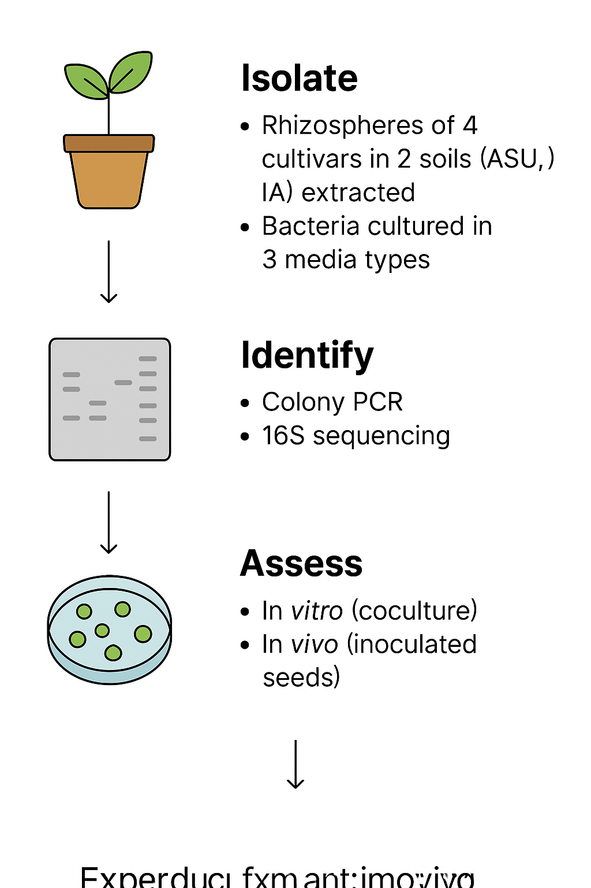
Figure. 01. Schematic showing the workflow.

- Rhizosphere Sampling and Microbial Isolation (Figure 1):
Two soybean cultivars with contrasting responses to Fusarium virguliforme: XO 04312 (tolerant) and XO 3752 (susceptible) were planted in pots filled with one of two distinct agricultural soils—Grundy/Haig soil from Iowa and Collins silt loam from Arkansas—chosen for their differing physical and chemical characteristics. A total of ten seeds per cultivar were grown in a controlled environment chamber under saturated watering conditions. Root systems were harvested at two time points: approximately 30 and 60 days after germination.
At each timepoint, plants were removed and processed under sterile conditions. From each cultivar, four root samples were collected and stored for DNA extraction, while the remaining roots and attached rhizosphere soil (~3 grams) were reserved for microbial culturing. Bacteria and fungi were isolated using serial dilutions and plating on selective and non-selective media (LB, R2A, and PDA).
To isolate rhizosphere microbial communities for DNA-based analysis, root-soil samples were vortexed in sterile PBS buffer containing a surfactant to detach microbes from root surfaces. The resulting suspension was filtered and centrifuged to collect microbial pellets, which were then resuspended, further purified by high-speed centrifugation, and stored at −80°C.

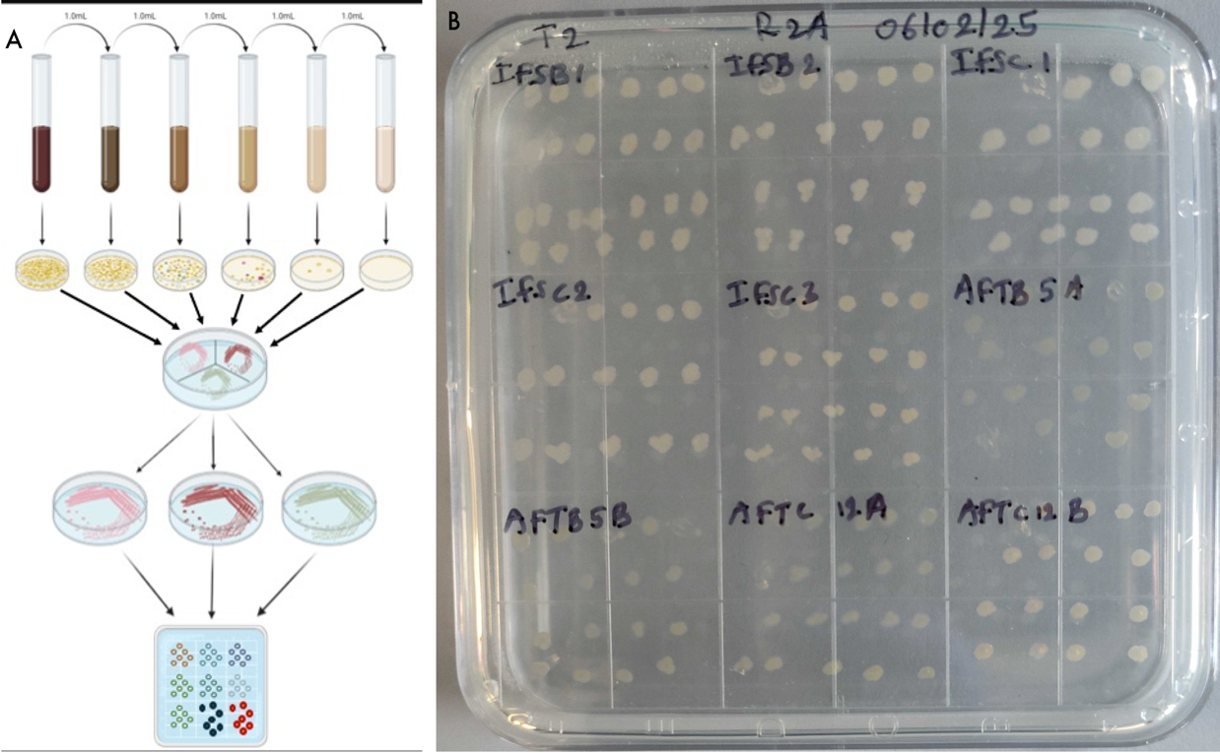
- Microbial Identification and Cataloging (updated)
Figure 02. A. Schematic showing bacterial culturing process. B. A subset of cultured bacterial on a plate
Bacterial isolates obtained from rhizosphere samples continue to be cataloged and morphologically characterized. A total of 459 isolates were cultured from the T2 timepoint. To date, DNA has been extracted from over 320 samples, with PCR amplification of the 16S rRNA gene performed for bacterial identification. A cumulative total of 200+ isolates have been sequenced using Oxford Nanopore technology, yielding identification of 30 additional bacterial species in the most recent sequencing batch, including Acidovorax soli, Chitinophaga caseinilytica, Variovorax guangxiensis, Pseudarthrobacter niigatensis, Pseudomonas glycinae, Pseudomonas fungipugnans, Sphingomonas trueperi, and others. Community-level beta diversity analysis confirmed distinct microbial community structures between the two soil types, and differential abundance analysis (DESeq2) identified Azospirillum, Bradyrhizobium, Pantoea, Magnetospirillum, and Nitrobacter as significantly enriched (padj < 0.05) in the resistant genotype.

- The sequencing data is being analyzed. These results will provide species-level taxonomic resolution and support the identification of bacterial candidates for further functional analysis and SynCom development.

- Community analysis of soil bacteria (Updated 3/15/26):
To investigate the composition of microbial communities associated with soybean rhizospheres, we amplified the 16S rRNA gene from DNA extracted from rhizosphere soil samples. These amplified products were prepared for high-throughput sequencing using Oxford Nanopore technology. Sequencing has been successfully completed, and we are currently in the data analysis phase. This analysis will provide insights into the bacterial diversity and relative abundance of microbial taxa present in each soil and cultivar treatment. Microbial communities from the rhizosphere were profiled using the 16S rRNA region, and Beta diversity analysis was performed to assess differences in rhizosphere microbial composition across the defined genotypic, soil, and growth stages. This analysis revealed distinct microbial community structures between the two soil types, indicating that the soil environment strongly influences rhizosphere composition. The differential abundance was assessed using DESeq2. Genotype and stage-specific shifts were evident, with Azospirillum, Bradyrhizobium, Pantoea, Magnetospirillum, and Nitrobacter significantly (padj < 0.05) enriched in resistant genotypes. Additionally, relative abundance analysis revealed that Bradyrhizobium, Bacillus, Mucilaginibacter, and Burkholderia–Caballeronia–Paraburkholderia were present across all conditions, underscoring their potential importance in rhizosphere function and soybean performance. These results highlight the importance of considering both genotype-specific enriched genera and common genera across soil types when developing microbial-assisted strategies to enhance plant growth, health, and yield through ecologically compatible and functionally resilient microbial communities.
.

e). In Vitro Screening of Biocontrol Candidates Against SDS Pathogen (Update: 3/15/26)
In vitro antagonism screening has now been completed across three independent trials for 22 bacterial isolates and three SynCom formulations. Results are reported as mean inhibition % ± SD across all three trials.
The strongest and most consistent performers were Bacillus velezensis (82.5% ± 1.5), Pseudomonas nicosulfuronedens (73.9% ± 2.8), and Bacillus paramycoides (44.4% ± 16.5). B. velezensis showed exceptional reproducibility across all three trials, and P. nicosulfuronedens emerged as a newly confirmed high-performing strain not previously reported in this context. Bacillus cereus averaged 80.1% ± 14.6, though variability in the third trial warrants additional confirmation. Moderate positive effects were observed for Pseudomonas koreensis (24.9% ± 0.6), P. plecoglossicida (20.9% ± 4.6), Priestia aryabhattai (18.9% ± 16.5), and Priestia megaterium (18.5% ± 16.2), though the latter two showed high variability and require further replication.
Organisms with consistently negative inhibition values — indicating stimulation of pathogen growth rather than suppression — include S. maltophilia (-26.0%), Hydrogenophaga palleronii (-23.7%), Achromobacter animicus (-23.7%), Variovorax paradoxus (-20.8%), and Cupriadavidus necator (-16.2%). These strains are being deprioritized for SynCom inclusion.
Three SynCom formulations were evaluated. SynCom1 (85.25%, 82.73%, 82.93% across trials; mean 83.6% ± 1.4) and SynCom2 (80.0%, 83.5%, 80.8%; mean 81.4% ± 1.9) both demonstrated strong and reproducible inhibition, with SynCom2 representing a newly tested formulation this quarter. SynCom3 performed inconsistently (mean 9.2% ± 15.9) and is not being advanced. The superior consistency of SynCom1 and SynCom2 relative to individual strains supports the multi-strain consortium strategy.

f). Extended Bacterial Identification and Whole Genome Sequencing (Updated 6/15/26)
Bacterial identification efforts continued this quarter, with 126 additional isolates sequenced and 32 newly identified bacterial species, bringing the cumulative total to 57 unique bacterial species identified via 16S rRNA sequencing. In parallel, whole genome sequencing was completed for 8 bacterial isolates, resulting in species-level identification of 3 additional isolates (2 Pseudomonas species and 1 Bacillus species), providing higher-resolution taxonomic and functional information than 16S sequencing alone.
g). In Vitro Screening of Additional SynCom Formulations: SynCom4 and SynCom5 (Updated 6/15/26)
Two additional SynCom formulations were evaluated for in vitro antagonism against F. virguliforme. SynCom4 (Priestia aryabhattai, Bacillus cereus, PP5, Bacillus paramycoides, and PN11) showed limited inhibition (17.27%). SynCom5 (Bacillus velezensis, Stenotrophomonas maltophilia, PP5, BAP9, and PN11) showed strong antagonistic activity (83.15%), comparable to the previously identified top-performing formulations, SynCom1 and SynCom2. A compatibility test for SynCom5 was completed, confirming that all five constituent bacterial strains grow together without antagonistic interaction, supporting its suitability as a multi-strain consortium for further development.
h). Meta-transcriptomic Analysis of SynCom1 (Updated 6/15/26)
Meta-transcriptomic analysis was performed for SynCom1 to begin characterizing gene expression activity within the consortium. [PLACEHOLDER: summary of meta-transcriptomic results and key findings to be added]
i). Peat-Based SynCom Formulation and Seed Soaking Trials (Updated 6/15/26)
A peat-based SynCom formulation was developed targeting a concentration of 10⁷ CFU per seed, and seeds treated with this formulation germinated successfully. Seed soaking trials were also conducted using SynCom5 at two soaking durations to evaluate effects on germination: a 1-hour soak resulted in successful germination of all seeds, whereas a 3-hour soak inhibited seed germination (Fig. 03).
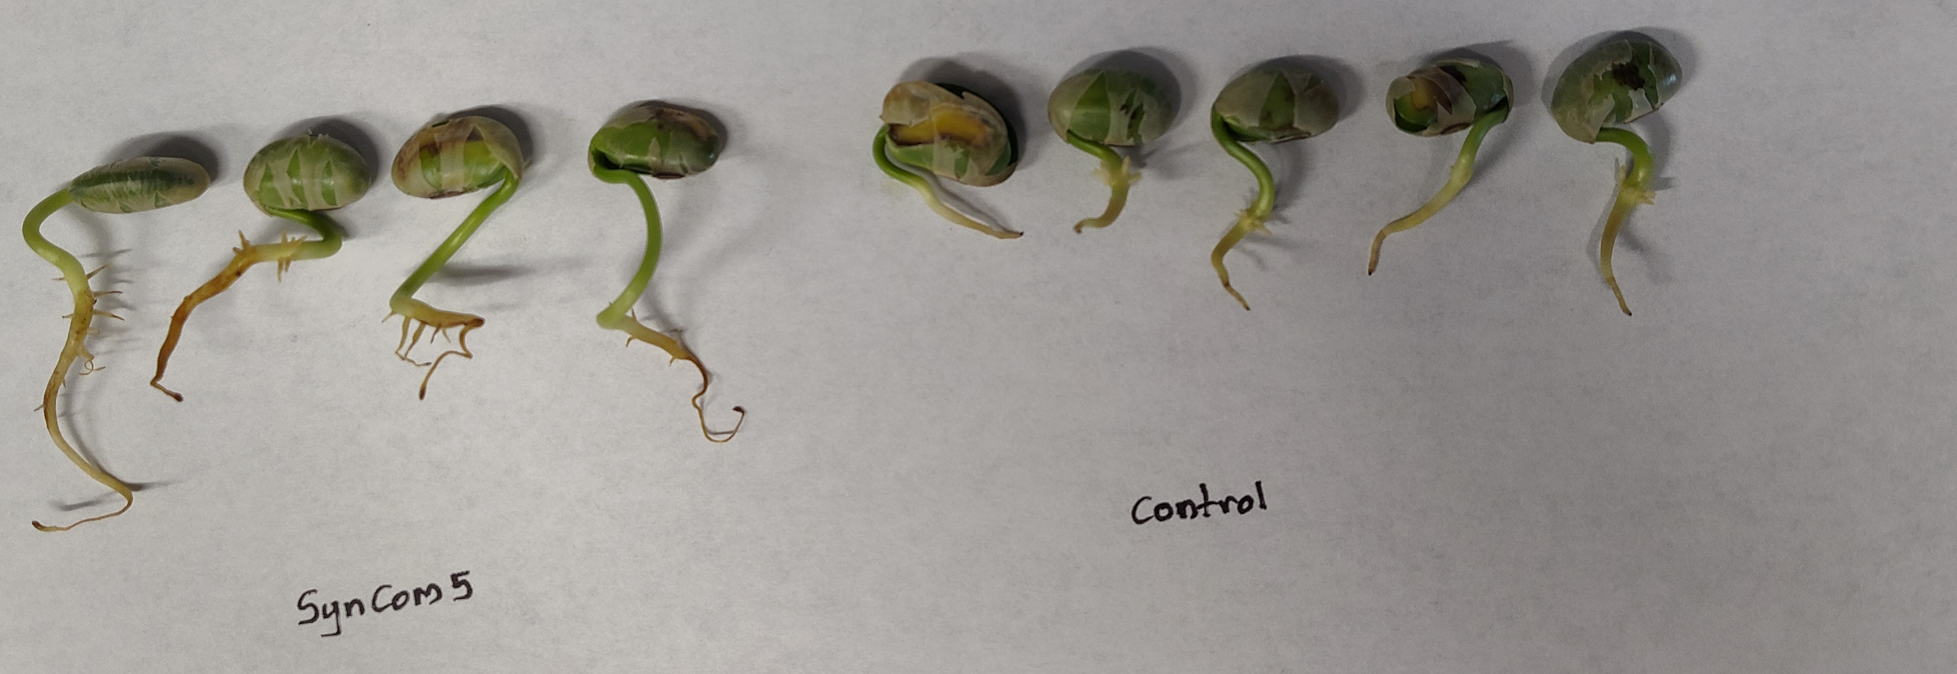

Figure 03. Germination of soybean seeds following a 1-hour SynCom5 seed-soaking treatment compared to an untreated control.
j). Seed Germination and Plant Growth Trial with SynCom5 (Updated 6/15/26)
A seed germination and plant growth trial was conducted using SynCom5, combining the 1-hour seed-soaking treatment with peat-based inoculation. Plants were grown for two weeks and showed no evidence of growth inhibition relative to controls, indicating that this treatment combination is compatible with normal soybean seedling development (Fig. 04, Fig. 05).
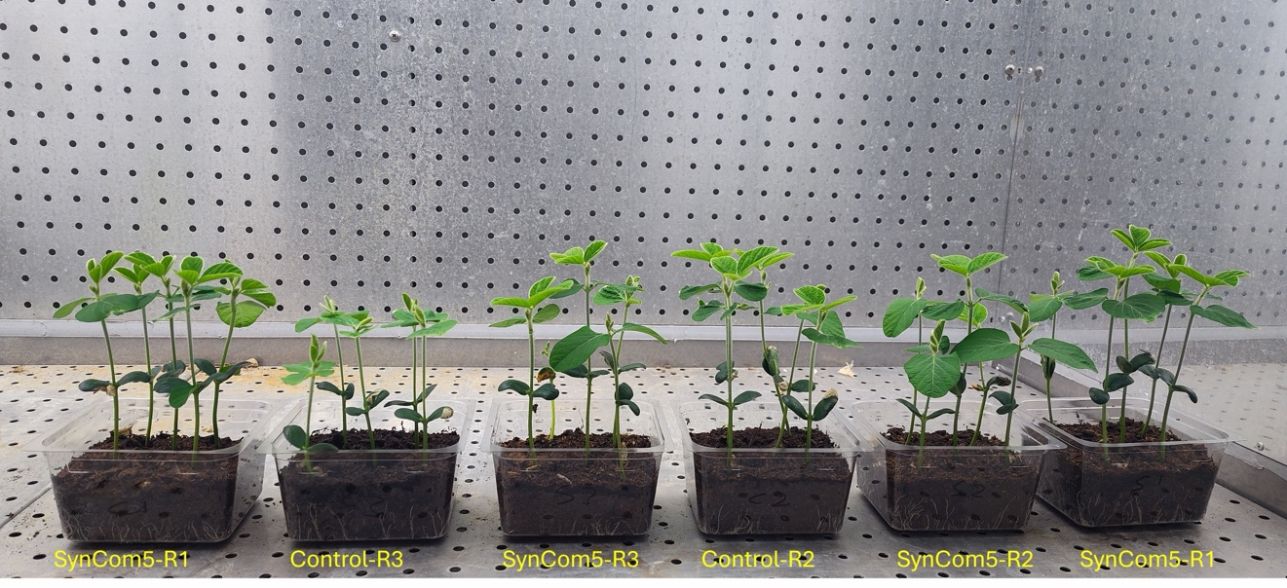

Figure 04. Two-week-old soybean seedlings grown from SynCom5-treated (1-hour soak + peat-based inoculation) and control seeds.
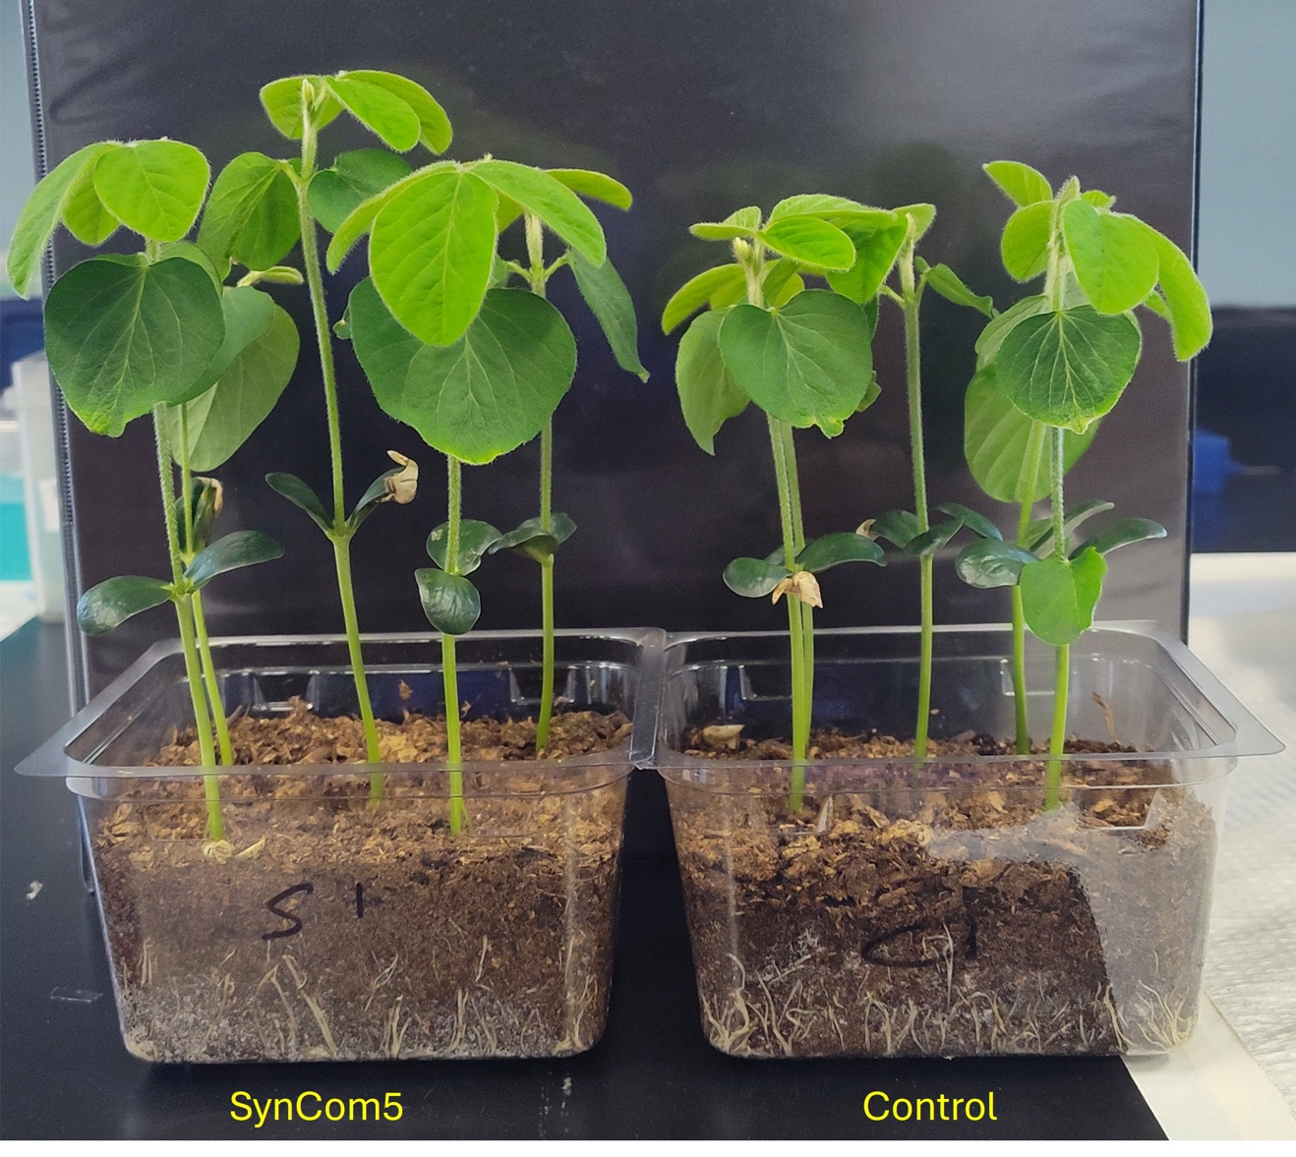

Figure 05. Close-up comparison of SynCom5-treated and control two-week-old soybean seedlings.

- Progress Summary
As of this reporting period, over 200 bacterial isolates have been sequenced for DNA-based identification, resulting in identification of 52+ unique bacterial species across all sequencing batches. Three independent antagonism trials have been completed for 22 isolates and three SynCom formulations, with results now reported as validated means with standard deviations. Phosphate solubilization assays were completed for 19 isolates; 9 demonstrated positive activity, with P. plecoglossicida and P. anthophila ranking highest. SynCom1 and SynCom2 both showed strong, reproducible antagonism against F. virguliforme under laboratory conditions. The rhizosphere processing, culture methods, community analysis, and antagonism screening pipelines have been standardized and optimized for reproducibility. All materials, including protocols and microbial isolate metadata, are being recorded in a centralized digital lab notebook using Benchling.
Update (6/15/26): Since the previous report, bacterial identification expanded with 126 additional isolates sequenced and 32 new species identified, bringing the cumulative total to 57 unique bacterial species. Whole genome sequencing was completed for 8 isolates, revealing 3 additional species-level identifications (2 Pseudomonas, 1 Bacillus). Two new SynCom formulations were screened for in vitro antagonism: SynCom4 (17.27%) and SynCom5 (83.15%), and a compatibility test confirmed all five SynCom5 constituent strains grow together without antagonism. Meta-transcriptomic analysis was initiated for SynCom1. A peat-based SynCom formulation (target 10⁷ CFU/seed) was developed and germinated successfully, and seed-soaking trials established that a 1-hour (but not 3-hour) SynCom5 soak supports normal germination. A combined seed-soaking and peat-based inoculation trial with SynCom5 showed no growth inhibition in soybean seedlings over two weeks (Fig. 03–05).

- Next Steps (Q3 Goals)
In the upcoming quarter, the following goals will be pursued:
- Manuscript submission summarizing the complete microbial community analysis.
- Setting up a greenhouse experiment to evaluate SynCom performance.

